Utah Division of Wildlife Resources Fishery Monitoring Report
Author: Taylor R. Stewart
Contact: taylorstewart@utah.gov
System: Willard Bay Reservoir
Sampling Dates: 7/26/2023; 10/17/2023 - 10/19/2023
Target Species: Channel Catfish, Walleye, Wiper, Yellow Perch, Age-0 Gizzard Shad, Logperch, Age-0 Smallmouth Bass, and Age-0 Yellow Perch
Species Stocked: Walleye and Wiper
Monitoring Objectives:
- Provide data for assessment of trends in species occurrence, relative abundance, biomass, and size structure of forage and sport fish assemblages.
- Evaluate population indices to improve the effectiveness of stocking efforts of Walleye and Wiper.
- Monitor and maintain a viable Walleye broodsource population.
Sampling Design and Methods:
Beach Seines
The prescribed summer beach seining survey occurred at four standardized locations in July when age-0 fish recruit to the gear (Table 1; Figure 1). Sampling was conducted using a 30-m bag seine with 6-mm wing mesh, 3-mm bag mesh, 2.4-m deep, and a 2.4-m bag. Seine was deployed by anchoring one end to shore and extending the seine by boat perpendicular to shore. Once the seine was fully extended, the seine was pulled to shore at an approximate 90° arc. All fish caught were identified to species and measured for total length (mm).
Gillnets
The prescribed fall gillnet survey occurred over a three-day period in October and sampled 24 sites with one net-night of effort at each site (Table 1; Figure 1). The survey was conducted in nearshore (ca. 1.8-2.4 m depths) and offshore (ca. 2.4-3.7 m depths) waters. All nets were positioned across depth contours beginning in shallower water. Experimental benthic gillnets were 24.8 m long by 1.8 m deep with eight 3.1-m panels that had bar mesh sizes of 19, 25, 32, 38, 44, 51, 57, and 64 mm. Nets were set overnight and retrieved at dawn. All fish caught were identified to species, measured for total length (mm) and weight (g), and ageing structures (i.e., dorsal or pectoral spines) were collected on Channel Catfish, Walleye, and Wiper from the first ten individuals in each 10-mm length category.
Statistical Methods
Relative abundance (i.e., catch-per-unit-effort) and biomass were analyzed as the respective number or weight for each species per net-night or area swept (i.e., density). Area covered by a seine tow was assumed to be a quadrant of a circle with a 30-m radius. Length frequencies were presented as an empirical cumulative distribution function (ECDF) and a histogram. The ECDF, which is the proportion of fish that are less than each observed length, was used to analyze changes over time while the histogram was used to show the frequency of individuals in each length interval for a single year. Growth was summarized with the traditional parameterization of the vonBertalanffy growth function. Recruitment was analyzed through year-class strength in two ways. First, the Studentized residuals from a catch curve analysis of the current population of Walleye were used to objectively define strong or weak year-classes based on where the residual is on the t-distribution. Second, a two-way ANOVA model and least-squares means for each year-class were used as a metric of year-class strength within the context of historical catch rates for both Walleye and Wiper. Weight-length residuals and relative weight were used as condition metrics. Changes in the fish community composition were analyzed across years using non-metric multidimensional scaling.
Summary:
Species Composition
Fish catches were comprised of Black Bullhead, Channel Catfish, Common Carp, Gizzard Shad, Logperch, Smallmouth Bass, Walleye, Wiper, and Yellow Perch (Figures 2 & 3). Walleye were the most abundant species by number caught (43.7%) and Channel Catfish were the most abundant species by weight (33.8%) in gillnets (Figure 2). Logperch were the most abundant species by number caught (72.6%) in beach seines (Figure 3). No age-0 Gizzard Shad were observed in beach seines.
Abundance
Walleye mean relative abundance was 4.3 fish/net-night (SE = 0.4), decreased by 60.7% from 2022, and were evenly dispersed spatially and between depths sampled (Figures 4 & 5). Catch rates of Walleye decreased or remained stable among all Gablehouse length categories (Figure 6). Wiper mean relative abundance was 1.5 fish/net-night (SE = 0.2), decreased by 65.1% from 2022, and were distributed sporadically (Figures 4 & 5). Catch rates among all Gablehouse length categories decreased to near zero (Figure 6). The negative trend in Wiper abundance is notable and has occurred since 2014. Channel Catfish and Yellow abundances have remained within historical bounds (Figures 4 & 6).
No age-0 Gizzard Shad were observed in 2023 and catch rates have decreased to near zero since 2017 (Figure 7), except for 2022 when estimates of age-0 Gizzard Shad were precluded because large volumes of organic material impeded accurate aggregate weights from being collected and prevented our ability to extrapolate total numbers. While the pelagic forage base was likely limited with low Gizzard Shad densities, Smallmouth Bass and Logperch catch rates increased significantly and would have provided forage opportunities in the littoral habitat (Figure 7).
Biomass
Walleye mean relative biomass was 4.0 kg/net-night (SE = 0.4) and decreased by 57.2% from 2022, but the trend in Walleye biomass is cyclic and remains within historical bounds (Figure 8). Channel Catfish mean relative biomass remained within historical bounds and would suggest that while relative abundance of Channel Catfish has decreased the mean weight of fish caught should have increased. Wiper mean relative biomass was 3.8 kg/net-night and decreased by 64.8% from 2022, and follows the same negative trend observed with relative abundance since 2014. Yellow Perch mean relative biomass was 1.0 kg/net-night, a historical high and an increase of 61.2% from 2022 (Figure 8).
Recruitment Index
The current population of Walleye is supported by seven year-classes (Figure 9). The year-class observed in 2023 is the only strong year-class; however, this value is inflated by age-0 fish who have recruited to the sampling gear but not to the population (i.e., age-1 or older fish). The 2022 Walleye year-class (i.e., age-1) was significantly weak, likely caused by low stocking numbers. The 2017-2021 year-classes were neutral (Figure 9). Accounting for historical catches, an inverse relationship between Walleye and Wiper was observed, starting after the start of the Walleye stocking program (i.e., 2014; Figure 10). Prior to 2014, Walleye and Wiper year-class strengths were positively related.
Size Structure
The size structure of Walleye remained consistent among years, except for a higher proportion of substock individuals in 2023 (Figure 11). These substock individuals were identified as age-0. Wiper continue to improve in length over time, with the largest proportion of individuals being caught in the quality- and preferred-length categories (Figures 11 & 12). Channel Catfish size structure has progressively shifted to larger individuals year-over-year (Figure 11). All shifts in length distributions between 2022 and 2023 were not statistically different, based on a bootstrapped Kolmogorov-Smirnov test (Figure 11).
Growth
Age structures were collected in 2023 and was the first reexamination of growth since the start of the walleye stocking program (Figure 13). Walleye growth was similar through age-2 and increased in 2023 starting at age-3. Walleye are growing more rapidly but have a lower maximum age in 2023 compared to 2013. Wiper growth is similar through age-10 for both years examined but a greater maximum age was observed in 2023 (Figure 13).
Condition
Weight-length residuals from all species appear normally distributed and centered at or near zero (Figure 14). Relative weights of Channel Catfish had a negative relationship with total length (Figure 15). Walleye and Wiper relative weight remained stable as length increased. Yellow Perch relative weight increased sharply with length (Figure 15).
Community Structure
The fish community has shifted over time from being dominated largely by Channel Catfish, Wiper, Yellow Perch to being dominated solely by Walleye (Figure 16). The relative presence of Wiper and Yellow Perch have been less since 2016. The forage community was dominated by Smallmouth Bass and Logperch in 2023 but the absence of effective sampling limits confidence in inferences made (Figure 17).
Stocking
Stocking quotas were met in 2023 (Figure 18). Wiper fry from an out-of-state source were pursued in the absence of adequate production through the state hatchery program.
All other measurements and indices appear within normal bounds.
Discussion:
The overall decrease in fish abundance is alarming and warrants monitoring. However, the significant increase in water volume and clarity from 2022 to 2023 could explain the observed decrease in catch rates. Increases in water volume can decrease primary productivity and decreases in primary productivity can increase water transparency. Willard Bay was near full pool starting in early-spring and was maintained at or near this elevation through all of 2023. Satellite images highlight the difference in turbidity and water clarity while gillnet surveys were conducted in 2022 and 2023 (Figure 19). Gillnet catchability and water transparency are negatively related. In addition, the low water in 2022 limited our ability to conduct a complete gillnet survey. The reduced number of nets set could have limited our statistical power. However, the reduced water volume in 2022 could have concentrated fish and benthic nets would have sampled most of the water column, thus further increasing catchability. The comparisons made in this report should be interpreted with caution as a variety of biotic and abiotic factors may have influenced survey results. The gillnet survey in 2024 will provide the most accurate comparison to 2023 since 2019 and be crucial to understand the complex trends currently observed in Willard Bay.
Anecdotal evidence (i.e., angler fishing reports, visual observations, etc.) suggests that a year-class of Gizzard Shad was present in the forage base that was not observed in our traditional sampling gear. Gizzard Shad were observed on sonar images in the fall of 2023 and several surface boils were reported. Angler reports also showed a strong return of age-0 Wipers that were not observed in our surveys.
Management Actions:
- Continue stocking 2,000,000 Walleye, 1,000,000 Wiper fry, and 5,000 Wiper at catchable lengths to supplement the Willard Bay Reservoir fishery. Reevaluate stocking numbers in 2024 to ensure stocking numbers are sustainable and consider an adaptive stocking model (e.g., alternating years of high stocking rates for each species).
- Continue monitoring age-0 Gizzard Shad populations through beach seines while evaluating alternative sampling methods (see Management Action #3).
- Evaluate the feasibility of implementing boat electrofishing or hydroacoustic (i.e., horizontally-oriented echosounder) sampling methods to index prey density as an alternative to summer beach seining. Beach seines can be labor- and time-intensive, lack precision and accuracy, and are spatially limited. Alternative sampling methods can increase the spatial and temporal coverage with minimal time investment, can be completed with a “skeleton” crew, and increase the accuracy of the forage base estimates; thus, improving management decisions for piscivorous fishes and aid in determining the appropriate stocking numbers for sportfish.
- Decrease bag limit on Yellow Perch from the statewide regulation to a limit of 10-20 fish per day. The Yellow Perch fishery is doing exceptionally well, with consistent angler catches of fish exceeding 300 mm and 600 grams. The use of social media has put a spotlight on this fishery and increased harvest. A special regulation to restrict harvest would protect the spawning stock given the boom-and-bust nature of Yellow Perch in Willard Bay and could provide more consistent recruitment.
- Conduct creel in 2026 to assess angler return and satisfaction after two years of high stocking rates.
- Finish age and growth analysis of Channel Catfish during the summer of 2024.

Tables:
Table 1: Date of collection, number of samples collected by sampling gear type, prescribed number samples by sampling gear type, mean water temperature (°C), and any additional data collected from Willard Bay Reservoir in 2023.
Gear Type | Date | # of Samples | # of Prescribed Samples | Water Temperature | Additional Comments
Beach Seine | 7/26/2023 | 4 | 4 | 25.5 | –
Gillnet | 10/17/2023 - 10/19/2023 | 24 | 24 | 17.2 | –

Table 2: Mean total length (TL; mm), mean weight (WT; g), mean relative weight (Wr), and percentage of individuals within each traditional proportional size distribution (PSD) category for each target species from Willard Bay Reservoir in 2023. All values in parentheses indicate standard deviation.
Target Species | Mean TL | Mean WT | Mean Wr | PSD-  Quality | PSD-  Preferred | PSD-  Memorable | PSD-  Trophy
Channel Catfish | 368.3 (130.0) | 655.2 (686.9) | 94.4 (9.7) | 93 | 5 | 0 | 0
Walleye | 384.7 (107.4) | 743.7 (619.8) | 103.0 (8.2) | 83 | 10 | 0 | 0
Wiper | 397.9 (123.9) | 1105.5 (742.4) | 96.5 (7.5) | 91 | 68 | 9 | 0
Yellow Perch | 204.3 (88.8) | 181.5 (177.8) | 93.1 (9.1) | 88 | 88 | 65 | 0
Age-0 Gizzard Shad | 51.3 (32.8) | – | – | 0 | 0 | 0 | 0
Logperch | 59.2 (14.4) | – | – | 0 | 0 | 0 | 0
Age-0 Smallmouth Bass | 56.5 (30.5) | – | – | 0 | 0 | 0 | 0
Age-0 Yellow Perch | 59.2 (44.7) | – | – | 0 | 0 | 0 | 0

Figures:
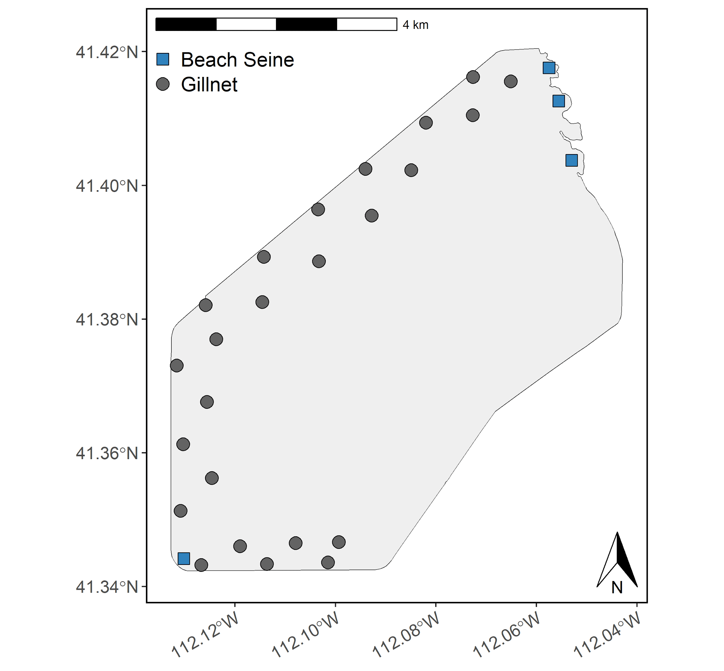
Figure 1: Map of Willard Bay Reservoir sampling sites. Gillnets are denoted as gray circles and beach seining locations are denoted as blue squares.
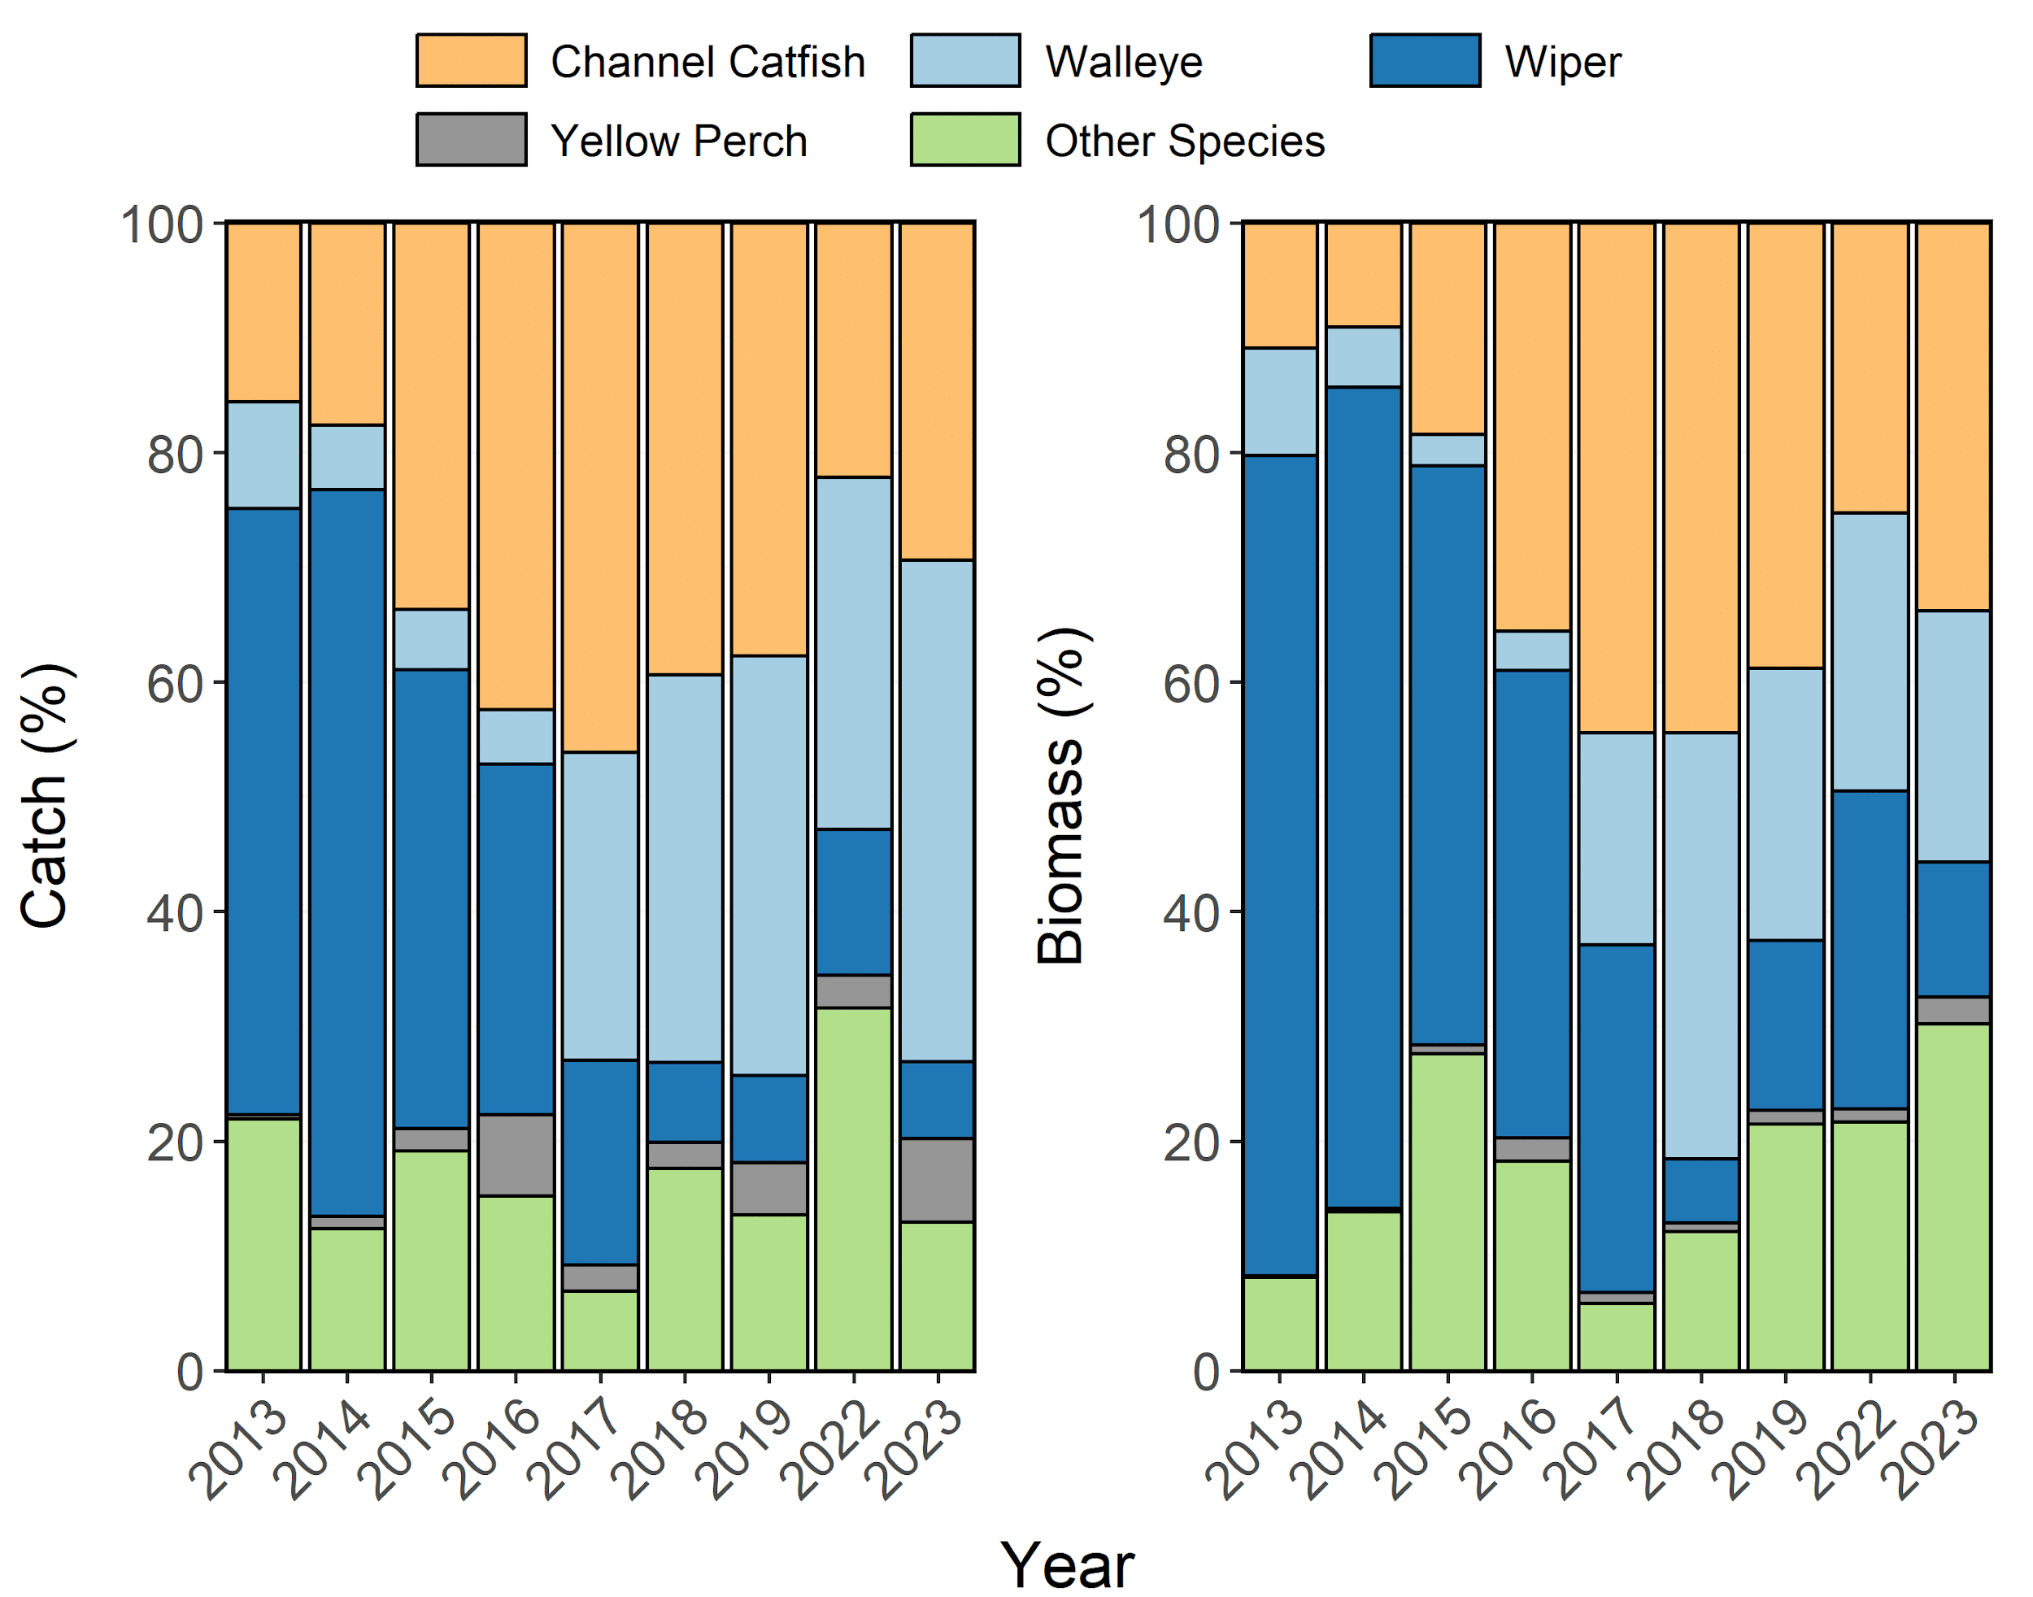
Figure 2: Species composition (%) by catch (# of fish) and biomass (kg) of Channel Catfish, Walleye, Wiper, and Yellow Perch sampled in gillnets from Willard Bay Reservoir between 2013-2023. Other species include Black Crappie, Gizzard Shad, Smallmouth Bass, Utah Sucker, Bluegill, Utah Chub, Yellow Bullhead, Common Carp, Green Sunfish, and Black Bullhead aggregated together.
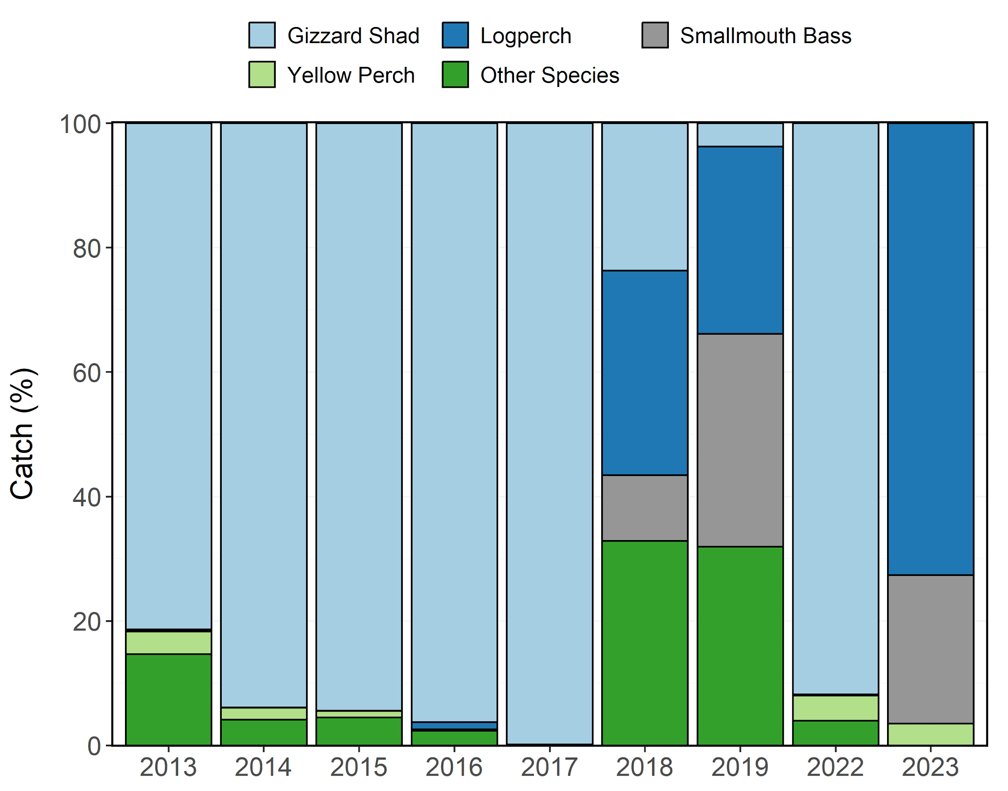
Figure 3: Species composition (%) by catch (# of fish) and biomass (kg) of Age-0 Gizzard Shad, Logperch, Age-0 Smallmouth Bass, and Age-0 Yellow Perch sampled during seining surveys from Willard Bay Reservoir between 2013-2023. Other species include Black Crappie, Bluegill, Channel Catfish, Common Carp, Green Sunfish, Largemouth Bass, Mosquitofish, Redside Shiner, Spottail Shiner, Walleye, and Wiper aggregated together.
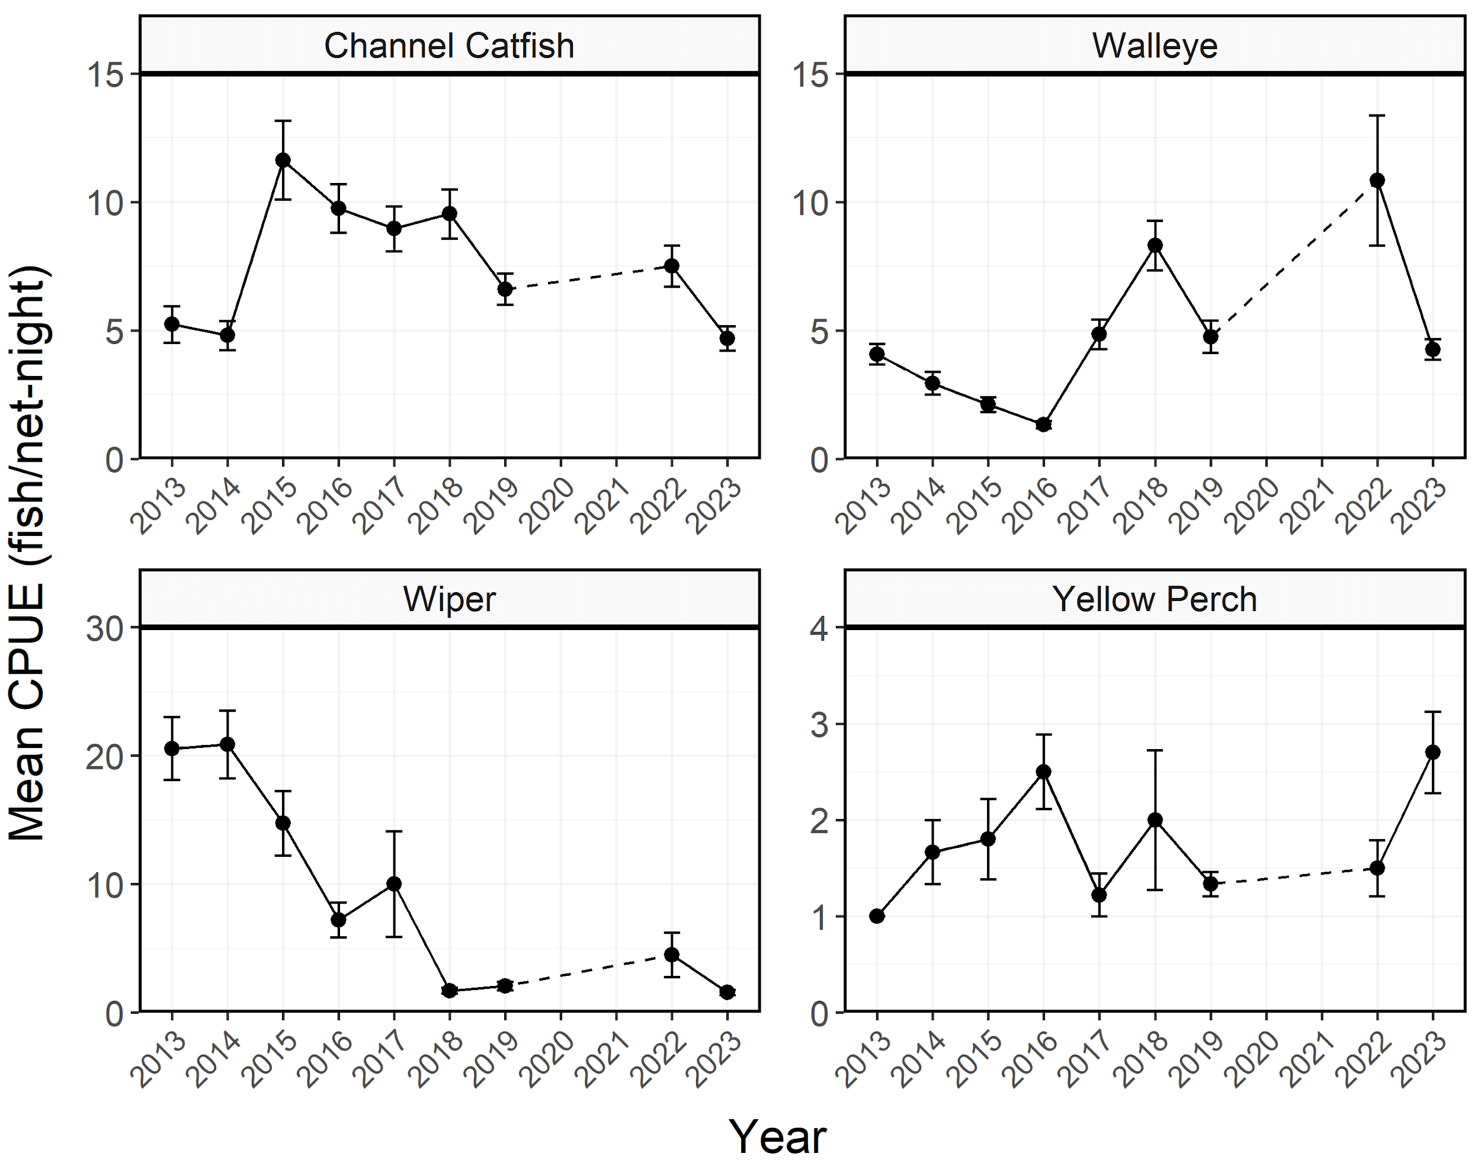
Figure 4: Mean relative abundance (CPUE; fish/net-night) of stock-length Channel Catfish, Walleye, Wiper, and Yellow Perch sampled in gillnets from Willard Bay Reservoir between 2013-2023. Error bars indicate standard error.
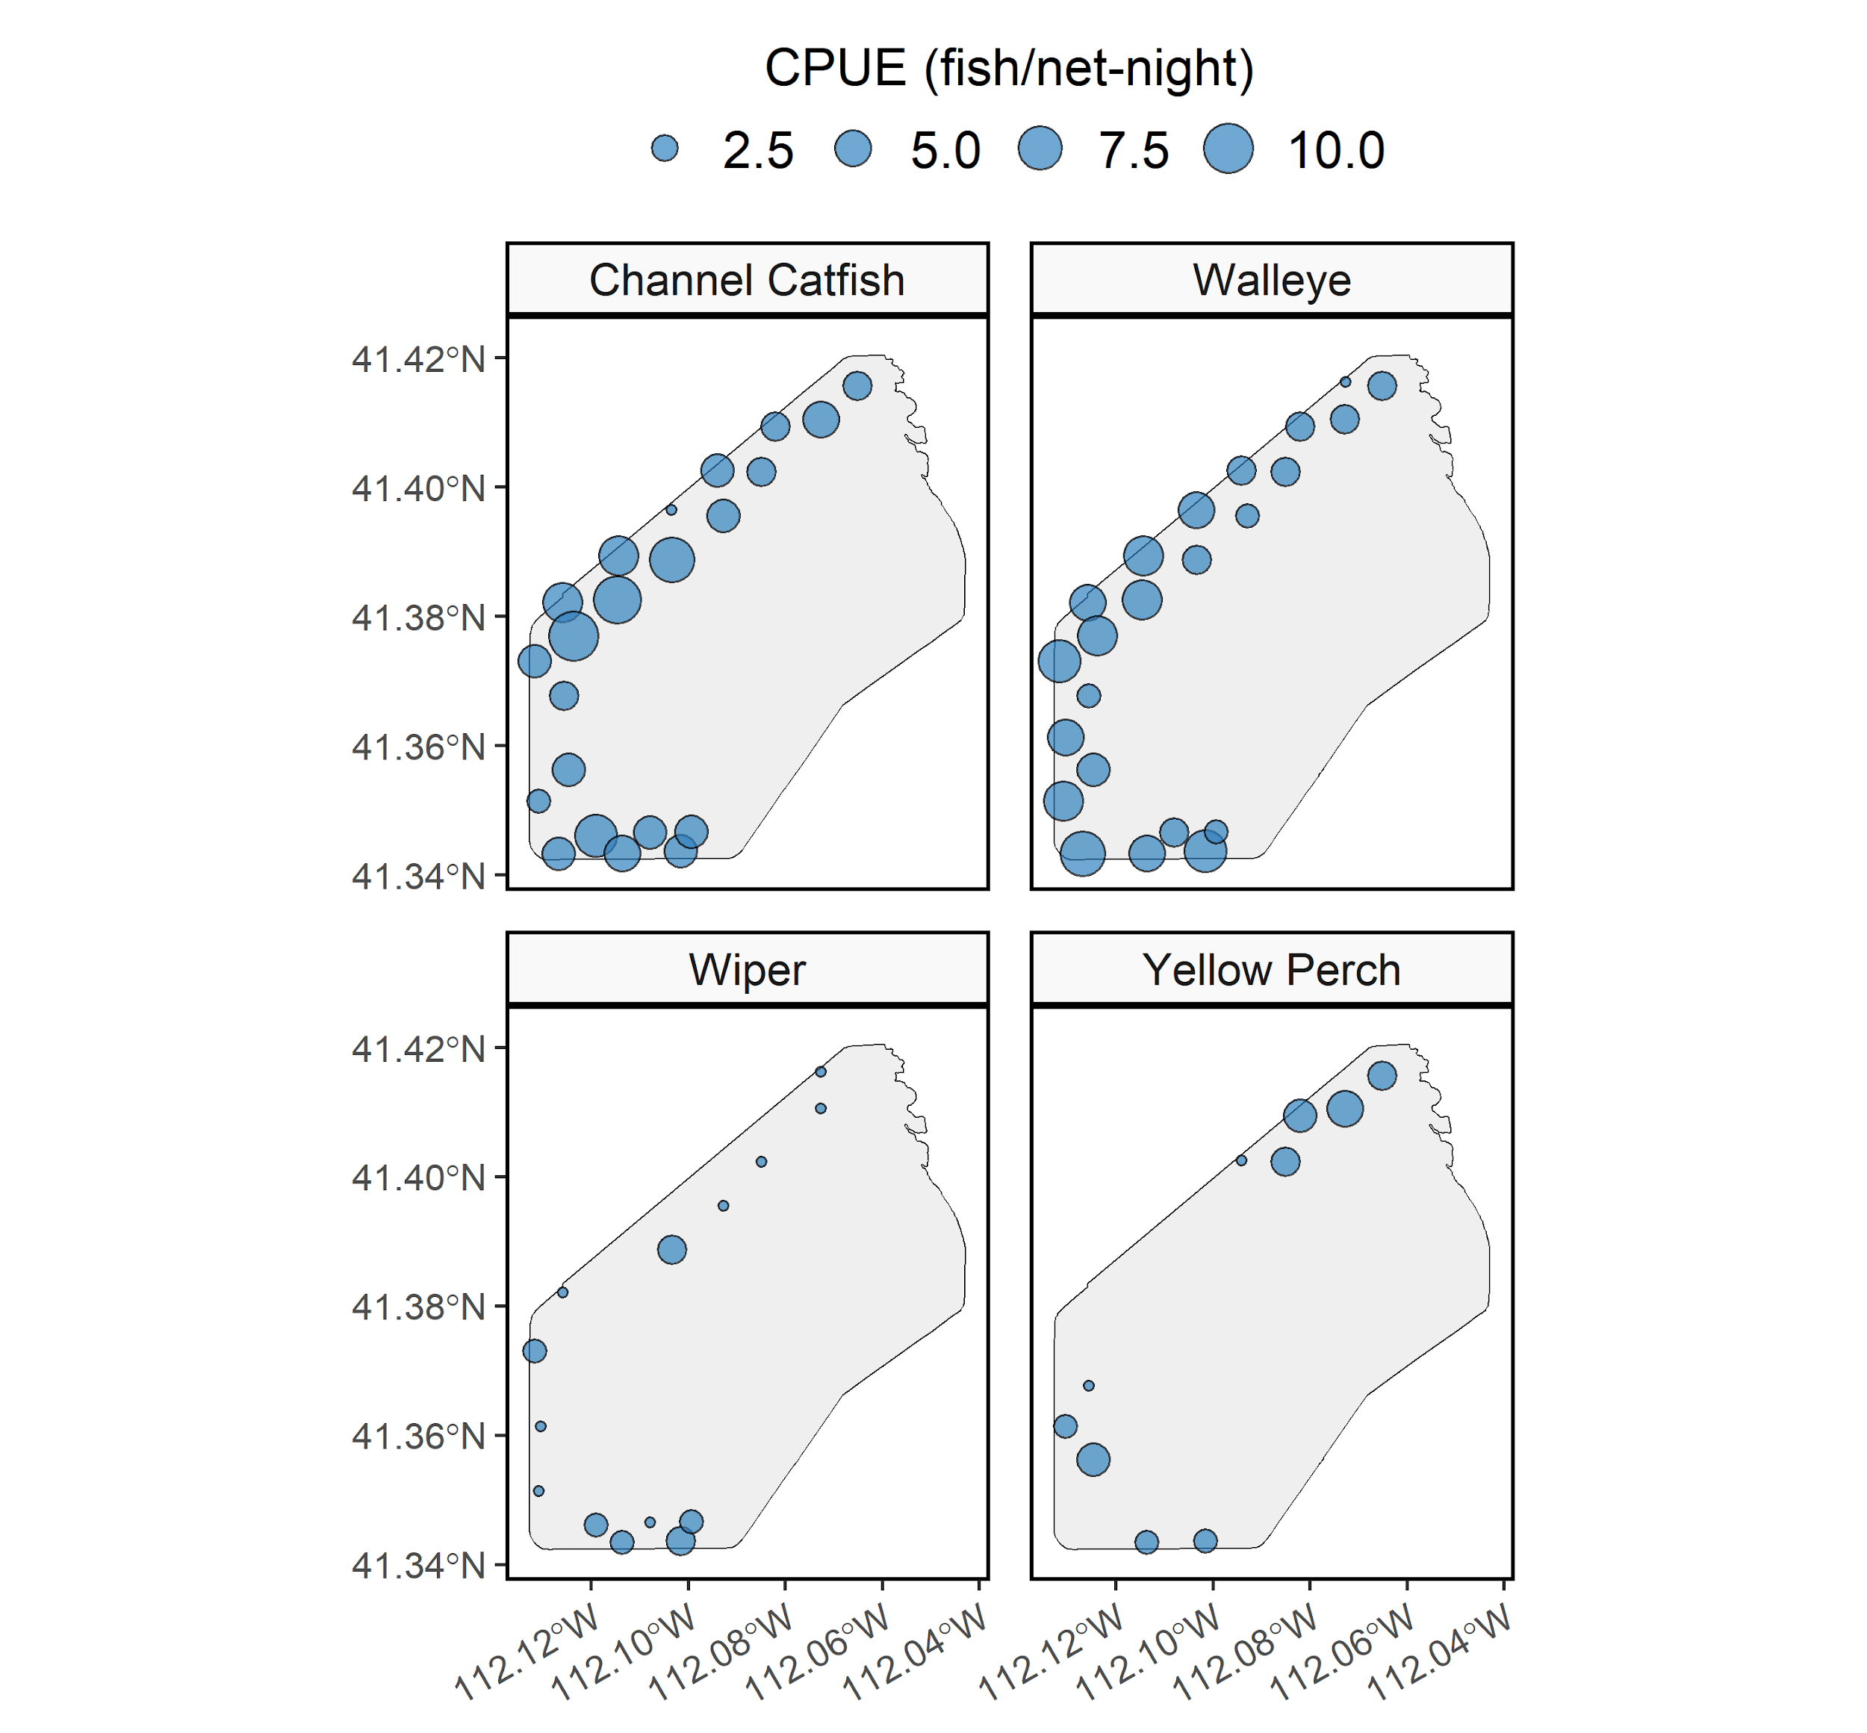
Figure 5: Mean relative abundance (CPUE; fish/net-night) of Channel Catfish, Walleye, Wiper, and Yellow Perch at each gillnet sampling location from Willard Bay Reservoir in 2023. CPUE is depicted with varying point size and the diameter of the point is directly proportional to CPUE.
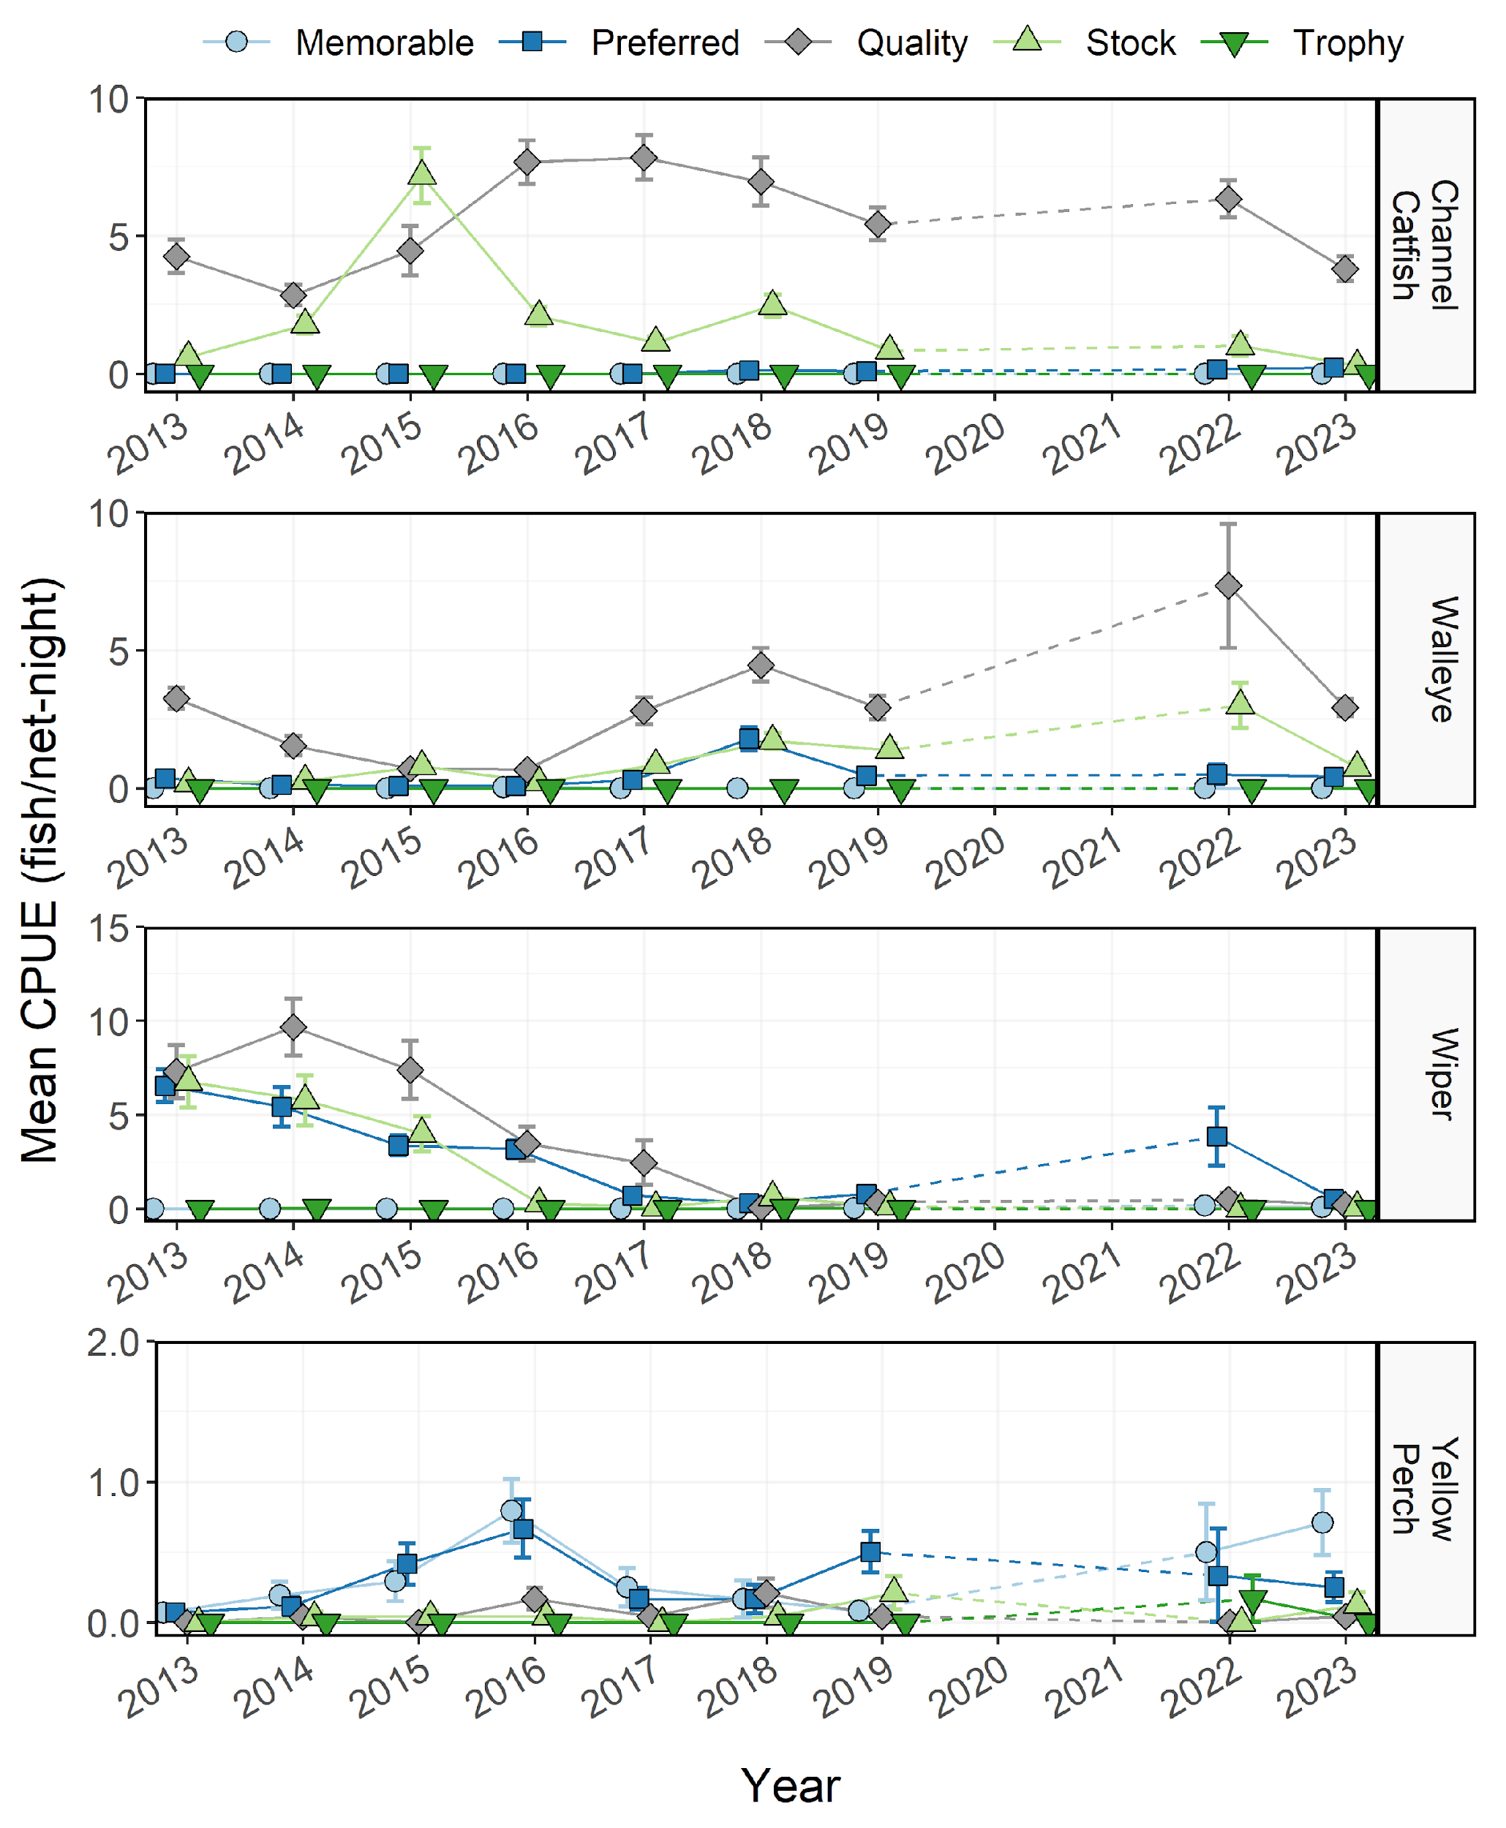
Figure 6: Mean relative abundance (CPUE; fish/net-night) of Channel Catfish, Walleye, Wiper, and Yellow Perch within each Gablehouse length category sampled in gillnets from Willard Bay Reservoir between 2013-2023. Error bars indicate standard error.
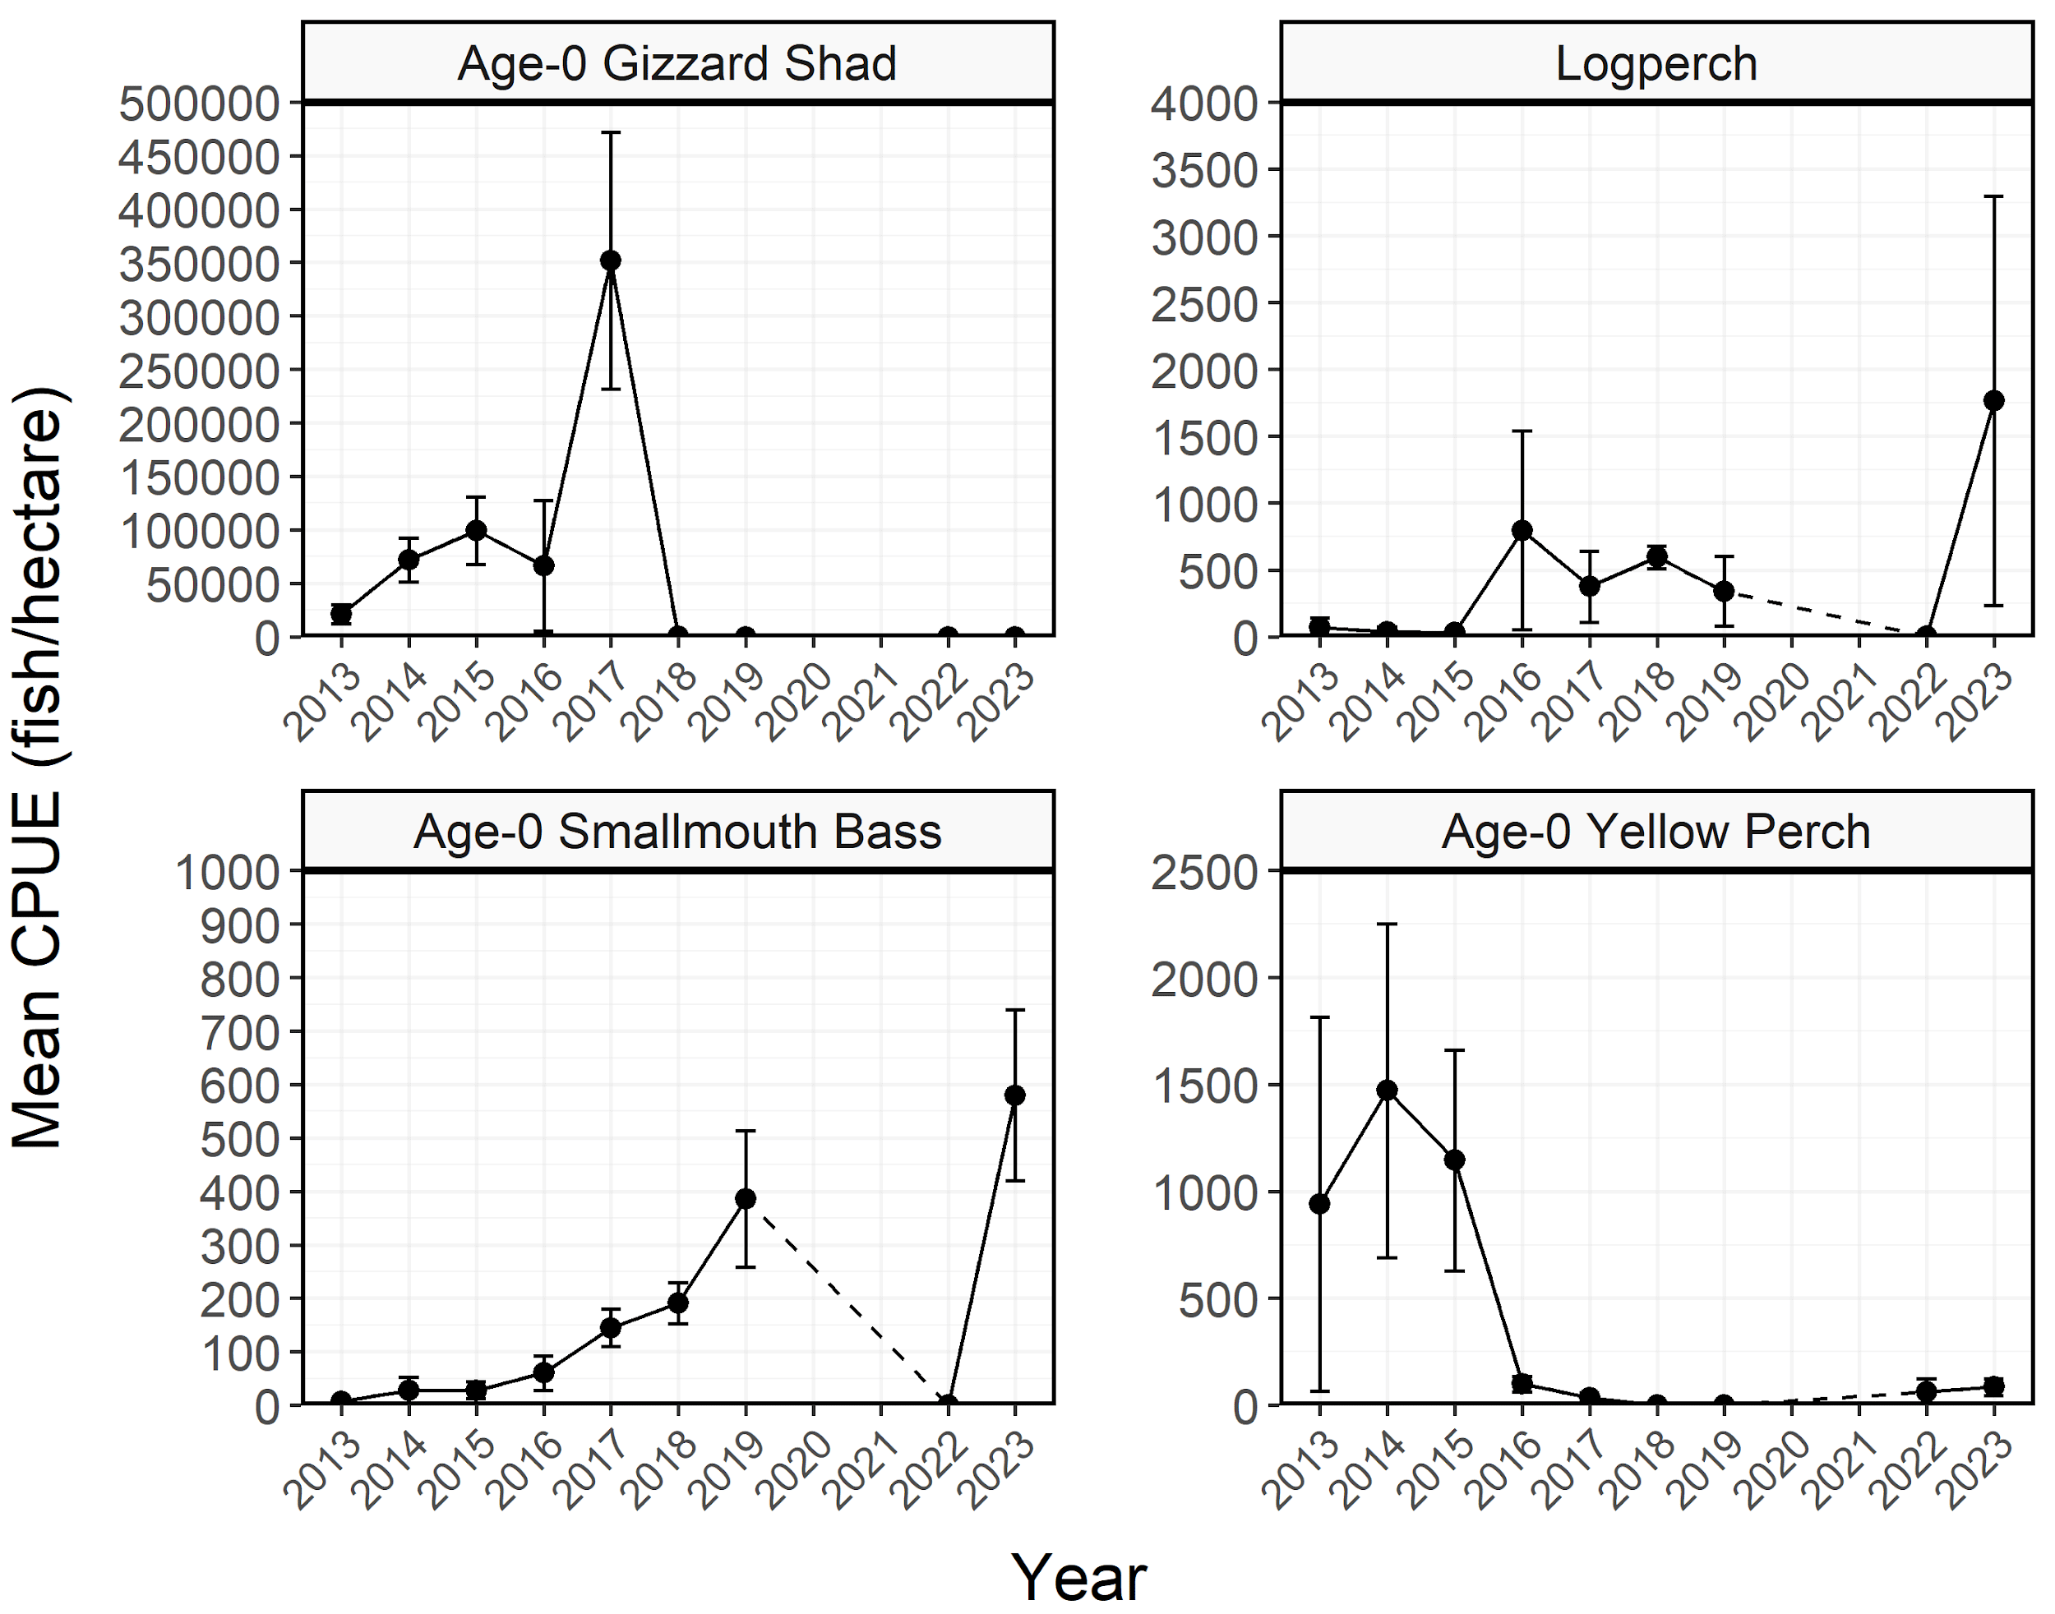
Figure 7: Mean relative abundance (CPUE; fish/hectare) of stock-length Age-0 Gizzard Shad, Logperch, Age-0 Smallmouth Bass, and Age-0 Yellow Perch sampled during seining surveys from Willard Bay Reservoir between 2013-2023. Dashed lines represent interpolation across years of missing data between points. Error bars indicate standard error.
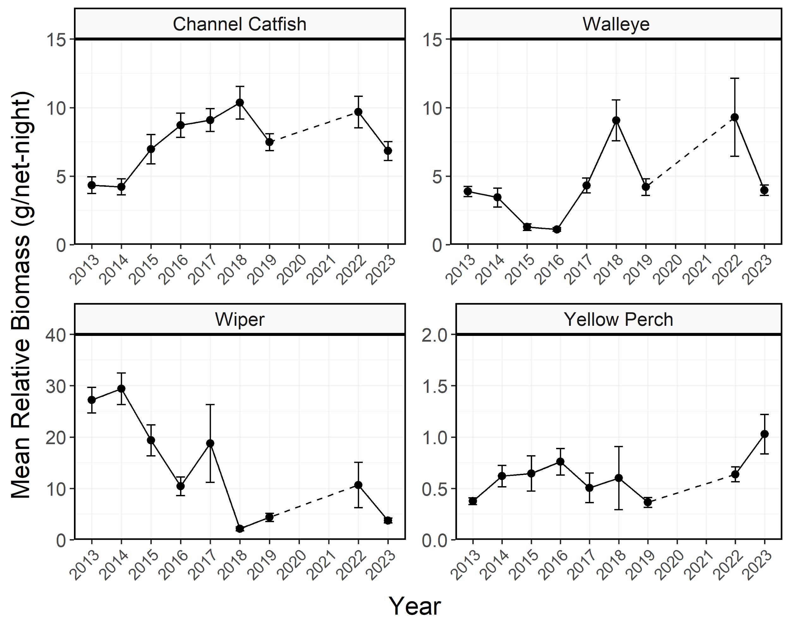
Figure 8: Mean relative biomass (kg/net-night) of stock-length Channel Catfish, Walleye, Wiper, and Yellow Perch sampled in gillnets from Willard Bay Reservoir between 2013-2023. Error bars indicate standard error.
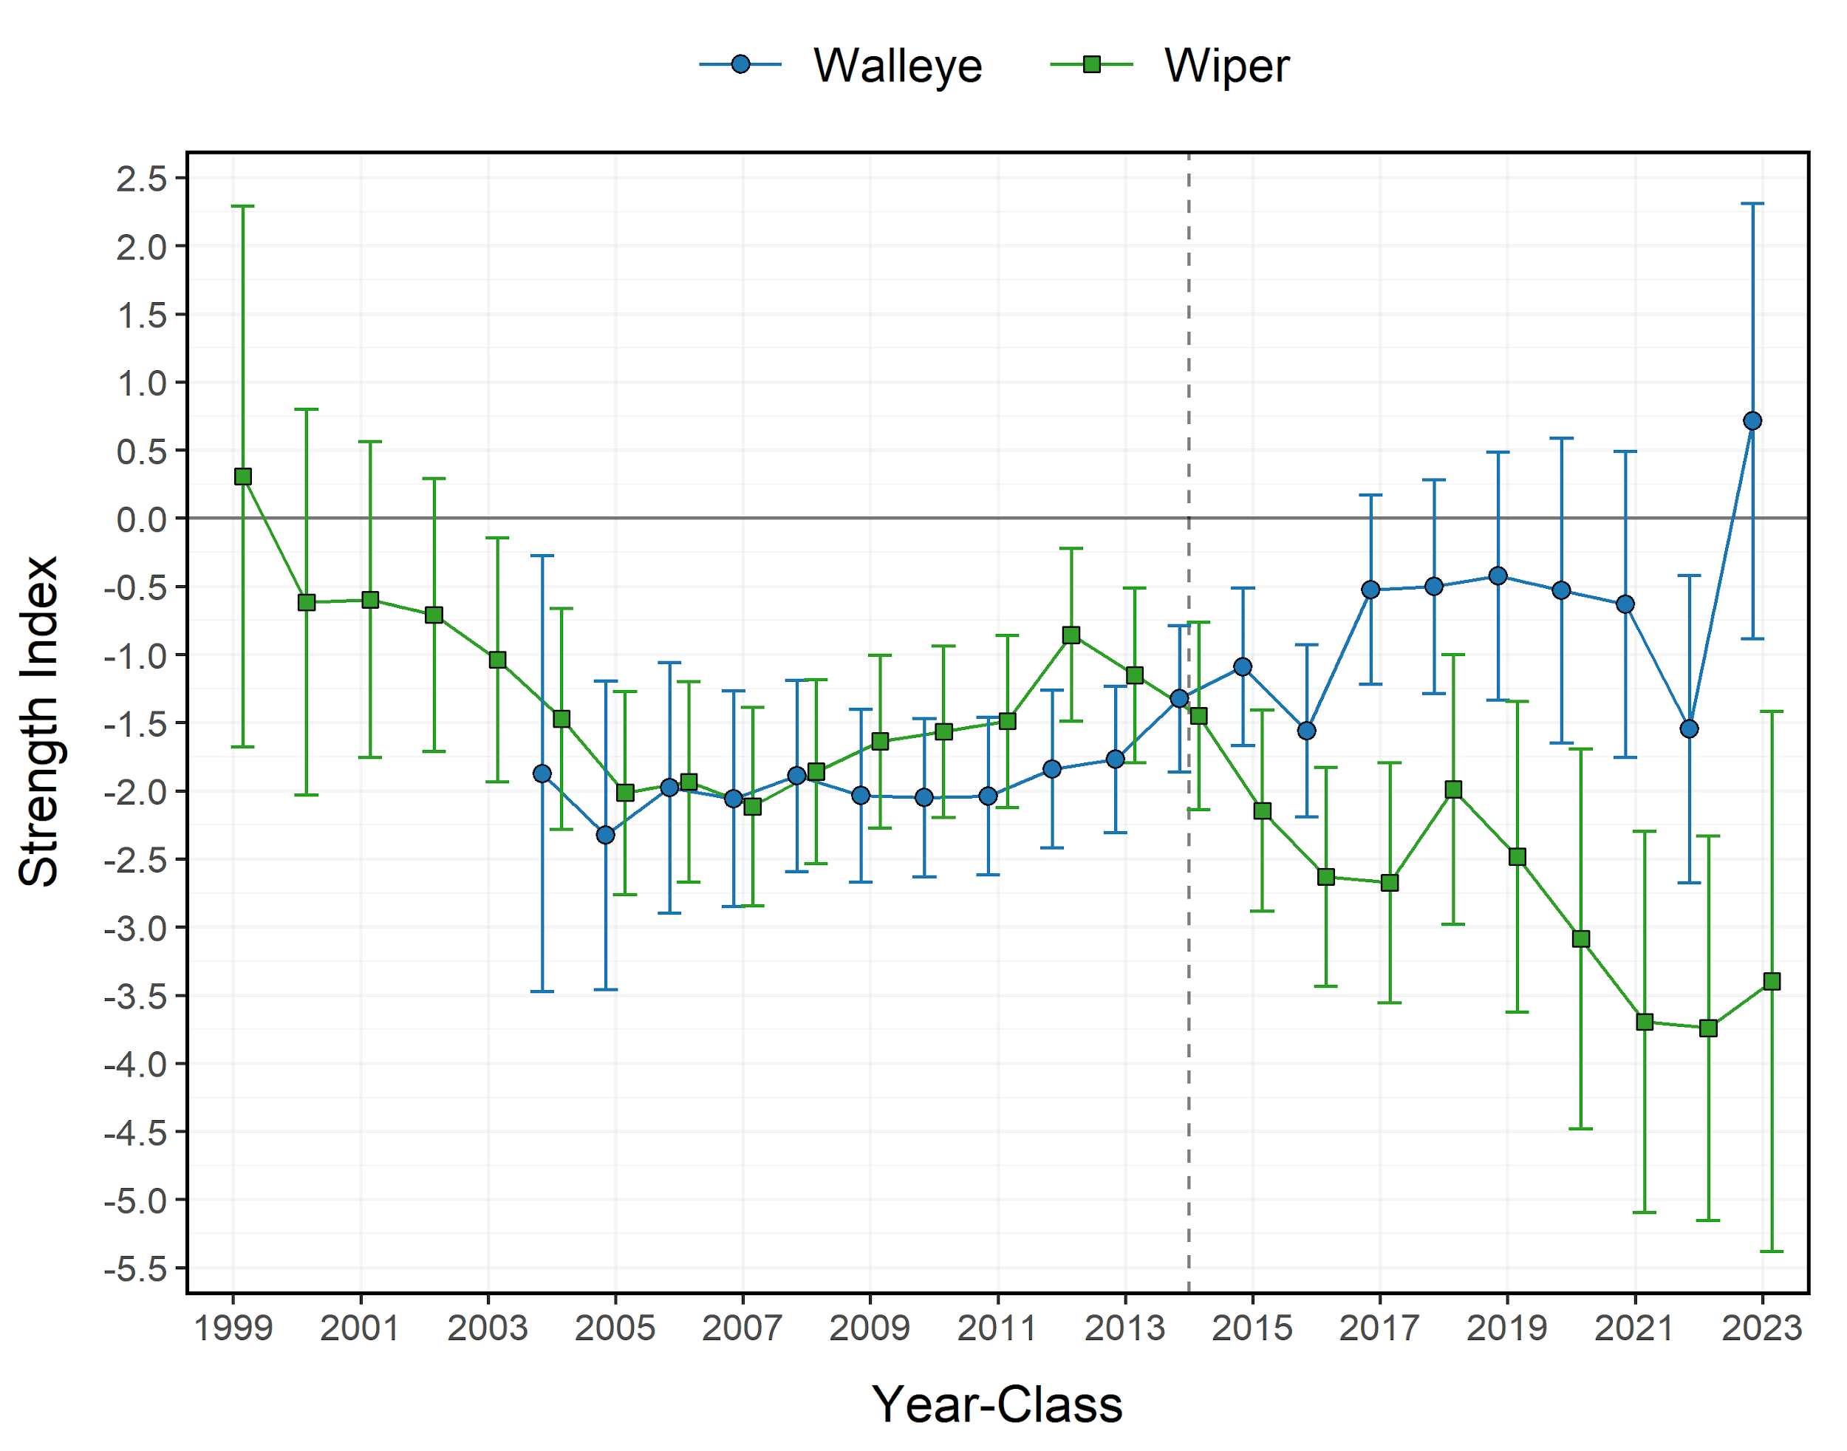
Figure 9: Least-squares means, with Tukey-adjusted 95% confidence intervals, of log CPUE for Willard Bay Reservoir Walleye and Wiper by year-class. The vertical dashed line indicates the start of the Walleye stocking program. Individual year-classes (i.e., points) are jittered to minimize overplotting.
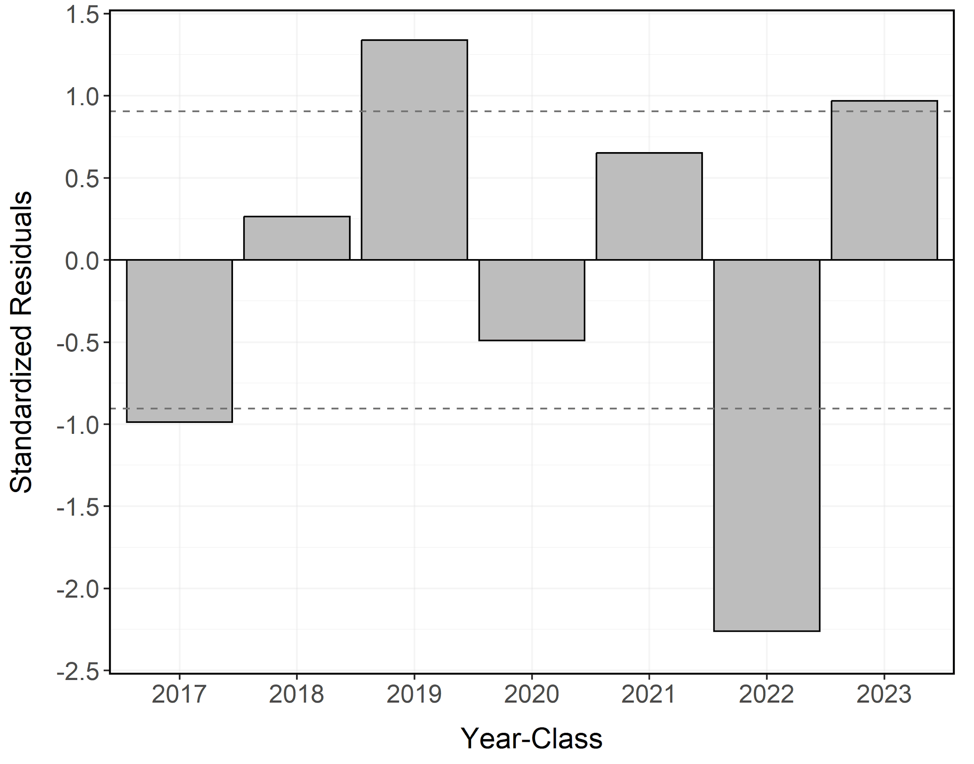
Figure 10: Studentized residuals from the weighted catch curve for Walleye from Willard Bay Reservoir. Horizontal dotted lines represent the upper and lower 20% of residuals. Year-classes above and below the upper dotted lines are classified as strong and weak, respectively.
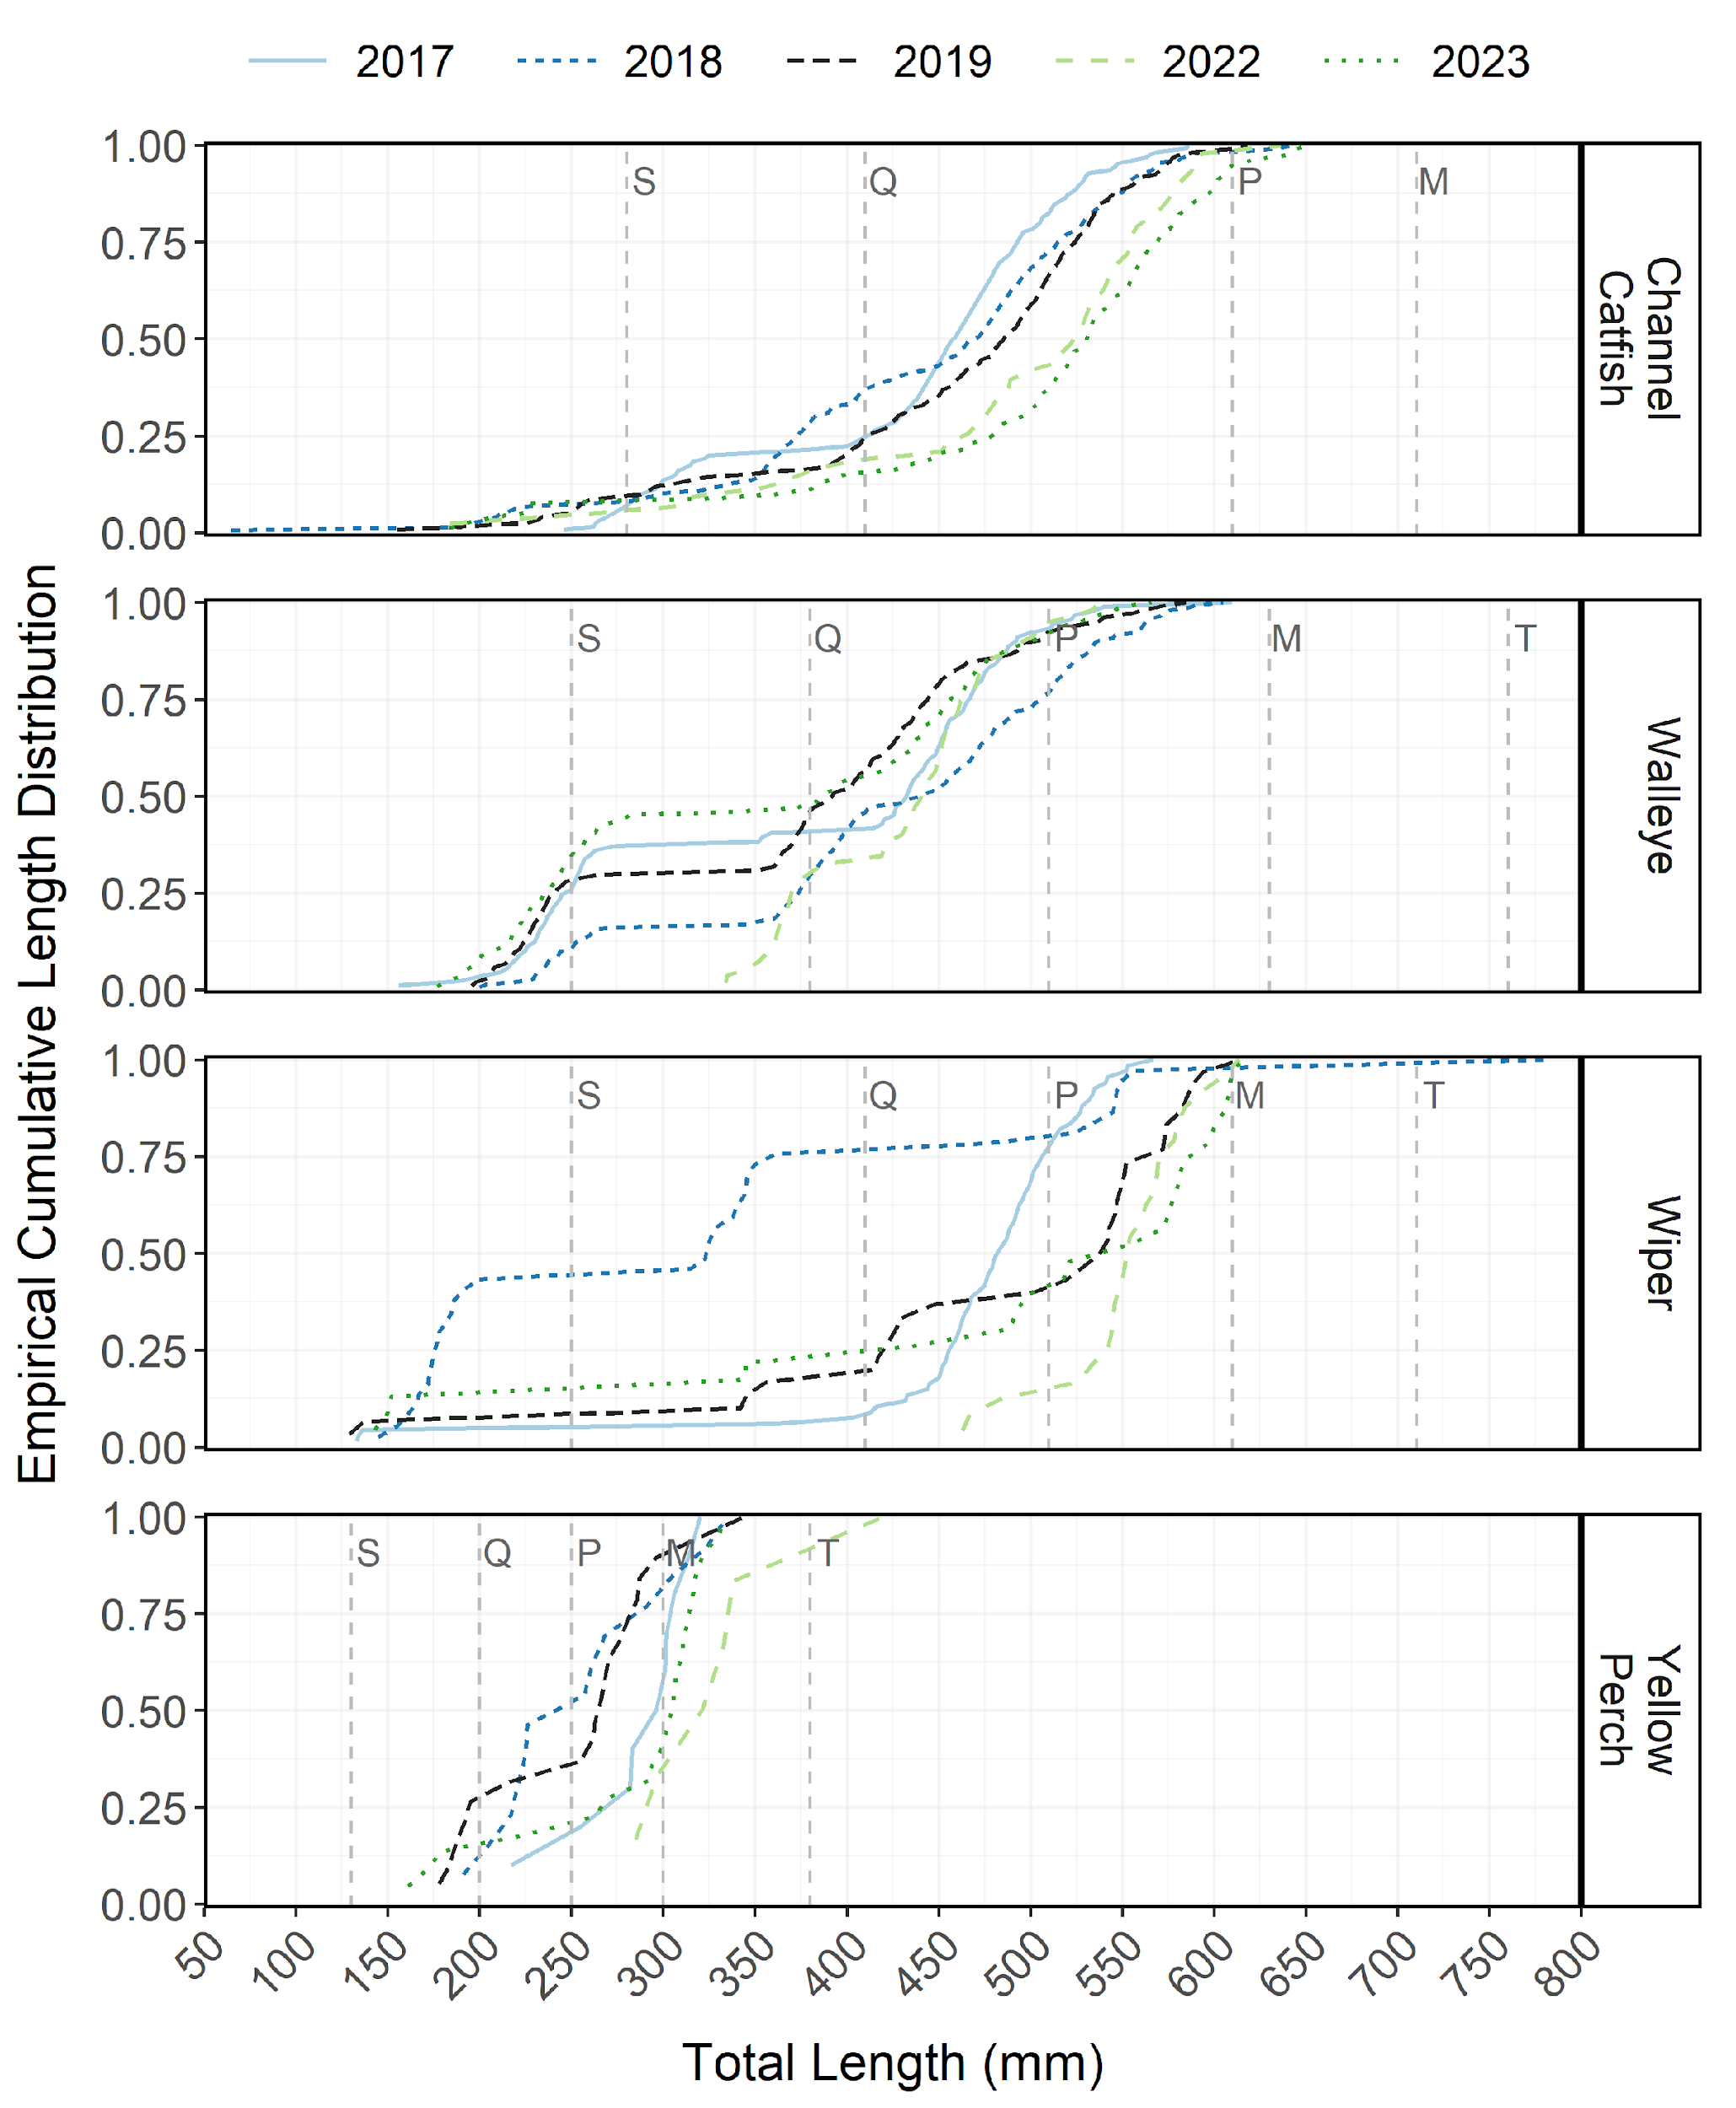
Figure 11: Empirical cumulative total length (mm) distribution of Channel Catfish, Walleye, Wiper, and Yellow Perch sampled from Willard Bay Reservoir between 2017-2023.
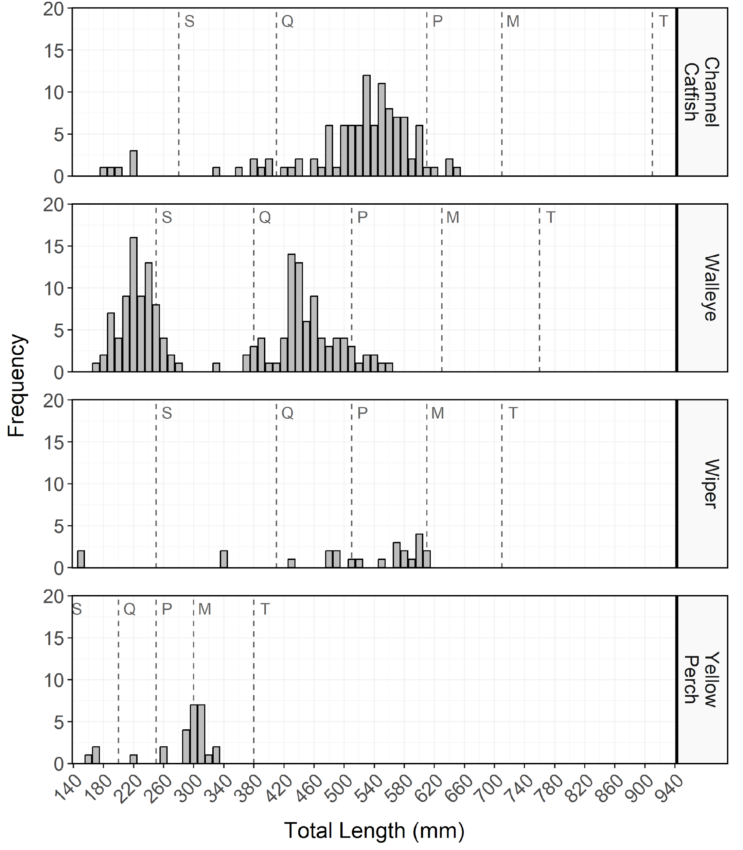
Figure 12: Total length (mm) frequency of Channel Catfish, Walleye, Wiper, and Yellow Perch sampled from Willard Bay Reservoir in 2023. The length intervals are left-inclusive and right-exclusive, and the x-axis labels represent the start of the length interval (i.e., left side). The start of each Gablehouse length category is identified by the vertical dashed lines and the category name (i.e., stock, quality, preferred, memorable, and trophy) is indicated by the first letter of each category on the right side of the dashed line.
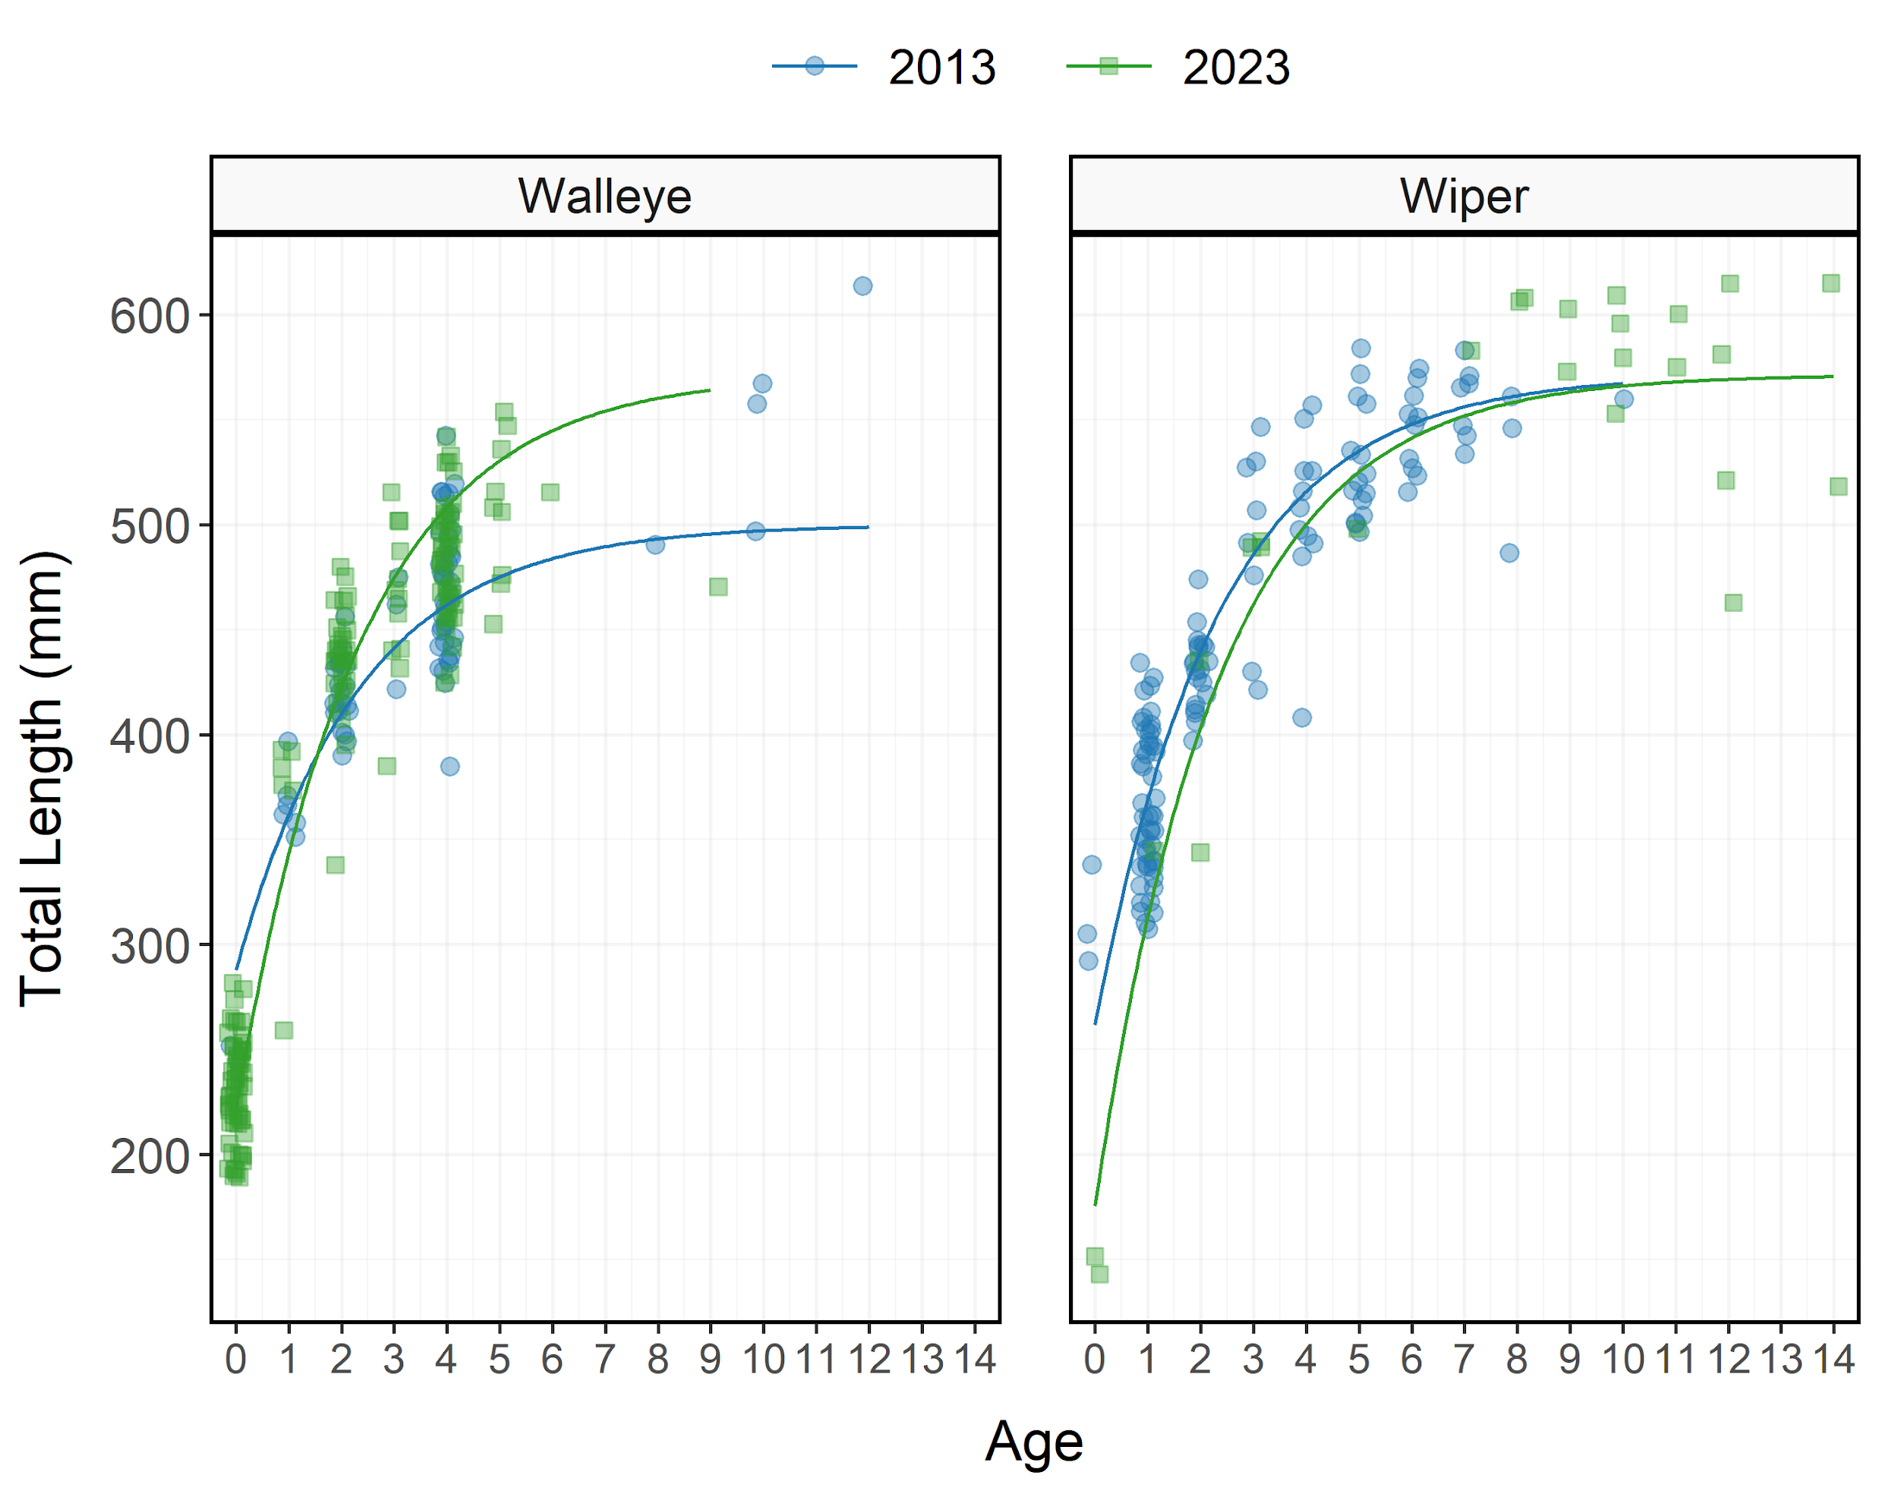
Figure 13: Total length versus age with superimposed best-fit vonBertalanffy growth model for Walleye from Willard Bay Reservoir in 2013 and 2023. Individual fish (i.e., points) are jittered to minimize overplotting.
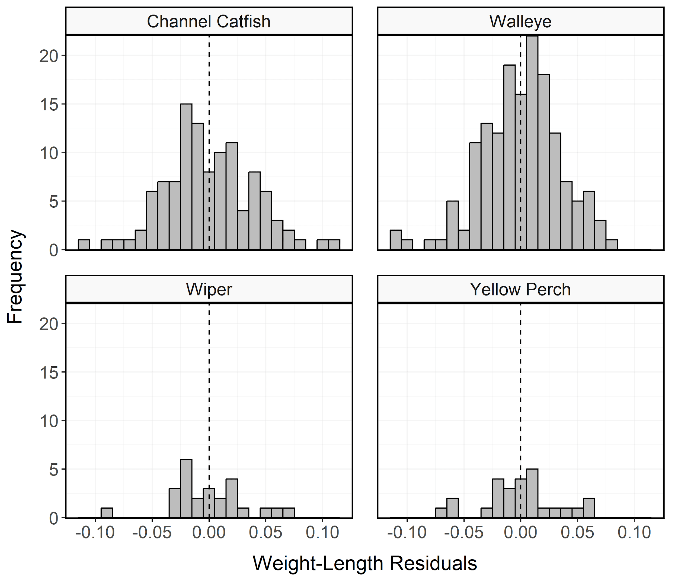
Figure 14: Histogram of residuals from the regression of log10 weight on log10 total length for Channel Catfish, Walleye, Wiper, and Yellow Perch sampled from Willard Bay Reservoir in 2023.
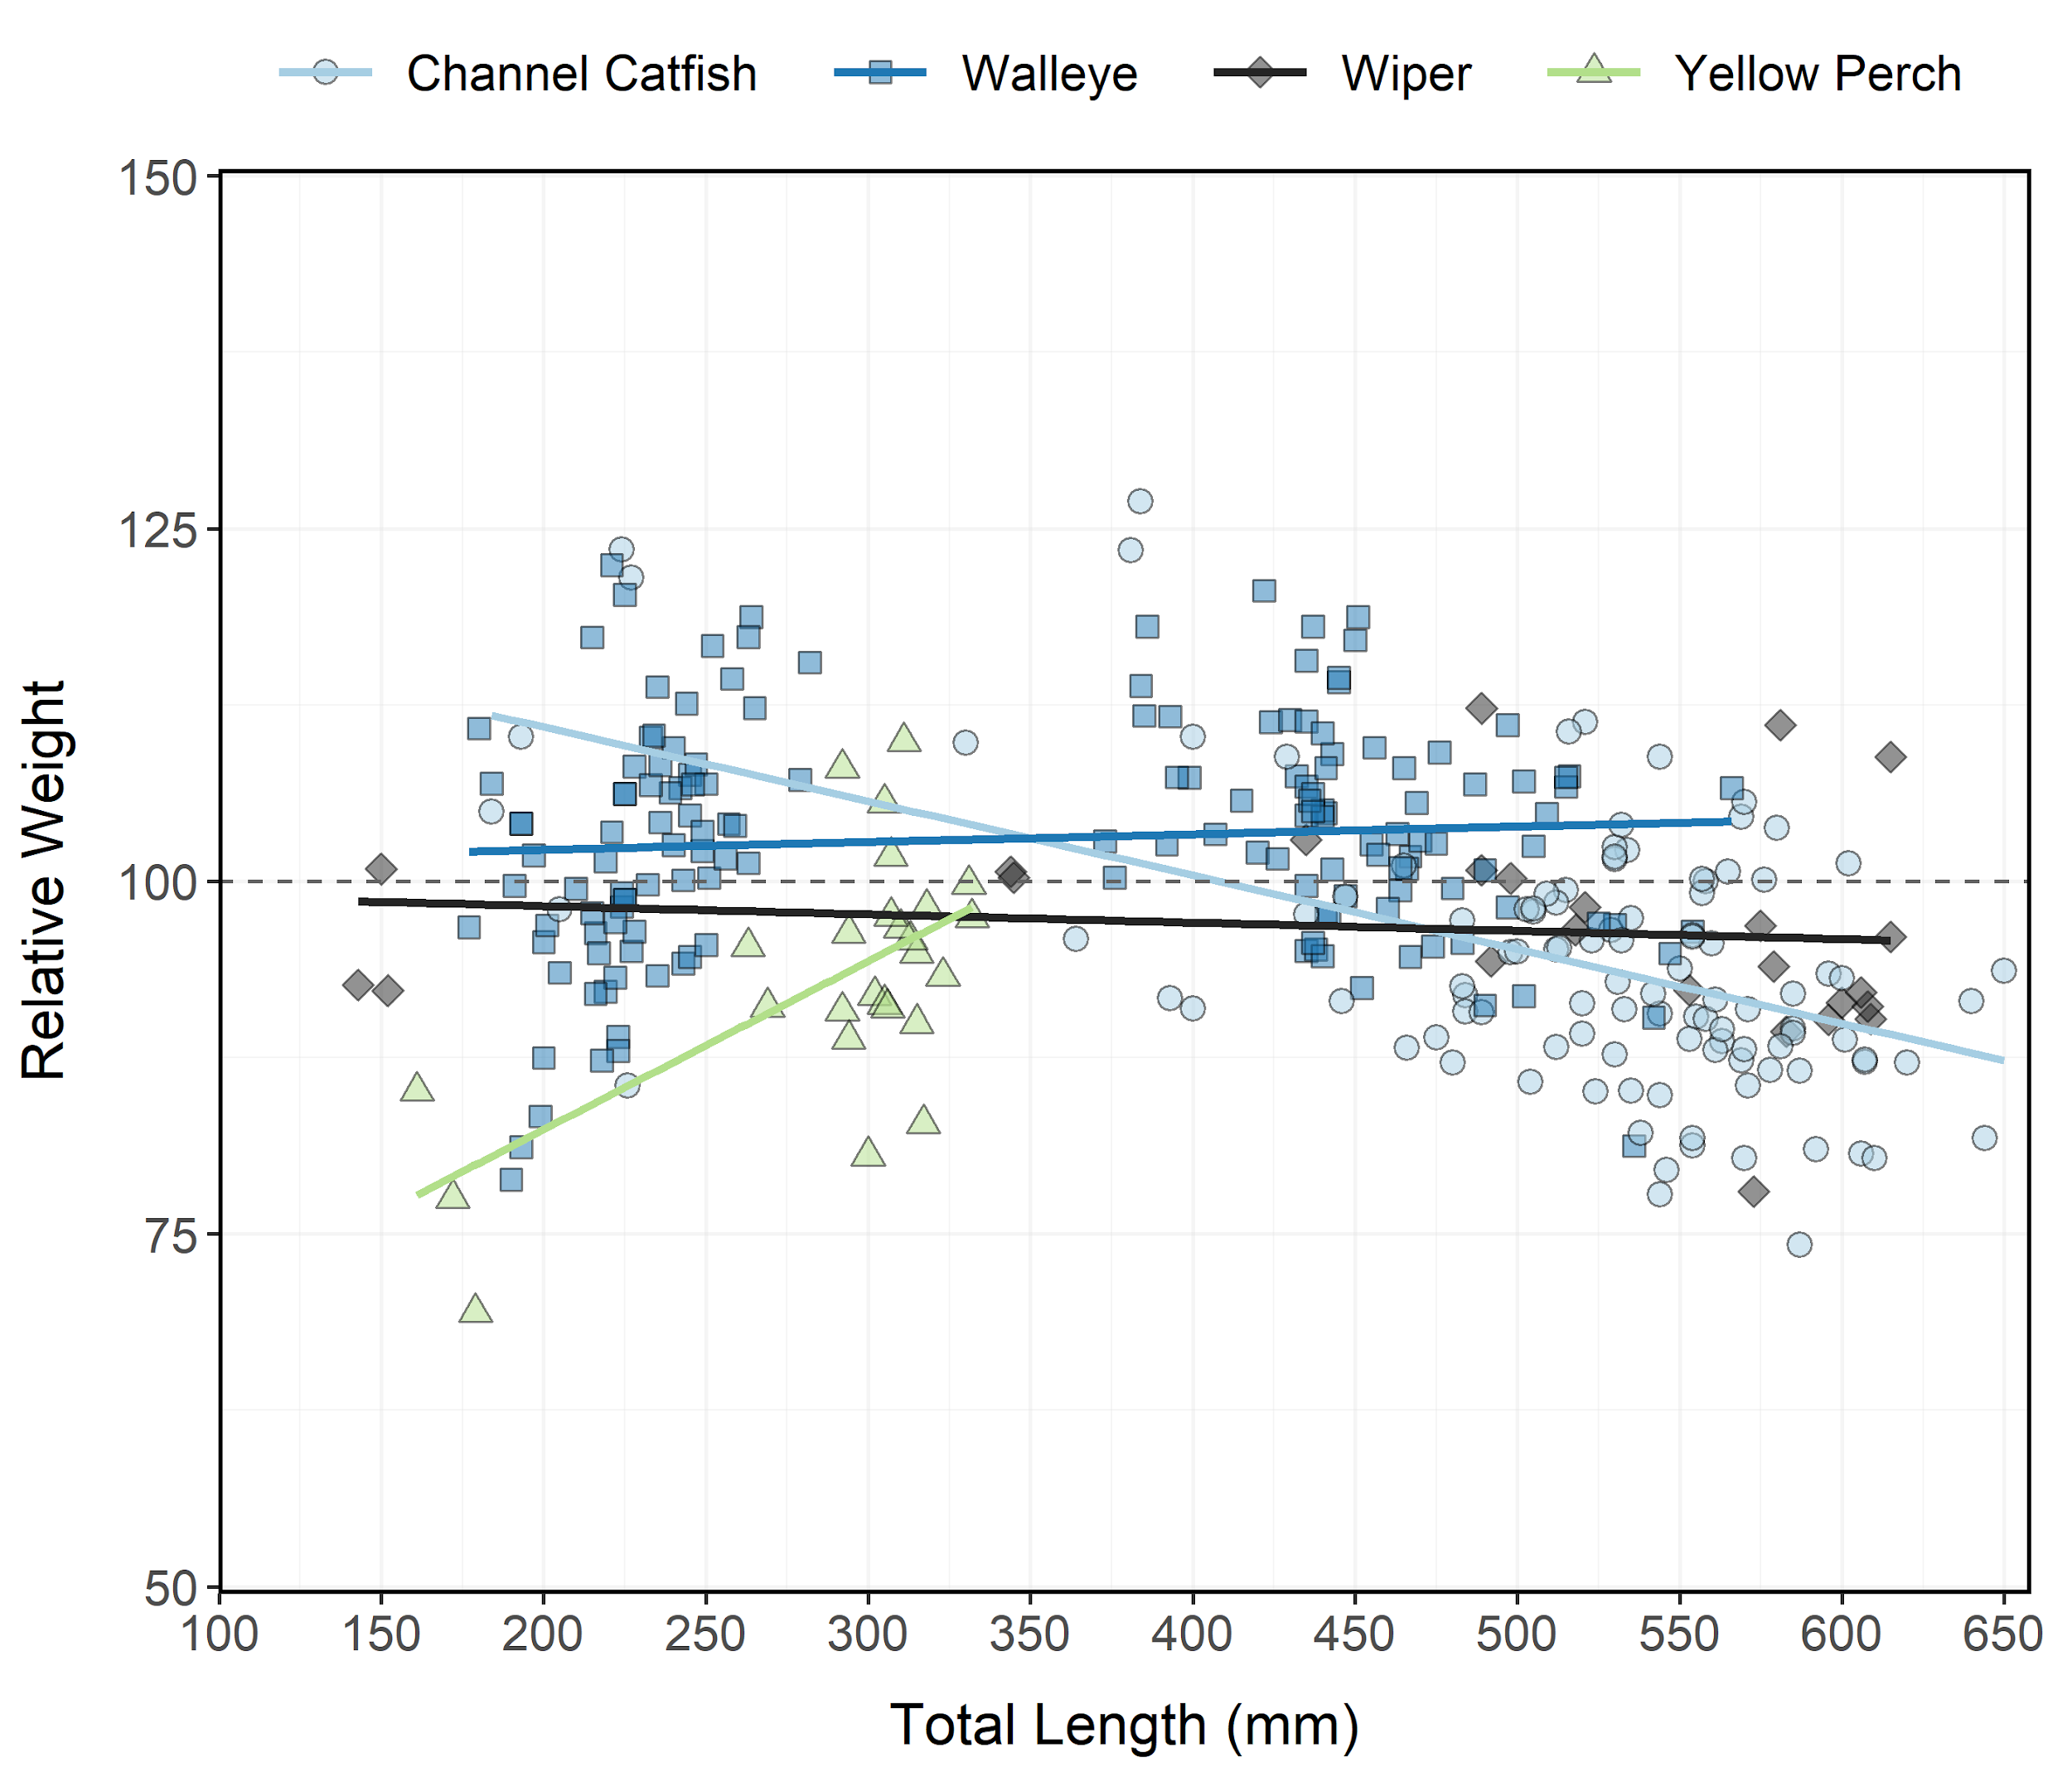
Figure 15: Relative weight (± standard error) of Channel Catfish, Walleye, Wiper, and Yellow Perch sampled from Willard Bay Reservoir in 2023 as an index of condition. The horizontal dashed line indicates a 1:1 relationship between standard weight and relative weight. Points and lines are jittered to minimize overplotting.
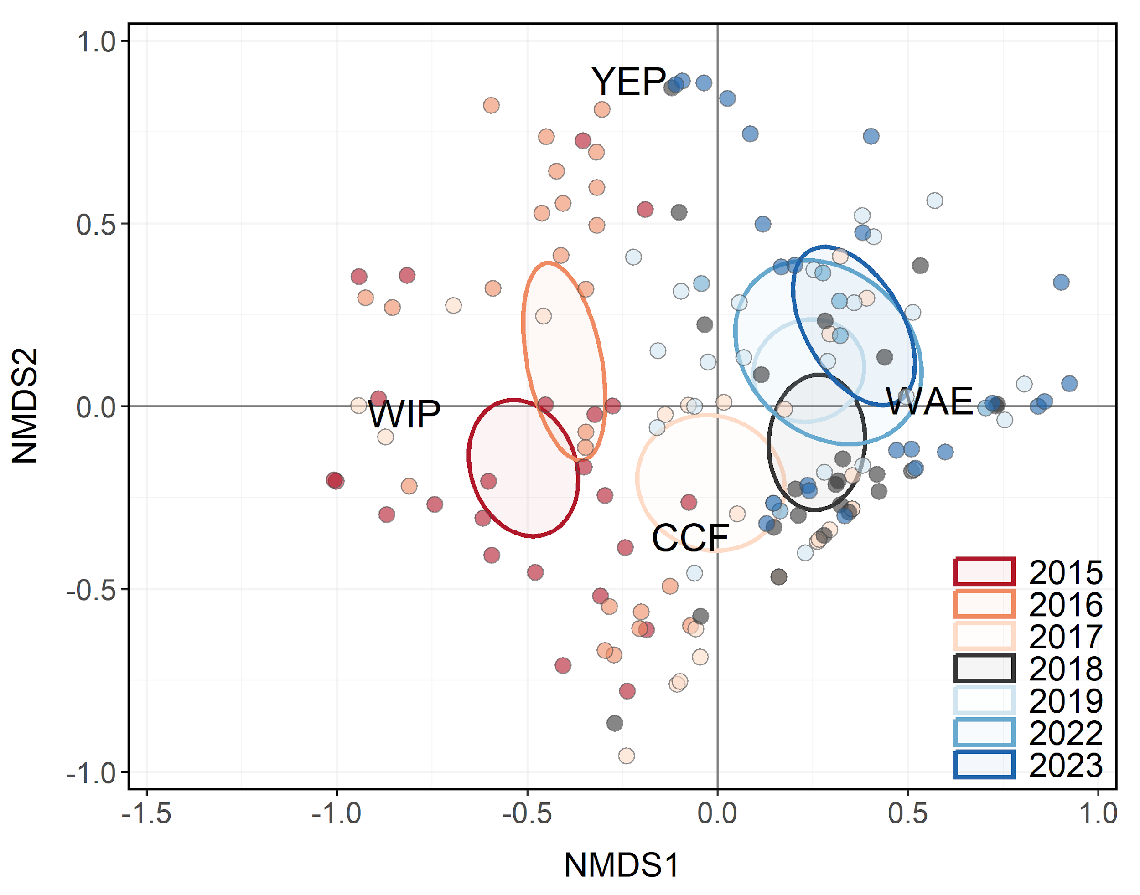
Figure 16: Non-metric multidimensional scaling (NMDS) bi-plot of stock-length Channel Catfish, Walleye, Wiper, and Yellow Perch sampled during gillnet surveys from Willard Bay Reservoir between 2015-2023. Points closer together have more similar relative abundances among species. Ellipses highlight the community structure within each year sampled.
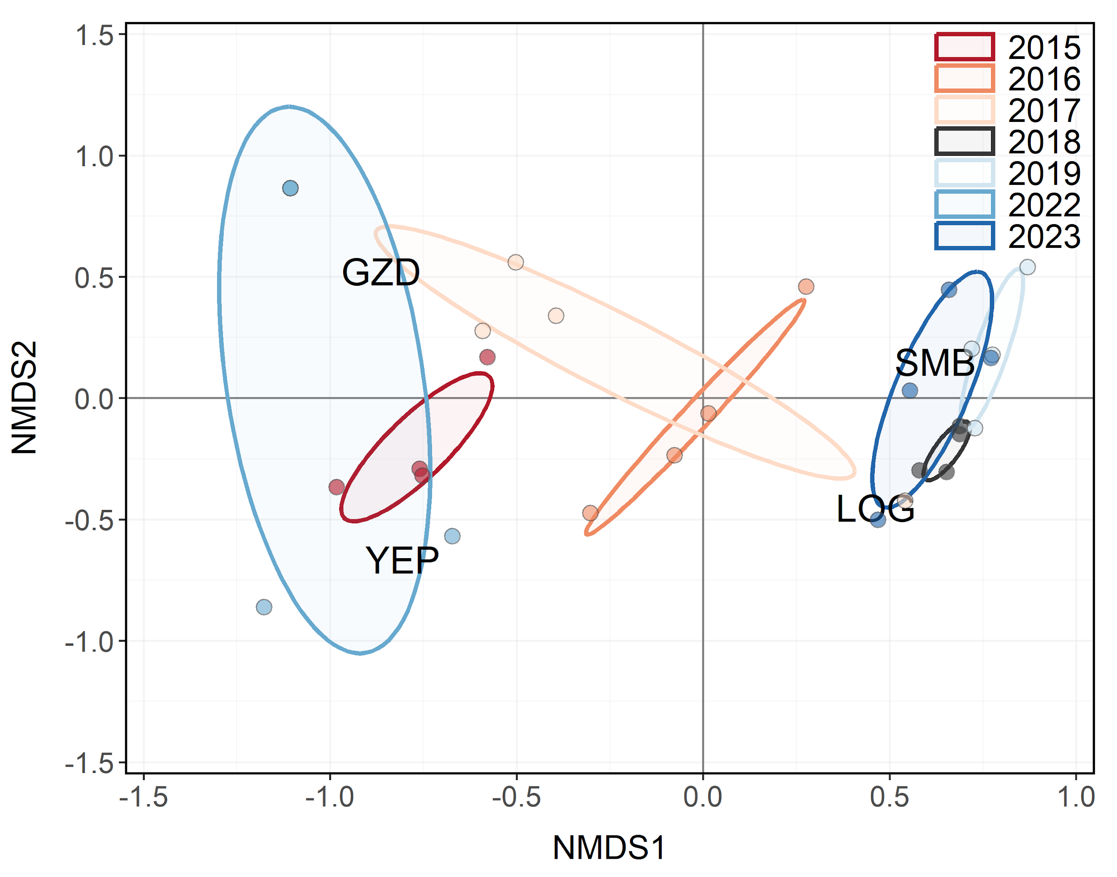
Figure 17: Non-metric multidimensional scaling (NMDS) bi-plot of stock-length Age-0 Gizzard Shad, Logperch, Age-0 Smallmouth Bass, and Age-0 Yellow Perch sampled during seining surveys from Willard Bay Reservoir between 2015-2023. Points closer together have more similar relative abundances among species. Ellipses highlight the community structure within each year sampled.
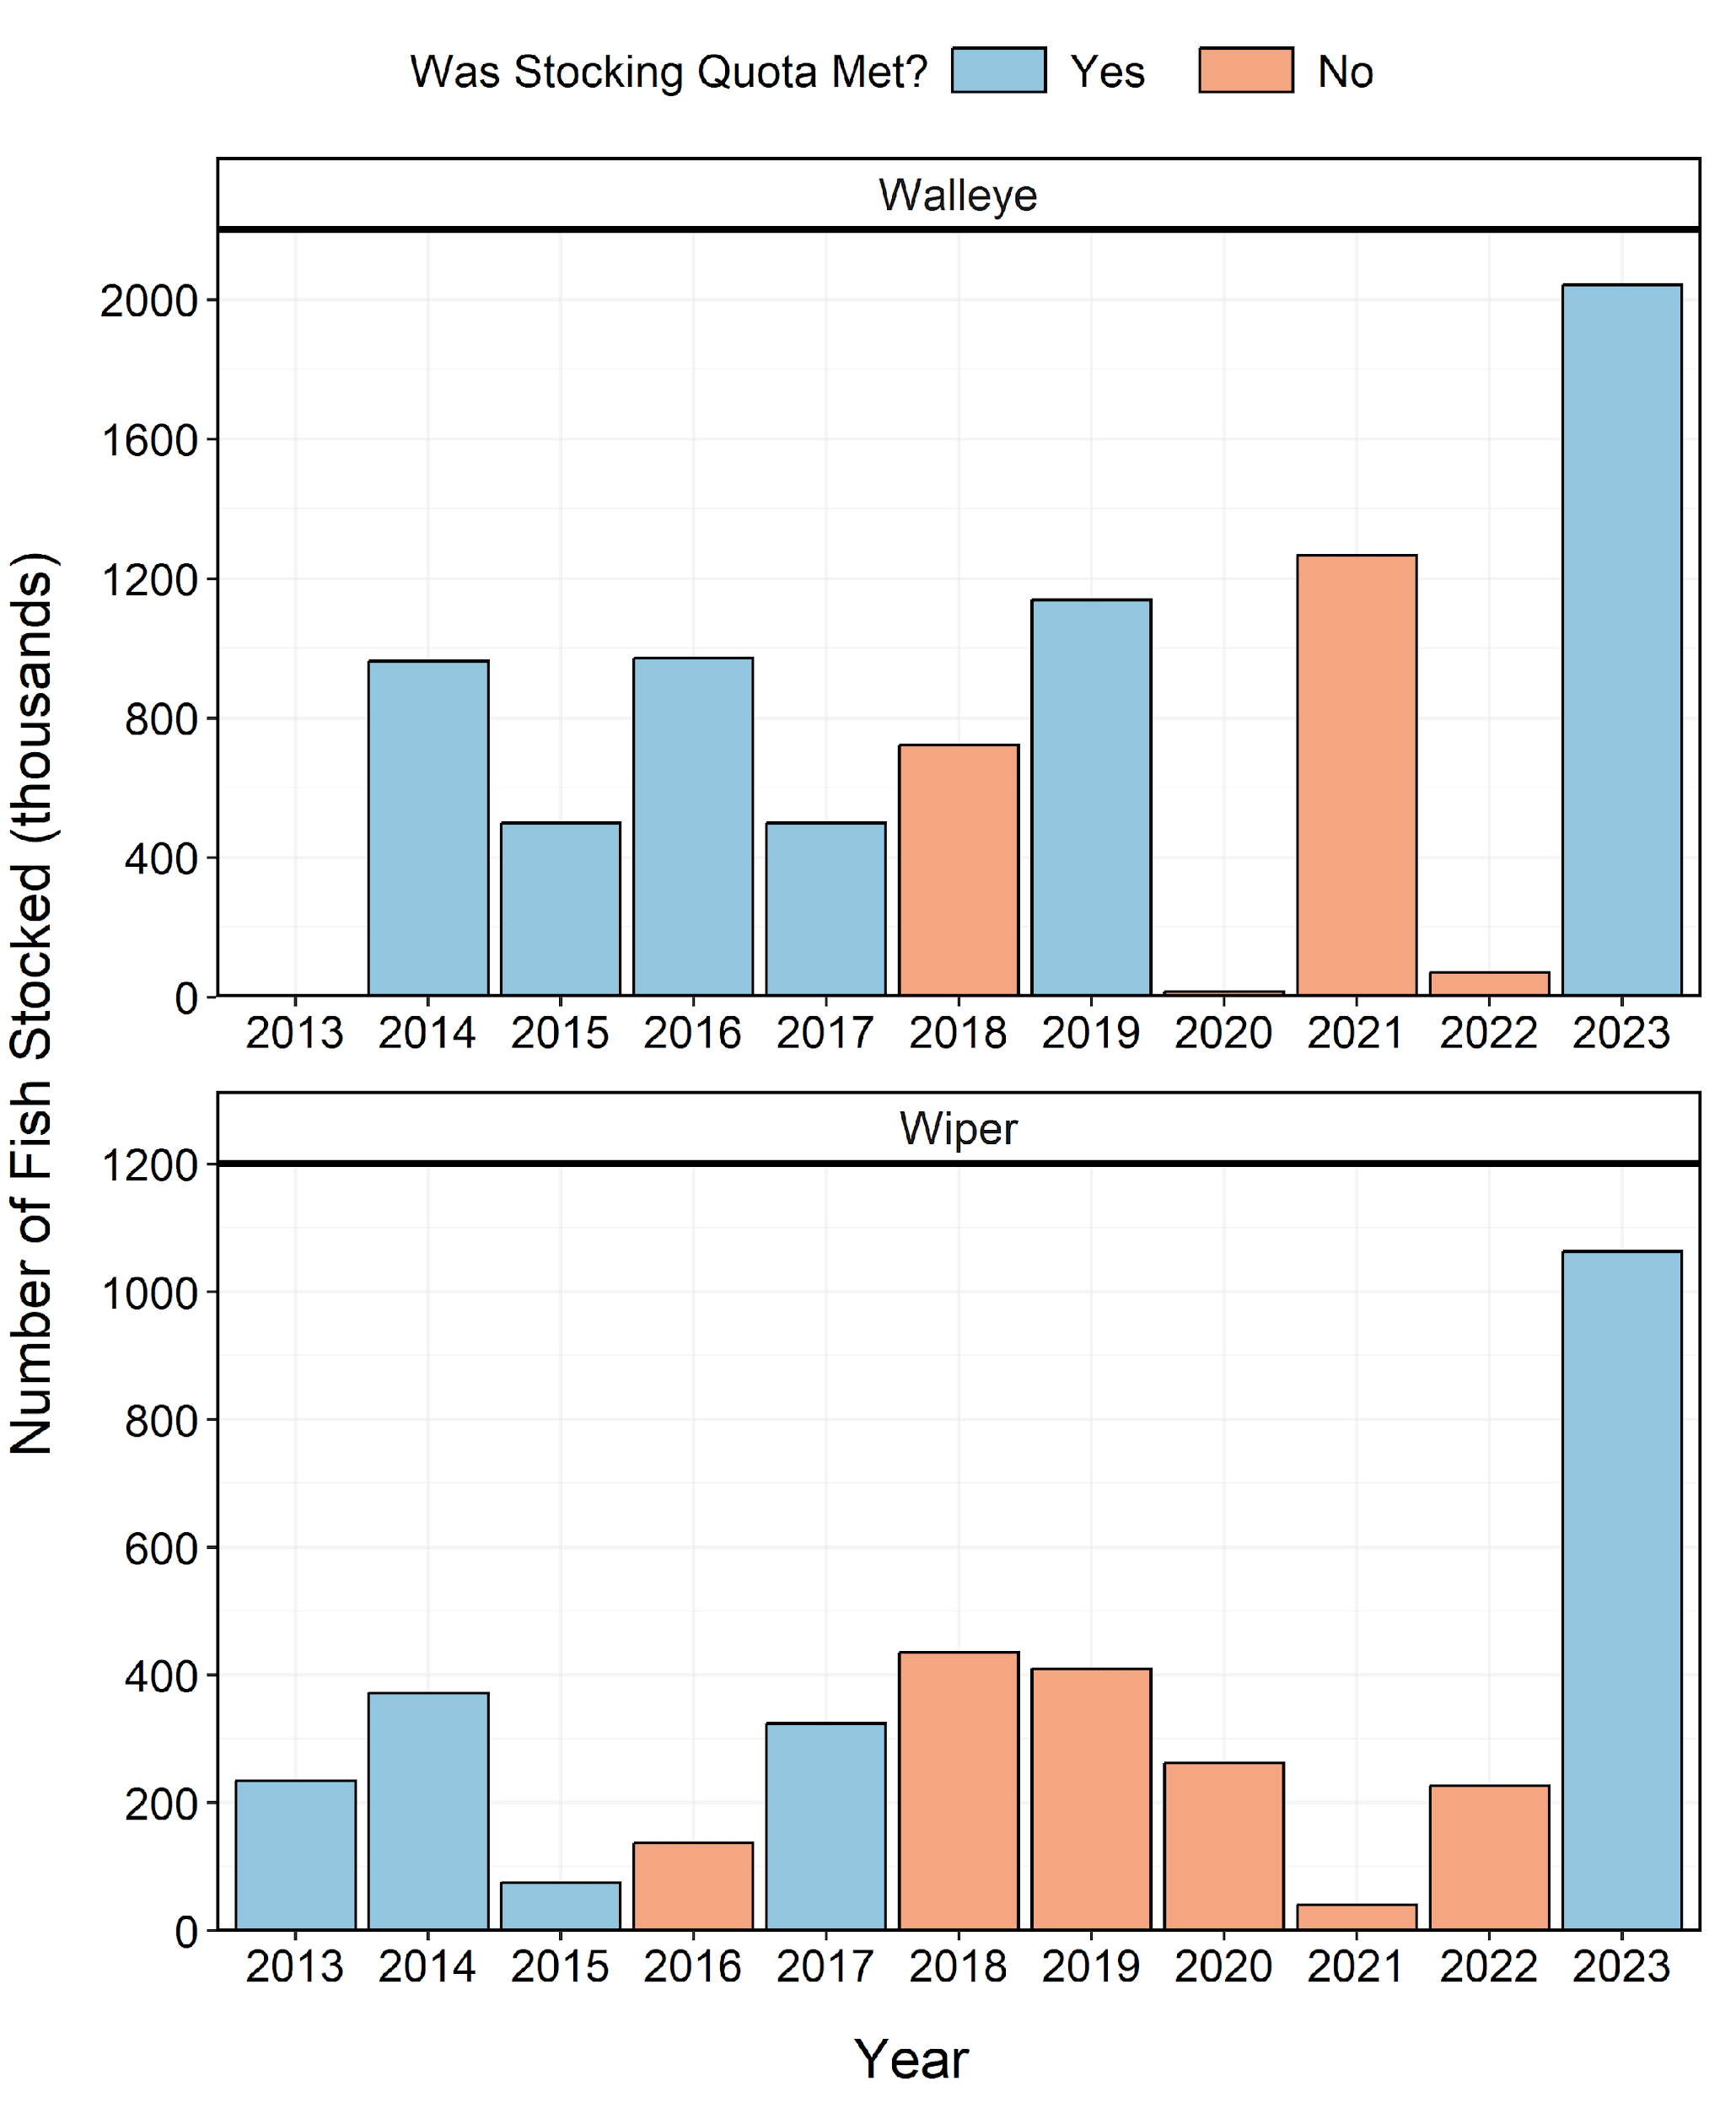
Figure 18: Number of individuals stocked in Willard Bay Reservoir from 2013-2023. Length-at-stocking and stocking quota varies among years. A stocking quota was determined to be met if the number of stocked individuals was at least 90% of the stocking quota.
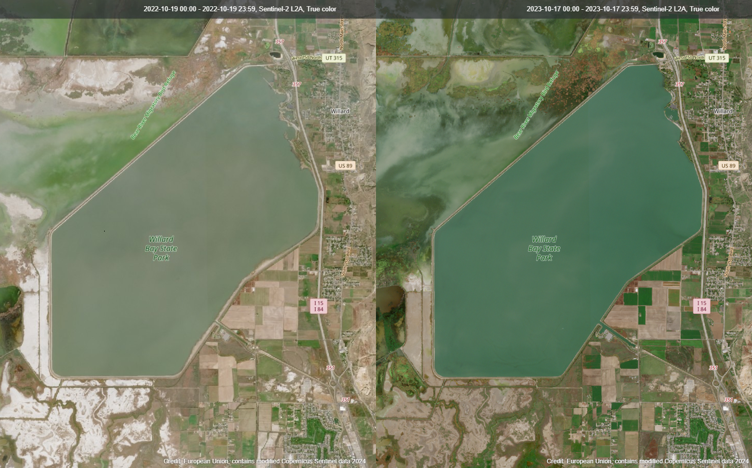
Figure 19: Satellite images from Willard Bay Reservoir in October of 2022 (left) and 2023 (right).

