Utah Division of Wildlife Resources Fishery Monitoring Report

**Author**: Taylor R. Stewart  
**Contact**: [taylorstewart@utah.gov](mailto:taylorstewart@utah.gov)

**System**: Pineview Reservoir  
**Sampling Dates**: 5/31/2023; 9/20/2023 - 9/22/2023  
**Target Species**: Black Bullhead, Black Crappie, Bluegill, Smallmouth Bass, and Yellow Perch  
**Species Stocked**: Tiger Muskellunge

**Monitoring Objectives**:

1. Provide data for assessment of trends in species occurrence, relative abundance, biomass, and size structure of forage and sport fish assemblages.
2. Evaluate the fish assemblage to ensure enough forage exists to support a popular pan-fish fishery in conjunction with predatory Tiger Muskellunge.
3. Improve size structure of Smallmouth Bass.

**Sampling Design and Methods**:  
*Trap Nets*  
Four fyke nets were set each day for a total of 12 net-nights of effort. Fyke nets consisted of two rectangular frames (92 x 153 cm), two throats through five hoops, and 13-mm mesh. Nets were deployed with a 15-m lead perpendicular to shore and set at standardized locations (Figure 1; Table 1). A low number of nets in acceptable condition restricted sampling all 16 standardized locations.

*Boat Electrofishing*  
Shoreline boat electrofishing was conducted to sample the littoral fish community. Ten standardized shoreline transects were sampled with an electrofishing boat equipped with a Smith-Root, Inc. variable voltage processor (Figure 1; Table 1). Electricity was delivered to the water with an intensity of 600 volts, frequency of 60 Hz, and 50% pulse-width resulting in a current of 10 amps. Transects were sampled for a total of 10 minutes.

*Statistical Methods*  
All fish caught were identified to species and measured for total length (mm) and weight (g). Trapnet and electrofishing data were combined to increase the sample size and statistical inference of size structure analyses. Relative abundance (*i.e.,* catch-per-unit-effort) and biomass were analyzed as the respective number or weight for each species per net-night or hour of electrofishing. Size structure was presented as an empirical cumulative distribution function (ECDF) and a histogram. The ECDF, which is the proportion of fish that are less than each observed length, was used to analyze changes among years while the histogram was used to show the frequency of individuals in each length interval for a single year. Weight-length residuals and relative weight were used as condition metrics. Changes in the fish community composition were analyzed among years using non-metric multidimensional scaling.

**Summary**:  
*Species Composition*  
Fish catches were comprised of Black Bullhead, Black Crappie, Bluegill, Common Carp, Green Sunfish, Smallmouth Bass, and Yellow Perch (Figures 2 & 3). Black Crappie were the most abundant species by number caught (63.7%) and weight (45.1%) in trapnets (Figure 2). Smallmouth Bass and Yellow Perch were the most abundant species by number caught (46.5 and 35.0%, respectively) but only comprised 14.6% of biomass caught along electrofishing transects (Figure 3).

*Abundance*  
Black Crappie mean relative abundance was 13.3 fish/net-night (SE = 6.6) and increased by an average of 24.1% survey-to-survey since 2008 (Figure 4). Black Crappie had the highest catch rates in the stock- and memorable-length categories (Figure 6). Bluegill mean relative abundance was 1.1 fish/net-night (SE = 0.6) and increased by 279.2% from sampling conducted in 2016 (Figure 4).

Smallmouth Bass mean relative abundance was 1.7 fish/hour (SE = 1.1) and decreased by 78.2% from electrofishing sampling conducted in 2015 (Figure 5). Smallmouth Bass continue to persist at low densities and had low catch rates among all Gablehouse length categories (Figure 7). Yellow Perch mean relative abundance was 8.6 fish/hour (SE = 2.9) and significantly increased by 1329% from 2015. Previous surveys in 2014-16 showed relative abundances of Yellow Perch at record lows, likely due to high densities from the year-class observed in 2012. This survey highlighted early signs that the Yellow Perch population is recovering with a new year-class of fish being recruited and adult numbers elevated from past surveys (Figure 5).

*Biomass*  
Relative biomass followed similar trends to relative abundance for all species and survey methods (Figures 8 & 9).

*Size Structure*  
The size structure of Black Crappie began expanding in 2016 and continues to maintain new year-classes of stock-length individuals and larger individuals in the preferred-length category (Figures 10 & 11). Smallmouth Bass were dominated by substock-length individuals, and older and larger Smallmouth Bass usually observed were absent. Shifts in length distributions between 2016 and 2023 were statistically different, based on a bootstrapped Kolmogorov-Smirnov test, for Black Crappie (*P* < 0.001) and Smallmouth Bass (*P* < 0.001; Figure 10).

*Condition*  
Relative weights of Black Crappie, Bluegill, Smallmouth Bass, and Yellow Perch had a negative relationship with total length (Figure 13). Bluegill, Smallmouth Bass, and Yellow Perch relative weights were highly variable in fish under 125 mm. Black Bullhead relative weight remained stable (Figure 13).

*Community Structure*  
The fish community has not had any strong shifts over time and remains diverse with all species present (Figure 14). No community structure analysis could be completed on the electrofishing surveys because the number of target species needs to be greater than two.

*Stocking*  
Stocking quotas have not been met for two consecutive years (Figure 15). However, a small number of larger (200-mm) Tiger Muskellunge were stocked in 2023 to supplement the shortfall of 50-mm fish.

All other measurements and indices appear within normal bounds.

**Management Actions**:

1. Evaluate the stocking program of Tiger Muskellunge. New stocking quotas for 2024 were adjusted to maintain stocking efforts with both 50 and 200-mm Tiger Muskellunge. Effort is underway to understand the primary ecological processes or factors affecting the early growth of juvenile Tiger Muskellunge and optimize stocking practices using a model-based approach in decision making. The objective is to enhance Tiger Muskellunge performance by adjusting size-at-stocking, stocking density, and stocking frequency within the constraints of a measured system carrying capacity. Until model development is finished, the management recommendation is to continue use of 50 and 200-mm fish stocked in the spring and summer to maintain the predatory and trophy Tiger Muskellunge fishery.
2. Observe Smallmouth Bass populations and consider management directly focused on promoting bass fisheries. The recent drought years decreased littoral habitat and likely condensed populations, leading to higher intra- and inter-specific competition. However, the high-water year in 2023 possibly provided refuge for a new year-class observed and could jump-start this fishery. In addition, fine-tuning Tiger Muskellunge stocking and optimal population size could decrease the predatory impact on Smallmouth Bass.
3. Develop techniques to evaluate the success of previous efforts to install artificial habitats.

**Tables:**

Table 1: Date of collection, number of samples collected by sampling gear type, prescribed number samples by sampling gear type, mean water temperature (°C), and any additional data collected from Pineview Reservoir in 2023.

| Gear Type | Date | # of Samples | # of Prescribed Samples | Water Temperature | Additional Comments |
| --- | --- | --- | --- | --- | --- |
| Boat Electrofishing | 5/31/2023 | 10 | 10 | 18.3 | – |
| Fyke | 9/20/2023 - 9/22/2023 | 12 | 16 | 19.7 | – |

Table 2: Mean total length (TL; mm), mean weight (WT; g), mean relative weight (Wr), and percentage of individuals within each traditional proportional size distribution (PSD) category for each trapnet target species from Pineview Reservoir in 2023. All values in parentheses indicate standard deviation.

| Target Species | Mean TL | Mean WT | Mean Wr | PSD-  Quality | PSD-  Preferred | PSD-  Memorable | PSD-  Trophy |
| --- | --- | --- | --- | --- | --- | --- | --- |
| Black Bullhead | 280.9 (32.3) | 275.4 (109.5) | 72.0 (7.2) | 94 | 24 | 0 | 0 |
| Black Crappie | 195.4 (54.7) | 136.2 (127.1) | 100.4 (21.9) | 36 | 33 | 1 | 0 |
| Bluegill | 138.8 (32.6) | 59.9 (53.6) | 109.2 (42.8) | 8 | 0 | 0 | 0 |
| Yellow Perch | 161.3 (35.4) | 54.0 (32.2) | 88.3 (18.1) | 38 | 0 | 0 | 0 |

Table 3: Mean total length (TL; mm), mean weight (WT; g), mean relative weight (Wr), and percentage of individuals within each traditional proportional size distribution (PSD) category for each electrofishing target species from Pineview Reservoir in 2023. All values in parentheses indicate standard deviation.

| Target Species | Mean TL | Mean WT | Mean Wr | PSD-  Quality | PSD-  Preferred | PSD-  Memorable | PSD-  Trophy |
| --- | --- | --- | --- | --- | --- | --- | --- |
| Smallmouth Bass | 149.5 (74.5) | 81.8 (160.3) | 94.7 (20.3) | 0 | 0 | 0 | 0 |
| Yellow Perch | 129.0 (45.0) | 34.9 (31.7) | 88.3 (18.1) | 10 | 0 | 0 | 0 |

**Figures:**

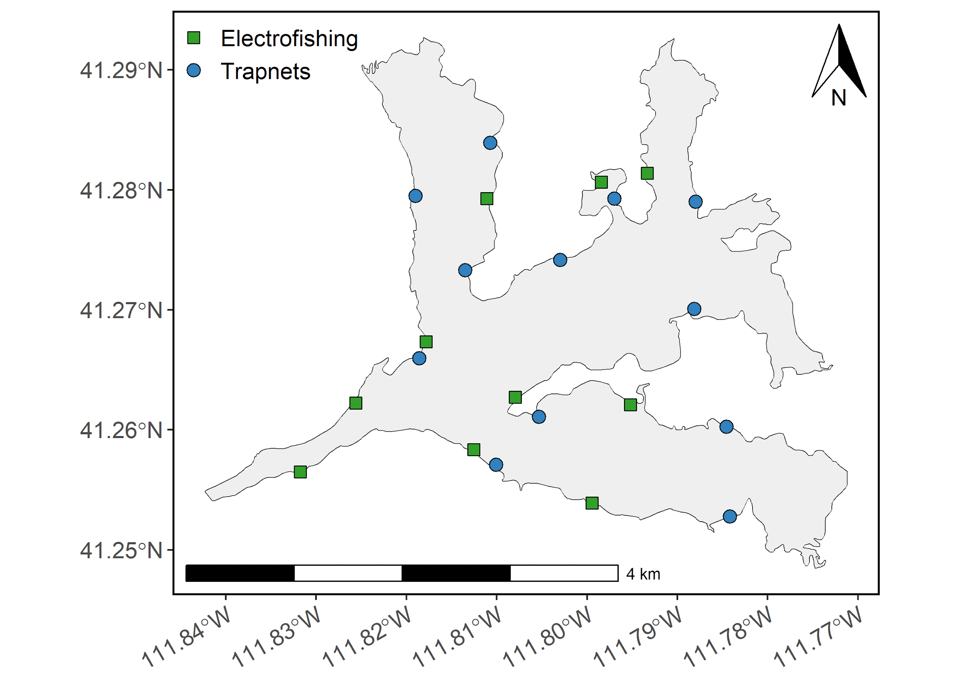

Figure 1: Map of Pineview Reservoir sampling sites. Trapnets are denoted as blue circles and boat electrofishing transects are denoted as green squares.

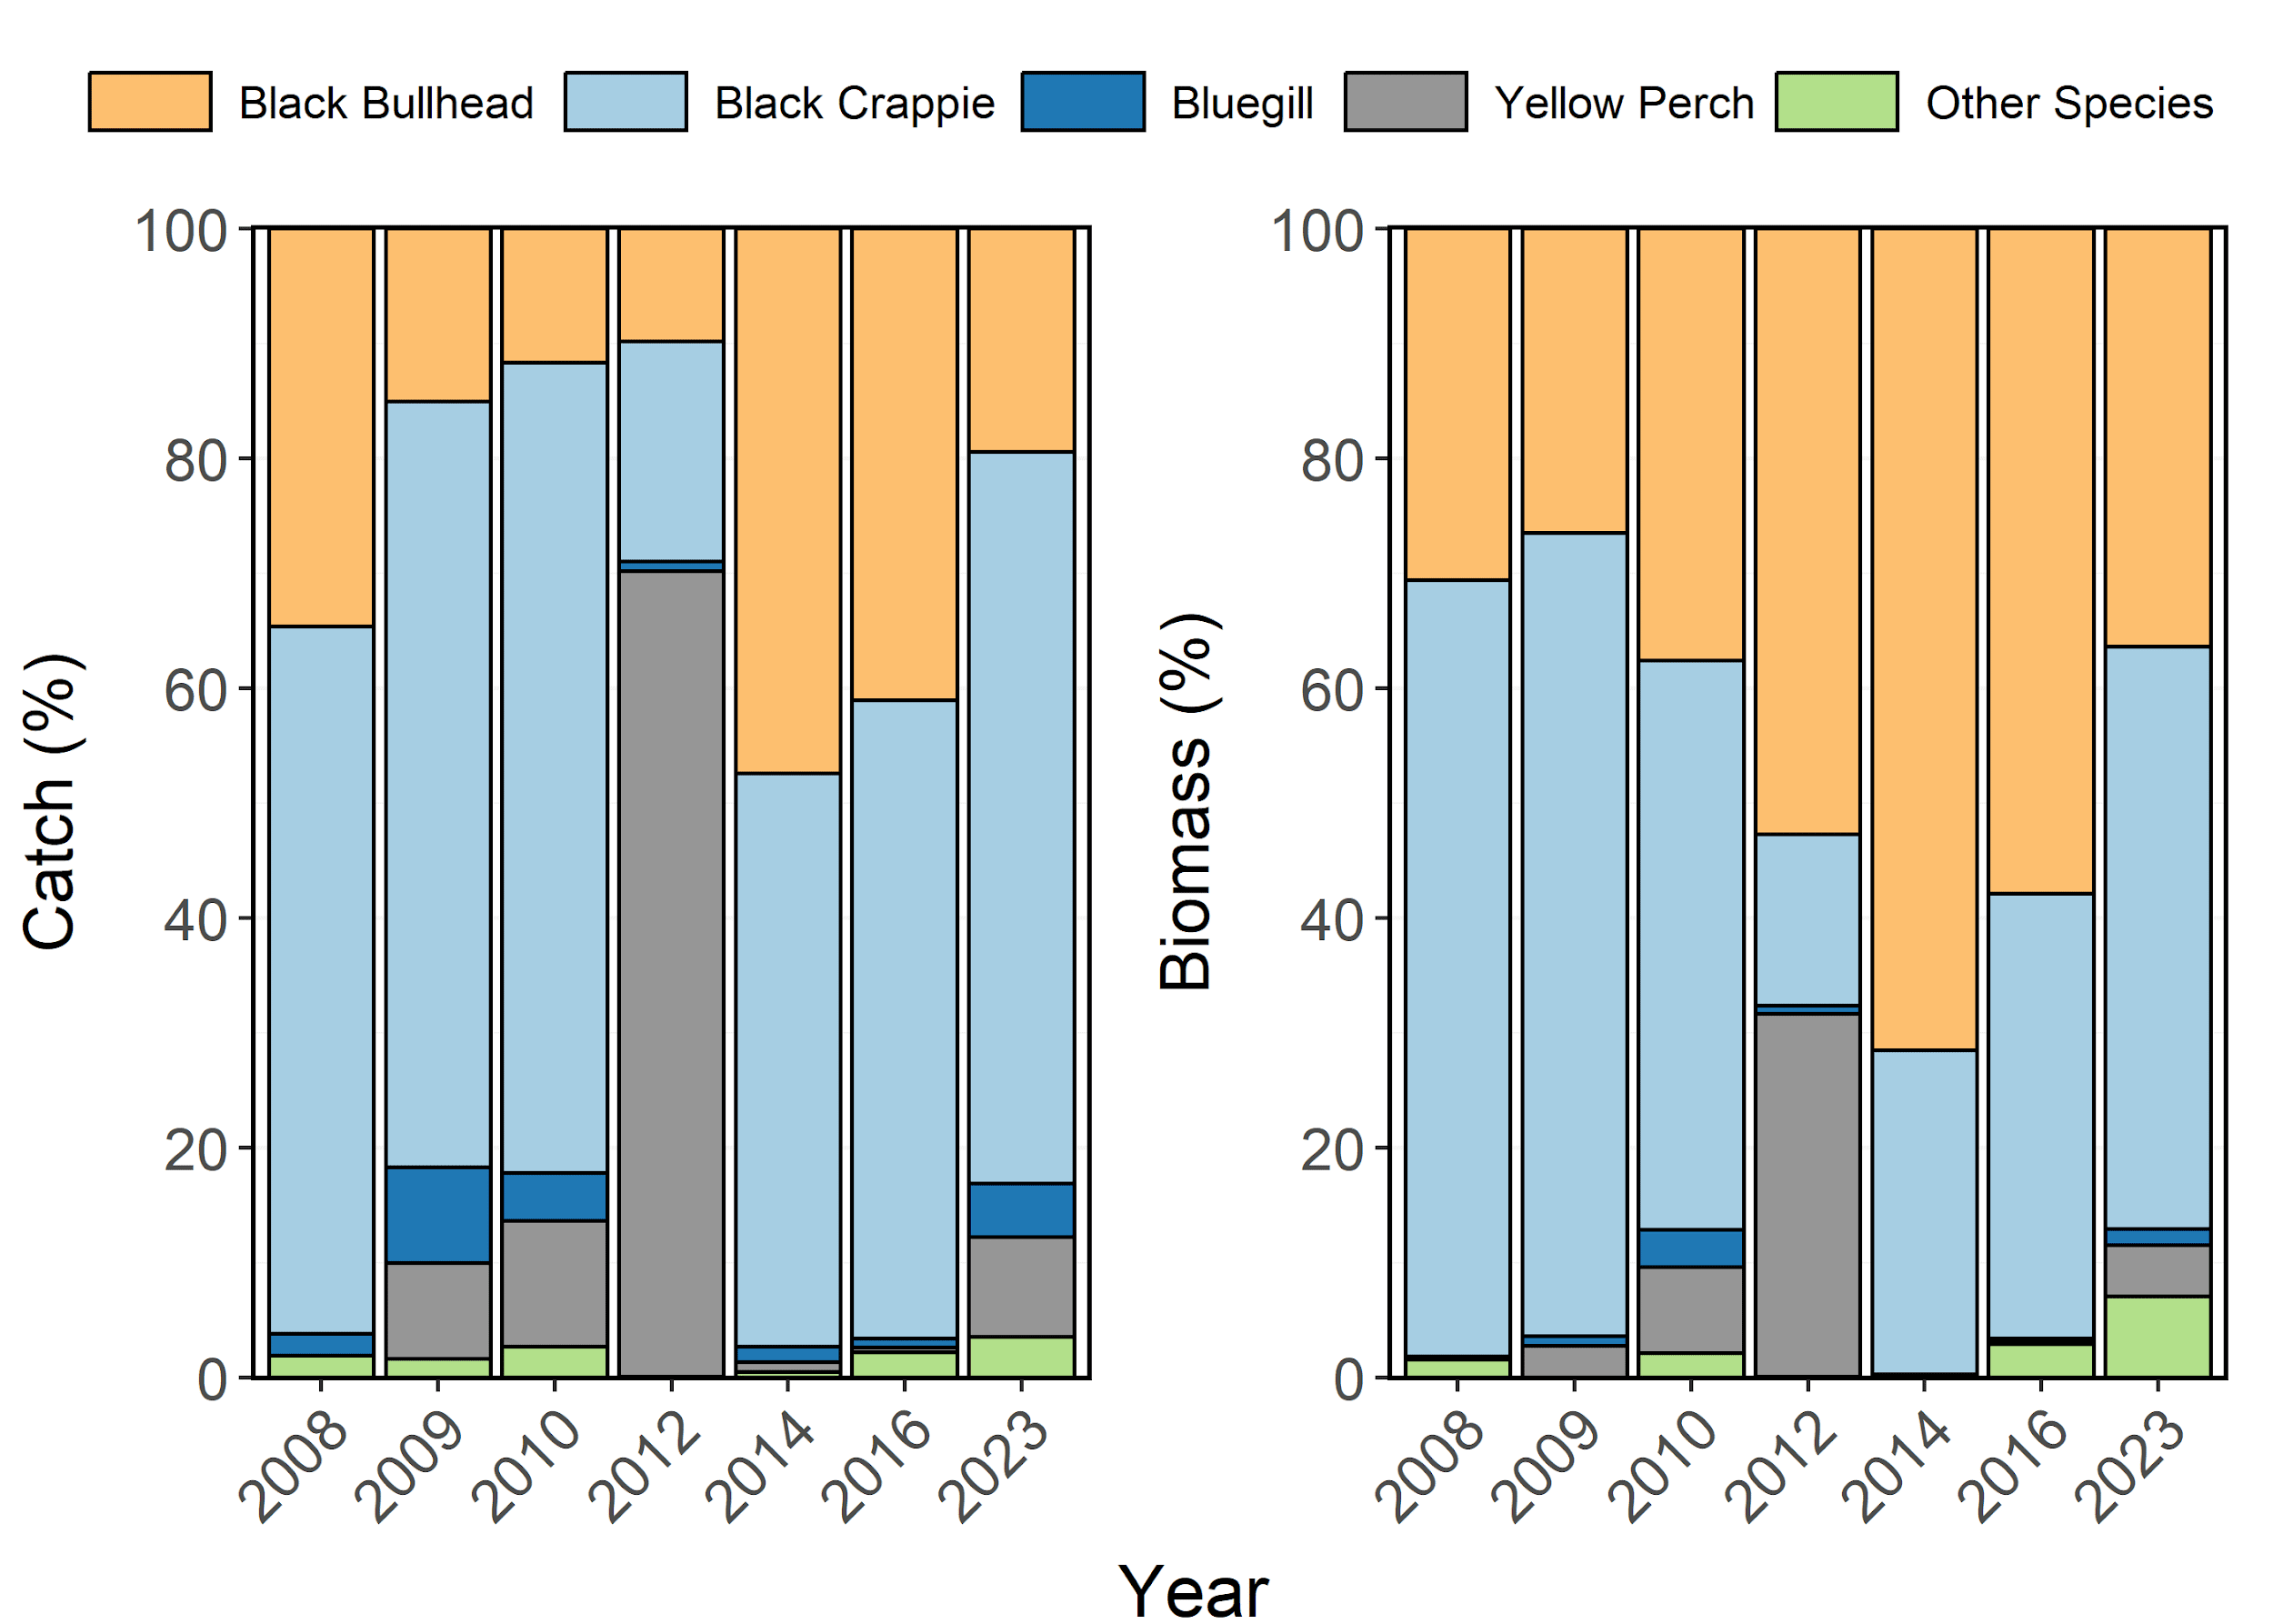

Figure 2: Species composition (%) by catch (# of fish) and biomass (kg) of Black Bullhead, Black Crappie, Bluegill, and Yellow Perch sampled in trapnets from Pineview Reservoir between 1997-2023. Other species include Common Carp and Smallmouth Bass aggregated together.

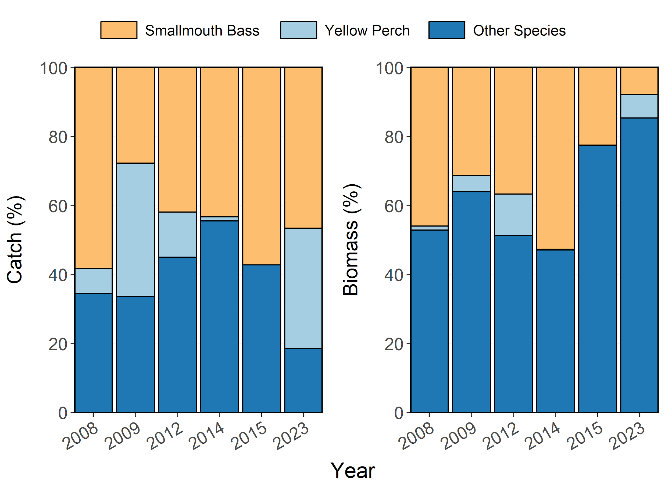

Figure 3: Species composition (%) by catch (# of fish) and biomass (kg) of Smallmouth Bass, and Yellow Perch sampled during electrofishing surveys from Pineview Reservoir between 1996-2023. Other species include Black Bullhead, Black Crappie, Bluegill, Common Carp, and Green Sunfish aggregated together.

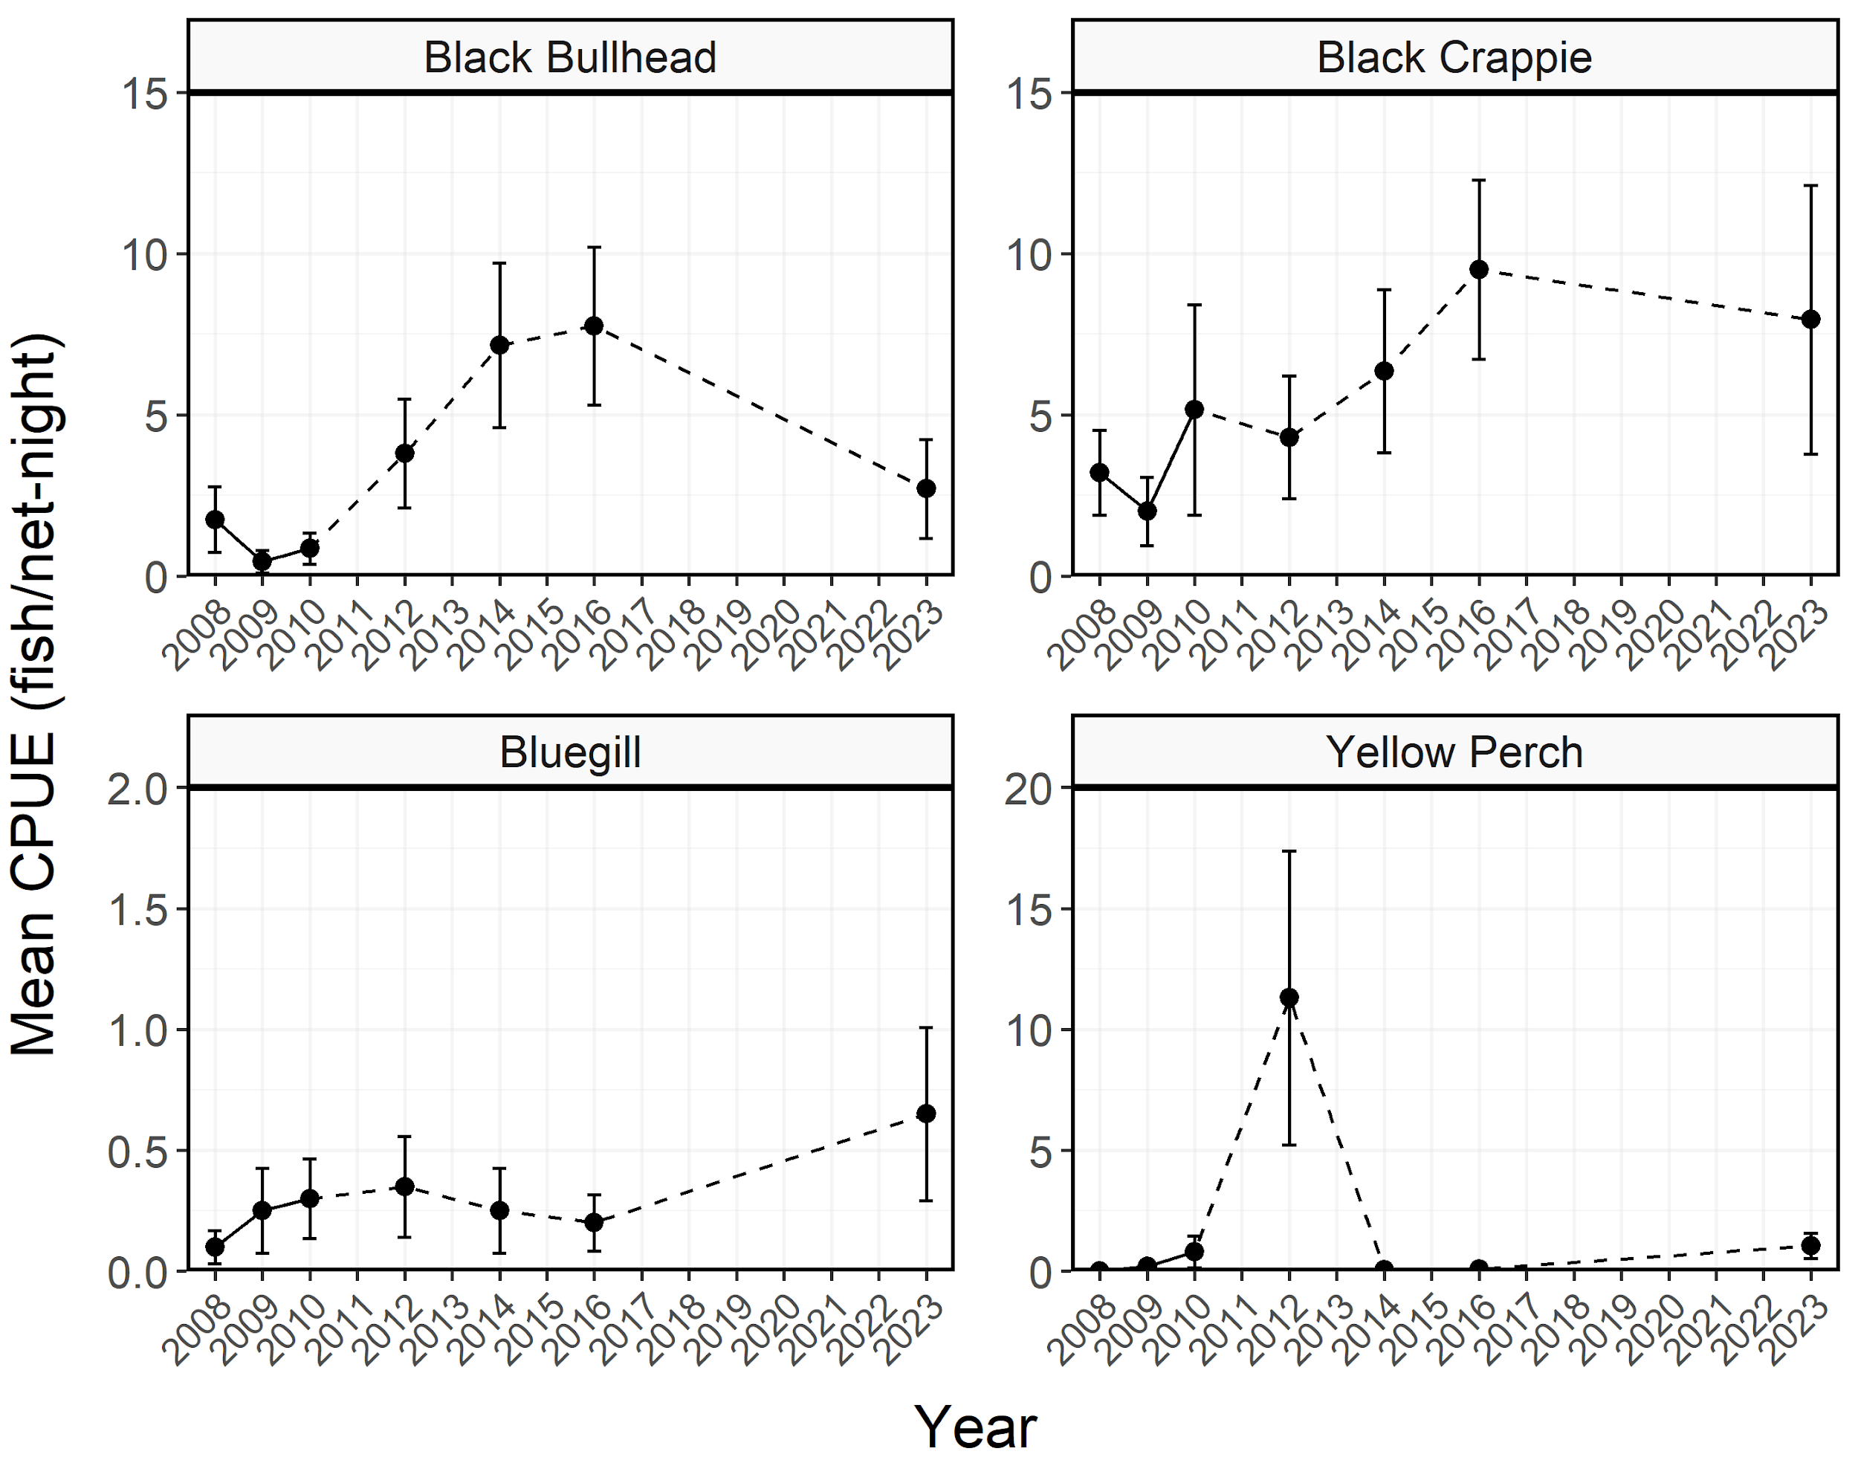

Figure 4: Mean relative abundance (CPUE; fish/net-night) of stock-length Black Bullhead, Black Crappie, Bluegill, and Yellow Perch sampled in trapnets from Pineview Reservoir between 1997-2023. Dashed lines represent interpolation across years of missing data between points. Error bars indicate standard error.

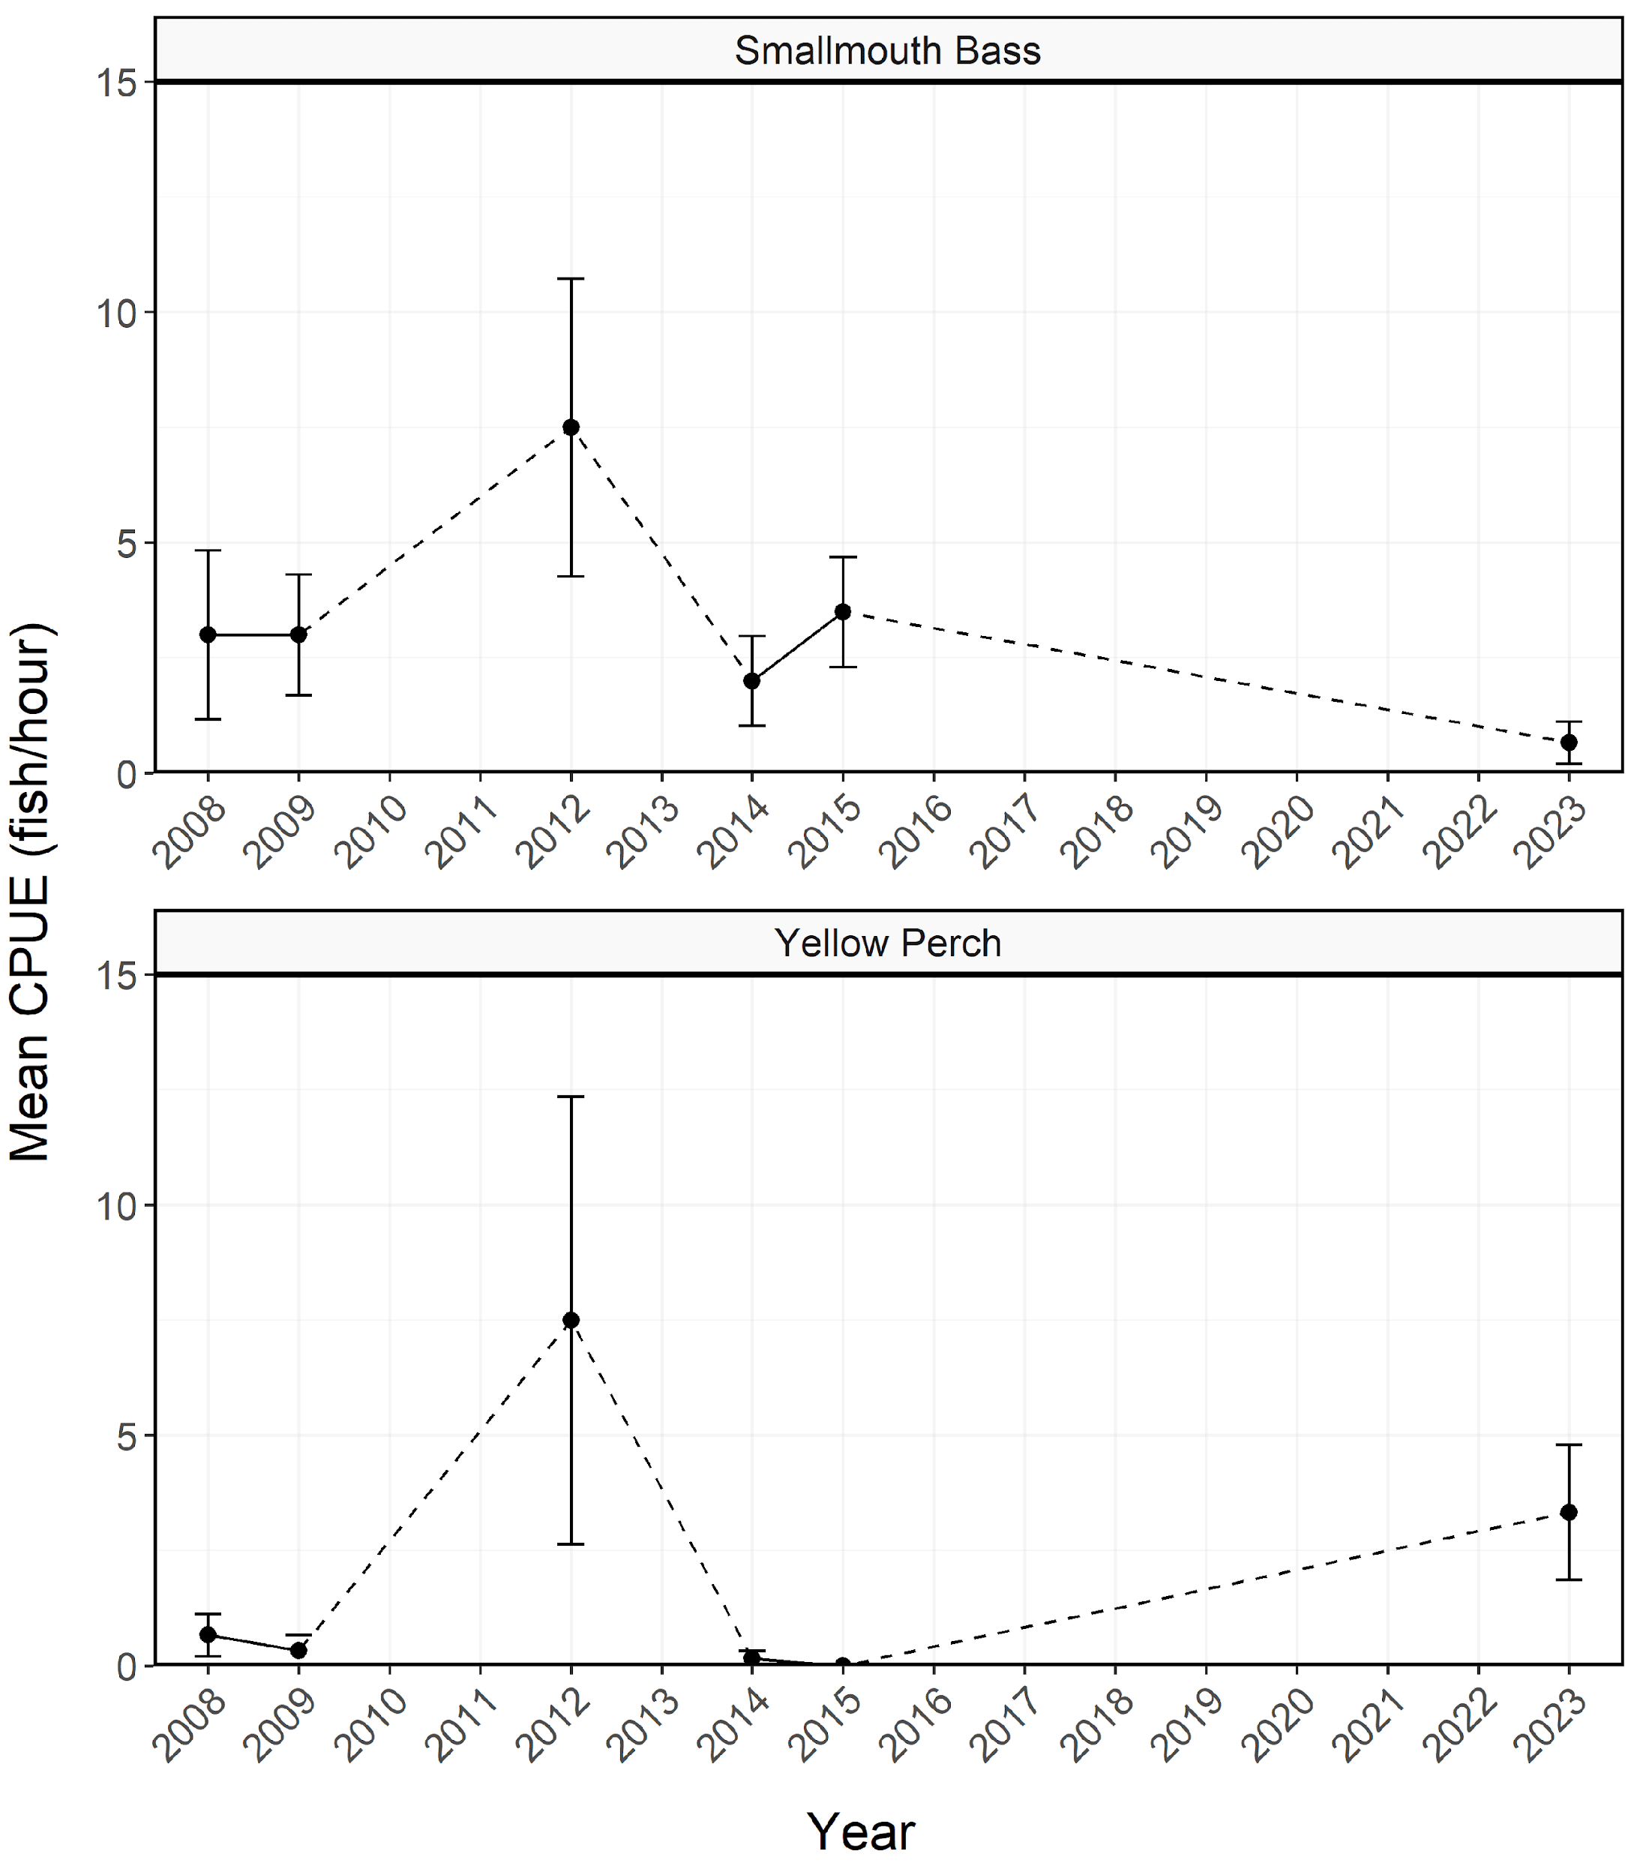

Figure 5: Mean relative abundance (CPUE; fish/net-night) of stock-length Smallmouth Bass and Yellow Perch sampled during electrofishing surveys from Pineview Reservoir between 1996-2023. Dashed lines represent interpolation across years of missing data between points. Error bars indicate standard error.

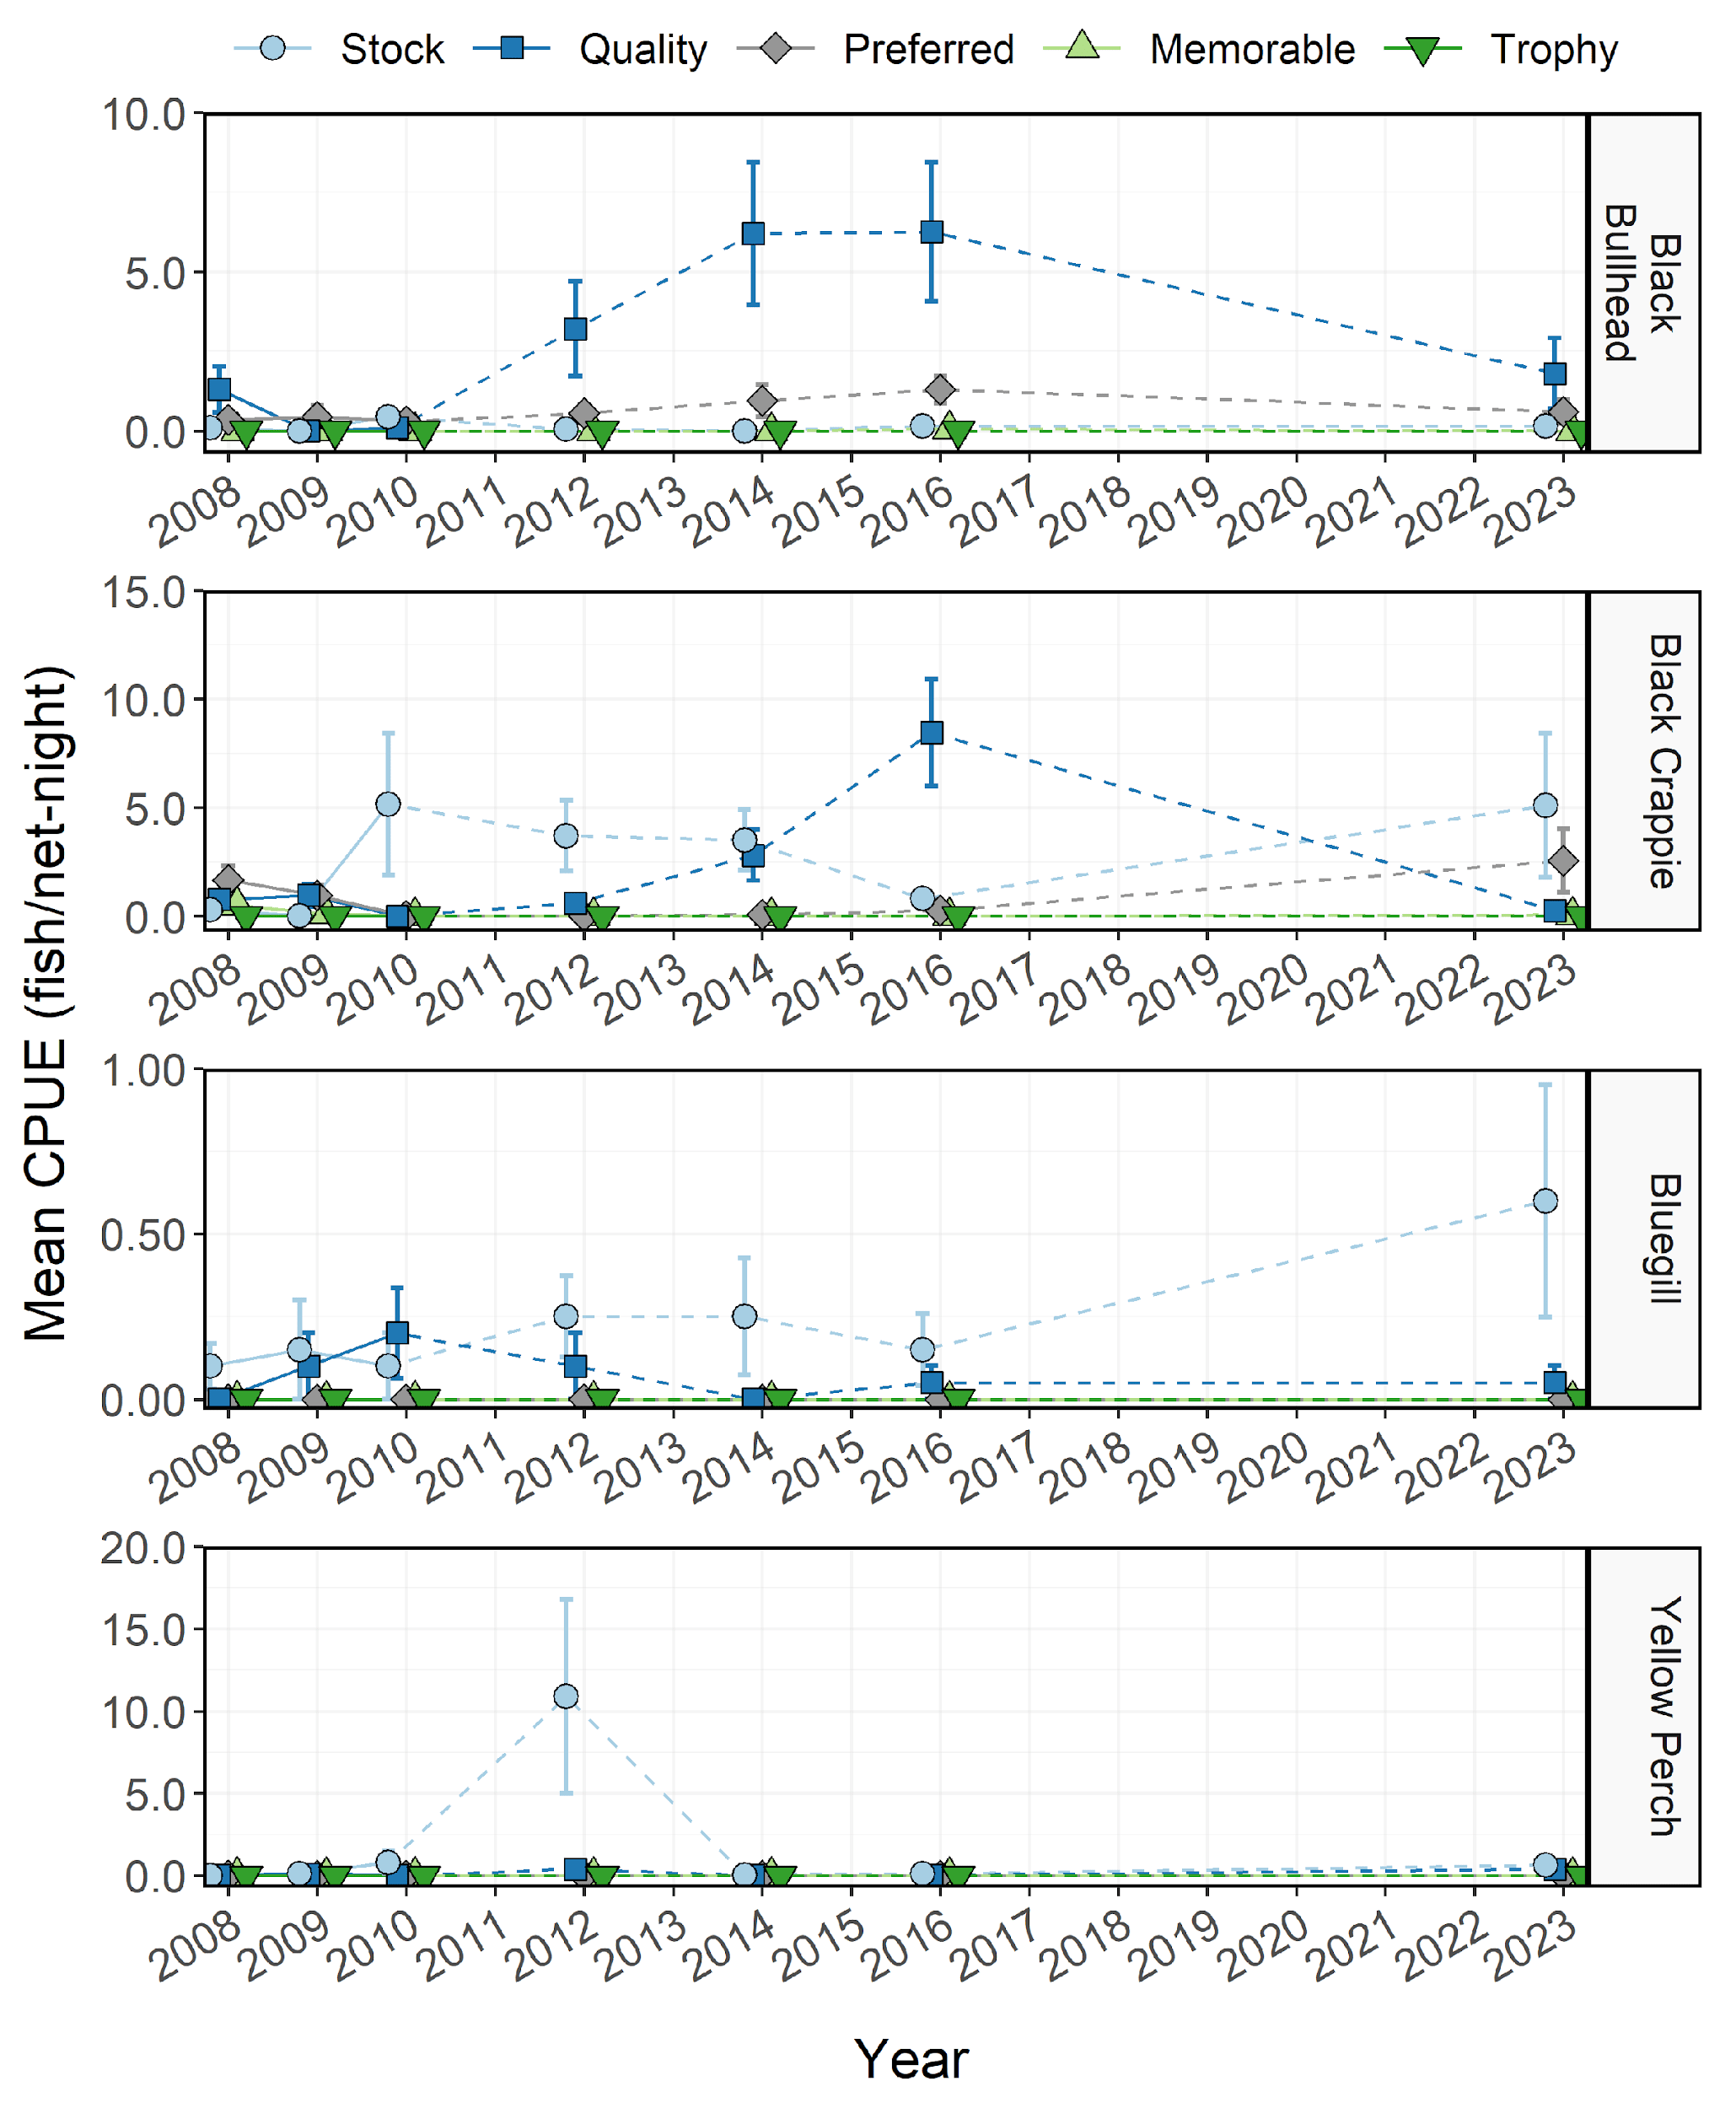

Figure 6: Mean relative abundance (CPUE; fish/net-night) of Black Bullhead, Black Crappie, Bluegill, and Yellow Perch within each Gablehouse length category sampled in trapnets from Pineview Reservoir between 1997-2023. Dashed lines represent interpolation across years of missing data between points. Error bars indicate standard error.

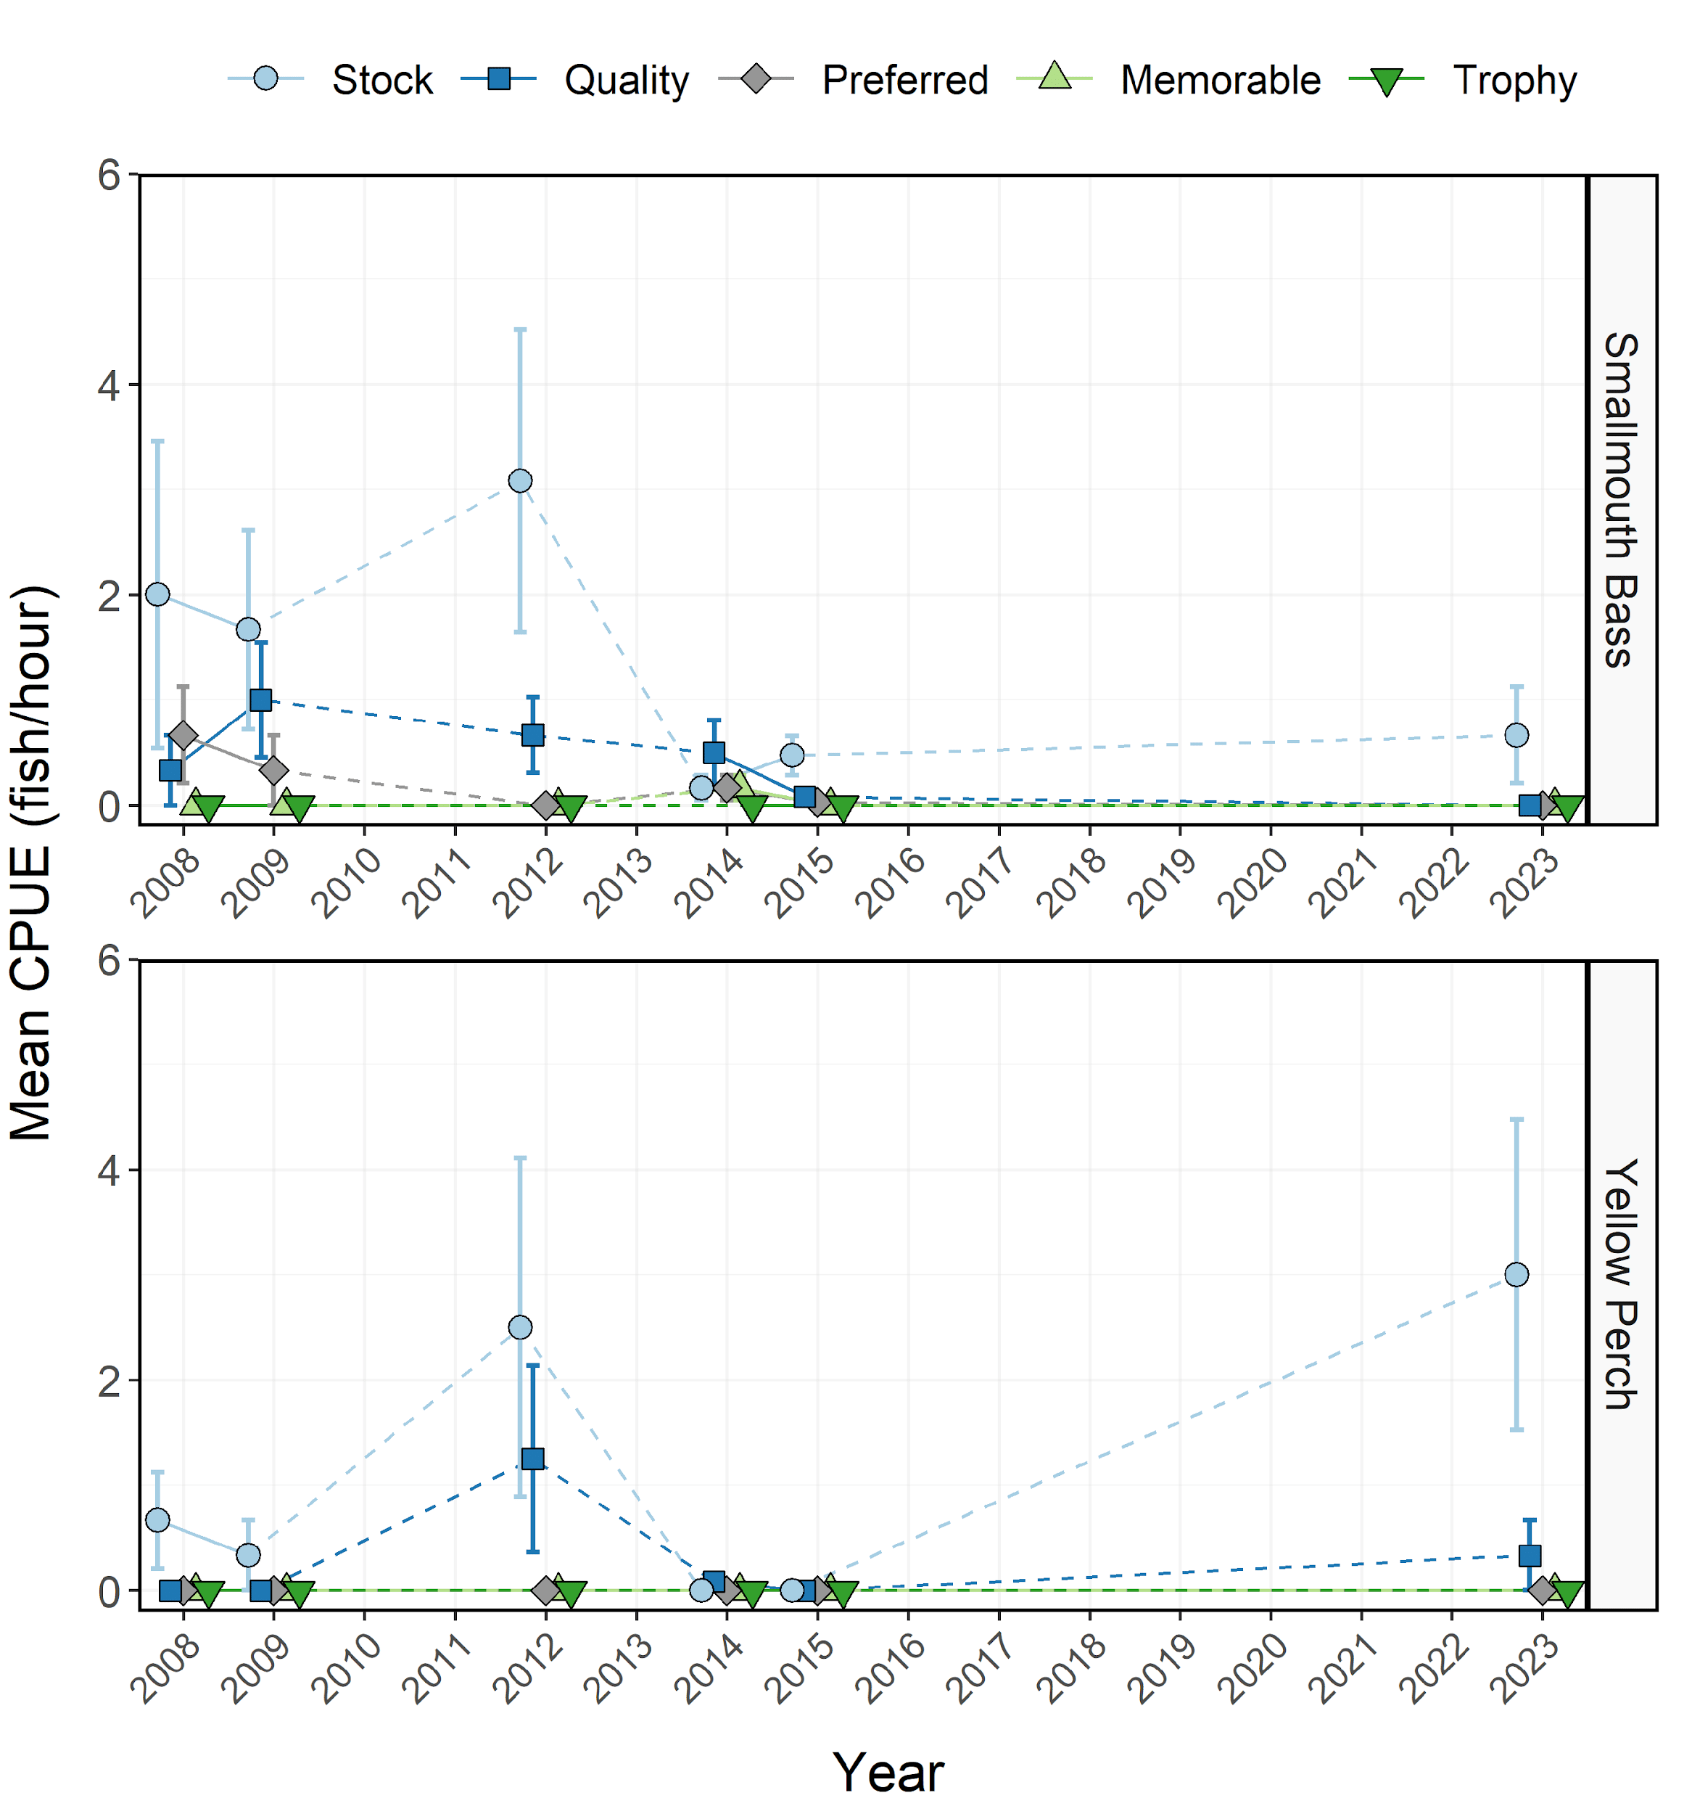

Figure 7: Mean relative abundance (CPUE; fish/net-night) of Smallmouth Bass and Yellow Perch within each Gablehouse length category sampled during electrofishing surveys from Pineview Reservoir between 1996-2023. Dashed lines represent interpolation across years of missing data between points. Error bars indicate standard error.

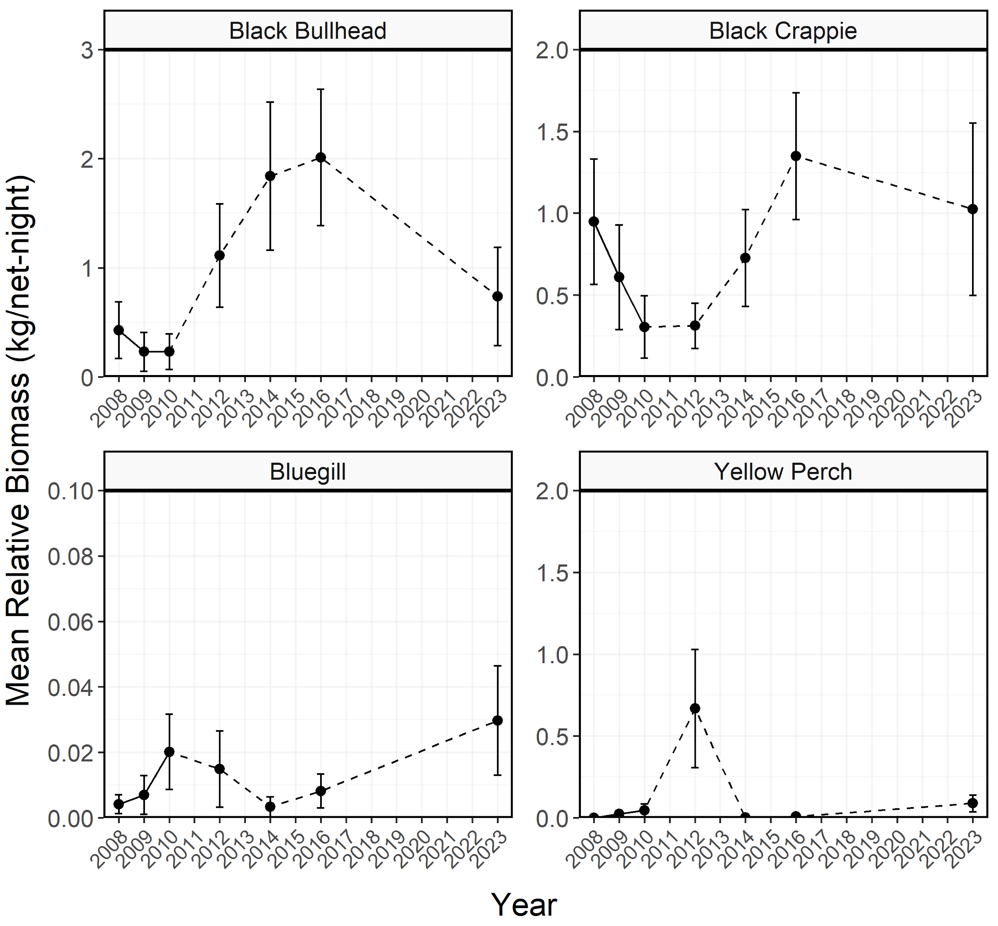

Figure 8: Mean relative biomass (kg/net-night) of stock-length Black Bullhead, Black Crappie, Bluegill, and Yellow Perch sampled in trapnets from Pineview Reservoir between 1997-2023. Dashed lines represent interpolation across years of missing data between points. Error bars indicate standard error.

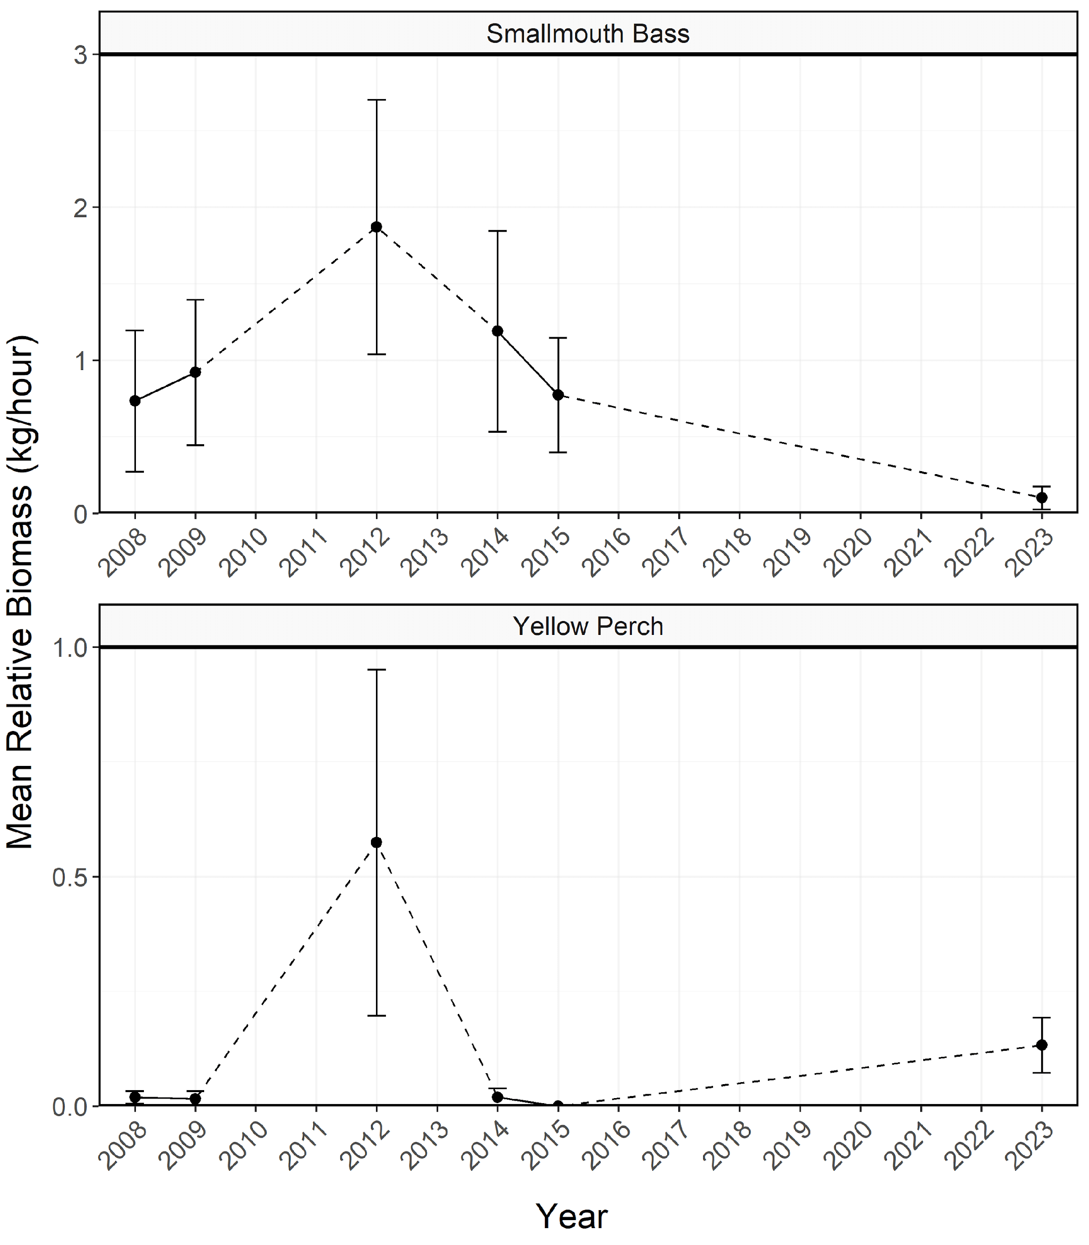

Figure 9: Mean relative biomass (kg/net-night) of stock-length Smallmouth Bass and Yellow Perch sampled during electrofishing surveys from Pineview Reservoir between 1996-2023. Dashed lines represent interpolation across years of missing data between points. Error bars indicate standard error.

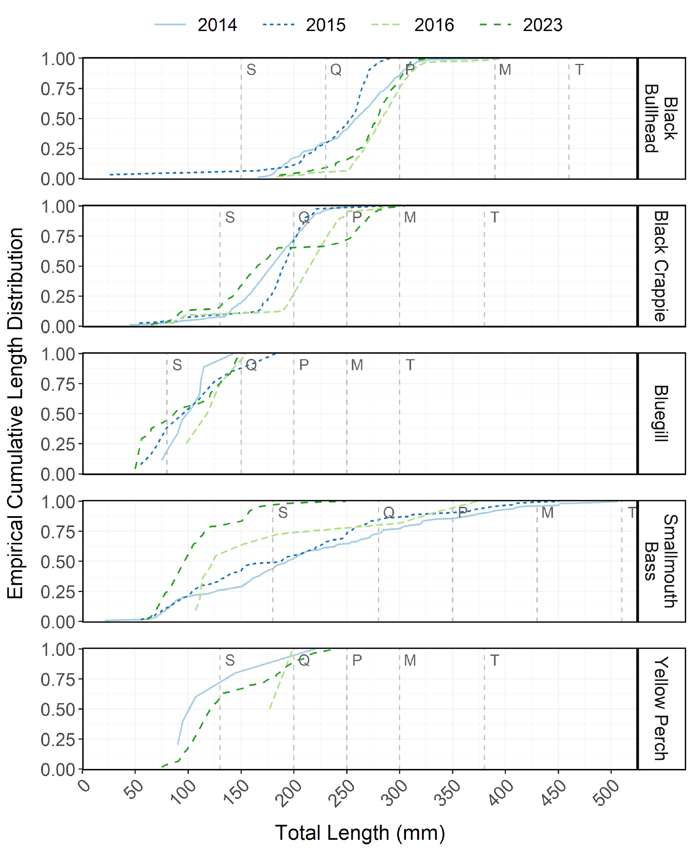

Figure 10: Empirical cumulative total length (mm) distribution of Black Bullhead, Black Crappie, Bluegill, Smallmouth Bass, and Yellow Perch sampled during trapnet and electrofishing surveys from Pineview Reservoir between 2013-2023.

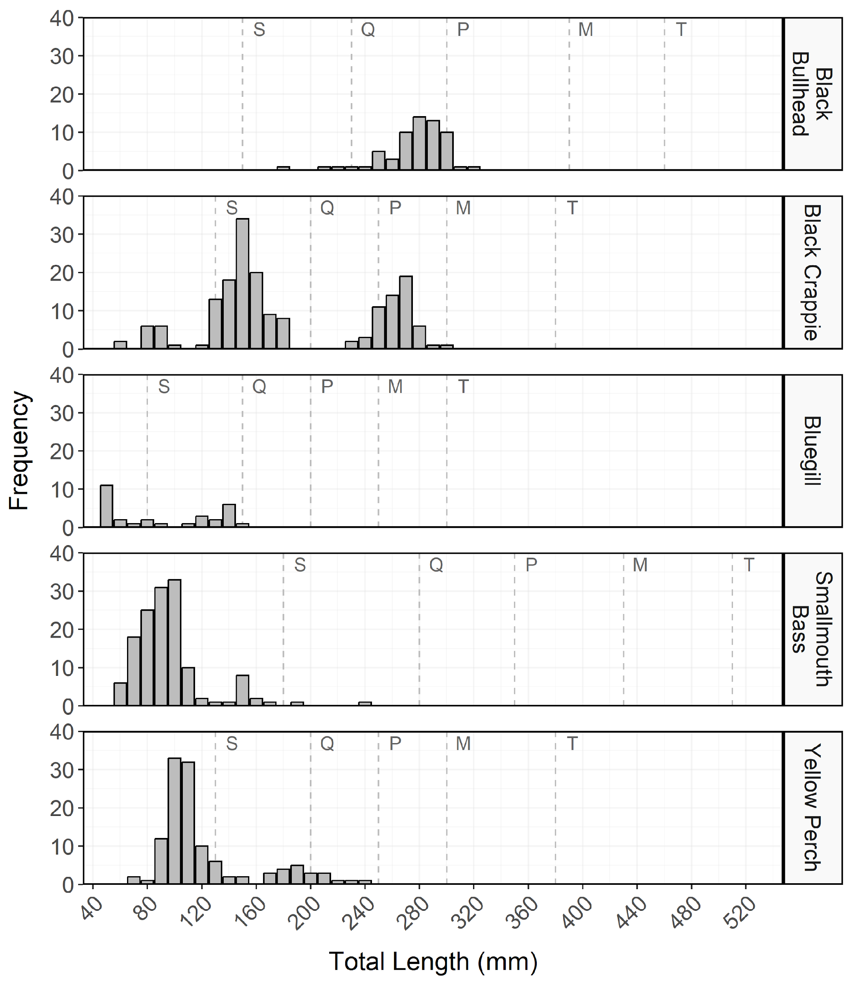

Figure 11: Total length (mm) frequency of Black Bullhead, Black Crappie, Bluegill, Smallmouth Bass, and Yellow Perch sampled during trapnet and electrofishing surveys from Pineview Reservoir in 2023. The length intervals are left-inclusive and right-exclusive, and the x-axis labels represent the start of the length interval (i.e., left side). The start of each Gablehouse length category is identified by the vertical dashed lines and the category name (i.e., stock, quality, preferred, memorable, and trophy) is indicated by the first letter of each category on the right side of the dashed line.

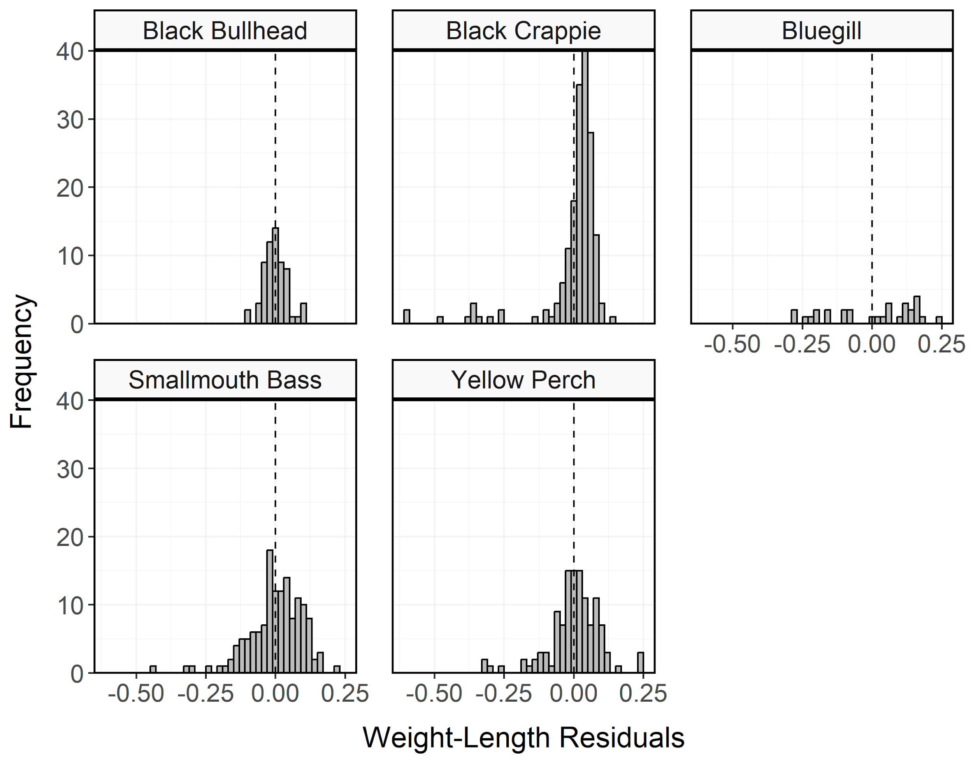

Figure 12: Histogram of residuals from the regression of log10 weight on log10 total length for Black Bullhead, Black Crappie, Bluegill, Smallmouth Bass, and Yellow Perch sampled during trapnet and electrofishing surveys from Pineview Reservoir in 2023. The dashed line represents zero.

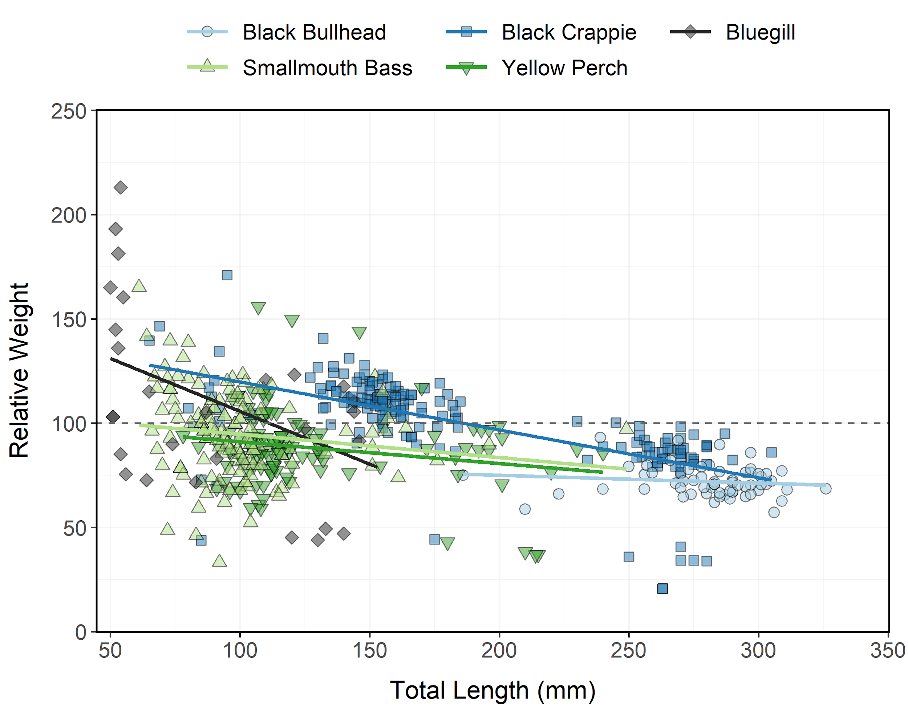

Figure 13: Relative weight of Black Bullhead, Black Crappie, Bluegill, Smallmouth Bass, and Yellow Perch sampled during trapnet and electrofishing surveys from Pineview Reservoir in 2023 as an index of condition. The horizontal dashed line indicates a 1:1 relationship between standard weight and relative weight.

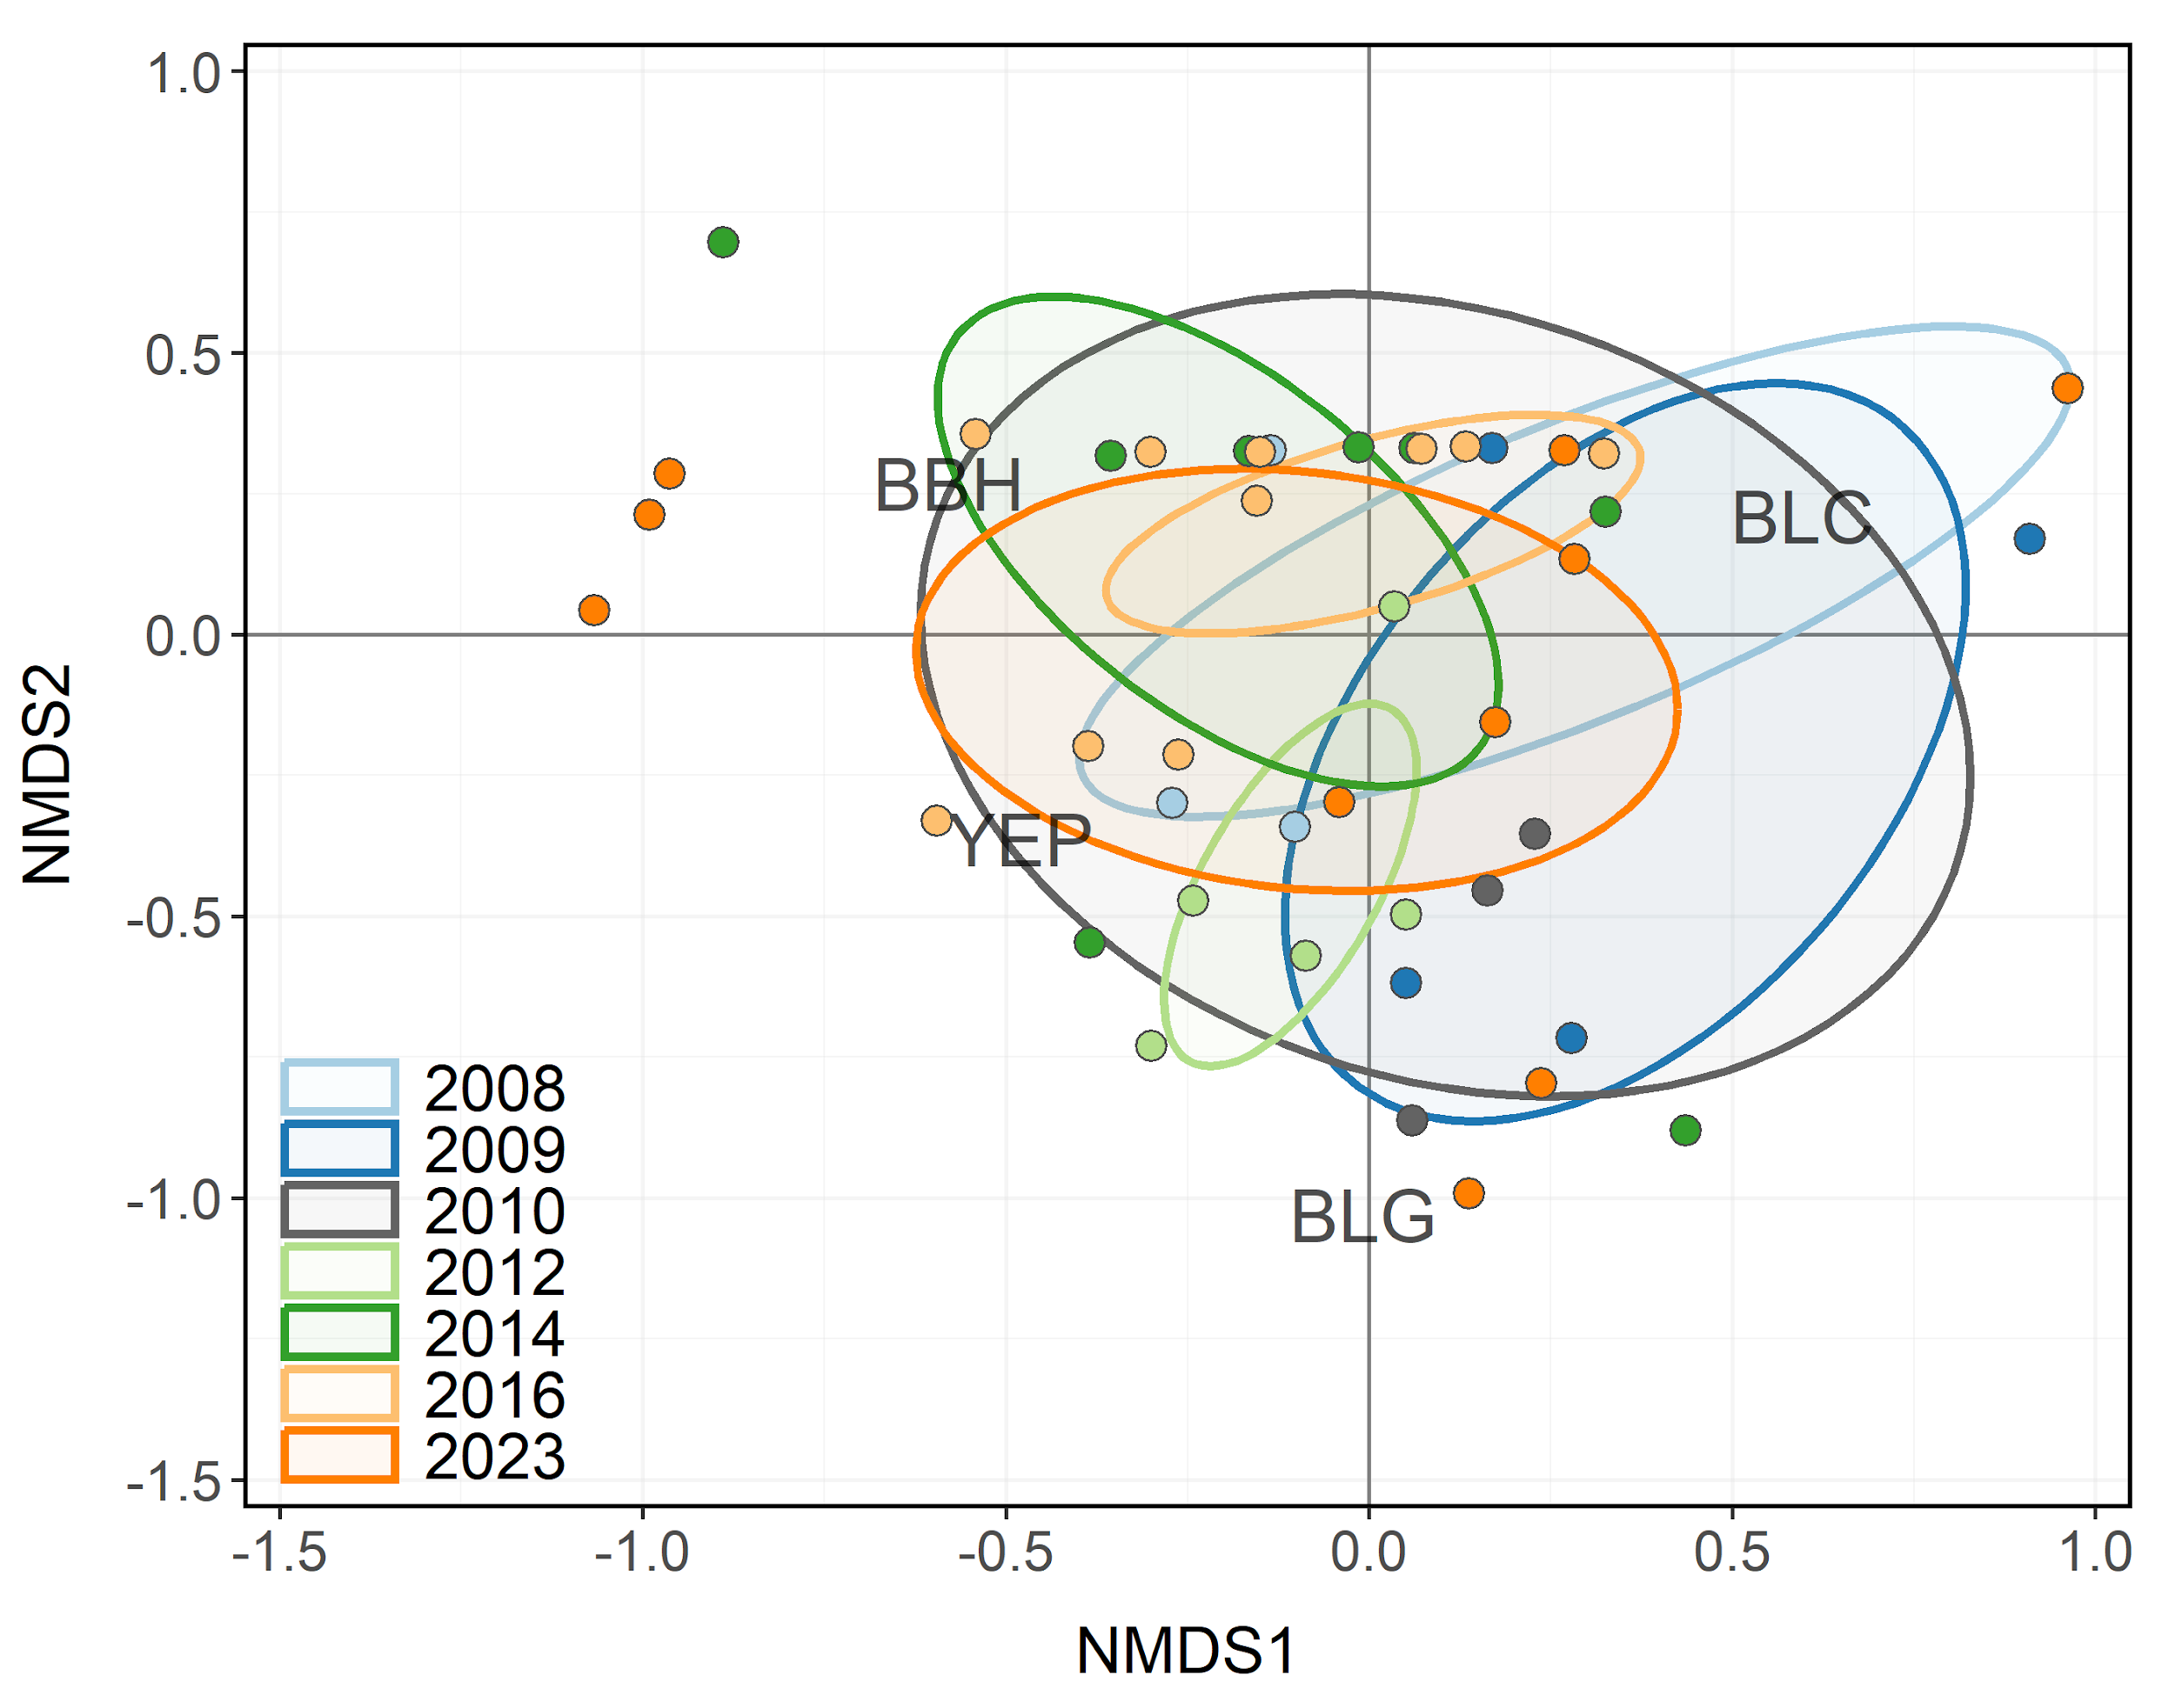

Figure 14: Non-metric multidimensional scaling (NMDS) bi-plot of stock-length Black Bullhead, Black Crappie, Bluegill, and Yellow Perch sampled during trapnet surveys from Pineview Reservoir between 1997-2023. Points closer together have more similar relative abundances among species. Ellipses highlight the community structure within each year sampled.

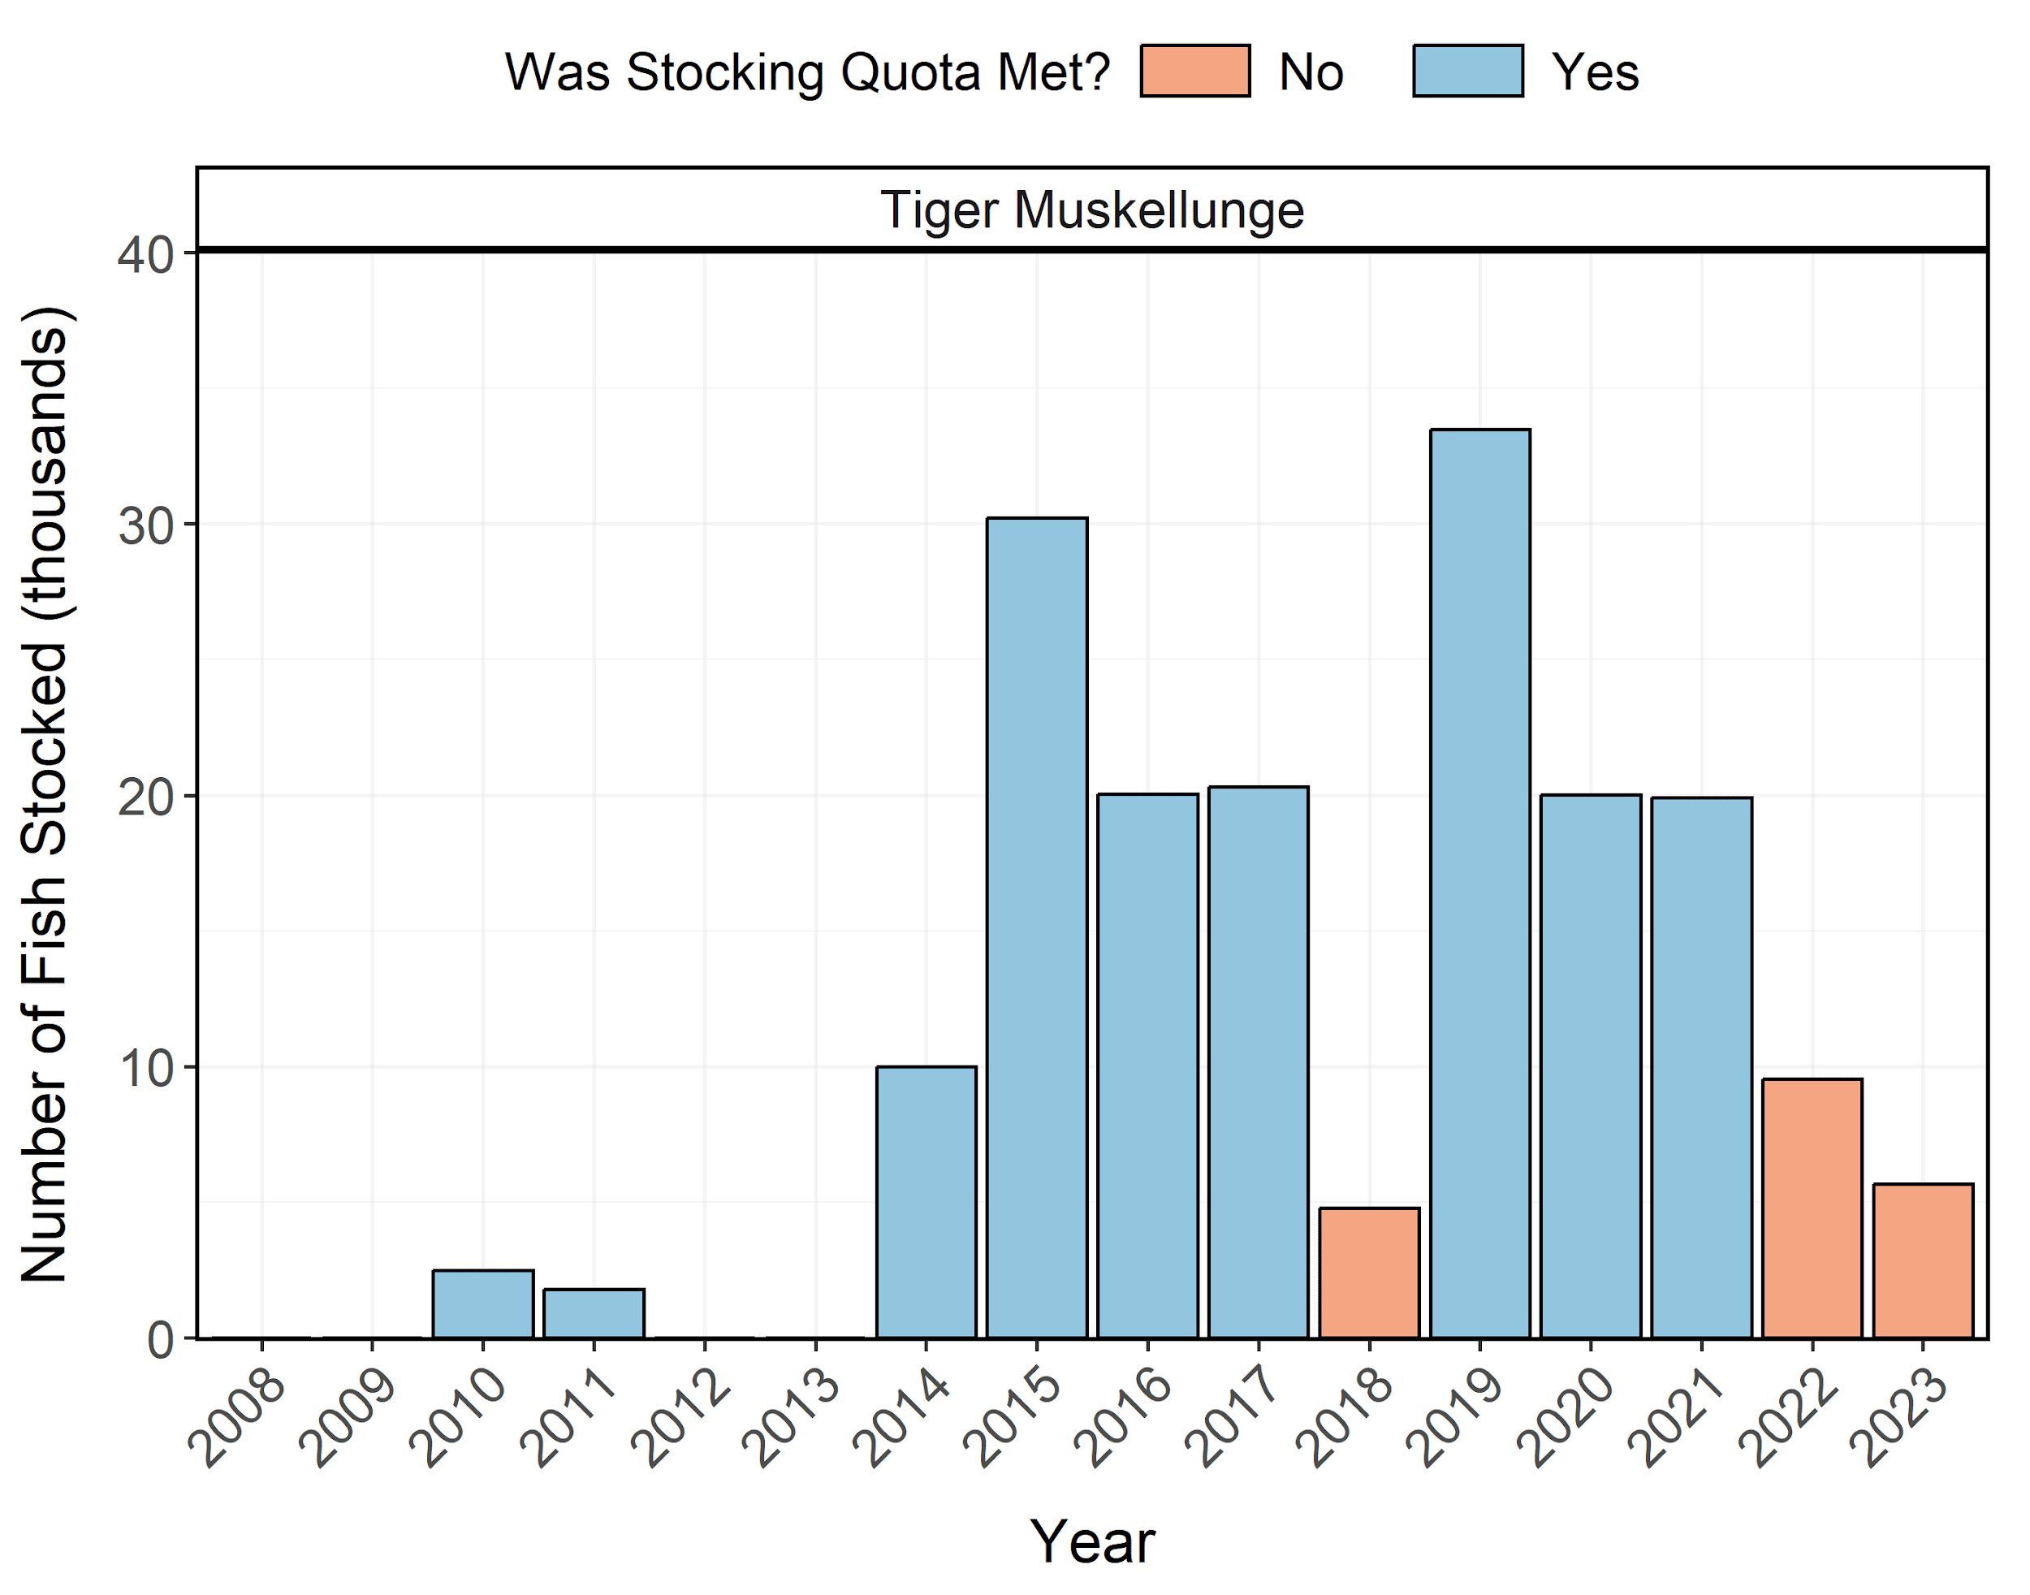

Figure 15: Number of individuals stocked in Pineview Reservoir from 2008-2023. Length-at-stocking and stocking quota varies among years. A stocking quota was determined to be met if the number of stocked individuals was at least 90% of the stocking quota.