Utah Division of Wildlife Resources Fishery Monitoring Report

**Author**: Taylor R. Stewart  
**Contact**: [taylorstewart@utah.gov](mailto:taylorstewart@utah.gov)

**System**: Mantua Reservoir  
**Sampling Dates**: 5/11/2023  
**Target Species**: Bluegill, Largemouth Bass, and Yellow Perch  
**Species Stocked**: Rainbow Trout and Channel Catfish

**Monitoring Objectives**:

1. Provide data for assessment of trends in species occurrence, relative abundance, biomass, and size structure of sport fish assemblages.
2. Evaluate the effectiveness of harvest regulations on Largemouth Bass and Bluegill.

**Sampling Methods**:  
*Boat Electrofishing*  
Ten standardized shoreline transects were sampled with an electrofishing boat equipped with a Smith-Root, Inc. variable voltage processor (Figure 1; Table 1). Electricity was delivered to the water with an intensity of 300 volts, frequency of 60 Hz, and 60% pulse-width resulting in a current of 10 amps. Transects were sampled for a total of 10 minutes. All fish caught were identified to species and measured for total length (mm) and weight (g).

*Statistical Methods*  
All fish caught were identified to species and measured for total length (mm) and weight (g). Relative abundance (*i.e.,* catch-per-unit-effort) and biomass were analyzed as the respective number or weight for each species per hour of electrofishing. Size structure was presented as an empirical cumulative distribution function (ECDF) and a histogram. The ECDF, which is the proportion of fish that are less than each observed length, was used to analyze changes among years while the histogram was used to shows the frequency of individuals in each length interval for a single year. Weight-length residuals and relative weight were used as condition metrics. Changes in the fish community composition were analyzed among years using non-metric multidimensional scaling.

**Summary**:  
*Species Composition*  
Fish catches were comprised of Black Bullhead, Bluegill, Fathead Minnow, Green Sunfish, Largemouth Bass, Rainbow Trout, and Yellow Perch in 2023 (Figure 2). Bluegill were the most abundant species by number caught (58.9%). Largemouth Bass were the most abundant species by weight (46.6%; Figure 2).

*Abundance*  
Bluegill mean relative abundance was 54.0 fish/hour (SD = 45.1) and decreased by 82.6% from sampling conducted in 2019 (Figure 3). Largemouth Bass abundance remained high, consistent, and within historical bounds. Yellow Perch mean relative abundance was 44.4 (SD = 28.2) and increased by 35.8% from sampling conducted in 2019 (Figure 3). The relative abundance of stock- and quality-length Bluegill decreased in 2023 while the relative abundance of preferred-length Bluegill increased (Figure 4). Largemouth Bass abundances within the quality and memorable PSD categories increased in 2023 while abundance in the stock PSD category decreased. Yellow Perch abundances increased in all PSD categories expect the memorable category (Figure 4).

*Biomass*  
The mean relative biomass of Bluegill has been on a decreasing trend from 2015 to 2023 and had the lowest relative biomass observed in 2023 over the last decade (6.8 kg/hour; Figure 5). The mean relative biomass of Largemouth Bass and Yellow Perch increased by 10.8 and 27.6%, respectively (Figure 5).

*Size Structure*  
Empirical cumulative length distributions highlighted shifts in size structure for all sport fish species Figure 6). Length distributions shifted towards smaller Bluegill and Yellow Perch and larger Largemouth Bass. Shifts in length distributions between 2019 and 2023 were statistically different, based on a bootstrapped Kolmogorov-Smirnov test, for Bluegill (P < 0.001), Largemouth Bass (P < 0.001), and Yellow Perch (P = 0.007; Figure 6). Substock-length Bluegill and Yellow Perch were the most abundant while quality-length Largemouth Bass were dominant (Figure 7).

*Condition*  
Relative weights of Bluegill are highly variable across lengths (Figure 9). Yellow Perch show a negative relationship between relative weight and length while Largemouth Bass show a positive relationship (Figure 9).

*Community Structure*  
The fish community has shifted over time from being dominated largely by Bluegill to a more diverse fish community with Largemouth Bass and Yellow Perch having important roles within the community structure (Figure 10).

*Stocking*  
Stocking quotas are being met and maintained (Figure 11).

All other measurements and indices appear within normal bounds.

**Management Actions**:

1. Sample this water in 2024 to assess the impact of the fish kill that occurred in September 2023.
2. Continue to promote this fishery, particularly the quality Largemouth Bass population.
3. Assess the size structure of the Bluegill population after 2024 sampling and consider a regulation change to restrict harvest.
4. Collect age structures on Bluegill, Largemouth Bass, and Yellow Perch in 2024 to characterize rates of growth and mortality. This information will provide managers additional insights on the growth and mortality of these species prior to considering a regulation change.

**Tables:**

Table 1: Date of collection, number of samples collected by sampling gear type, prescribed number samples by sampling gear type, mean water temperature (°C), and any additional data collected from Mantua Reservoir in 2023.

| Gear Type | Date | # of Samples | # of Prescribed Samples | Water Temperature | Additional Comments |
| --- | --- | --- | --- | --- | --- |
| Boat Electrofishing | 5/11/2023 | 10 | 10 | 15.1 | – |

Table 2: Mean total length (TL; mm), mean weight (WT; g), mean relative weight (Wr), and percentage of individuals within each traditional proportional size distribution (PSD) category for each target species from Mantua Reservoir in 2023. All values in parentheses indicate standard deviation.

| Target Species | Mean  TL | Mean  WT | Mean  Wr | PSD-  Quality | PSD-  Preferred | PSD-  Memorable | PSD-  Trophy |
| --- | --- | --- | --- | --- | --- | --- | --- |
| Bluegill | 133.6  (39.4) | 72.5  (61.9) | 100.2  (24.4) | 71 | 37 | 0 | 0 |
| Largemouth Bass | 228.3  (93.9) | 268.6  (323.0) | 92.3  (19.1) | 91 | 20 | 0 | 0 |
| Yellow Perch | 136.8  (54.0) | 45.4  (53.5) | 96.1  (18.1) | 33 | 22 | 0 | 0 |

**Figures:**

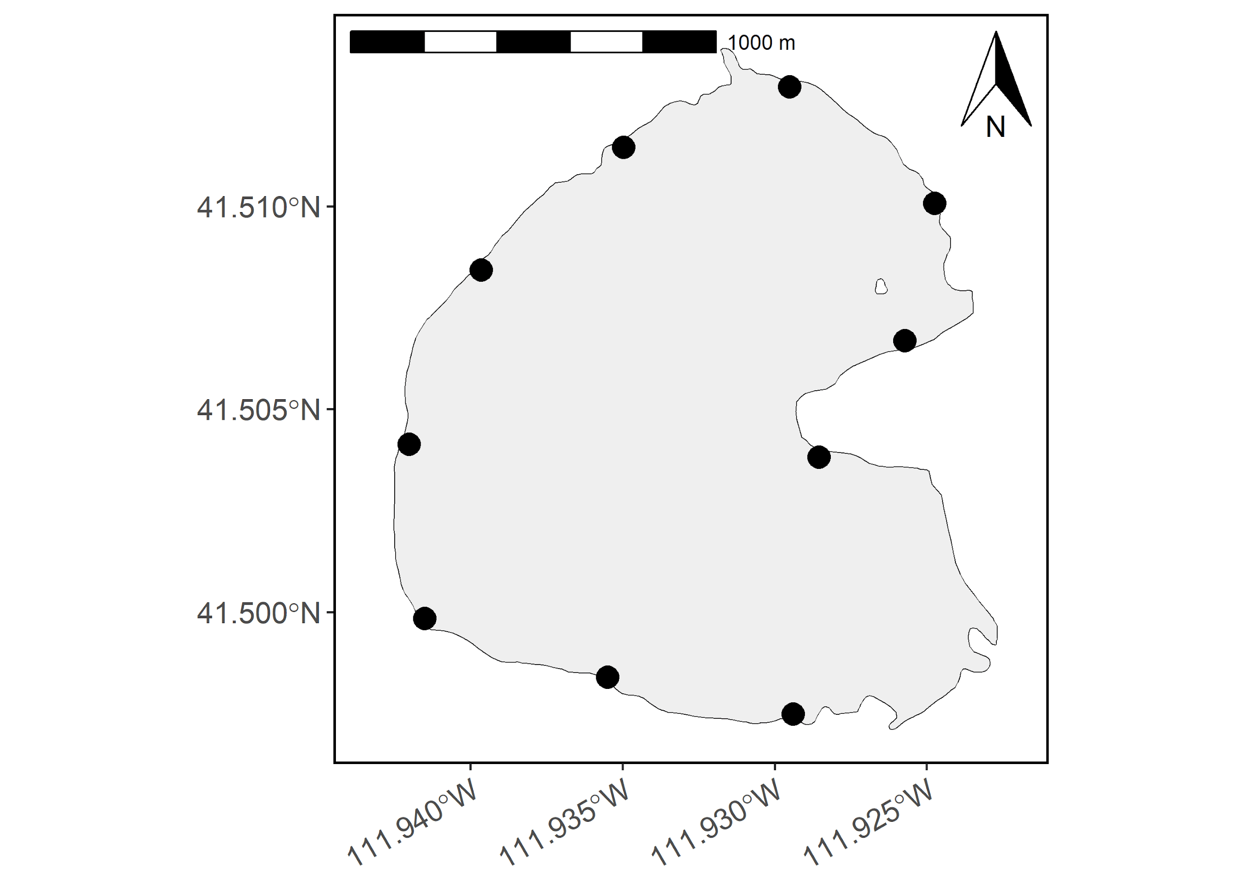

Figure 1: Map of Mantua Reservoir with electrofishing sampling sites denoted as black circles.

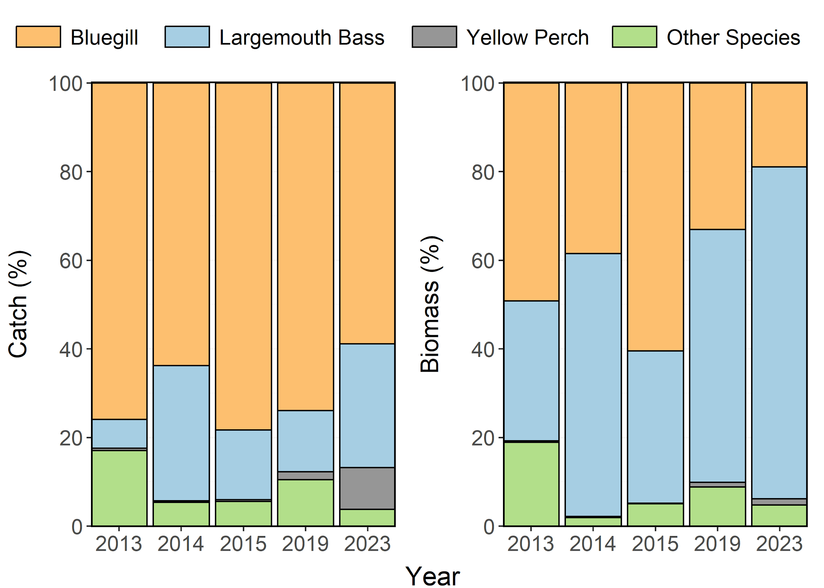

Figure 2: Species composition (%) by catch (# of fish) and biomass (kg) of Bluegill, Largemouth Bass, and Yellow Perch from Mantua Reservoir in 1997-2023. Other species include Black Bullhead, Fathead Minnow, Green Sunfish, and Rainbow Trout aggregated together.

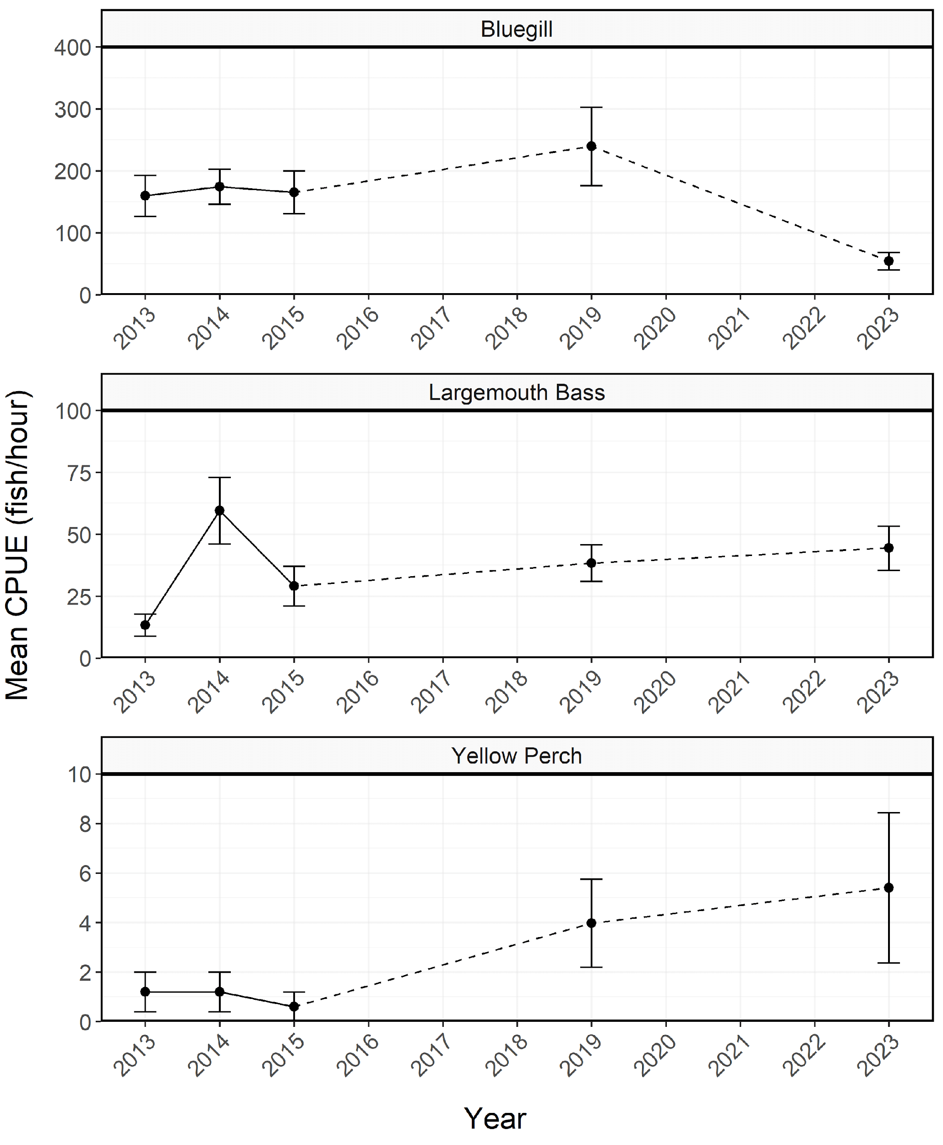

Figure 3: Mean relative abundance (fish/hour) of stock-length Bluegill, Largemouth Bass, and Yellow Perch from Mantua Reservoir in 1997-2023. Error bars indicate standard error.

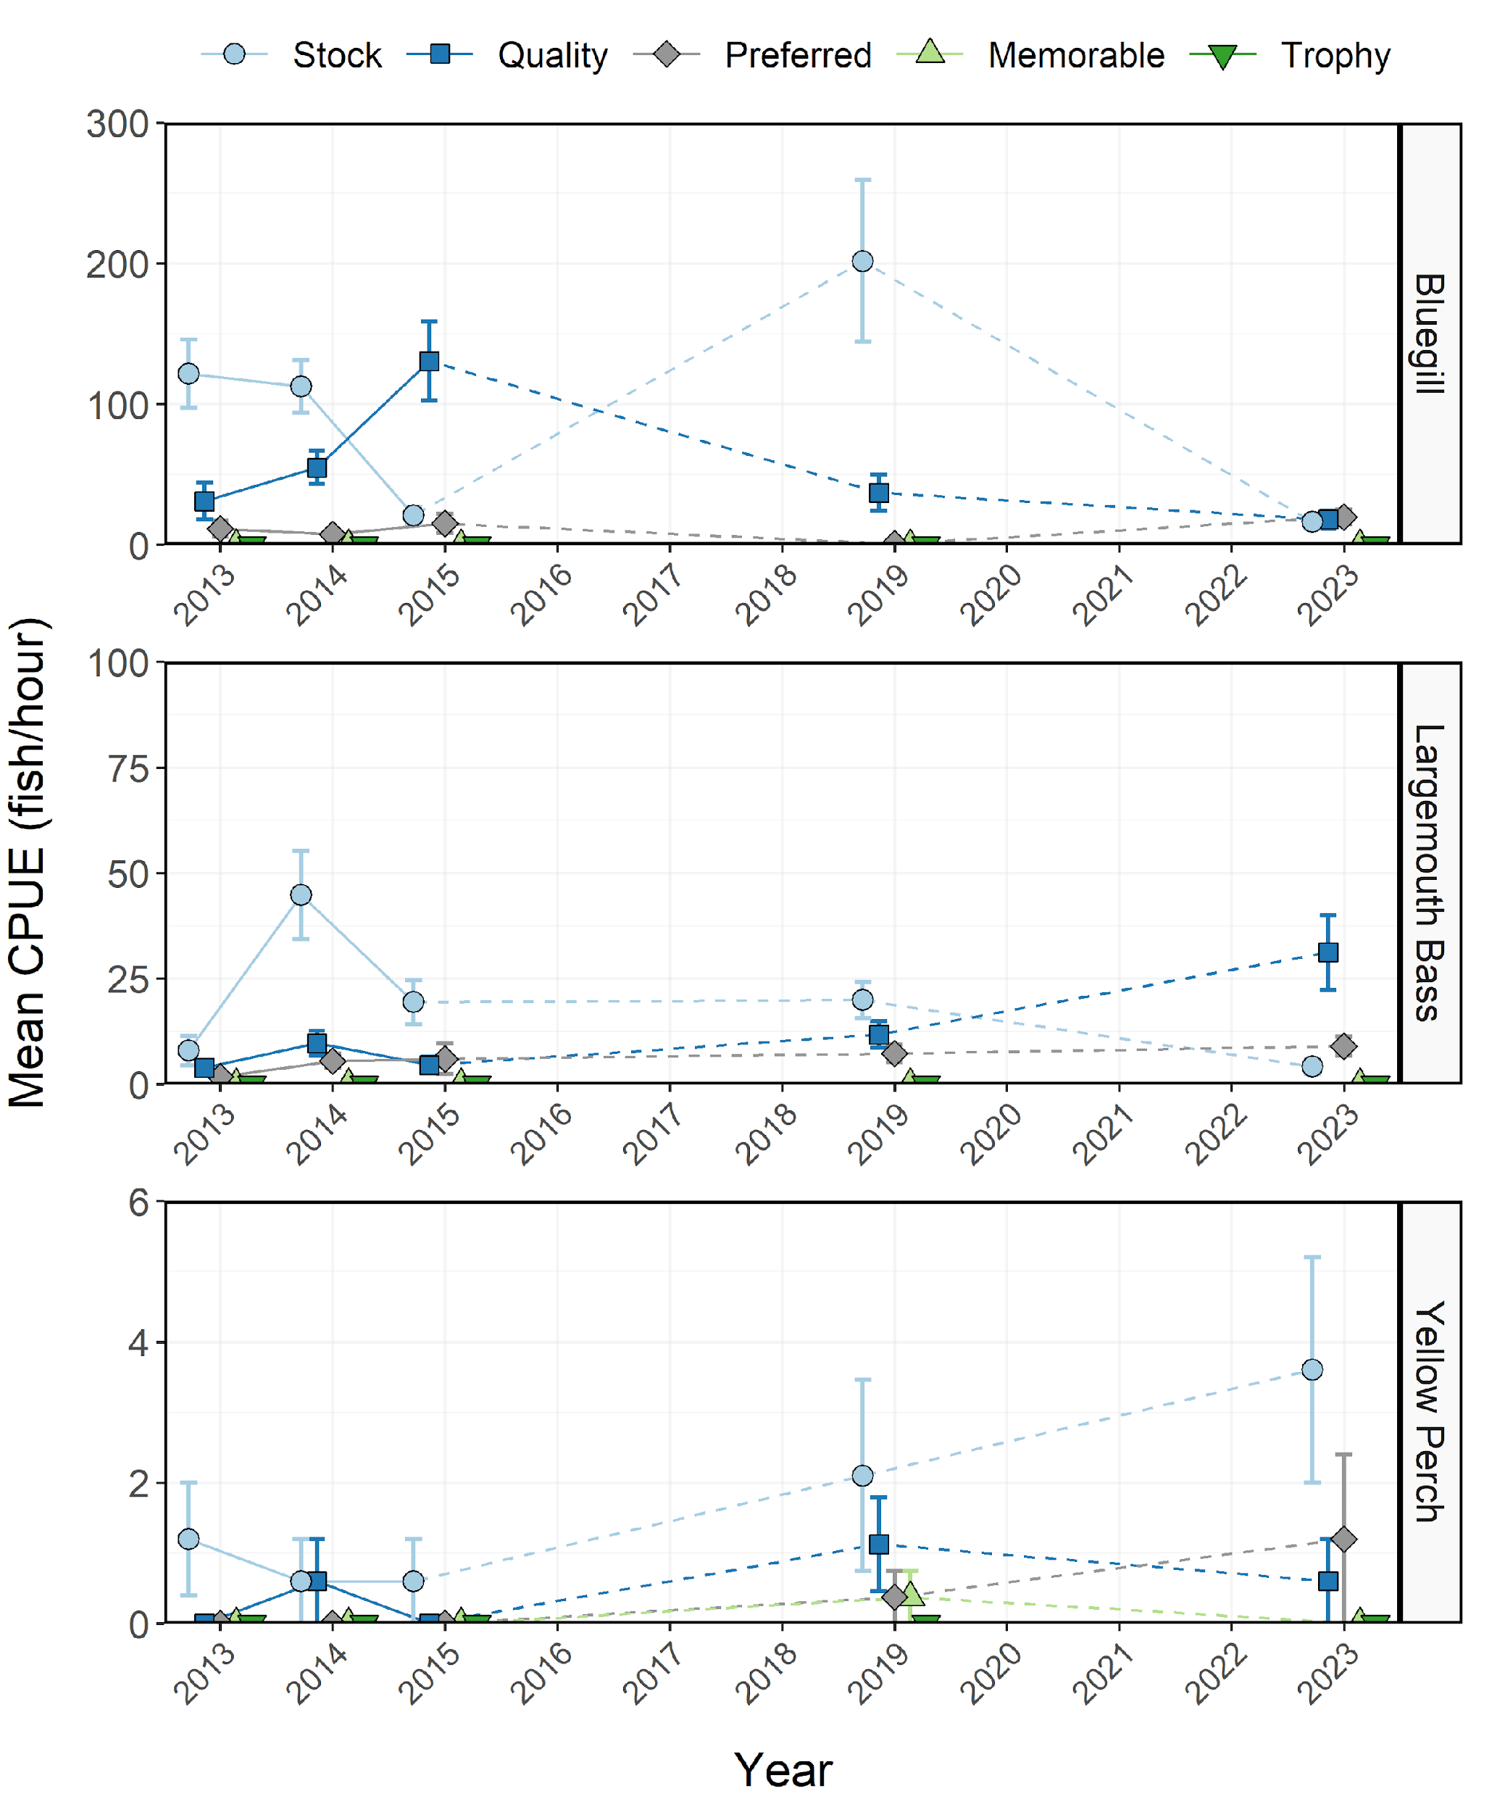

Figure 4: Mean relative abundance (fish/hour) of Bluegill, Largemouth Bass, and Yellow Perch within each Gablehouse length category from Mantua Reservoir in 1997-2023. Error bars indicate standard error.

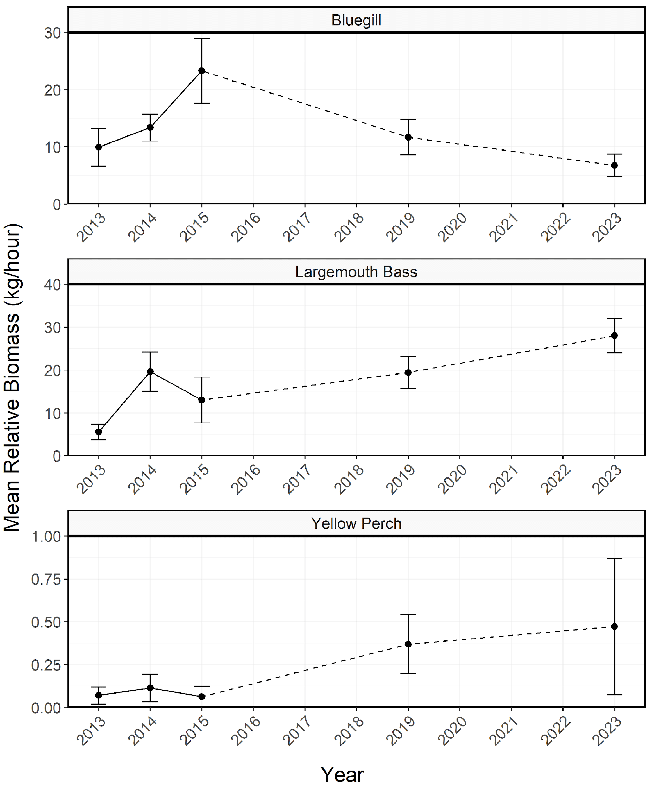

Figure 5: Mean relative biomass (kg/hour) of stock-length Bluegill, Largemouth Bass, and Yellow Perch from Mantua Reservoir in 1997-2023. Error bars indicate standard error.

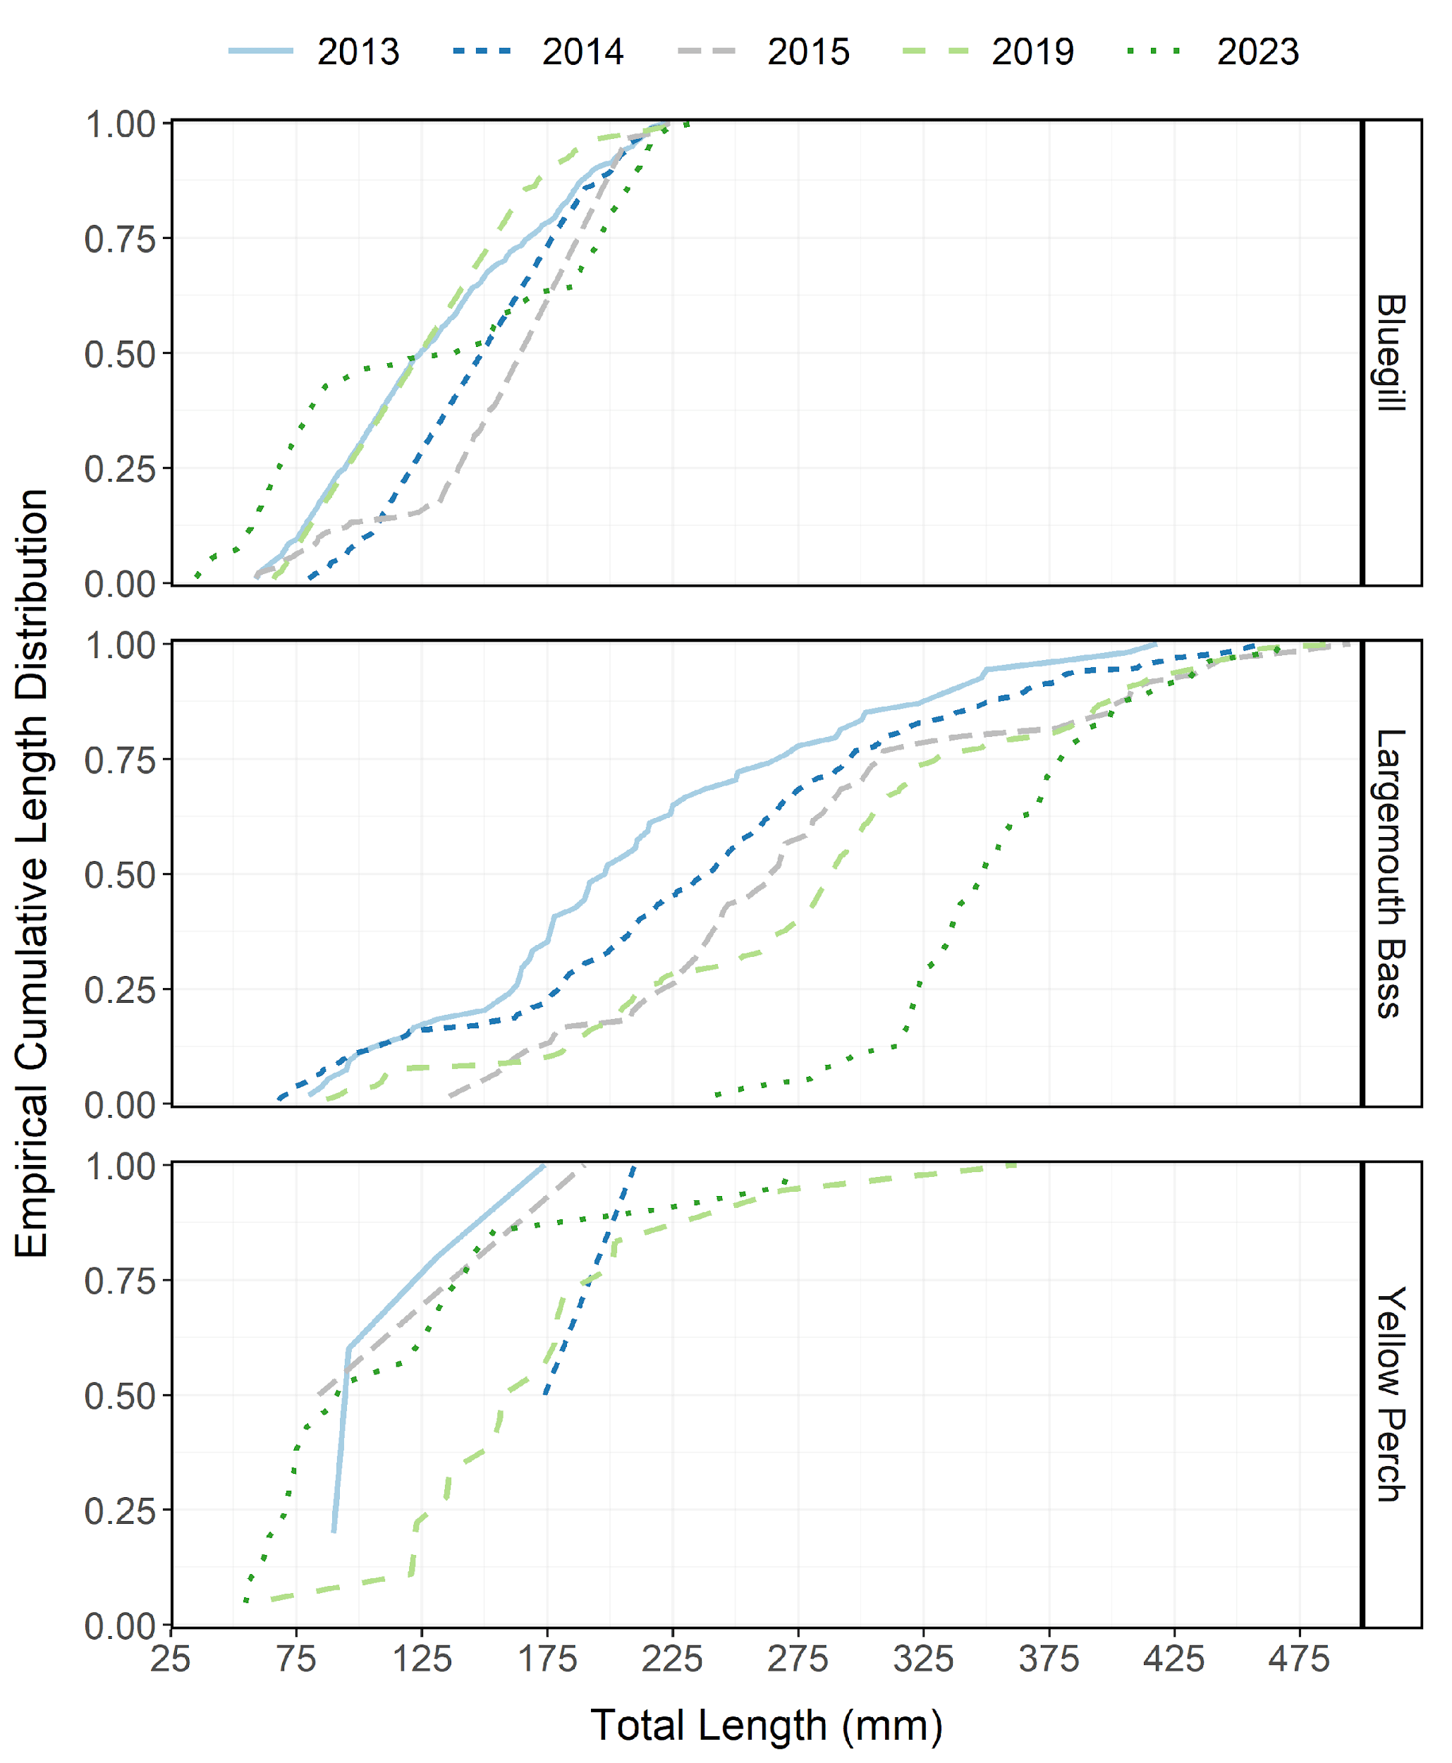

Figure 6: Empirical cumulative total length (mm) distribution of Bluegill, Largemouth Bass, and Yellow Perch from Mantua Reservoir in 1997-2023.

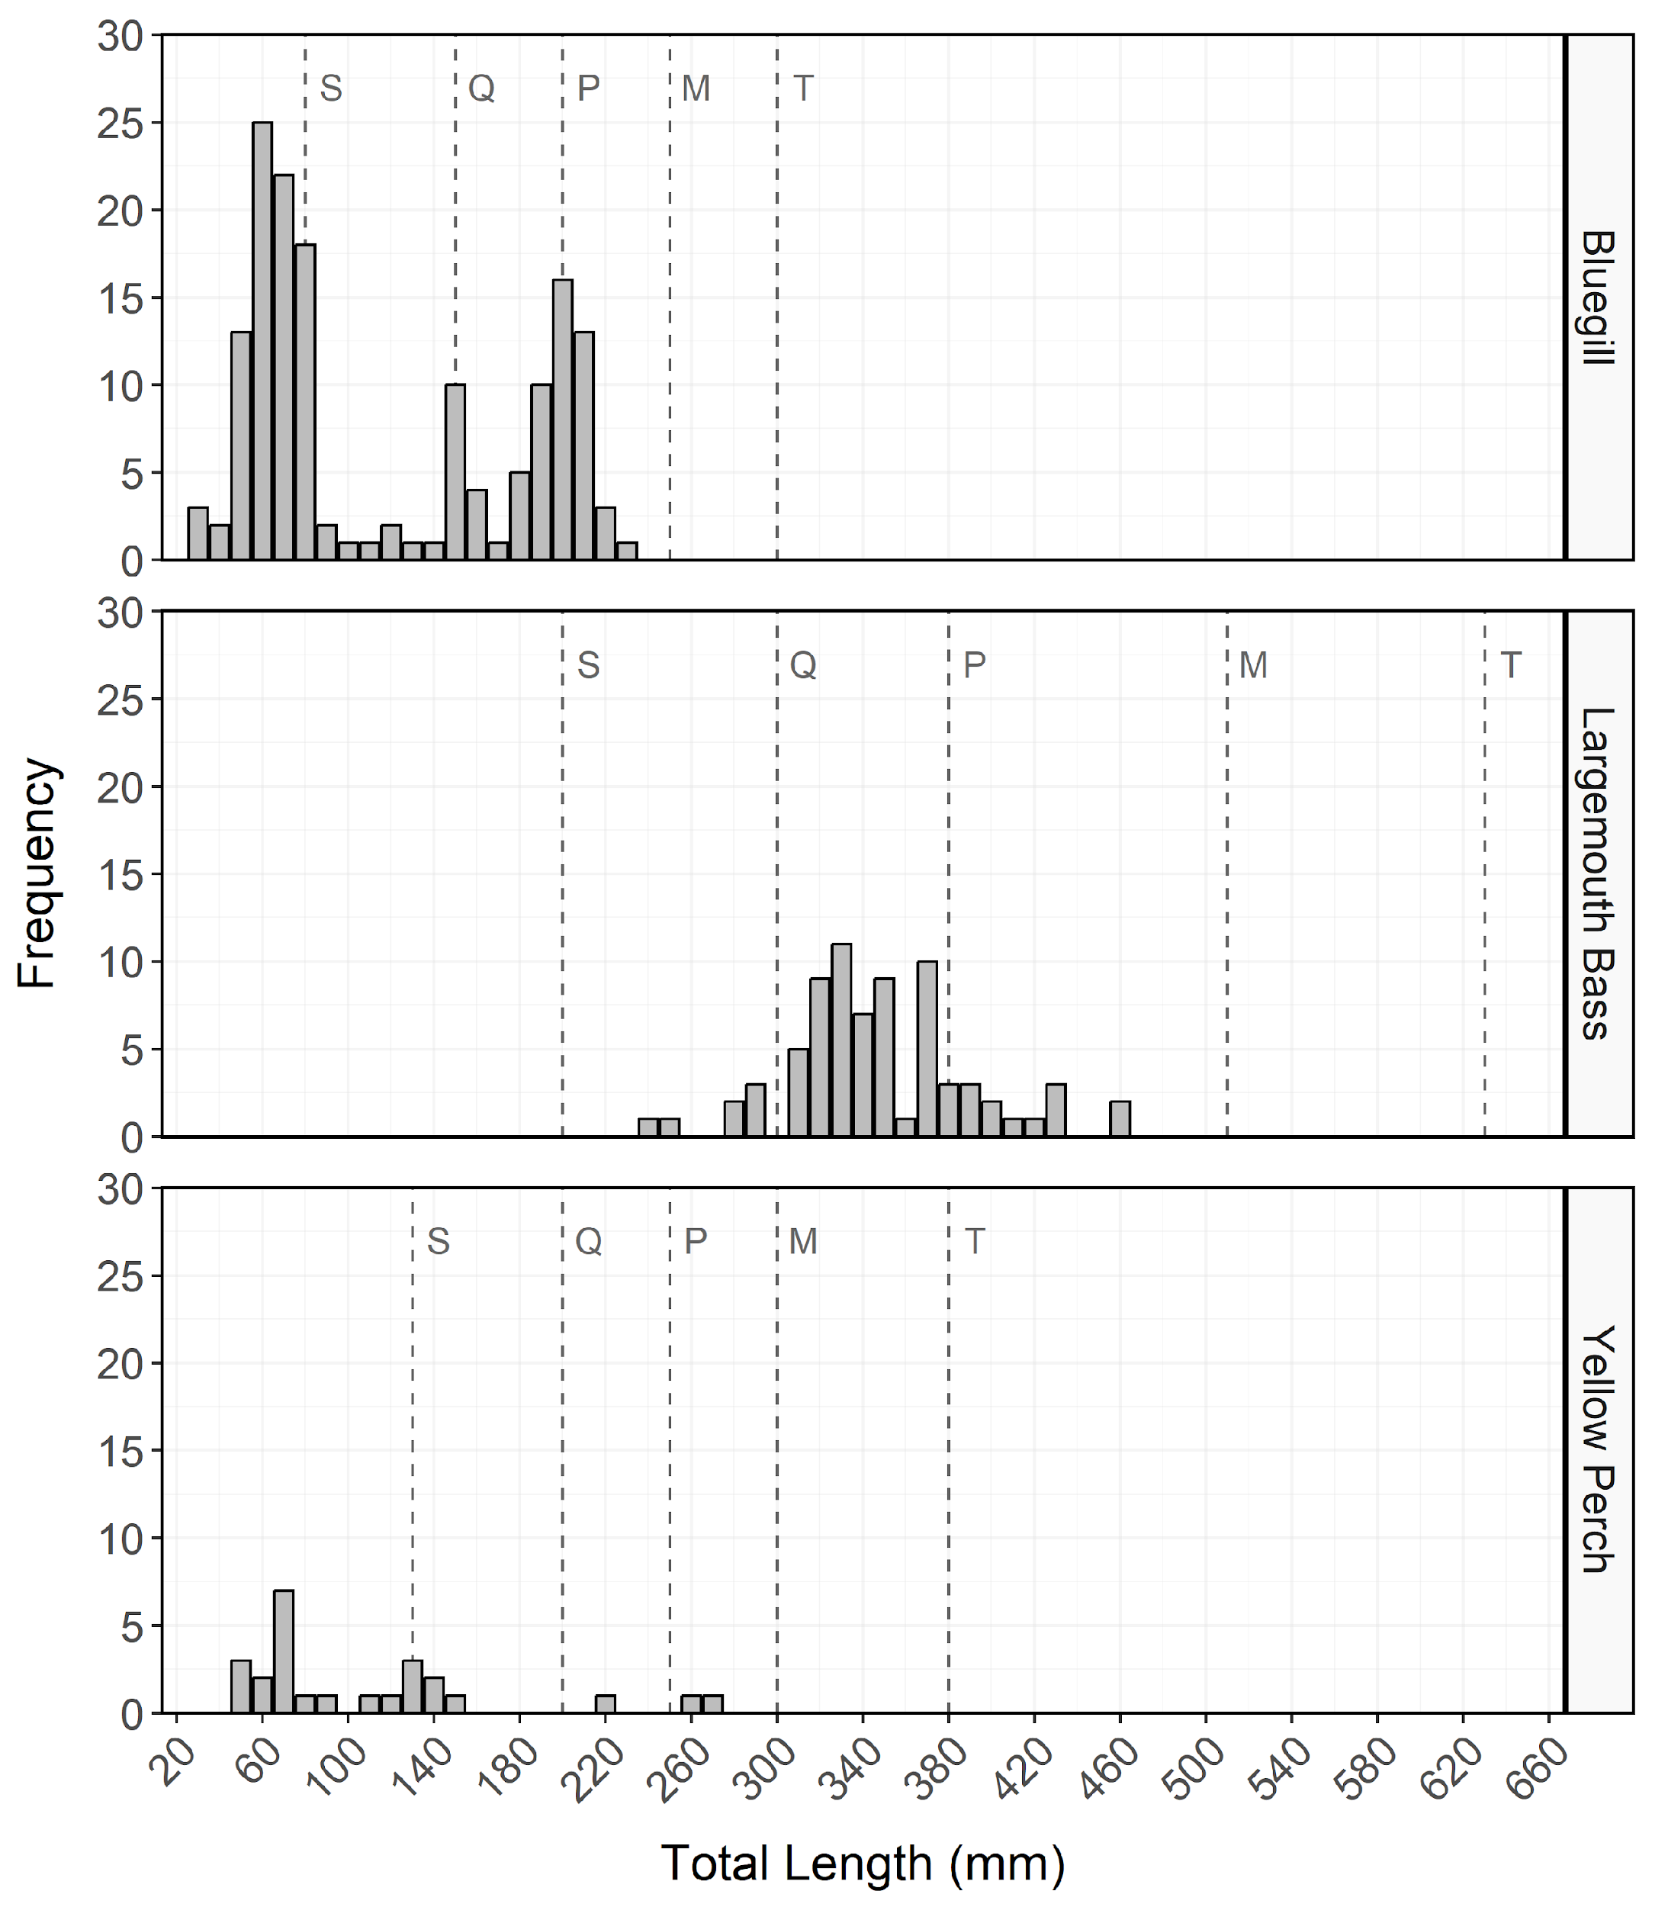

Figure 7: Total length (mm) frequency of Bluegill, Largemouth Bass, and Yellow Perch from Mantua Reservoir in 2023. The length intervals are left-inclusive and right-exclusive, and the x-axis labels represent the start of the length interval (i.e., left side). The start of each Gablehouse length category is identified by the vertical dashed lines and the category name (i.e., stock, quality, preferred, memorable, and trophy) is indicated by the first letter of each category on the right side of the dashed line.

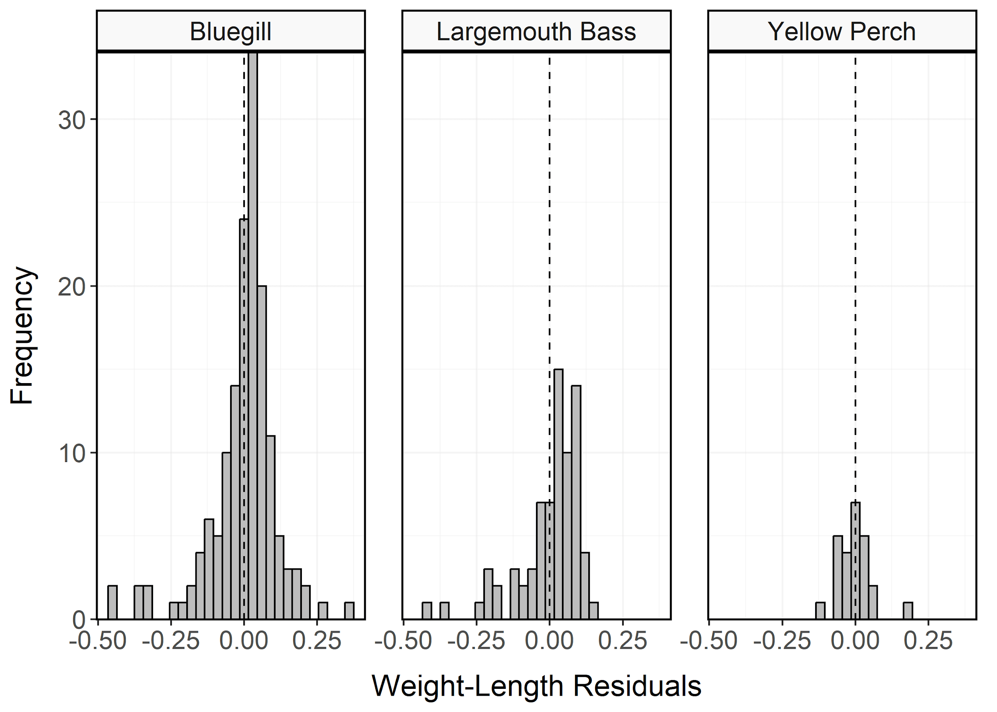

Figure 8: Histogram of residuals from the regression of log10 weight on log10 total length for Bluegill, Largemouth Bass, and Yellow Perch from Mantua Reservoir in 2023.

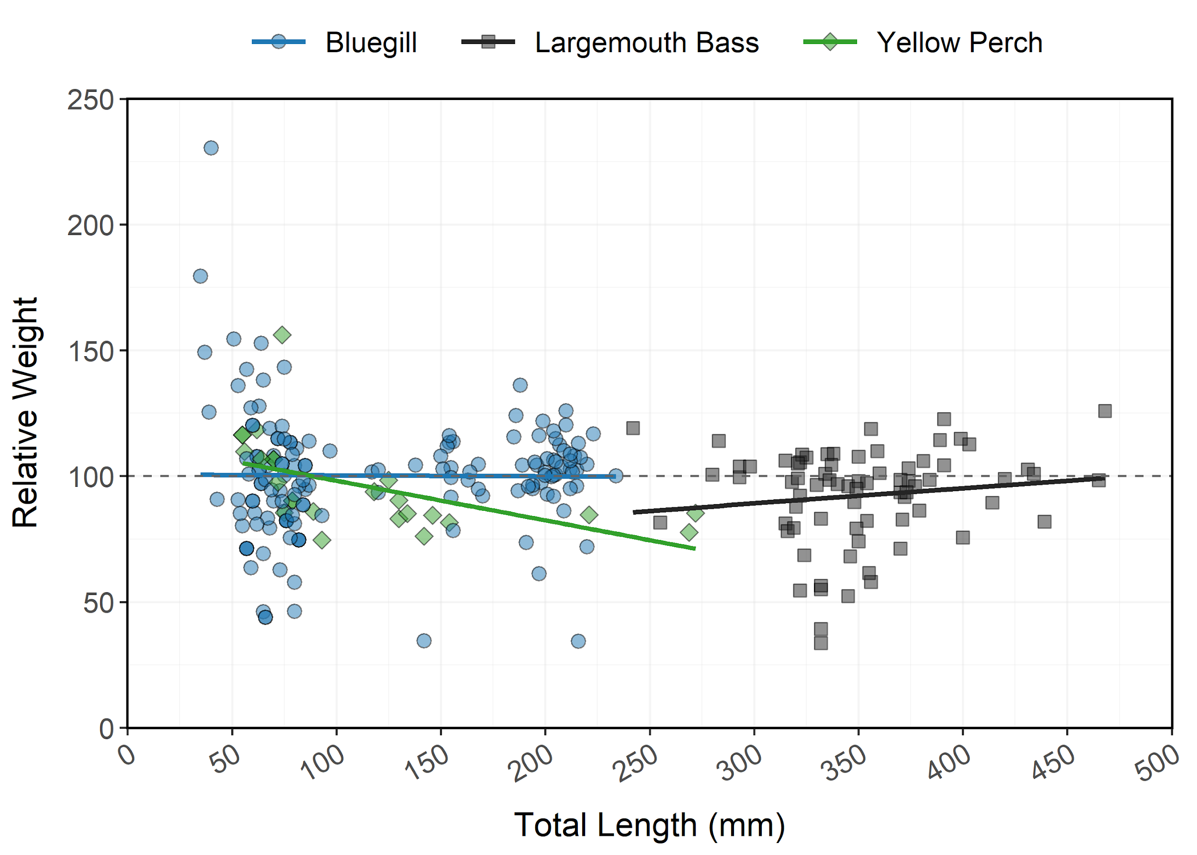

Figure 9: Relative weight (± standard error) of Bluegill, Largemouth Bass, and Yellow Perch from Mantua Reservoir in 2023 as an index of condition. The horizontal dashed line indicates a 1:1 relationship between standard weight and relative weight. Points and lines are jittered to minimize overplotting.

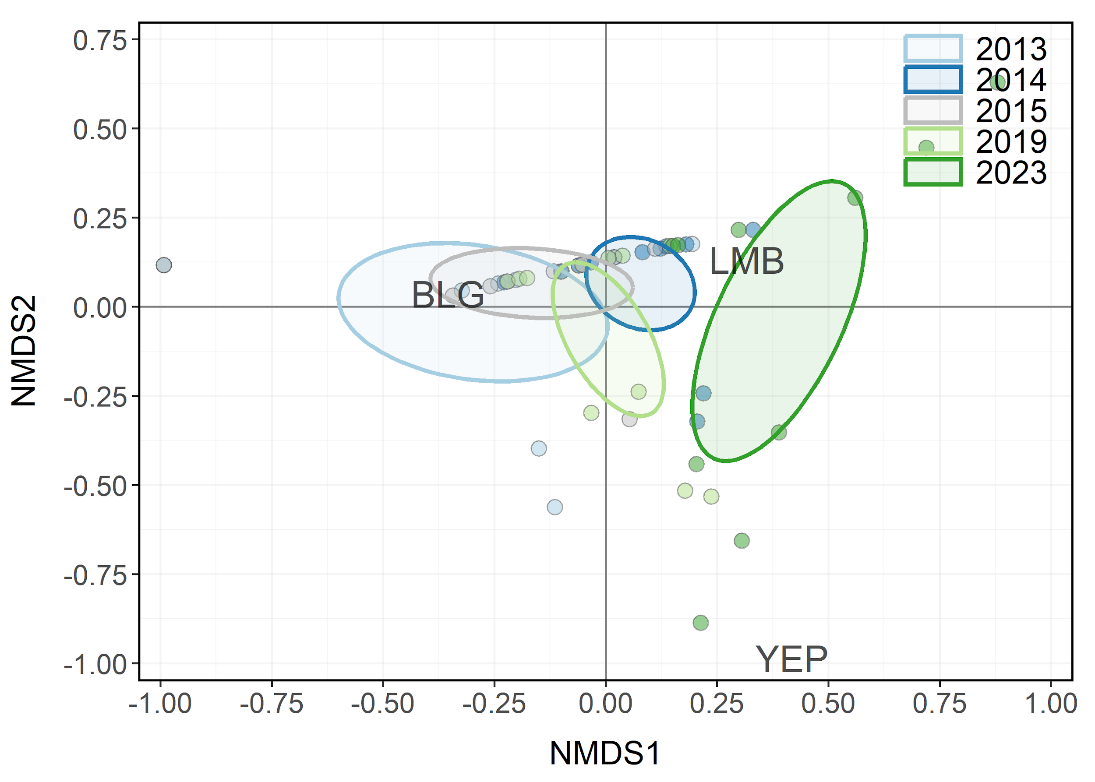

Figure 10: Non-metric multidimensional scaling (NMDS) bi-plot of stock-length Bluegill, Largemouth Bass, and Yellow Perch from Mantua Reservoir in 1997-2023. Points closer together have more similar relative abundances among species. Ellipses highlight the community structure within each year sampled.

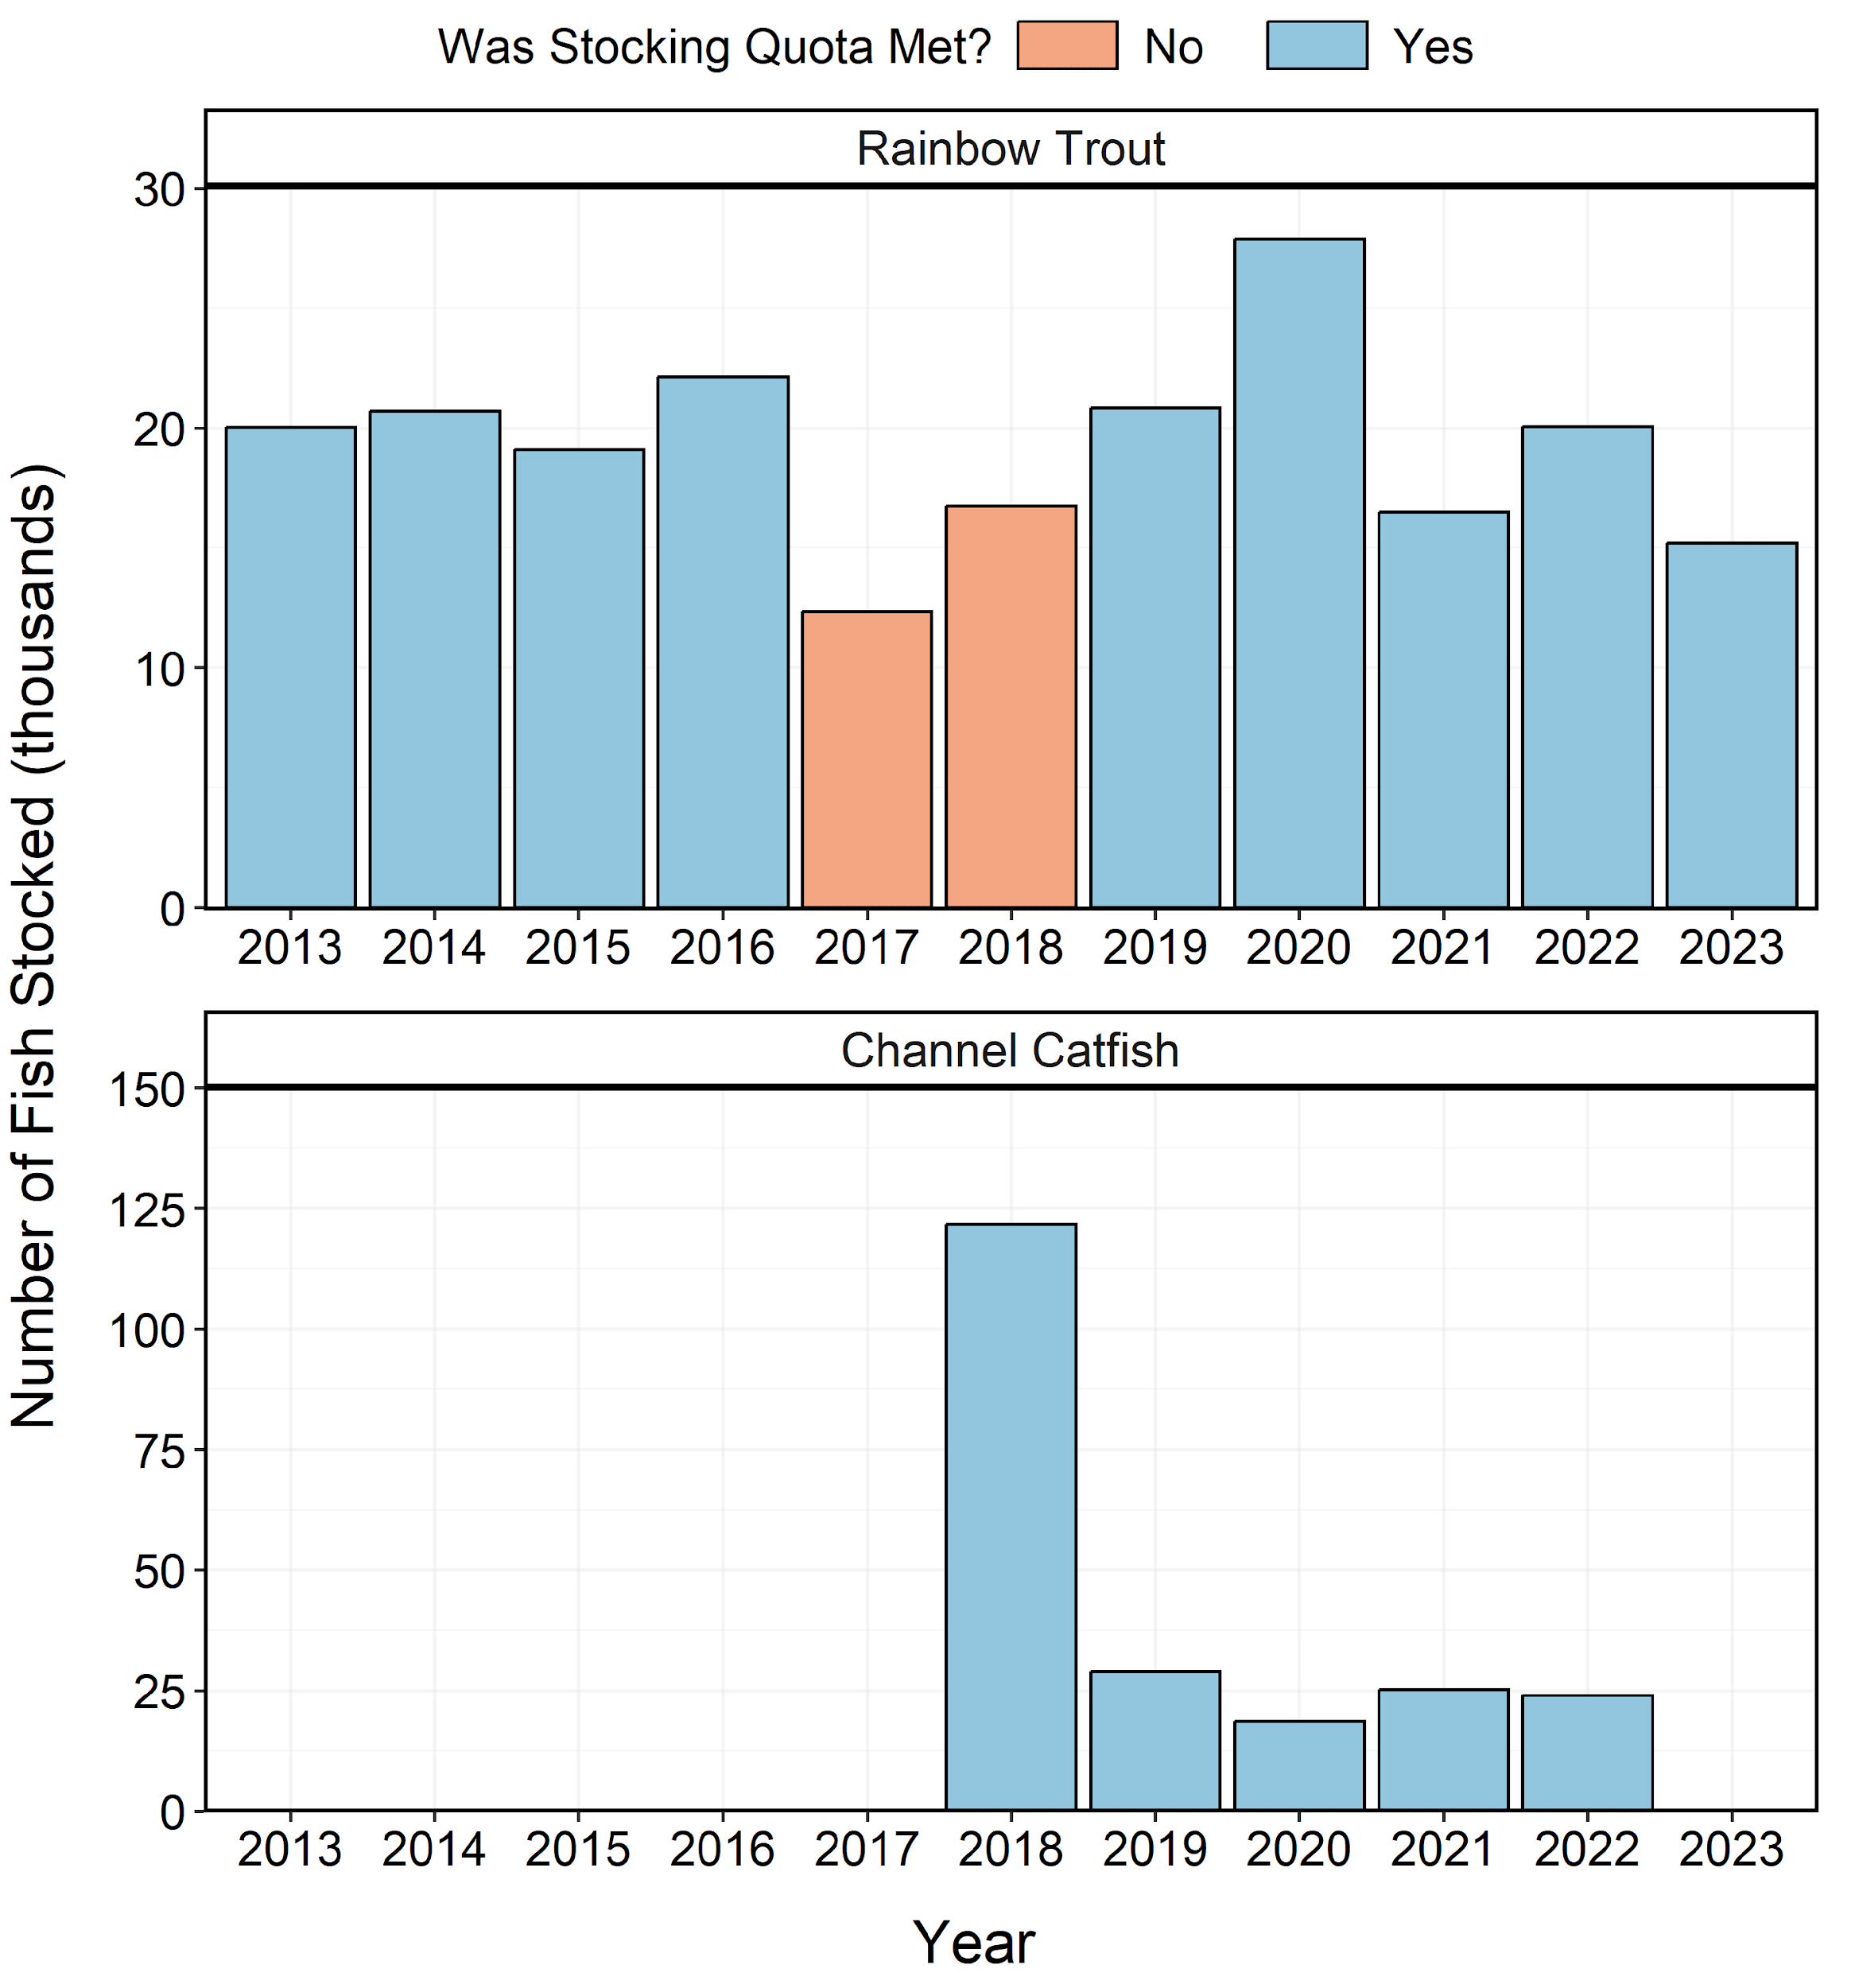

Figure 11: Number of individuals stocked in Mantua Reservoir from 2013-2023. Length-at-stocking and stocking quota varies among years. A stocking quota was determined to be met if the number of stocked individuals was at least 90% of the stocking quota.