Utah Division of Wildlife Resources Fishery Monitoring Report

**Author**: Taylor R. Stewart  
**Contact**: [taylorstewart@utah.gov](mailto:taylorstewart@utah.gov)

**System**: Lost Creek Reservoir  
**Sampling Dates**: 5/23/2023 - 5/25/2023  
**Target Species**: Cutthroat Trout, Kokanee Salmon, Rainbow Trout, Splake, Tiger Trout, and Utah Chub  
**Species Stocked**: Cutthroat Trout, Kokanee, Rainbow Trout, Splake, and Tiger Trout

**Monitoring Objectives**:

1. Provide data for assessment of trends in species occurrence, relative abundance, biomass, and size structure of forage and sport fish assemblages.
2. Evaluate population indices to improve the effectiveness of stocking efforts of Cutthroat Trout, Kokanee Salmon (hereafter Kokanee), Rainbow Trout, Splake, and Tiger Trout.
3. Establish a naturally reproducing population of Kokanee.
4. Use top-down control to regulate Utah Chub population size.

**Sampling Design and Methods**:  
*Curtain Nets*  
A new sampling design was implemented in 2022 to improve the effectiveness of sampling methods in reservoirs that contain Kokanee and in deep reservoirs where benthic gillnets do not effectively quantify species that occupy pelagic habitats. The sampling design used experimental gillnets with extended depths (*i.e.,* curtain gillnets) suspended in the water column, thus giving managers the ability to sample benthic and pelagic habitats simultaneously or sample stratified portions of the pelagic fish community. Sampling occurred in the spring. Three curtain gillnets were suspended in the pelagic zone at 6-m depth intervals ranging from 0 to 18-m depth and an additional gillnet was set nearshore with 6 m of water to sample the benthic and littoral habitats (Table 1). All gillnets were 45.7 m long by 6.1 m deep with six 7.6-m panels that had bar mesh sizes of 13, 19, 25, 38, 51, and 64 mm. Nets were set overnight and retrieved at dawn. This sampling design was replicated at two sampling sites in distinct regions of the reservoir (Figure 1).

Prior to 2022, experimental benthic gillnets were used to conduct sampling. Benthic gillnets were 24.8 m long by 1.8 m deep with eight 3.1-m panels that had bar mesh sizes of 19, 25, 32, 38, 44, 51, 57, and 64 mm. The change in gear types precludes our ability to analyze data prior to 2022 as the assumptions that catchability was constant between gear types was violated.

*Statistical Methods*  
All fish caught were identified to species and measured for total length (mm) and weight (g). Benthic gillnet and curtain gillnet data were combined to increase the sample size and statistical inference of size structure analyses. Relative abundance (*i.e.,* catch-per-unit-effort) and biomass were analyzed as the respective number or weight for each species per net-night. Size structure was presented as an empirical cumulative distribution function (ECDF) and a histogram. The ECDF, which is the proportion of fish that are less than each observed length, was used to analyze changes among years while the histogram was used to show the frequency of individuals in each length interval for a single year. Weight-length residuals and relative weight were used as condition metrics. Changes in the fish community composition were analyzed among years using non-metric multidimensional scaling.

**Summary**:  
*Species Composition*  
Fish catches were comprised of Cutthroat Trout, Brown Trout, Kokanee, Mountain Sucker, Rainbow Trout, Splake, Tiger Trout, and Utah Chub (Figure 2). Utah Chub (*i.e.,* primary forage species) were the most abundant species by number caught (77.3%) and weight (48.6%) and Rainbow Trout were the most abundant sport fish species by number caught (12.2%) and weight (23.4%; Figure 2).

*Abundance*  
Rainbow Trout mean relative abundance was 26.5 fish/net-night (SE = 7.0), had the highest relative abundance in the 0 to 6-m depth zone, and increased by 60.6% from sampling conducted in 2022 (Figures 3 & 4; Table 2). Cutthroat Trout mean relative abundance was 13.5 fish/net-night (SE = 6.5) and dominated the 0 to 6-m pelagic depth zone. Kokanee mean relative abundance was 9.7 fish/net-night (SE = 5.1) and decreased by 65.2% from sampling conducted in 2022. However, the mean relative abundances of quality- and memorable-length Kokanee increased (Figure 5). Splake and Tiger Trout mean relative abundances remain low (< 2.5 fish/net-night) and were only found in littoral and benthic habitats (Figures 3 & 4). Splake mean relative abundance increased by 340.0% from sampling conducted in 2022 and increased in the memorable- and trophy-length categories (Figure 5).

*Biomass*  
The mean relative biomass of Cutthroat Trout, Kokanee, Rainbow Trout, Tiger Trout remained stable (Figure 6). Splake and Utah Chub mean relative biomass increased 266.7 and 317.7%, respectively, from sampling conducted in 2022 (Figure 6; Table 2).

*Size Structure*  
The size structure of Kokanee suggests two adult age classes were present in 2023 (*i.e.,* stocked individuals from 2021 and 2022; Figures 7 & 8). Kokanee stocked in 2020 appear absent from the population suggesting survival to age-3, and subsequently survival to maturity, is low. Tiger Trout of quality- and preferred-lengths were absent from the survey data. The size structure of Utah Chub showed three age-classes present were present in 2023, two additional age-classes not present in the 2022 sampling data. The changes in Utah Chub size structure suggests that recent drought years and high water temperatures likely increased their reproductive potential and ability to recruit to the population (Figures 7 & 8). Shifts in length distributions between 2022 and 2023 were statistically different, based on a bootstrapped Kolmogorov-Smirnov test, for Kokanee (*P* < 0.001), Rainbow Trout (*P* < 0.001), Tiger Trout (*P* < 0.001), and Utah Chub (*P* < 0.001; Figure 7).

*Condition*  
Relative weights of all target species were low and remained low as fish length increased (Figure 10).

*Community Structure*  
The fish community has shifted from a fishery dominated by Kokanee, Cutthroat Trout, and Rainbow Trout in 2022 to a more diverse fish community with the relative importance of Kokanee decreasing and Splake, Tiger Trout, and Utah Chub increasing in 2023 (Figure 11). Additional years of sampling will greatly improve inferences regarding shifts in the fish community.

*Stocking*  
Stocking quotas are largely being met and maintained (Figure 12). Reestablishing Kokanee stocking will be imperative to support recent efforts to establish this fishery and not squander three years of stocking. While it is encouraging to see Kokanee spawning, the efficacy of the spawn and ability for larvae and juveniles to survive is unknown. Kokanee stocking will be required for the foreseeable future.

All other measurements and indices appear within normal bounds.

**Management Actions**:

1. Continue to perform sampling with curtain gillnets. After an additional year of data collection in 2025, a power analysis will be conducted to determine the effectiveness of the new sampling design. Sampling effort may need to increase to provide accurate and reliable population estimates.
2. Monitor fish assemblages as Lost Creek State Park continues to be developed and presumably fishing pressure on the reservoir increases. Stocking rates may need to be increased in future years.
3. Evaluate the stocking program of Kokanee. Three years of stocking Kokanee were performed in an attempt to establish a naturally-reproducing population. No stocking was performed in 2023 because of a low number of broodstock spawning, limiting the number of offspring available to be stocked throughout the state. The inlet river was monitored in 2023 to see if adult Kokanee were running up the river to spawn. Low numbers of Kokanee (<200 fish) were observed 1-km up the river. Total length and opercles were collected from spent adults to identify the age-class(es) spawning. Additional years of monitoring are required to determine if the current stocking program is effective, a naturally-reproducing population has established, and the amount of fishing mortality being induced on this population. Current recommendation is to increase Kokanee stocking density from 12,500 to 22,500 in 2024.
4. Observe Utah Chub populations to ensure salmonids in Lost Creek Reservoir are at a high enough density to apply sufficient top-down control over this forage species. Utah Chub and salmonid species can negatively interact when forage densities are high and compete for limited food resources. A proactive increase in Splake and Tiger Trout was done during the summer of 2023 as a high abundance of substock-length Utah Chubs were observed. An alternative strategy could be to substitute these stocked species with low densities of a species that has better spatial and thermal overlap with Utah Chubs (*e.g.,* Wiper). However, additional years of survey data are needed under the new sampling design to support this proposed change.
5. Conduct an age and growth study of both salmonids and Utah Chubs in the reservoir to characterize rates of growth and mortality of all species, and recruitment of Utah Chubs. This information would allow managers to determine how rates of Utah Chub growth and mortality respond to an increasing number of large piscivorous fishes in the reservoir. The next opportunity of this data to be collected will be in 2025.

**Tables:**

Table 1: Number of samples collected by sampling gear type, prescribed number samples by sampling gear type, mean water temperature (°C), and any additional data collected from Lost Creek Reservoir in 2023.

| Gear Type | # of Samples | # of Prescribed Samples | Water Temperature | Additional Comments |
| --- | --- | --- | --- | --- |
| Curtain Gillnets | 8 | 8 | 14.8 | An overnight storm caused a 0-6m benthic net to collapse. |

Table 2: Mean total length (TL; mm), mean weight (WT; g), mean relative weight (Wr), and percentage of individuals within each traditional proportional size distribution (PSD) category for each target species from Lost Creek Reservoir in 2023. All values in parentheses indicate standard deviation.

| Target Species | Mean TL | Mean WT | Mean Wr | PSD-  Quality | PSD-  Preferred | PSD-  Memorable | PSD-  Trophy |
| --- | --- | --- | --- | --- | --- | --- | --- |
| Kokanee | 230.7  (56.4) | 131.9  (104.5) | 85.9  (6.4) | 78 | 43 | 0 | 0 |
| Rainbow Trout | 316.4  (51.5) | 352.5  (258.7) | 80.2  (12.6) | 7 | 1 | 0 | 0 |
| Splake | 387.8  (103.8) | 579.5  (490.4) | 84.6  (15.8) | 100 | 55 | 45 | 9 |
| Tiger Trout | 300.2  (64.0) | 260.1  (136.7) | 95.0  (5.2) | 0 | 0 | 0 | 0 |
| Utah Chub | 195.0  (43.2) | 375.5  (2010.0) | 94.1  (16.3) | 39 | 8 | 2 | 1 |

**Figures:**

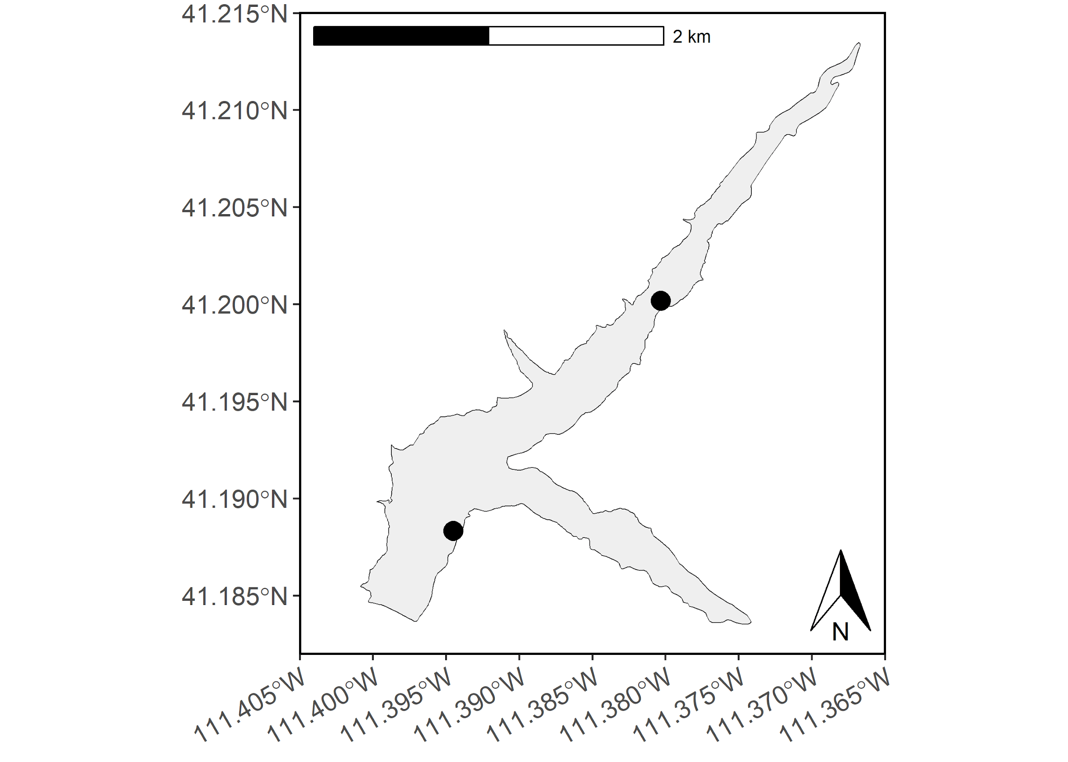

Figure 1: Map of Lost Creek Reservoir with curtain net sampling sites denoted as black circles.

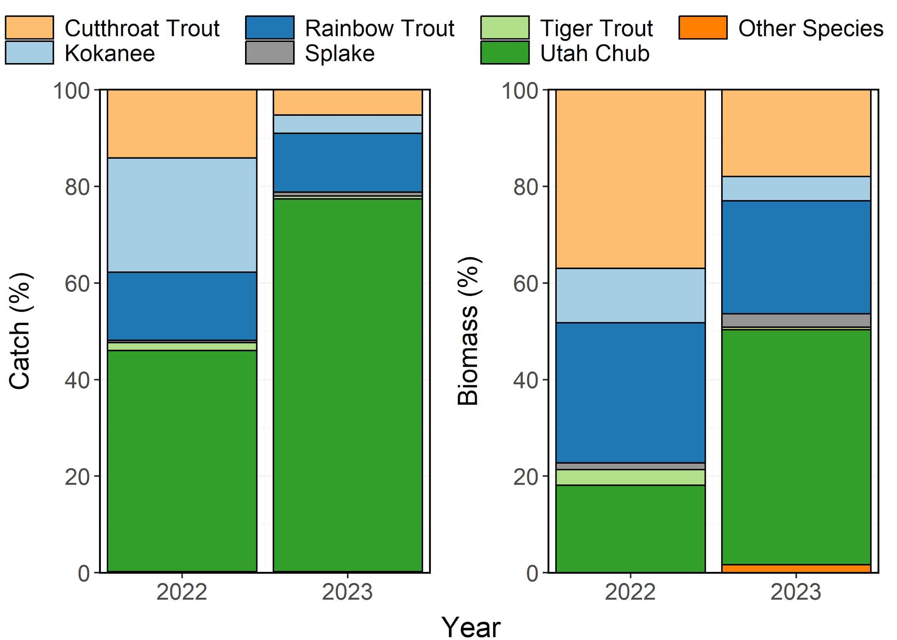

Figure 2: Species composition (%) by catch (# of fish) and biomass (kg) of Cutthroat Trout, Kokanee Salmon, Rainbow Trout, Splake, Tiger Trout, and Utah Chub from Lost Creek Reservoir in 2022-2023. Other species include Brown Trout and Mountain Sucker aggregated together.

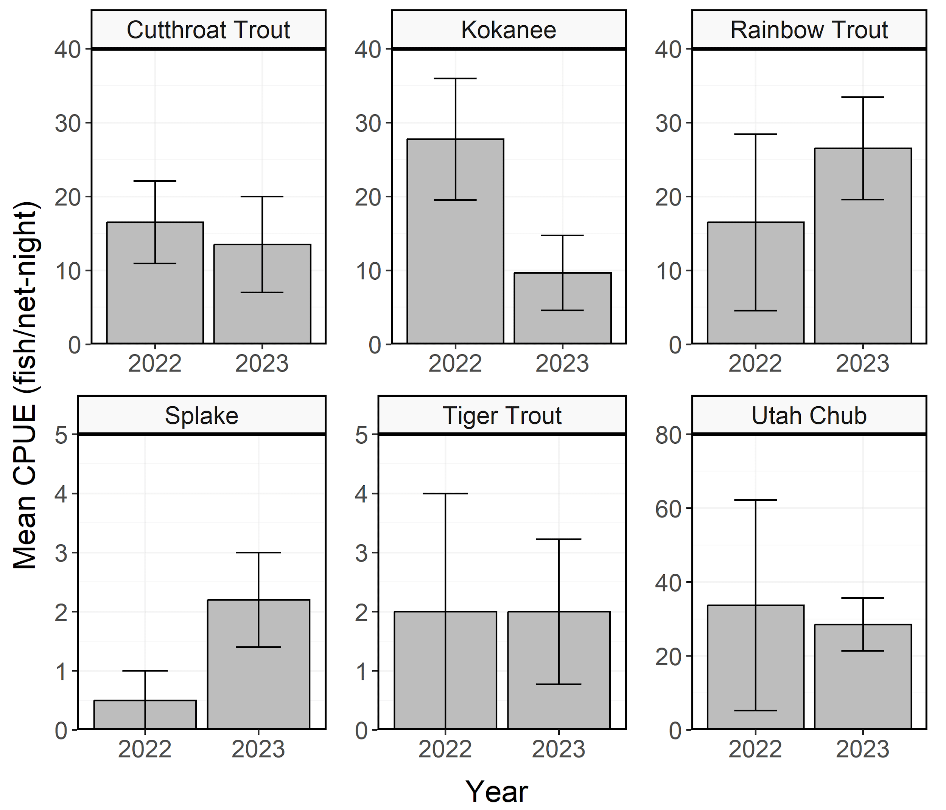

Figure 3: Mean relative abundance (CPUE; fish/net-night) of stock-length Cutthroat Trout, Kokanee Salmon, Rainbow Trout, Splake, Tiger Trout, and Utah Chub from Lost Creek Reservoir in 2022-2023. Error bars indicate standard error.

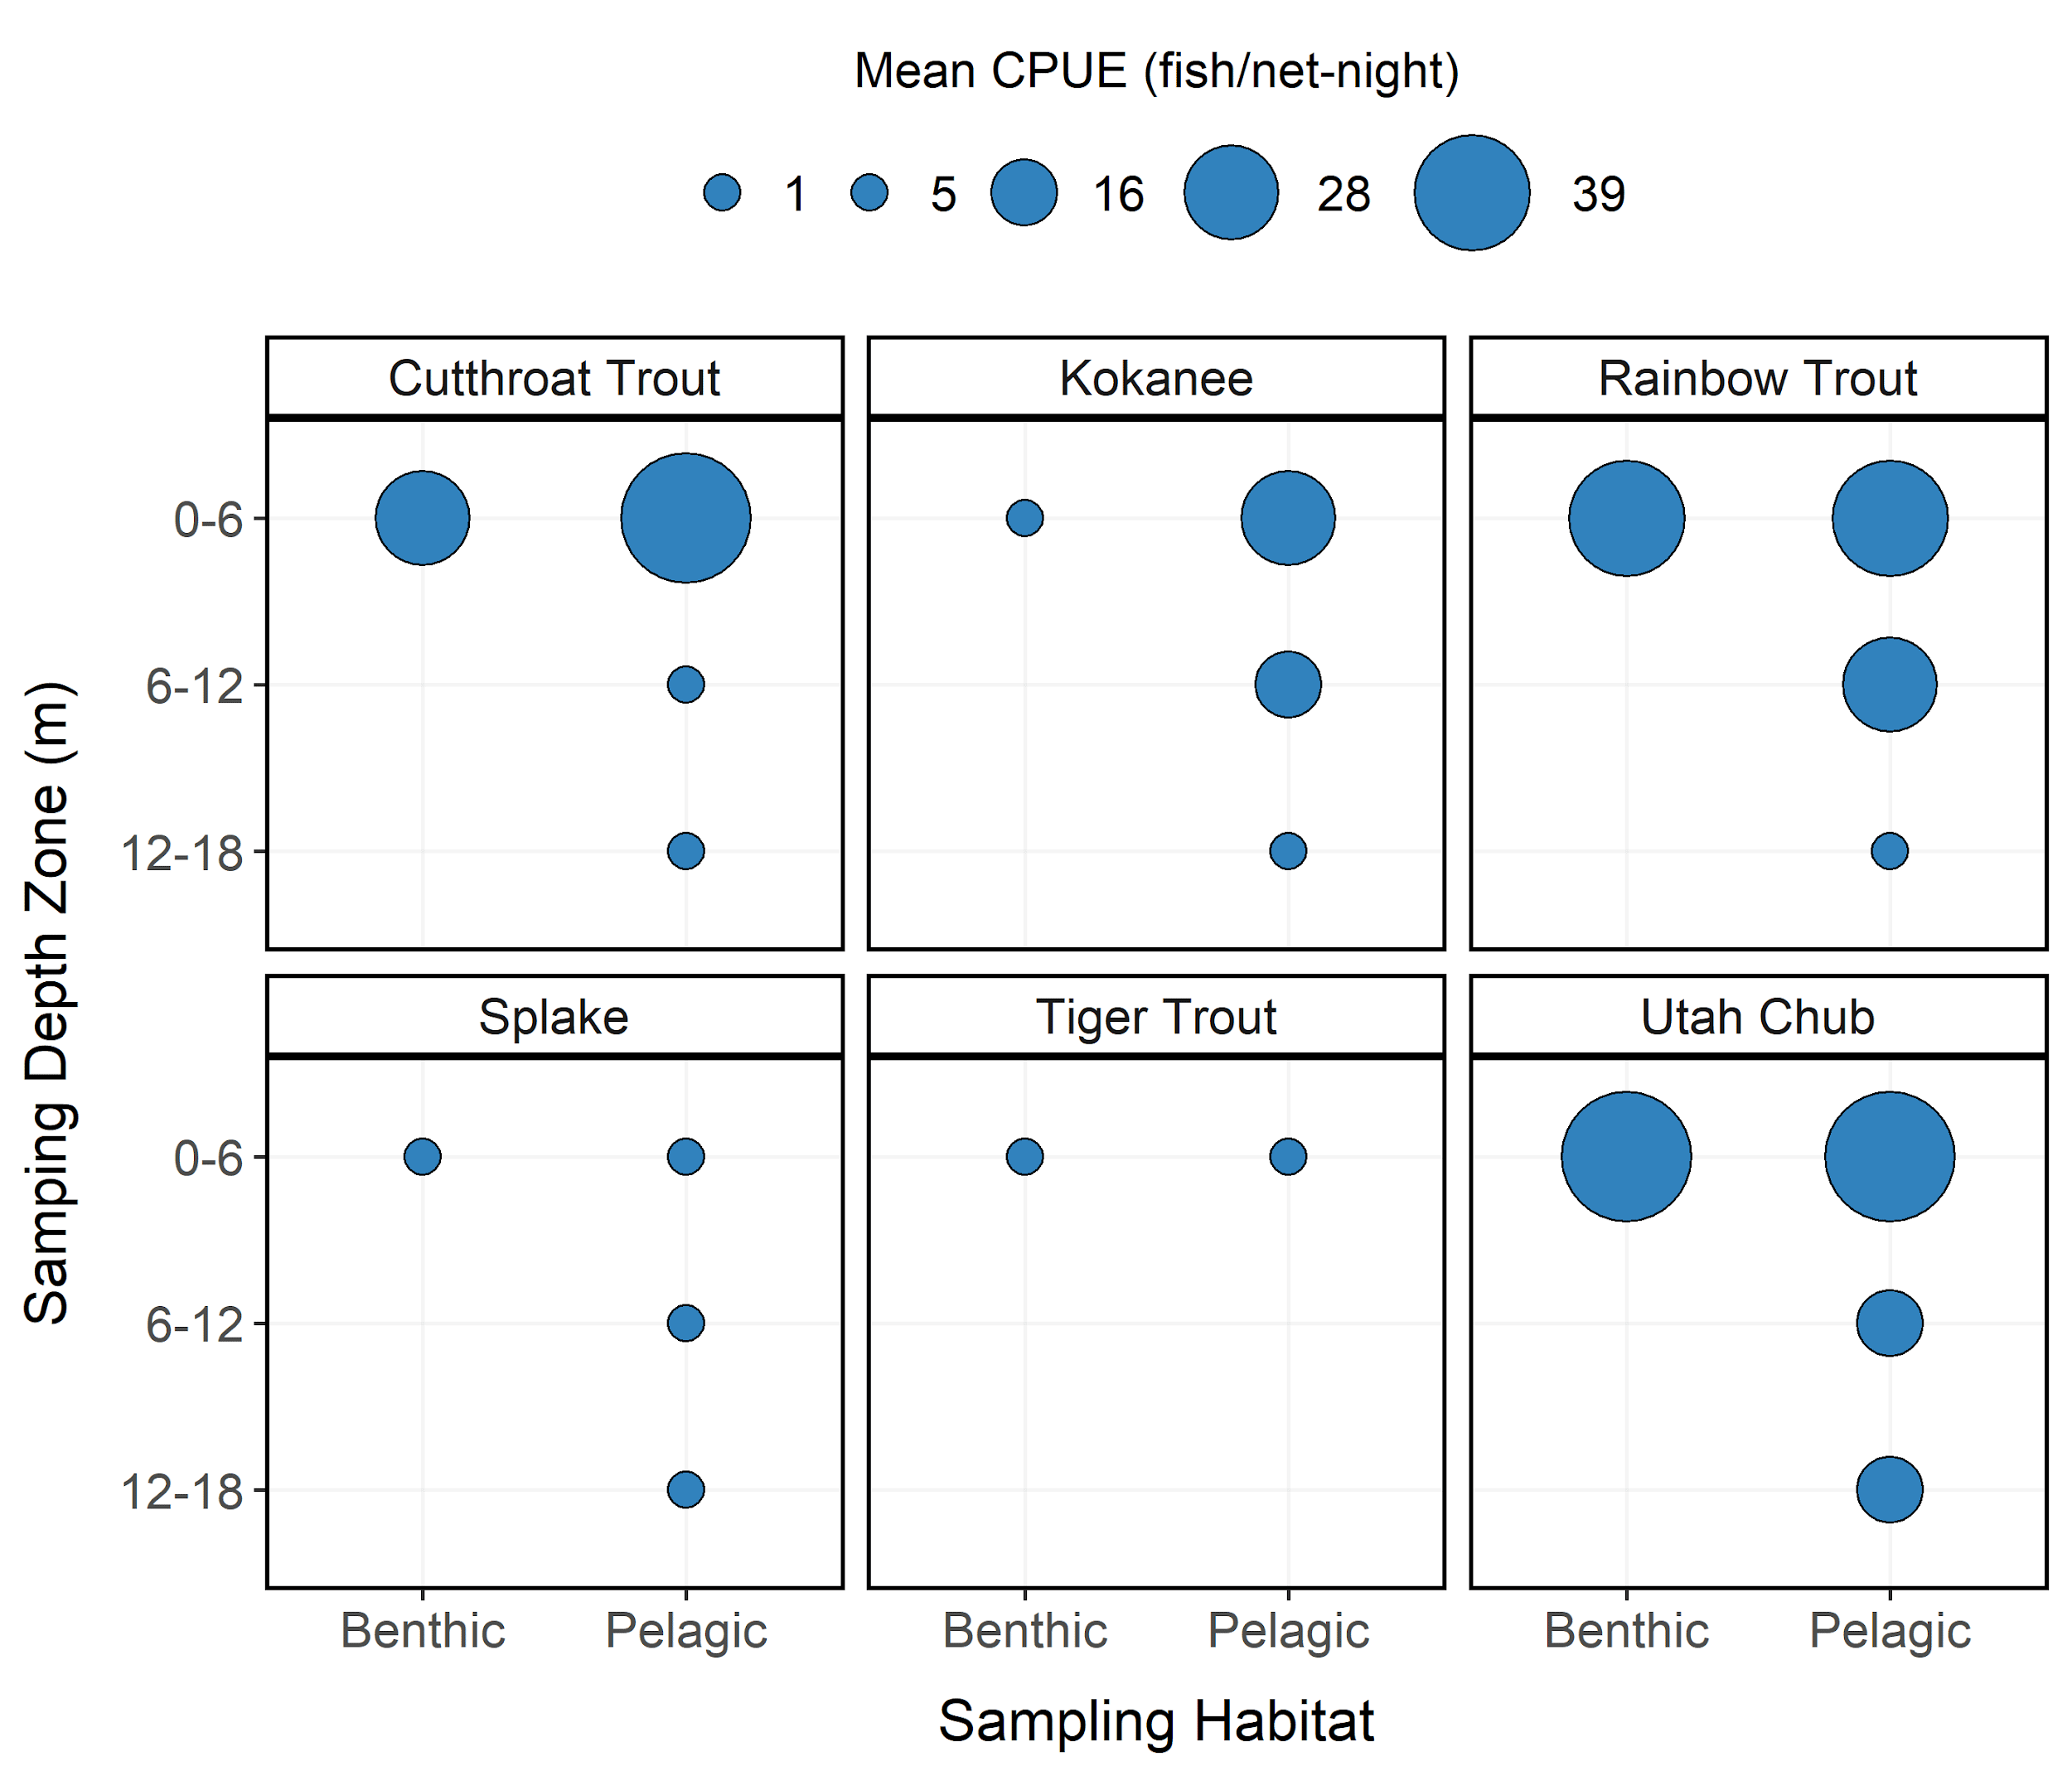

Figure 4: Mean relative abundance (CPUE; fish/net-night) of Cutthroat Trout, Kokanee Salmon, Rainbow Trout, Splake, Tiger Trout, and Utah Chub at each sampling depth and habitat zones from Lost Creek Reservoir in 2023. CPUE is depicted with varying point size and the diameter of the point is directly proportional to CPUE. No sampling was conducted in the 6-12 and 12-18 m depth zones for benthic habitat.

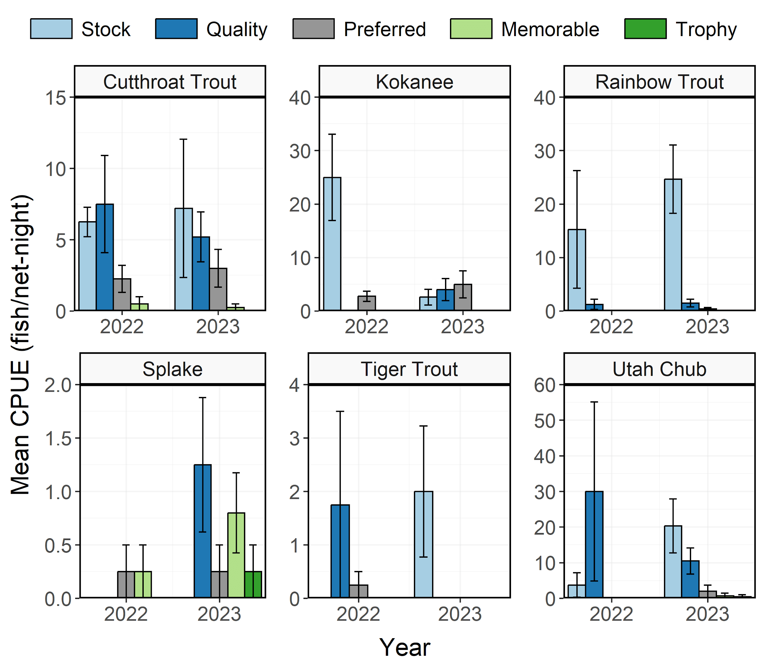

Figure 5: Mean relative abundance (CPUE; fish/net-night) of Cutthroat Trout, Kokanee Salmon, Rainbow Trout, Splake, Tiger Trout, and Utah Chub within each Gablehouse length category from Lost Creek Reservoir in 2022-2023. Error bars indicate standard error.

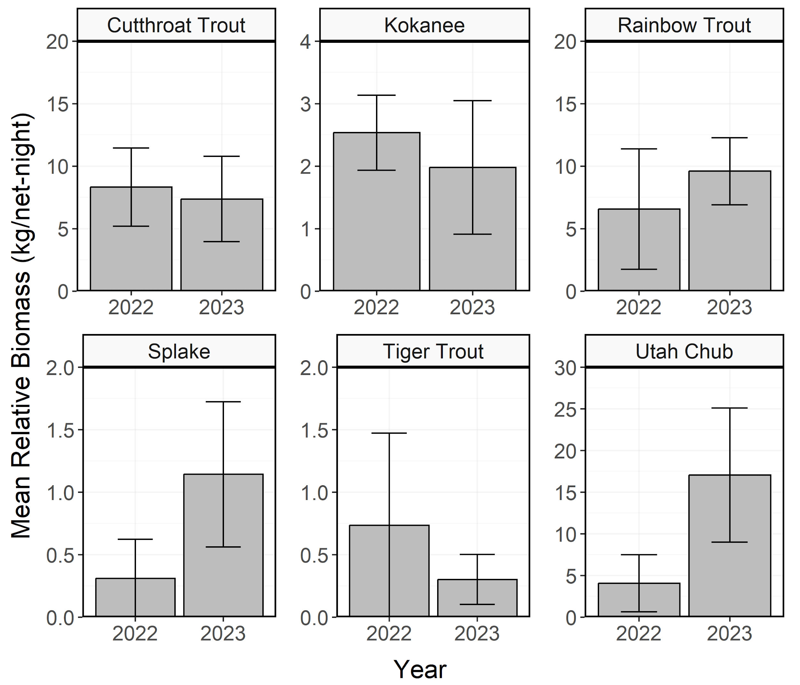

Figure 6: Mean relative biomass (kg/net-night) of stock-length Cutthroat Trout, Kokanee Salmon, Rainbow Trout, Splake, Tiger Trout, and Utah Chub from Lost Creek Reservoir in 2022-2023. Error bars indicate standard error.

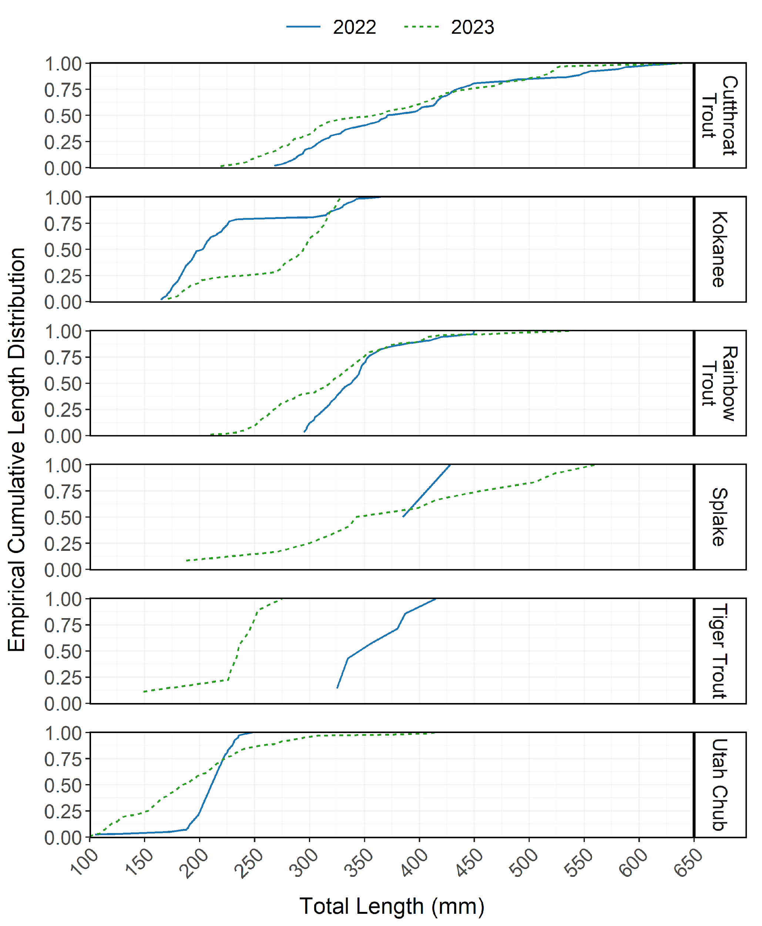

Figure 7: Empirical cumulative total length (mm) distribution of Cutthroat Trout, Kokanee Salmon, Rainbow Trout, Splake, Tiger Trout, and Utah Chub from Lost Creek Reservoir in 2022-2023.

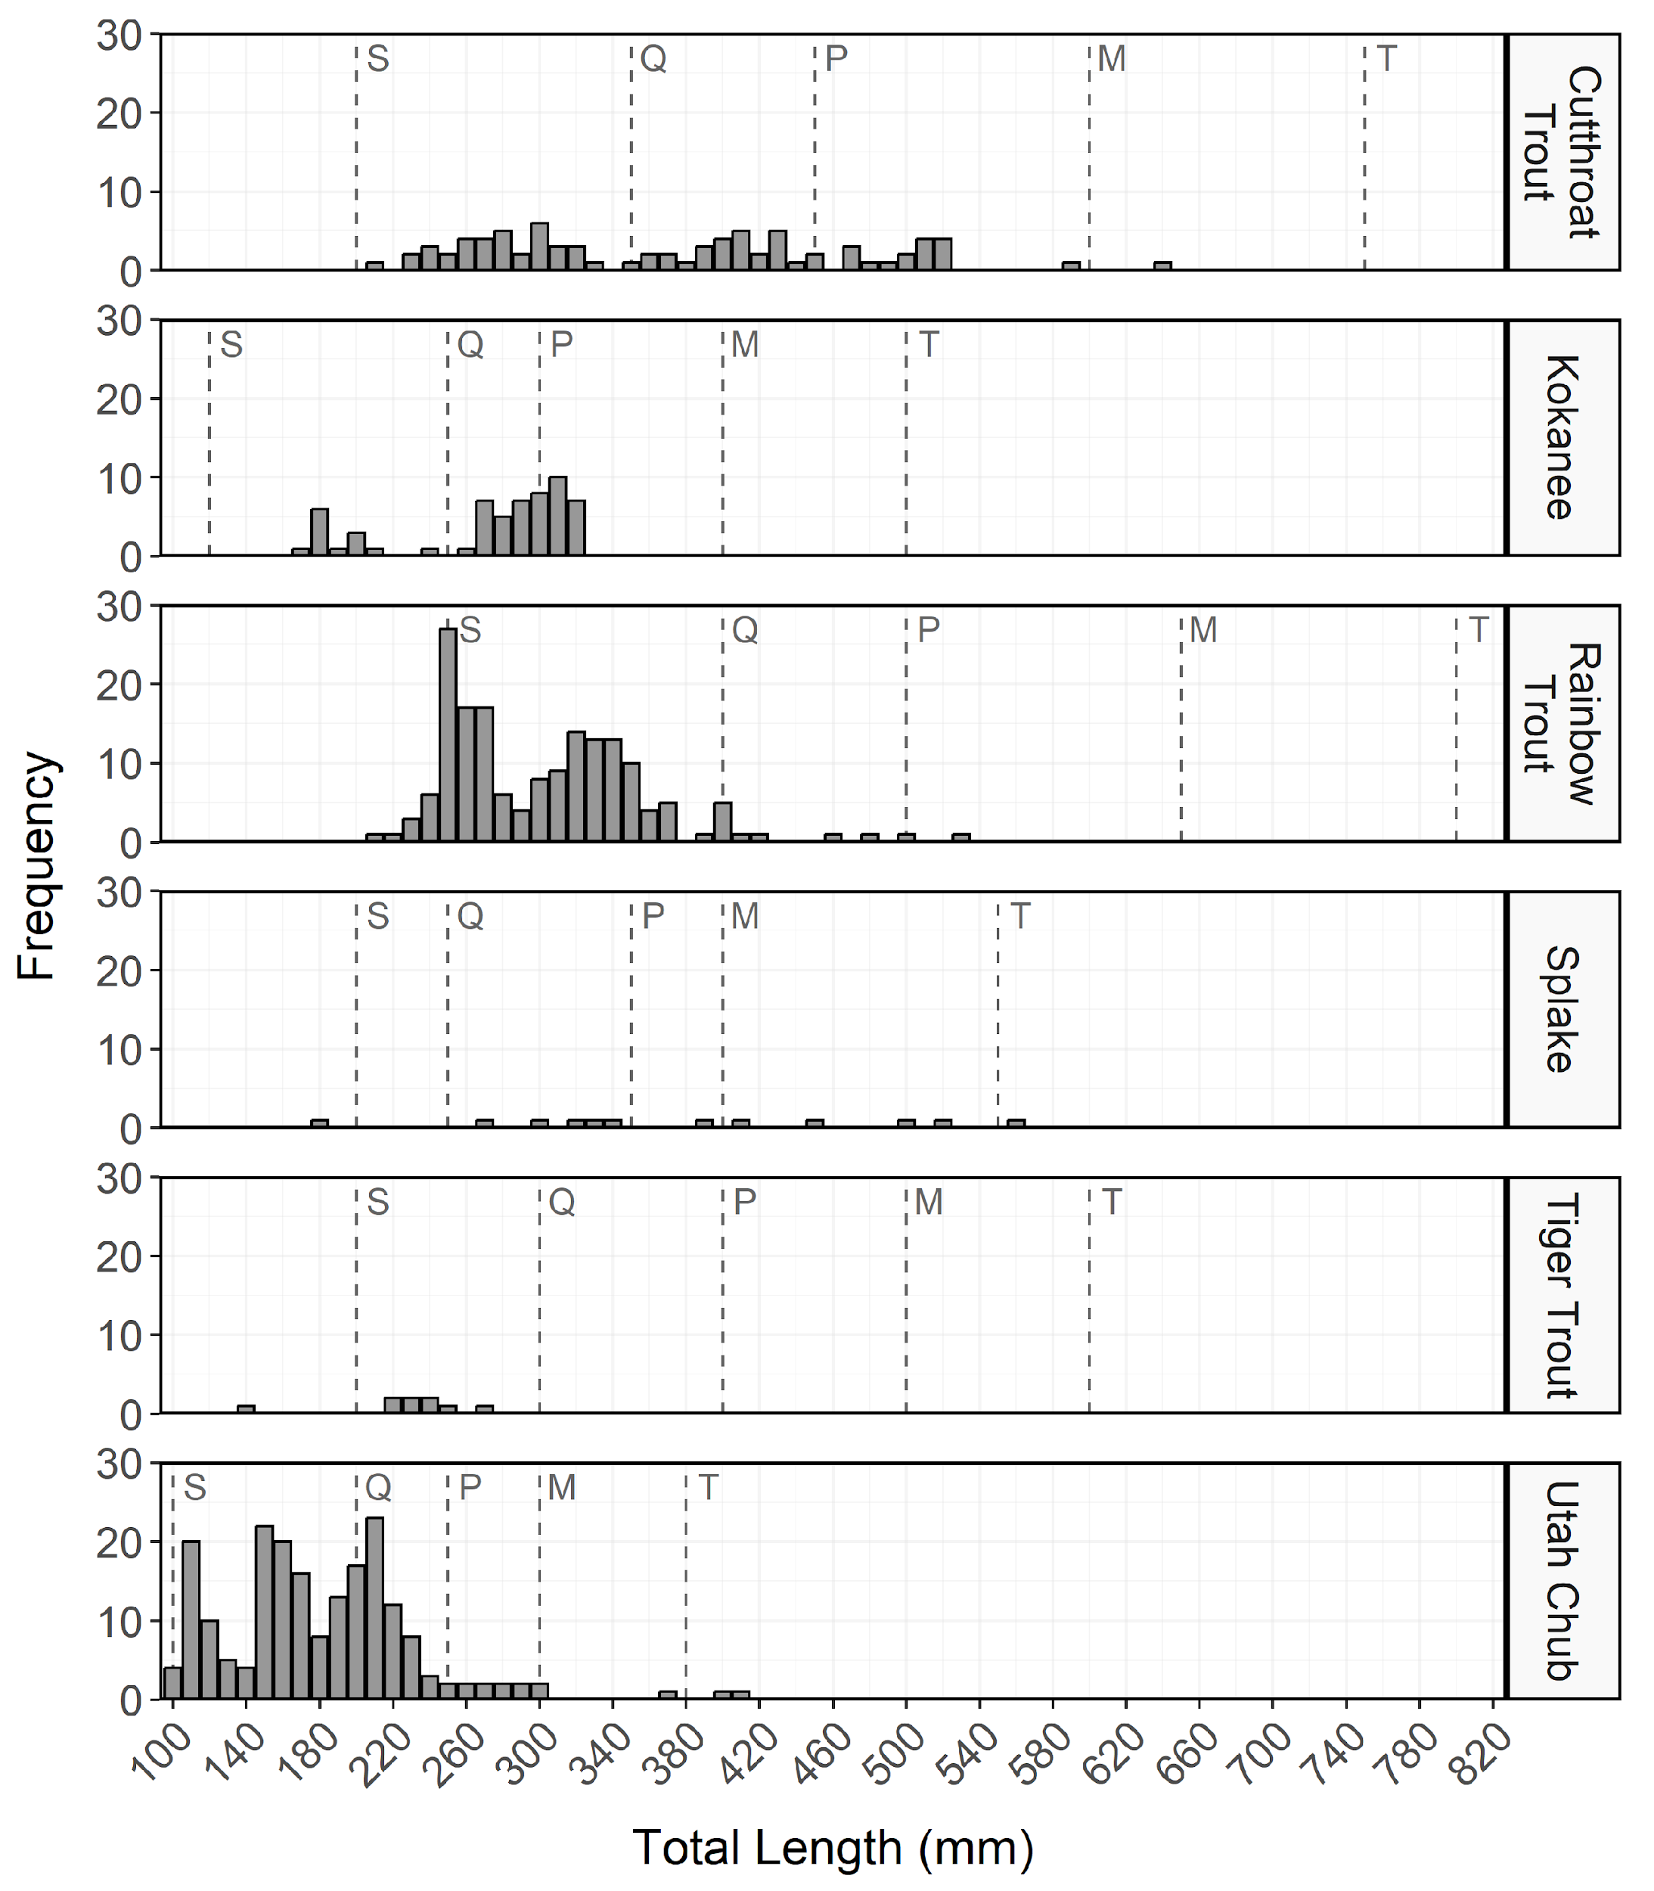

Figure 8: Total length (mm) frequency of Cutthroat Trout, Kokanee Salmon, Rainbow Trout, Splake, Tiger Trout, and Utah Chub from Lost Creek Reservoir in 2023. The length intervals are left-inclusive and right-exclusive, and the x-axis labels represent the start of the length interval (i.e., left side). The start of each Gablehouse length category is identified by the vertical dashed lines and the category name (i.e., stock, quality, preferred, memorable, and trophy) is indicated by the first letter of each category on the right side of the dashed line.

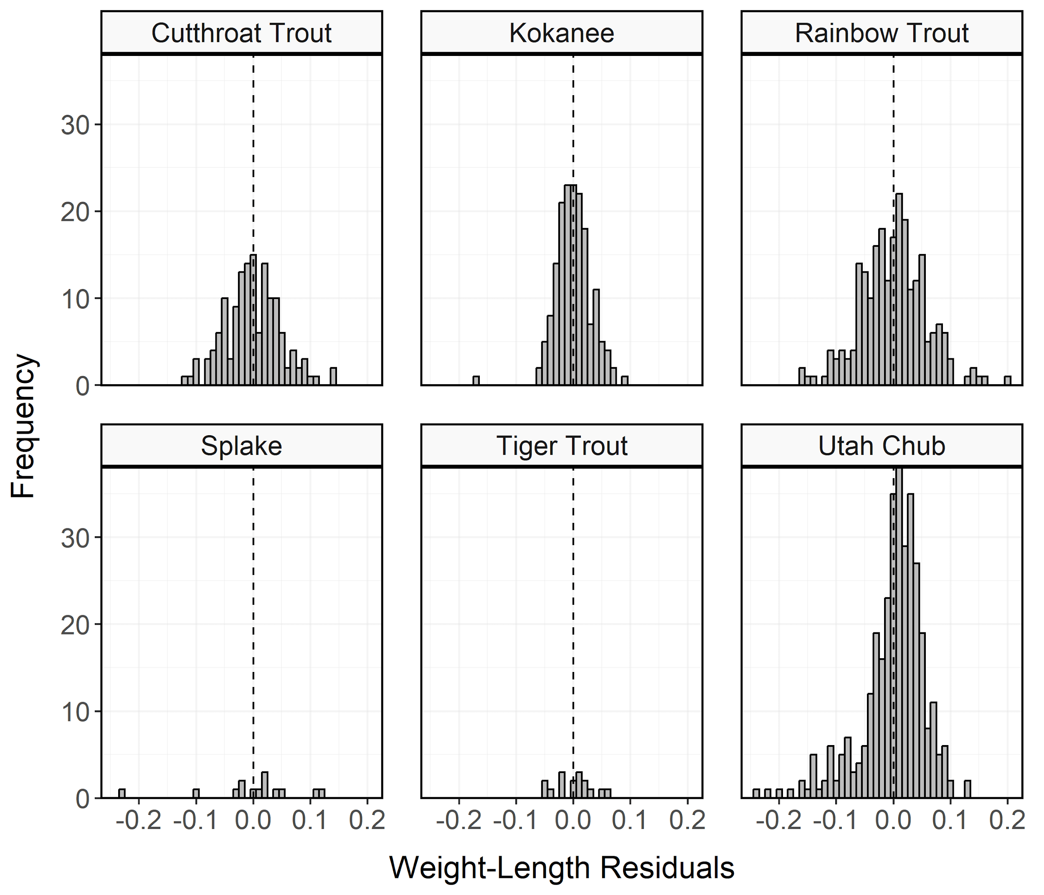

Figure 9: Histogram of residuals from the regression of log10 weight on log10 total length for Cutthroat Trout, Kokanee Salmon, Rainbow Trout, Splake, Tiger Trout, and Utah Chub from Lost Creek Reservoir in 2023.

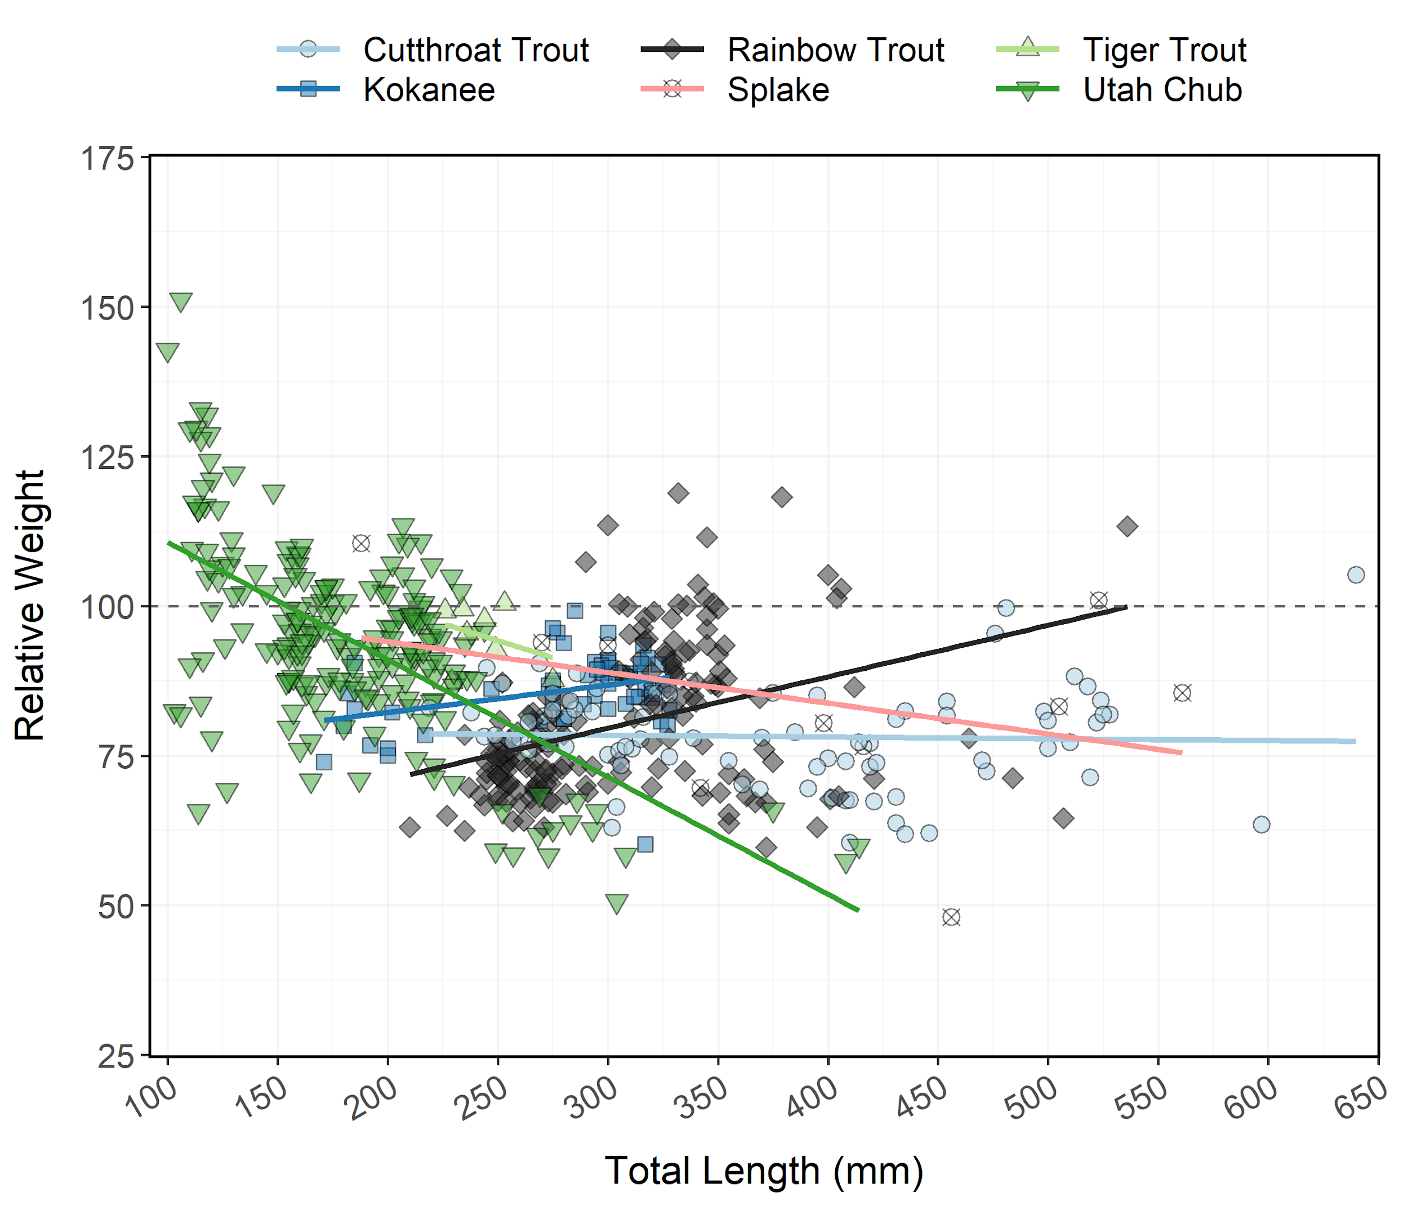

Figure 10: Relative weight (± standard error) of Cutthroat Trout, Kokanee Salmon, Rainbow Trout, Splake, Tiger Trout, and Utah Chub from Lost Creek Reservoir in 2023 as an index of condition. The horizontal dashed line indicates a 1:1 relationship between standard weight and relative weight. Points and lines are jittered to minimize overplotting.

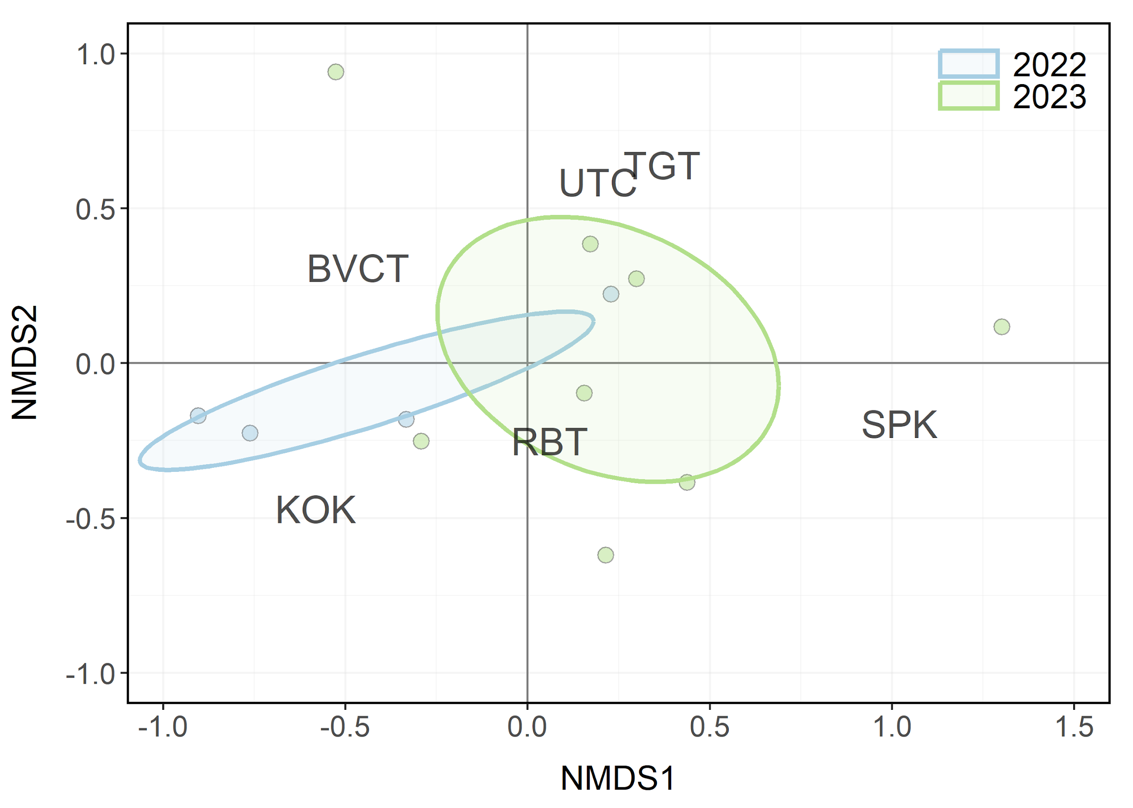

Figure 11: Non-metric multidimensional scaling (NMDS) bi-plot of stock-length Cutthroat Trout, Kokanee Salmon, Rainbow Trout, Splake, Tiger Trout, and Utah Chub from Lost Creek Reservoir in 2022-2023. Points closer together have more similar relative abundances among species. Ellipses highlight the community structure within each year sampled.

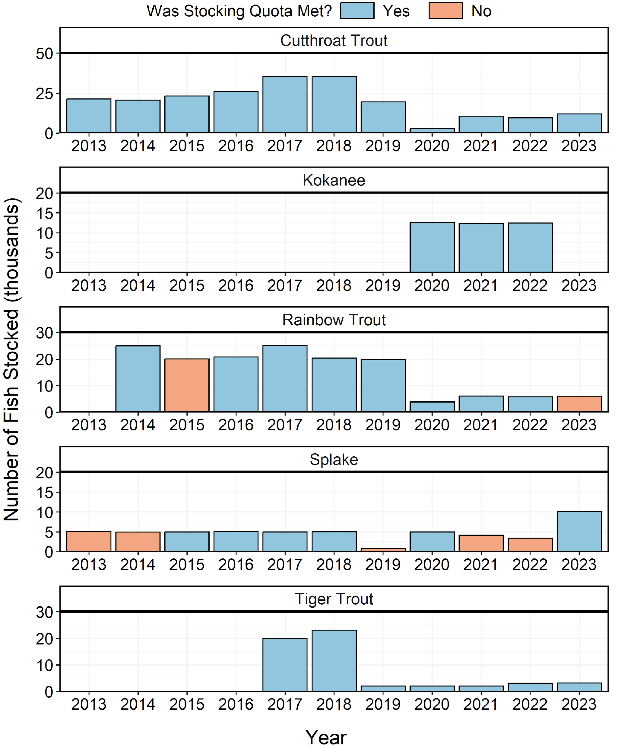

Figure 12: Number of individuals stocked in Lost Creek Reservoir from 2013-2023. Length-at-stocking and stocking quota varies among years. A stocking quota was determined to be met if the number of stocked individuals was at least 90% of the stocking quota.