Utah Division of Wildlife Resources Fishery Monitoring Report

**Author**: Taylor R. Stewart  
**Contact**: [taylorstewart@utah.gov](mailto:taylorstewart@utah.gov)

**System**: Hyrum Reservoir  
**Sampling Dates**: 5/9/2023; 5/18/2023  
**Target Species**: Bluegill, Brown Trout, Largemouth Bass, Rainbow Trout, Utah Sucker, and Yellow Perch  
**Species Stocked**: Brown Trout and Rainbow Trout

**Monitoring Objectives**:

1. Provide data for assessment of trends in species occurrence, relative abundance, biomass, and size structure of forage and sport fish assemblages.
2. Evaluate population indices to improve the effectiveness of Rainbow Trout and Brown Trout stocking efforts.

**Sampling Design and Methods**:  
*Gillnets*  
The prescribed spring gill netting survey occurred over a single day in May and sampled eight standardized sites with one net-night of effort at each site (Table 1; Figure 1). Experimental benthic gillnets were 24.8 m long by 1.8 m deep with eight 3.1-m panels that had bar mesh sizes of 19, 25, 32, 38, 44, 51, 57, and 64 mm. All nets were positioned across depth contours beginning in shallower water. Nets were set overnight and retrieved at dawn.

*Boat Electrofishing*

Shoreline boat electrofishing was conducted to sample the littoral fish community. Ten standardized shoreline transects were sampled with an electrofishing boat equipped with a Smith-Root, Inc. variable voltage processor (Figure 1). Electricity was delivered to the water with an intensity of 300 volts, frequency of 60 Hz, and 60% pulse-width resulting in a current of 10 amps. Transects were sampled for a total of 10 minutes.

*Statistical Methods*

All fish caught were identified to species and measured for total length (mm) and weight (g). Gillnet and electrofishing data were combined to increase the sample size and statistical inference of size structure analyses. Relative abundance (*i.e.,* catch-per-unit-effort) and biomass were analyzed as the respective number or weight for each species per net-night or hour of electrofishing. Size structure was presented as an empirical cumulative distribution function (ECDF) and a histogram. The ECDF, which is the proportion of fish that are less than each observed length, was used to analyze changes over time while the histogram was used to show the frequency of individuals in each length interval for a single year. Weight-length residuals and relative weight were used as condition metrics. Changes in the fish community composition were analyzed among years using non-metric multidimensional scaling.

**Summary**:  
*Species Composition*  
Fish catches were comprised of Brown Trout, Largemouth Bass, Rainbow Trout, Utah Sucker, and Yellow Perch (Figures 2 & 3). Utah Sucker were the most abundant species by number caught (91.0%) and weight (94.6%) in gillnets (Figure 2). Largemouth Bass were the most abundant species by number caught (43.3%) and Utah Sucker were the most abundant species by weight (55.4%) along electrofishing transects (Figure 3).

*Abundance*  
Utah Sucker mean relative abundances were 11.4 fish/net-night (SE = 1.9) and 9.0 fish/hour (SE = 4.8), and relative abundances of Utah Sucker decreased by 10.9% from gillnet sampling conducted in 2012 but increased by 417.1% from electrofishing sampling in 2007 (Figures 4 & 5; Tables 2 & 3). The catch rate of Utah Suckers in the preferred-length and greater categories remain high (Figures 6 & 7). Largemouth Bass mean relative abundance was 12.0 fish/hour (SE = 12.0), remained stable compared to historical values, and catch rates increased in the quality- and preferred-length categories (Figure 7). The relative abundances of Bluegill, Brown Trout, Rainbow Trout, and Yellow Perch decreased to at or near zero (Figure 4 & 5; Tables 2 & 3).

*Biomass*  
Utah Sucker mean relative biomasses were 9.9 kg/net-night (SE = 1.9) and 18.5 kg/hour (SE = 4.8), and relative biomasses of Utah Sucker decreased by 45.3% from gillnet sampling conducted in 2012 but increased by 1414.5% from electrofishing sampling in 2007 (Figures 8 & 9; Tables 2 & 3). Largemouth Bass mean relative biomass was 13.8 kg/hour (SE = 12.0) increased by 307.7% compared to historical values. The mean relative biomass of Bluegill, Brown Trout, Rainbow Trout, and Yellow Perch decreased (range = 81.1-100.0%) from previous sampling (Figures 8 & 9; Tables 2 & 3).

*Size Structure*  
The size structure of Largemouth Bass increased and multiple individuals in the preferred-length category were observed for the first time (Figure 10). Utah Sucker size structure remained similar to previous years but increased in the number of quality- and preferred-length individuals suggesting the Utah Suckers the size of the spawning stock may have increased. Rainbow Trout size structure decreased and were only observed in the stock-length category (Figure 11). Shifts in length distributions between 2012 and 2023 were statistically different, based on a bootstrapped Kolmogorov-Smirnov test, for Rainbow Trout (*P* = 0.030) and Utah Sucker (*P* = 0.002; Figure 10).

*Condition*  
Relative weights of Brown Trout and Largemouth Bass had a negative relationship with total length; however, sample sizes were low for both species (Figure 13). Rainbow Trout relative weight was low and had no relationship with total length. Utah Sucker relative weights were normal, variable, and had a positive relationship with total length (Figure 13).

*Community Structure*  
The fish community has shifted over time from being dominated largely by Brown Trout, Rainbow Trout, and Yellow Perch to a less diverse fish community with Largemouth Bass and Utah Sucker having important roles within the community structure (Figures 14 & 15).

*Stocking*  
Stocking quotas are being met and maintained (Figure 16).

All other measurements and indices appear within normal bounds.

**Management Actions**:

1. Sampling will be conducted again in 2024 to ensure the high-water year observed in 2023 did not skew results. These two years of data will be used to guide aggressive management actions (*e.g.,* novel species introduction) in the future with the primary objective of controlling the Utah Sucker population.
2. Evaluate stocking efforts. Rainbow Trout do not appear to be well-supported in the reservoir. The increase in littoral, warmwater species suggests that the thermal and trophic dynamics may have shifted within the reservoir. A fall gillnet survey will be conducted in 2024 to ensure the spring gillnet survey is accurately representing the pelagic fish community.

**Tables:**

Table 1: Date of collection, number of samples collected by sampling gear type, prescribed number samples by sampling gear type, mean water temperature (°C), and any additional data collected from Hyrum Reservoir in 2023.

| Gear Type | Date | # of Samples | # of Prescribed Samples | Water Temperature | Additional Comments |
| --- | --- | --- | --- | --- | --- |
| Boat Electrofishing | 5/9/2023 | 6 | 6 | 10.6 | – |
| Gillnet | 5/18/2023 | 8 | 8 | 12.7 | – |

Table 2: Mean total length (TL; mm), mean weight (WT; g), mean relative weight (Wr), and percentage of individuals within each traditional proportional size distribution (PSD) category for each gillnet target species from Hyrum Reservoir in 2023. All values in parentheses indicate standard deviation.

| Target Species | Mean  TL | Mean  WT | Mean  Wr | PSD-  Quality | PSD-  Preferred | PSD-  Memorable | PSD-  Trophy |
| --- | --- | --- | --- | --- | --- | --- | --- |
| Brown Trout | 455.2 (136.8) | 1154.7 (859.3) | 83.6  (9.5) | 67 | 67 | 67 | 0 |
| Rainbow Trout | 309.1 (56.4) | 356.3 (213.9) | 79.8 (10.4) | 0 | 0 | 0 | 0 |
| Utah Sucker | 430.7 (86.6) | 1189.5 (637.9) | 99.1 (11.0) | 97 | 89 | 44 | 17 |
| Yellow Perch | 142.9 (28.4) | 35.3  (22.8) | – | 0 | 0 | 0 | 0 |

Table 3: Mean total length (TL; mm), mean weight (WT; g), mean relative weight (Wr), and percentage of individuals within each traditional proportional size distribution (PSD) category for each electrofishing target species from Hyrum Reservoir in 2023. All values in parentheses indicate standard deviation.

| Target Species | Mean  TL | Mean  WT | Mean  Wr | PSD-  Quality | PSD-  Preferred | PSD-  Memorable | PSD-  Trophy |
| --- | --- | --- | --- | --- | --- | --- | --- |
| Bluegill | 97.8 (25.4) | 23.8  (32.6) | – | 0 | 0 | 0 | 0 |
| Largemouth Bass | 133.3 (81.9) | 95.4 (265.1) | 107.3 (9.9) | 100 | 75 | 0 | 0 |
| Utah Sucker | 300.4 (184.1) | 751.3 (857.6) | 99.1 (11.0) | 97 | 89 | 44 | 17 |
| Yellow Perch | 174.0 (48.2) | 77.6  (41.5) | – | 0 | 0 | 0 | 0 |

**Figures:**

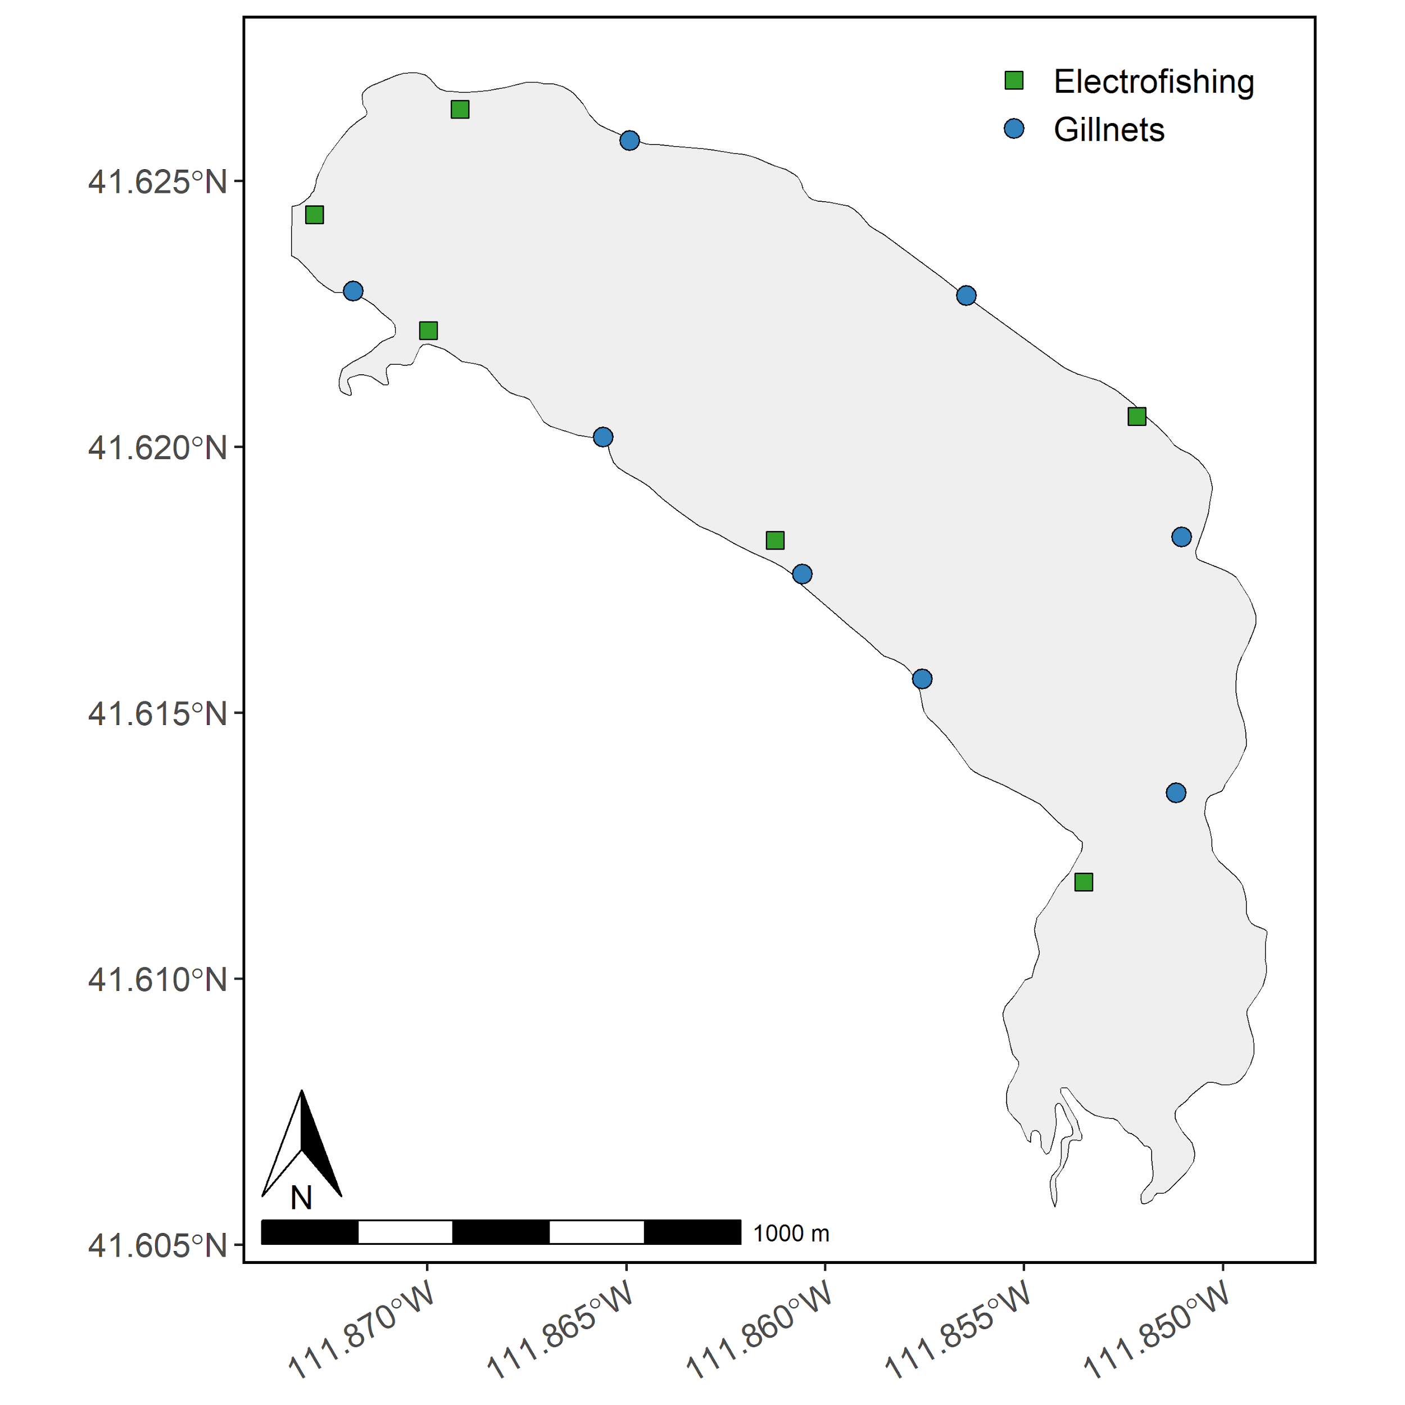

Figure 1: Map of Hyrum Reservoir sampling sites. The starting points for each boat electrofishing transect are denoted as green squares and gillnets are denoted as blue circles. Boat electrofishing transects are conducted counterclockwise.

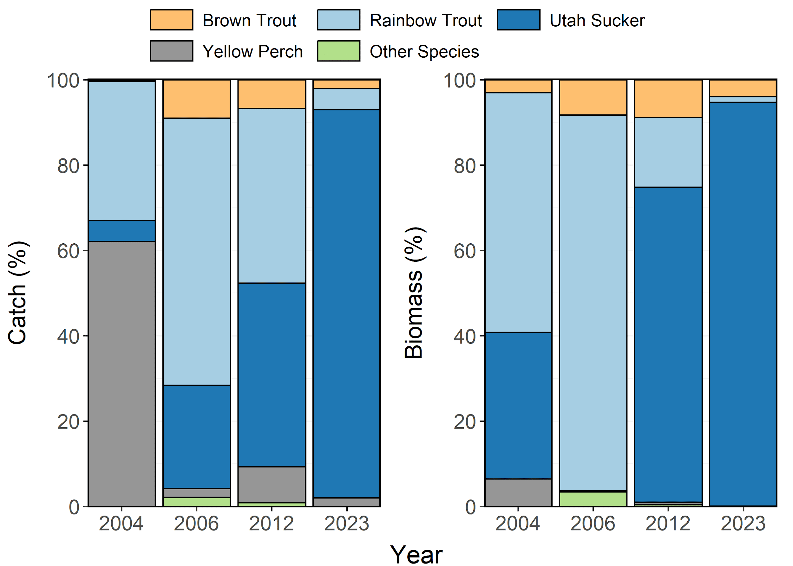

Figure 2: Species composition (%) by catch (# of fish) and biomass (kg) of Brown Trout, Rainbow Trout, Utah Sucker, and Yellow Perch sampled in gillnets from Hyrum Reservoir between 2004-2023. Other species include Bluegill and Largemouth Bass aggregated together.

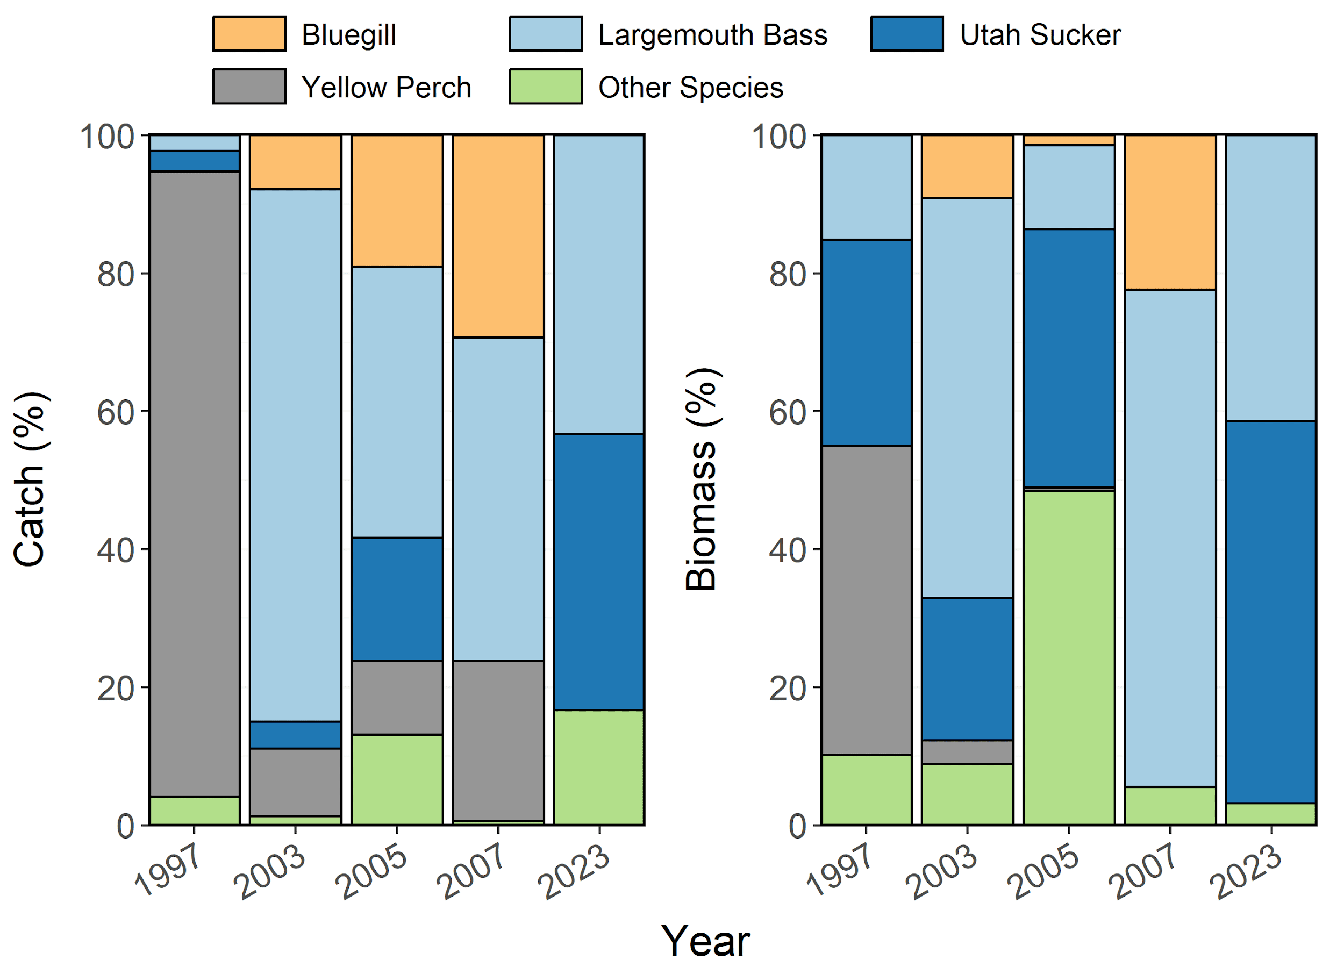

Figure 3: Species composition (%) by catch (# of fish) and biomass (kg) of Bluegill, Largemouth Bass, Utah Sucker, and Yellow Perch sampled during electrofishing surveys from Hyrum Reservoir between 1997-2023. Other species include Brown Trout, Rainbow Trout, and Tiger Trout aggregated together.

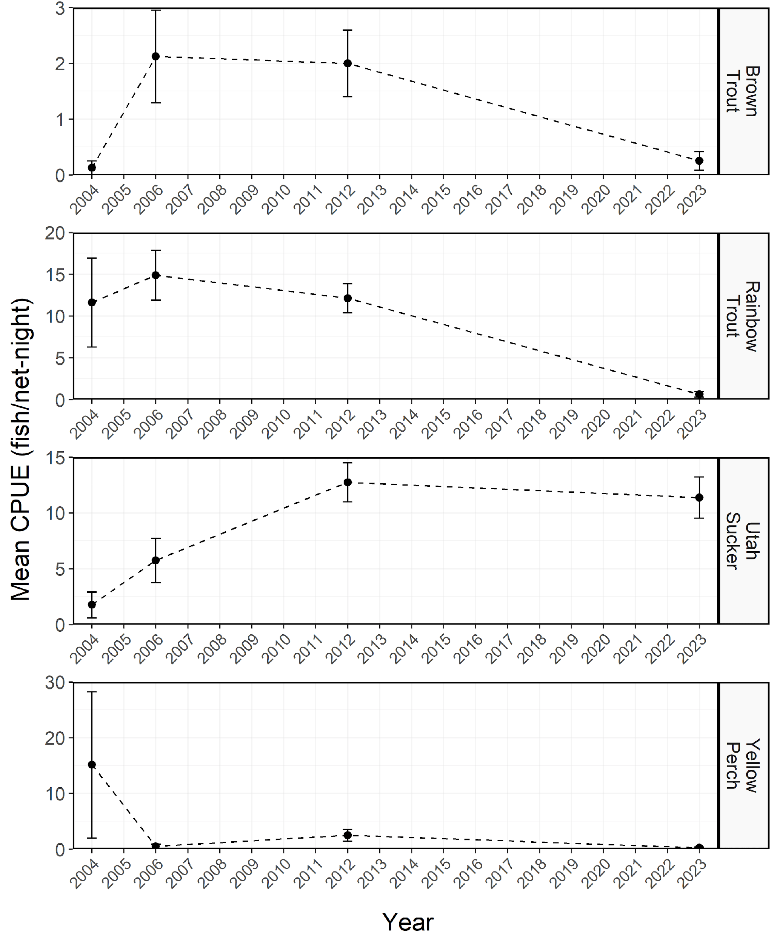

Figure 4: Mean relative abundance (CPUE; fish/net-night) of stock-length Brown Trout, Rainbow Trout, Utah Sucker, and Yellow Perch sampled in gillnets from Hyrum Reservoir between 2004-2023. Dashed lines represent interpolation across years of missing data between points. Error bars indicate standard error.

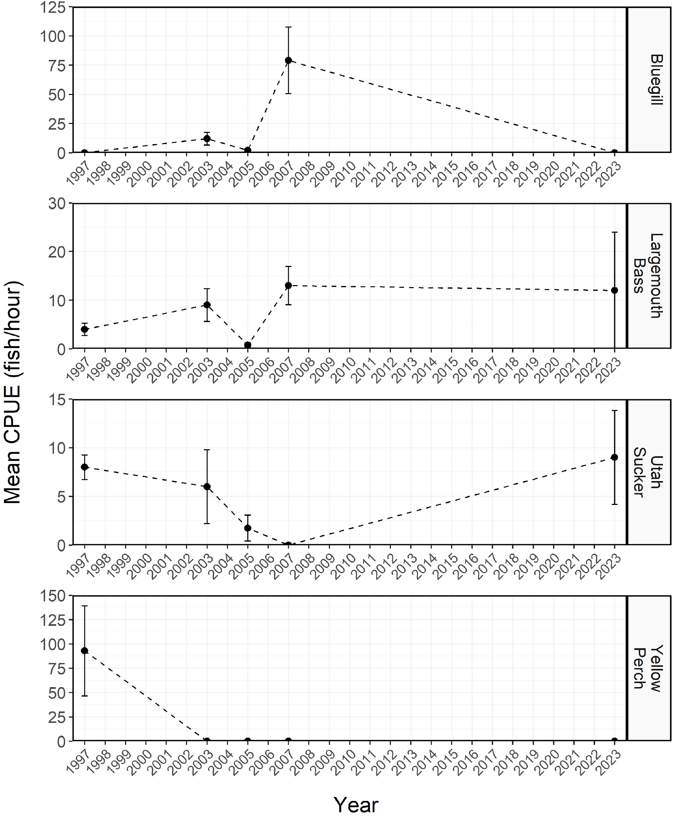

Figure 5: Mean relative abundance (CPUE; fish/net-night) of stock-length Bluegill, Largemouth Bass, Utah Sucker, and Yellow Perch sampled during electrofishing survey from Hyrum Reservoir between 1997-2023. Dashed lines represent interpolation across years of missing data between points. Error bars indicate standard error.

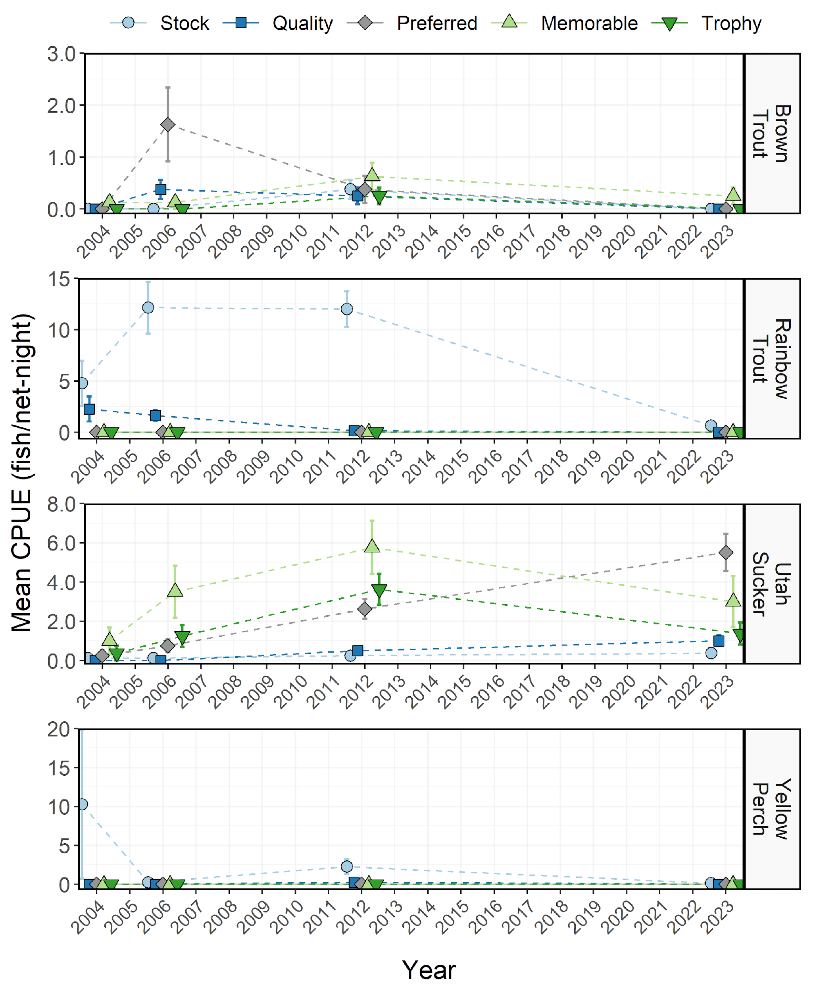

Figure 6: Mean relative abundance (CPUE; fish/net-night) of Brown Trout, Rainbow Trout, Utah Sucker, and Yellow Perch within each Gablehouse length category sampled in gillnets from Hyrum Reservoir between 2004-2023. Points and lines are jittered to minimize overplotting. Dashed lines represent interpolation across years of missing data between points. Error bars indicate standard error.

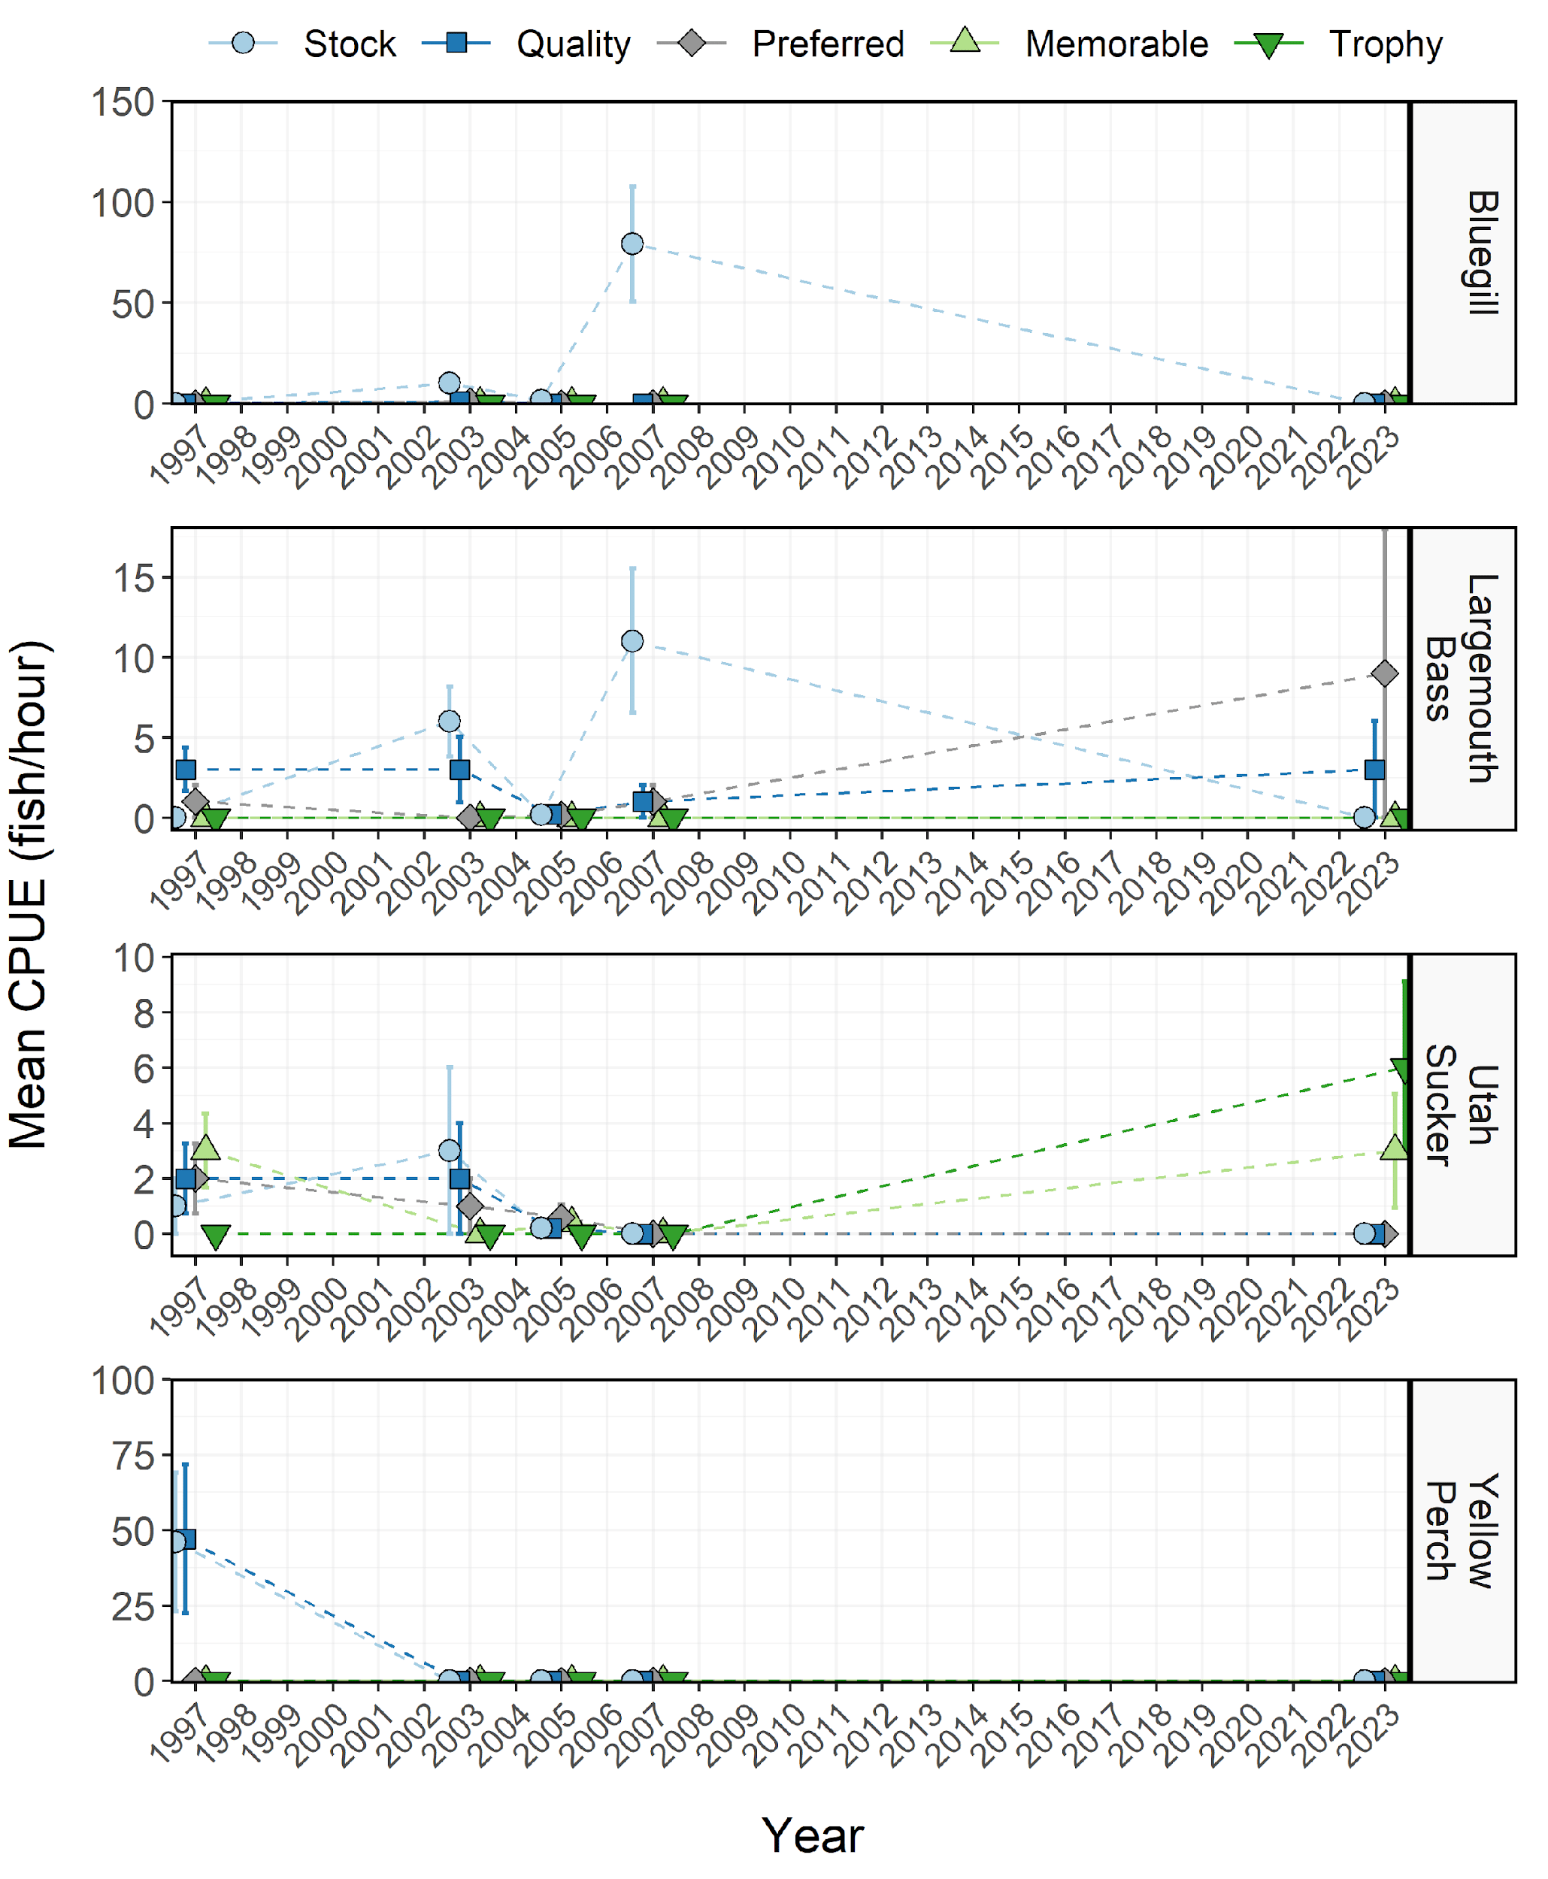

Figure 7: Mean relative abundance (CPUE; fish/net-night) of Bluegill, Largemouth Bass, Utah Sucker, and Yellow Perch within each Gablehouse length category sampled during electrofishing surveys from Hyrum Reservoir between 1997-2023. Points and lines are jittered to minimize overplotting. Dashed lines represent interpolation across years of missing data between points. Error bars indicate standard error.

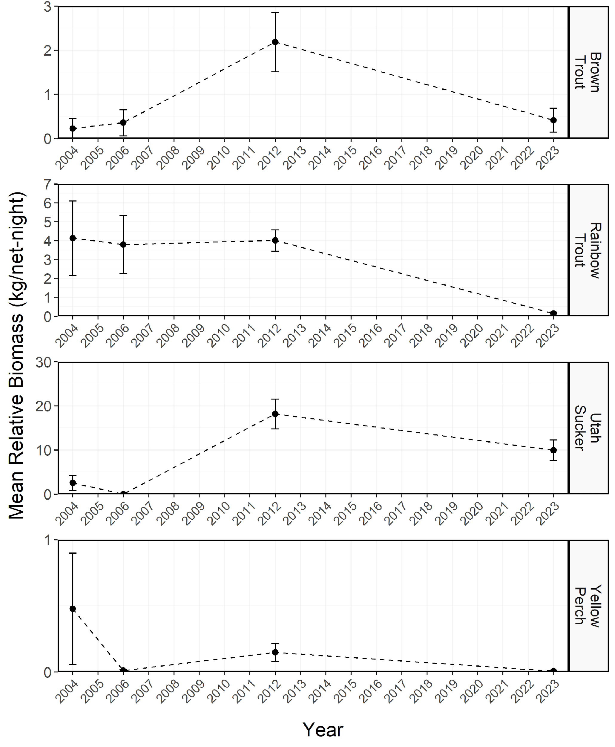

Figure 8: Mean relative biomass (kg/net-night) of stock-length Brown Trout, Rainbow Trout, Utah Sucker, and Yellow Perch sampled in gillnets from Hyrum Reservoir between 2004-2023. Dashed lines represent interpolation across years of missing data between points. Error bars indicate standard error.

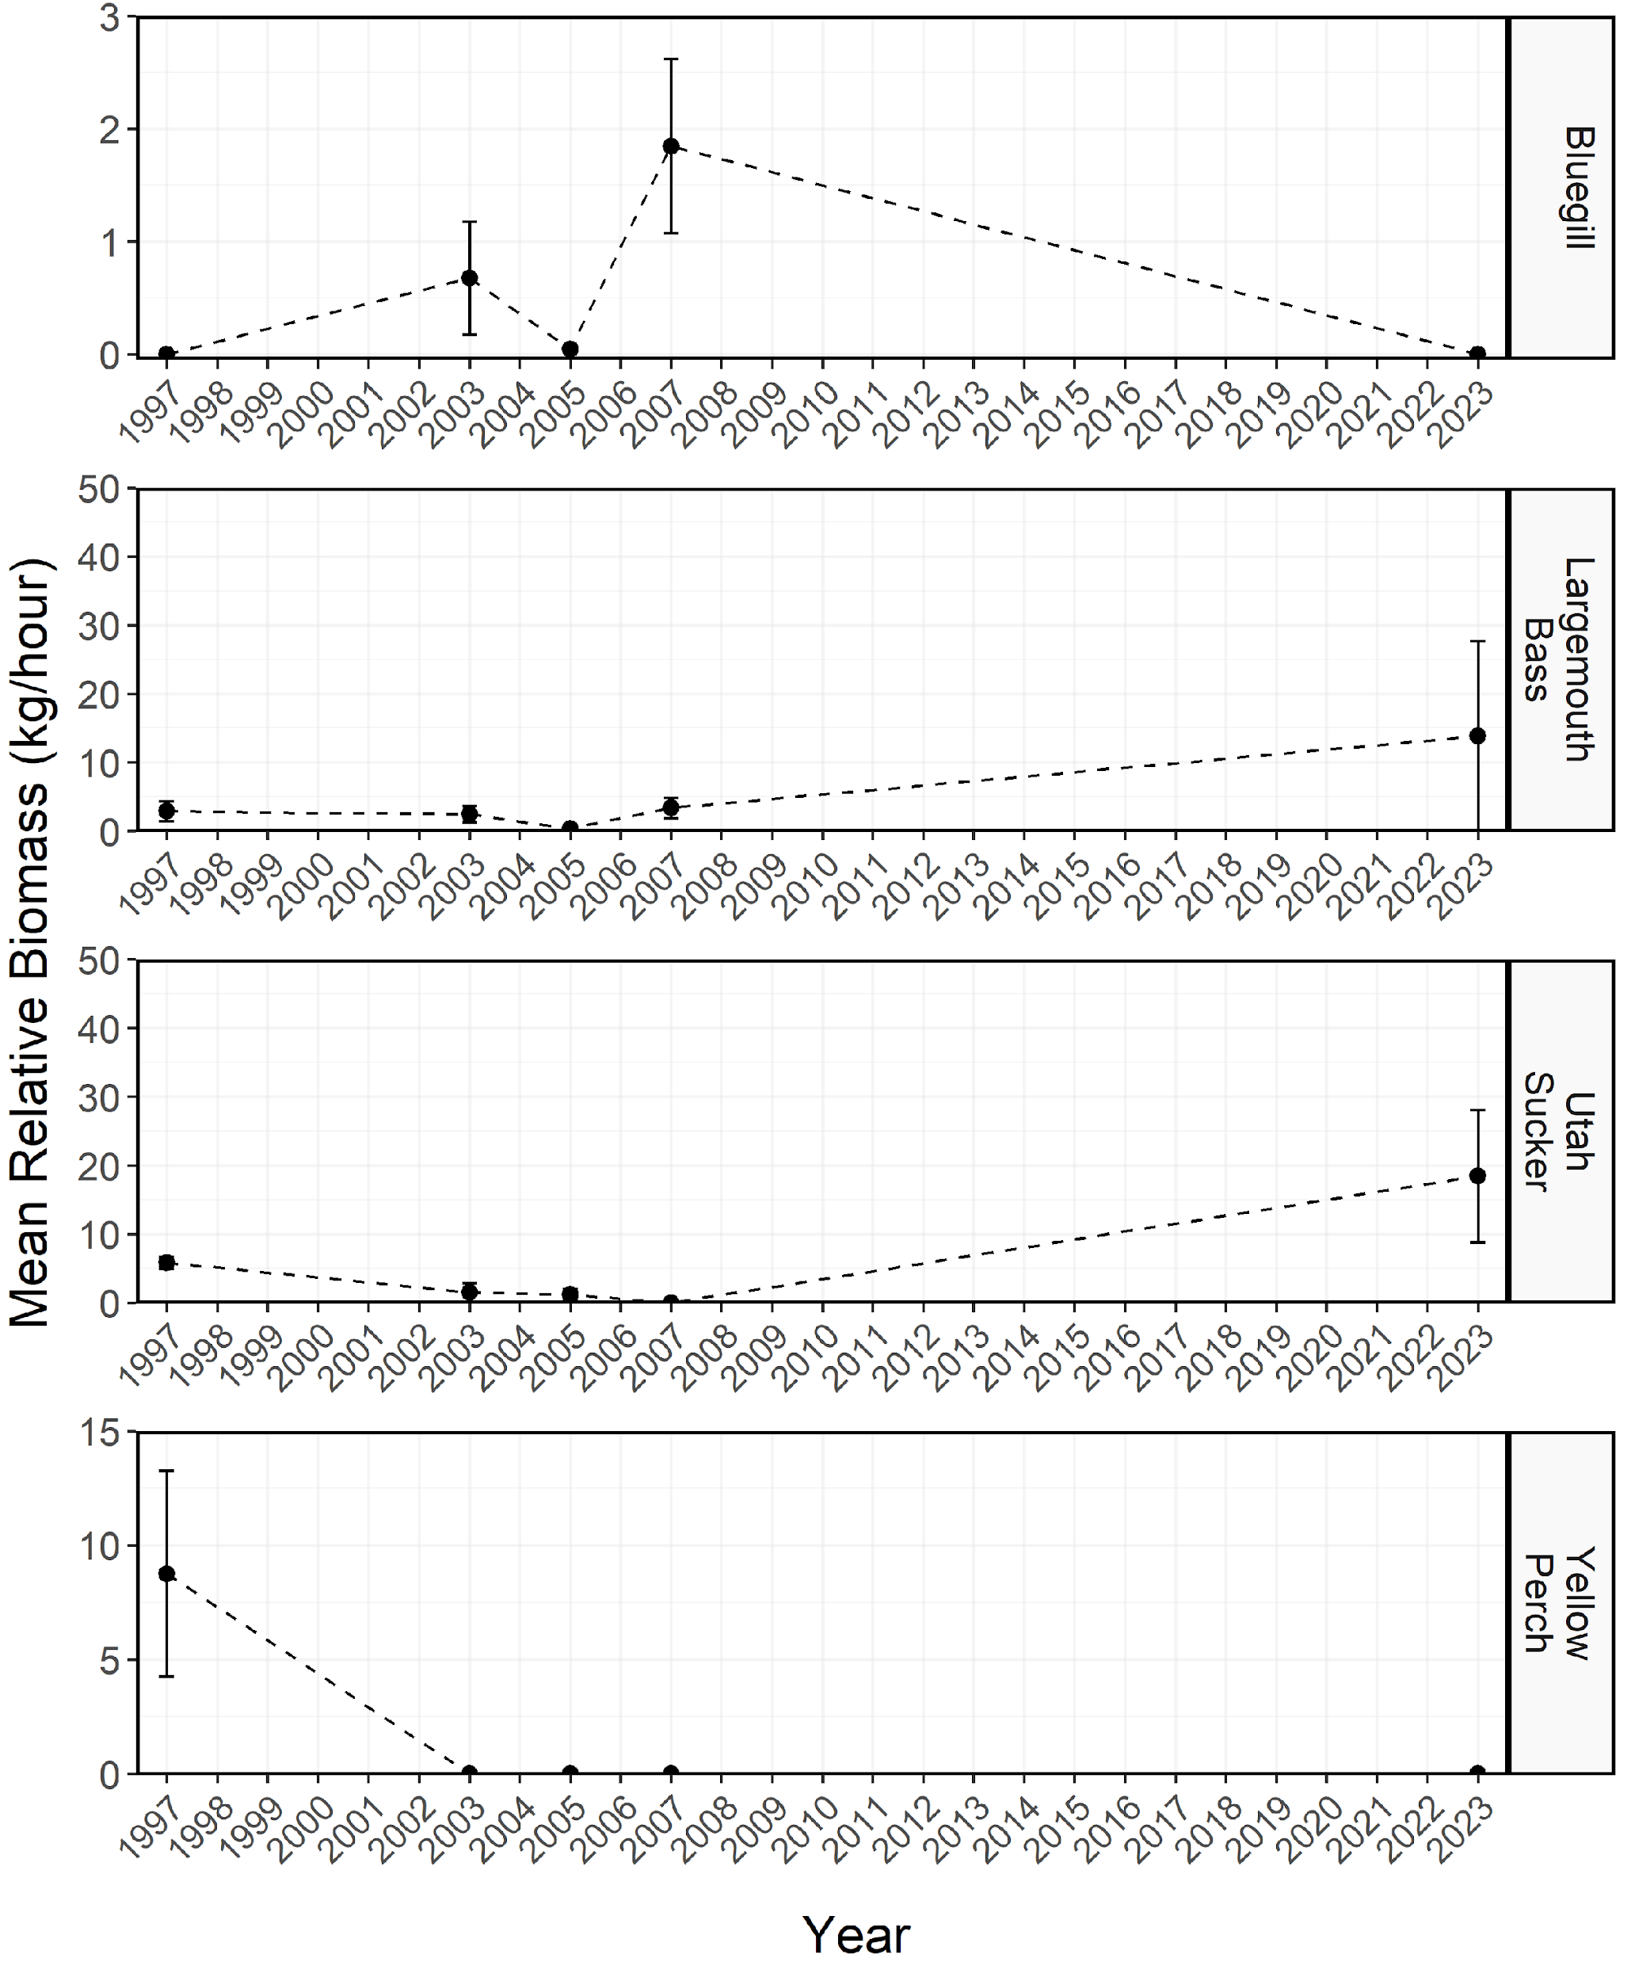

Figure 9: Mean relative biomass (kg/net-night) of stock-length Bluegill, Largemouth Bass, Utah Sucker, and Yellow Perch sampled during electrofishing surveys from Hyrum Reservoir between 1997-2023. Dashed lines represent interpolation across years of missing data between points. Error bars indicate standard error.

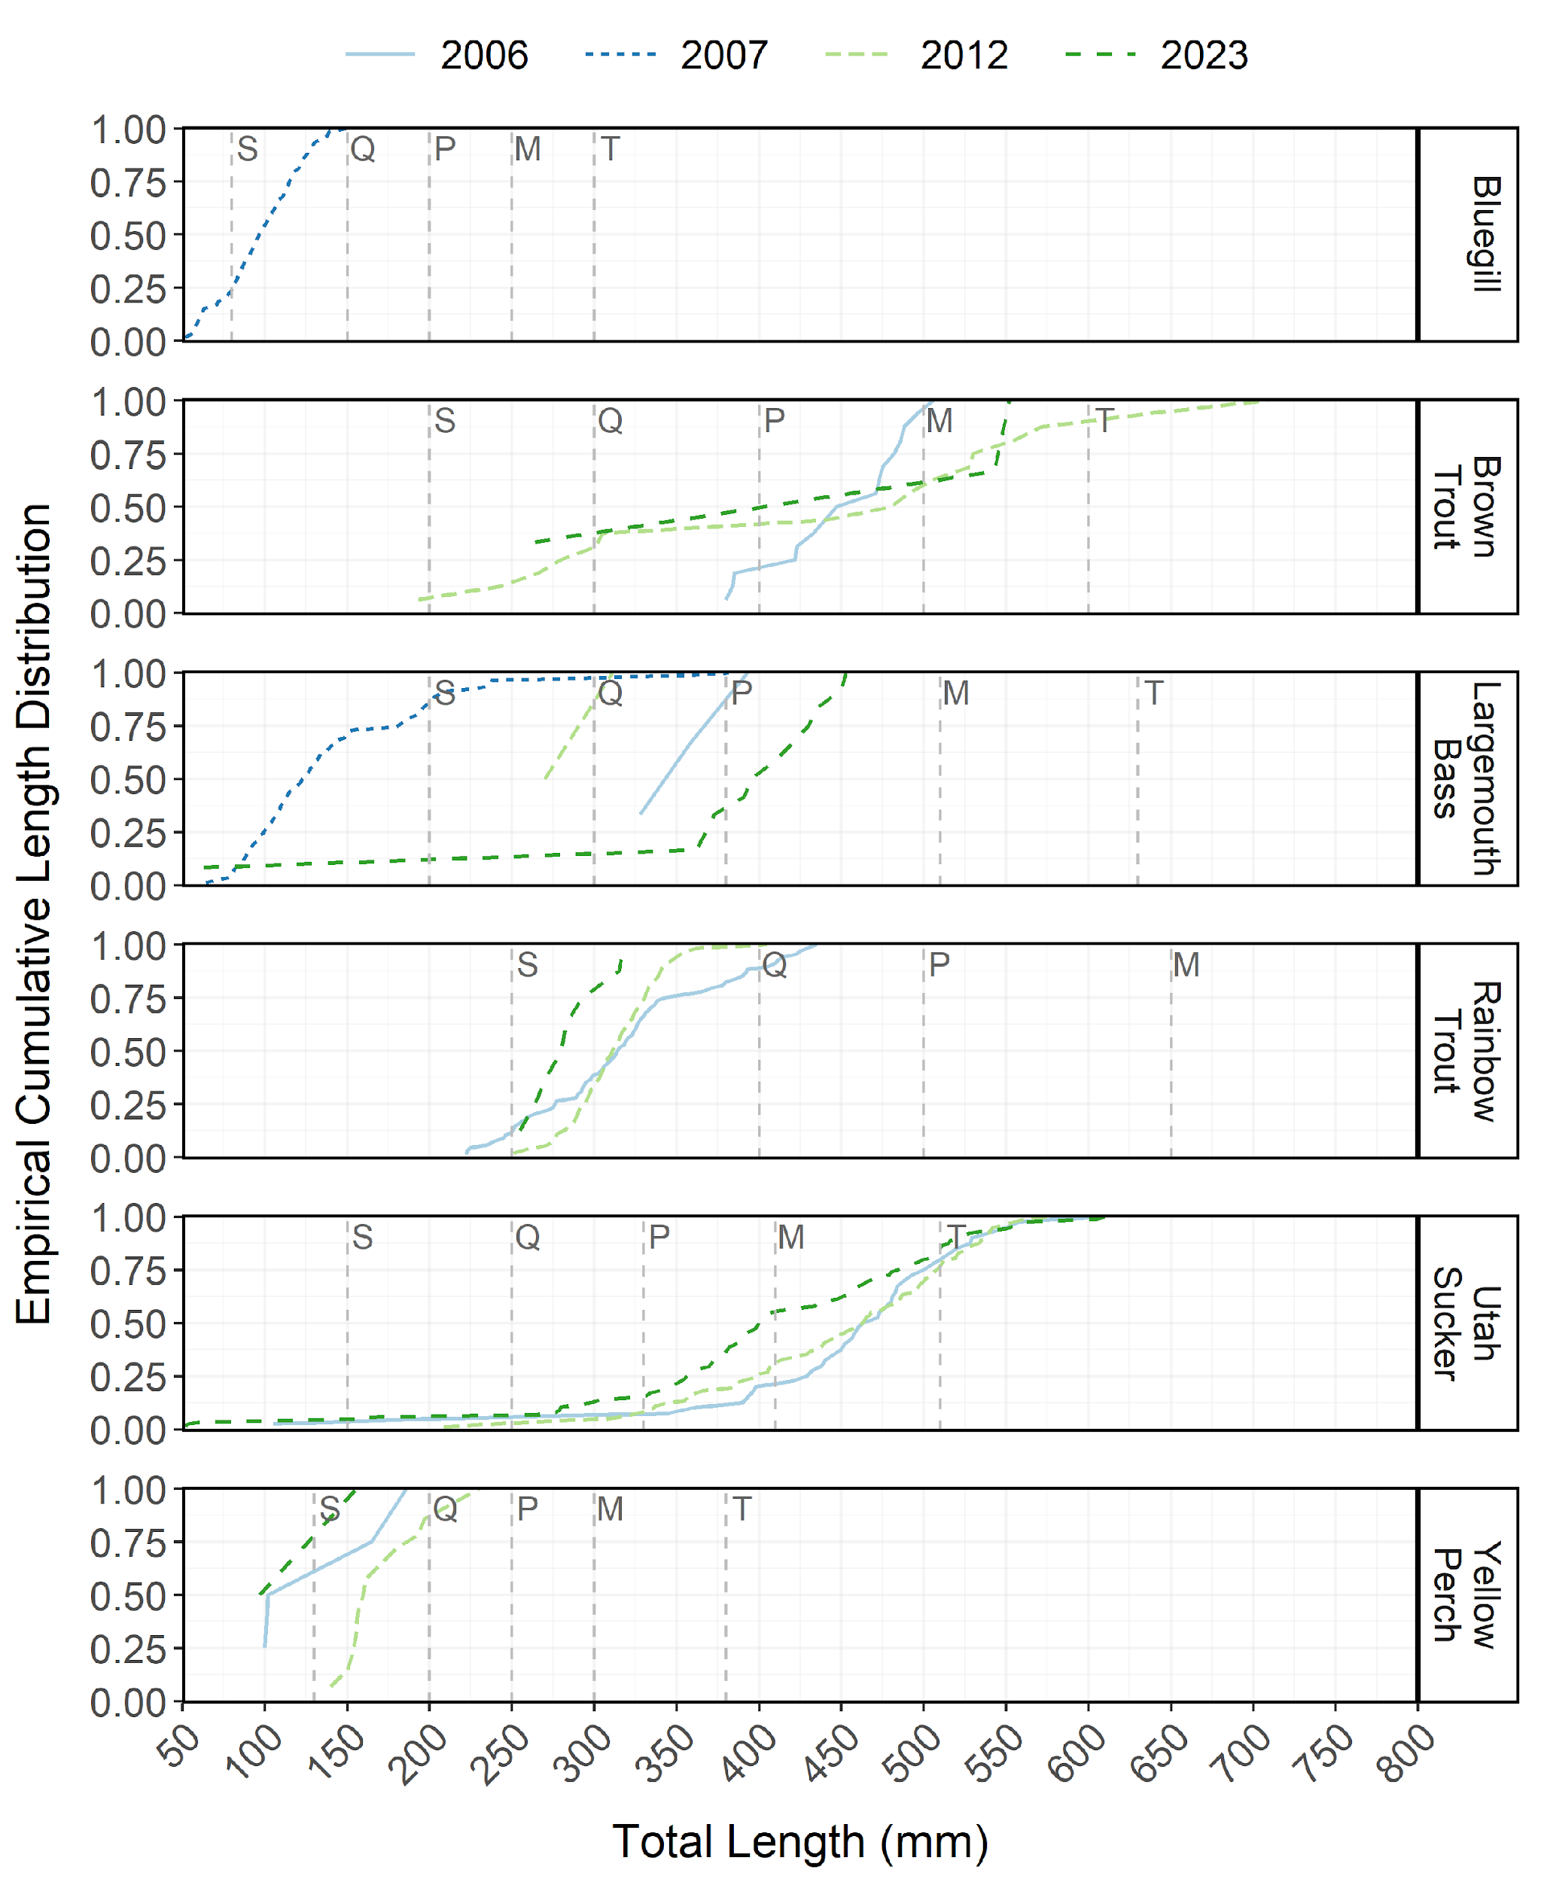

Figure 10: Empirical cumulative total length (mm) distribution of Bluegill, Brown Trout, Largemouth Bass, Rainbow Trout, Utah Sucker, and Yellow Perch sampled during curtain net and electrofishing surveys from Hyrum Reservoir between 2006-2023.

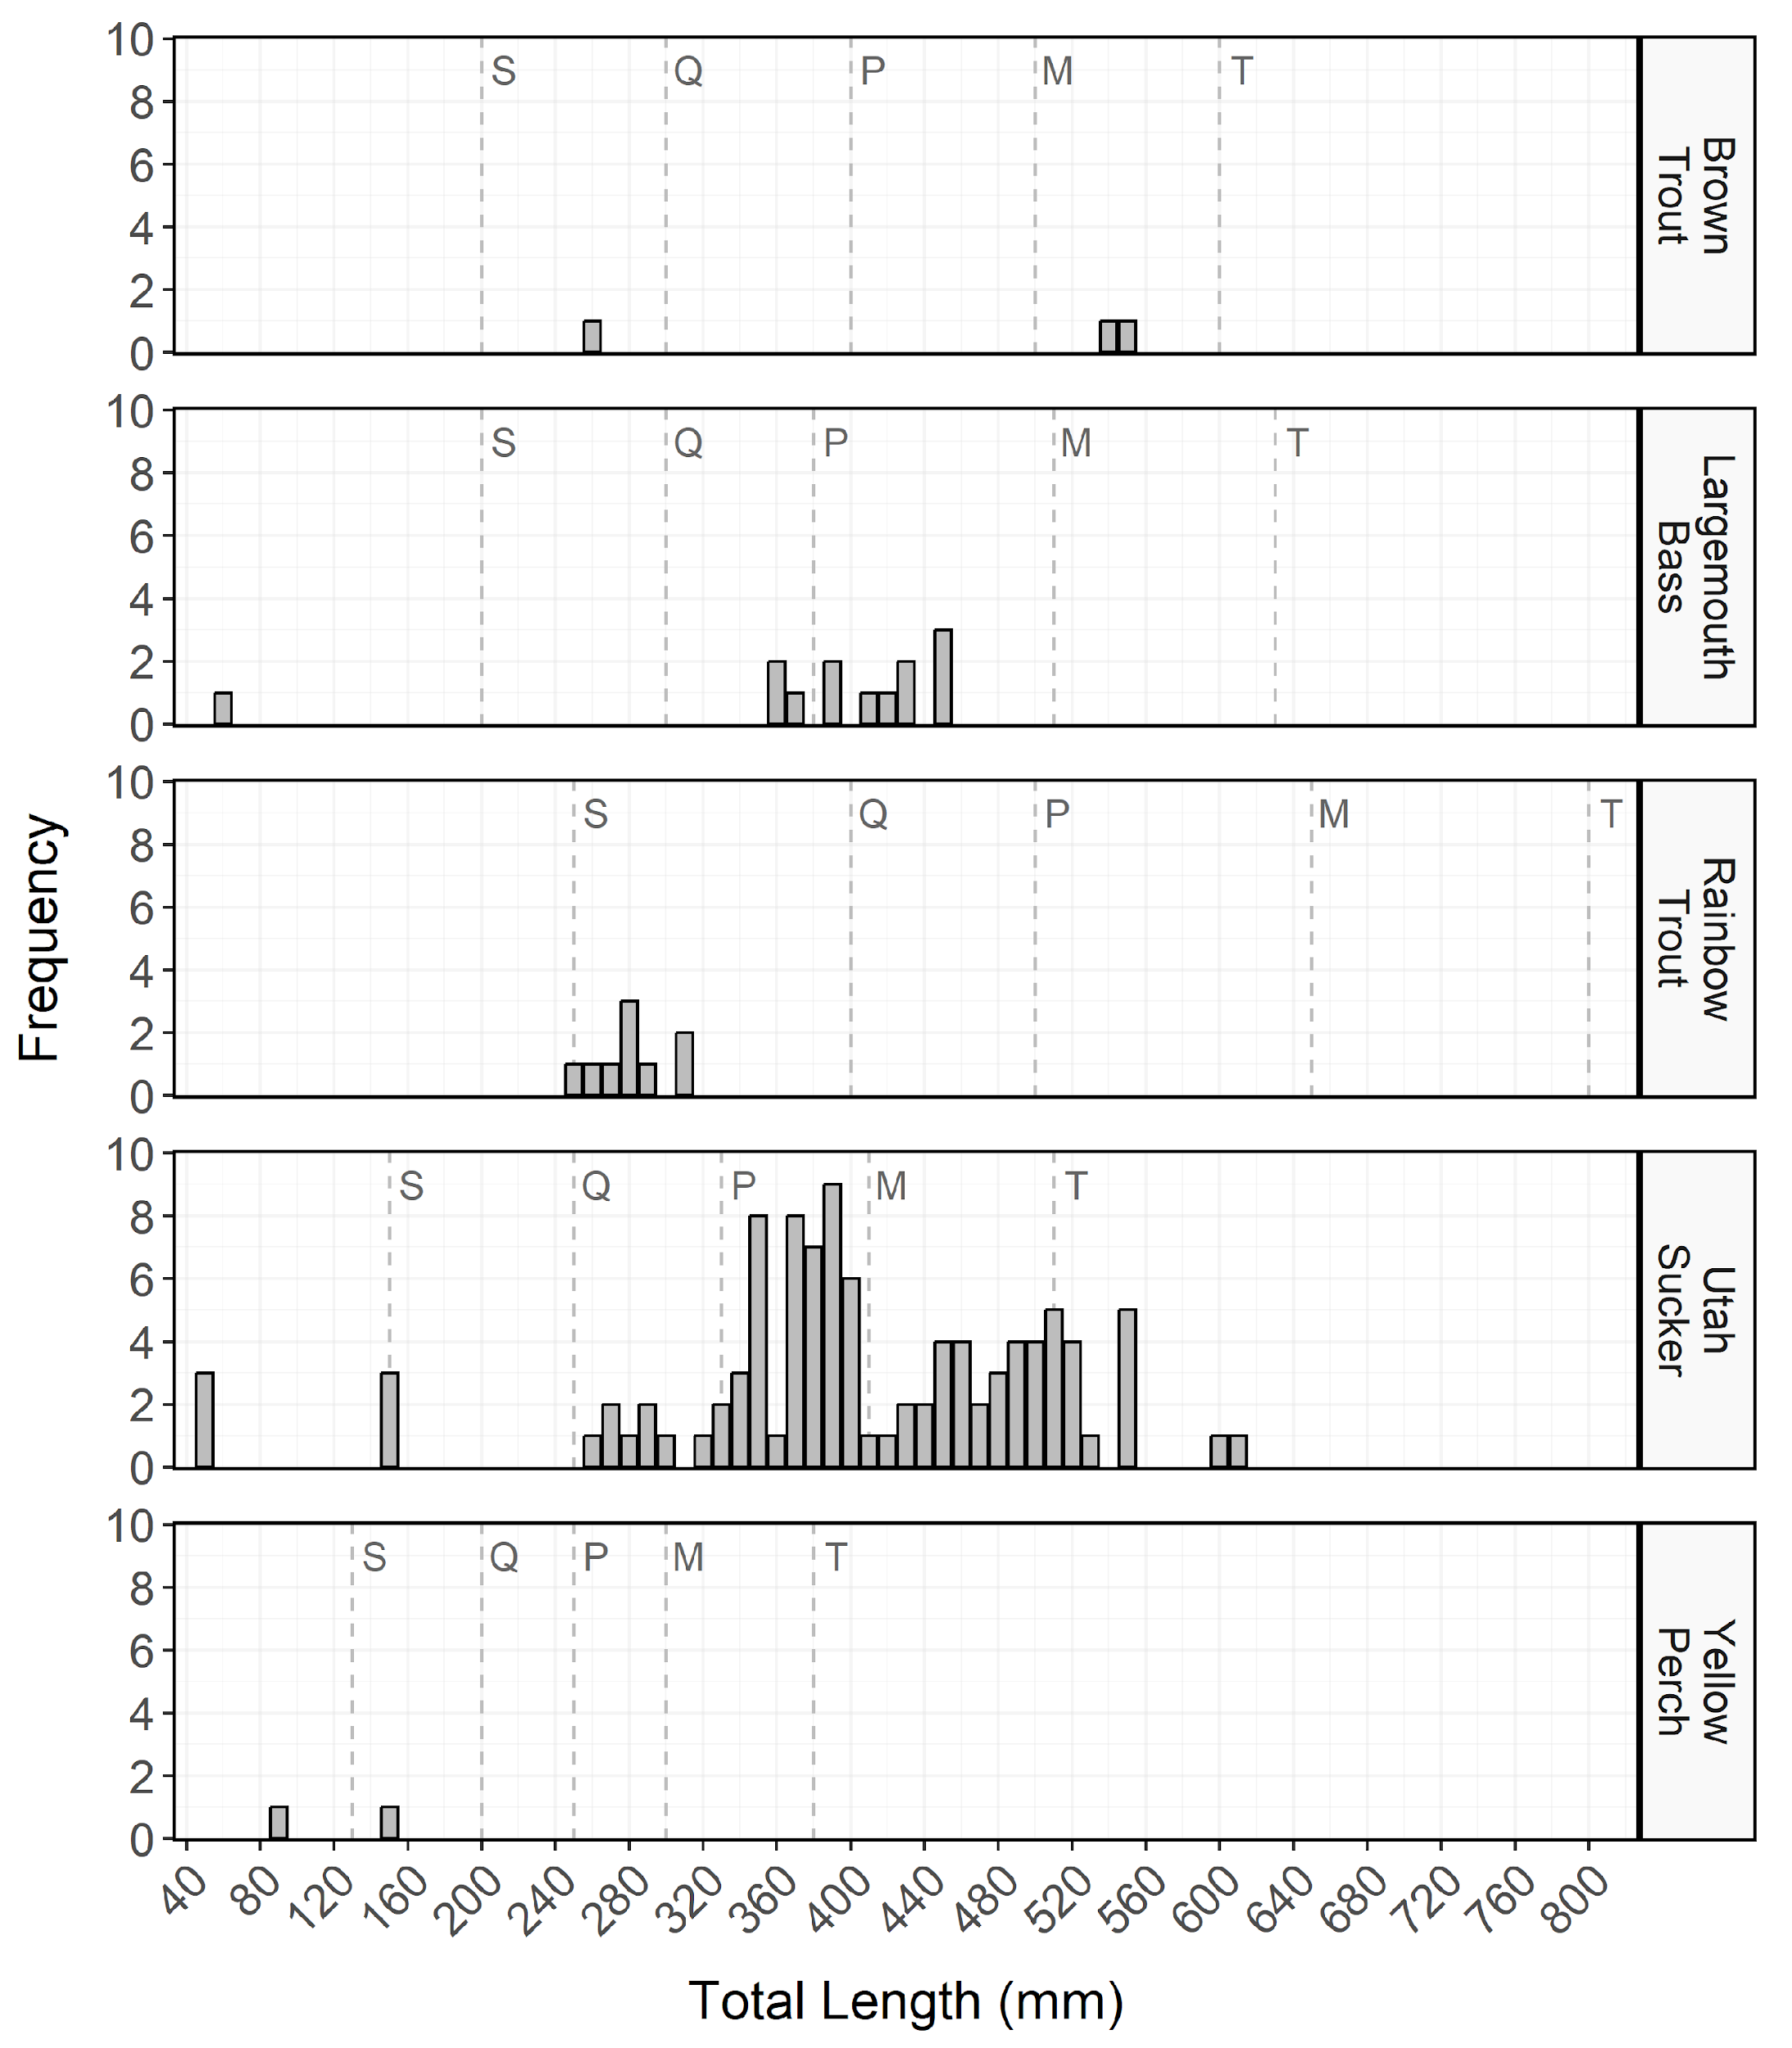

Figure 11: Total length (mm) frequency of Bluegill, Brown Trout, Largemouth Bass, Rainbow Trout, Utah Sucker, and Yellow Perch sampled during curtain net and electrofishing surveys from Hyrum Reservoir in 2023. The length intervals are left-inclusive and right-exclusive, and the x-axis labels represent the start of the length interval (i.e., left side). The start of each Gablehouse length category is identified by the vertical dashed lines and the category name (i.e., stock, quality, preferred, memorable, and trophy) is indicated by the first letter of each category on the right side of the dashed line.

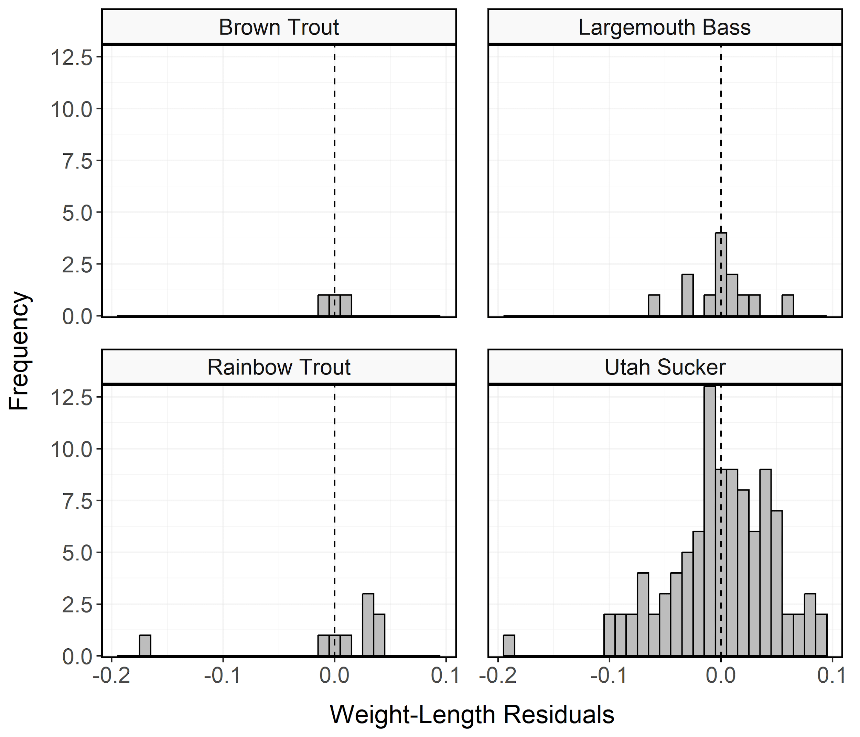

Figure 12: Histogram of residuals from the regression of log10 weight on log10 total length for Brown Trout, Largemouth Bass, Rainbow Trout, and Utah Sucker sampled during curtain net and electrofishing surveys from Hyrum Reservoir in 2023. Analyses are restricted to species with more than two observations.

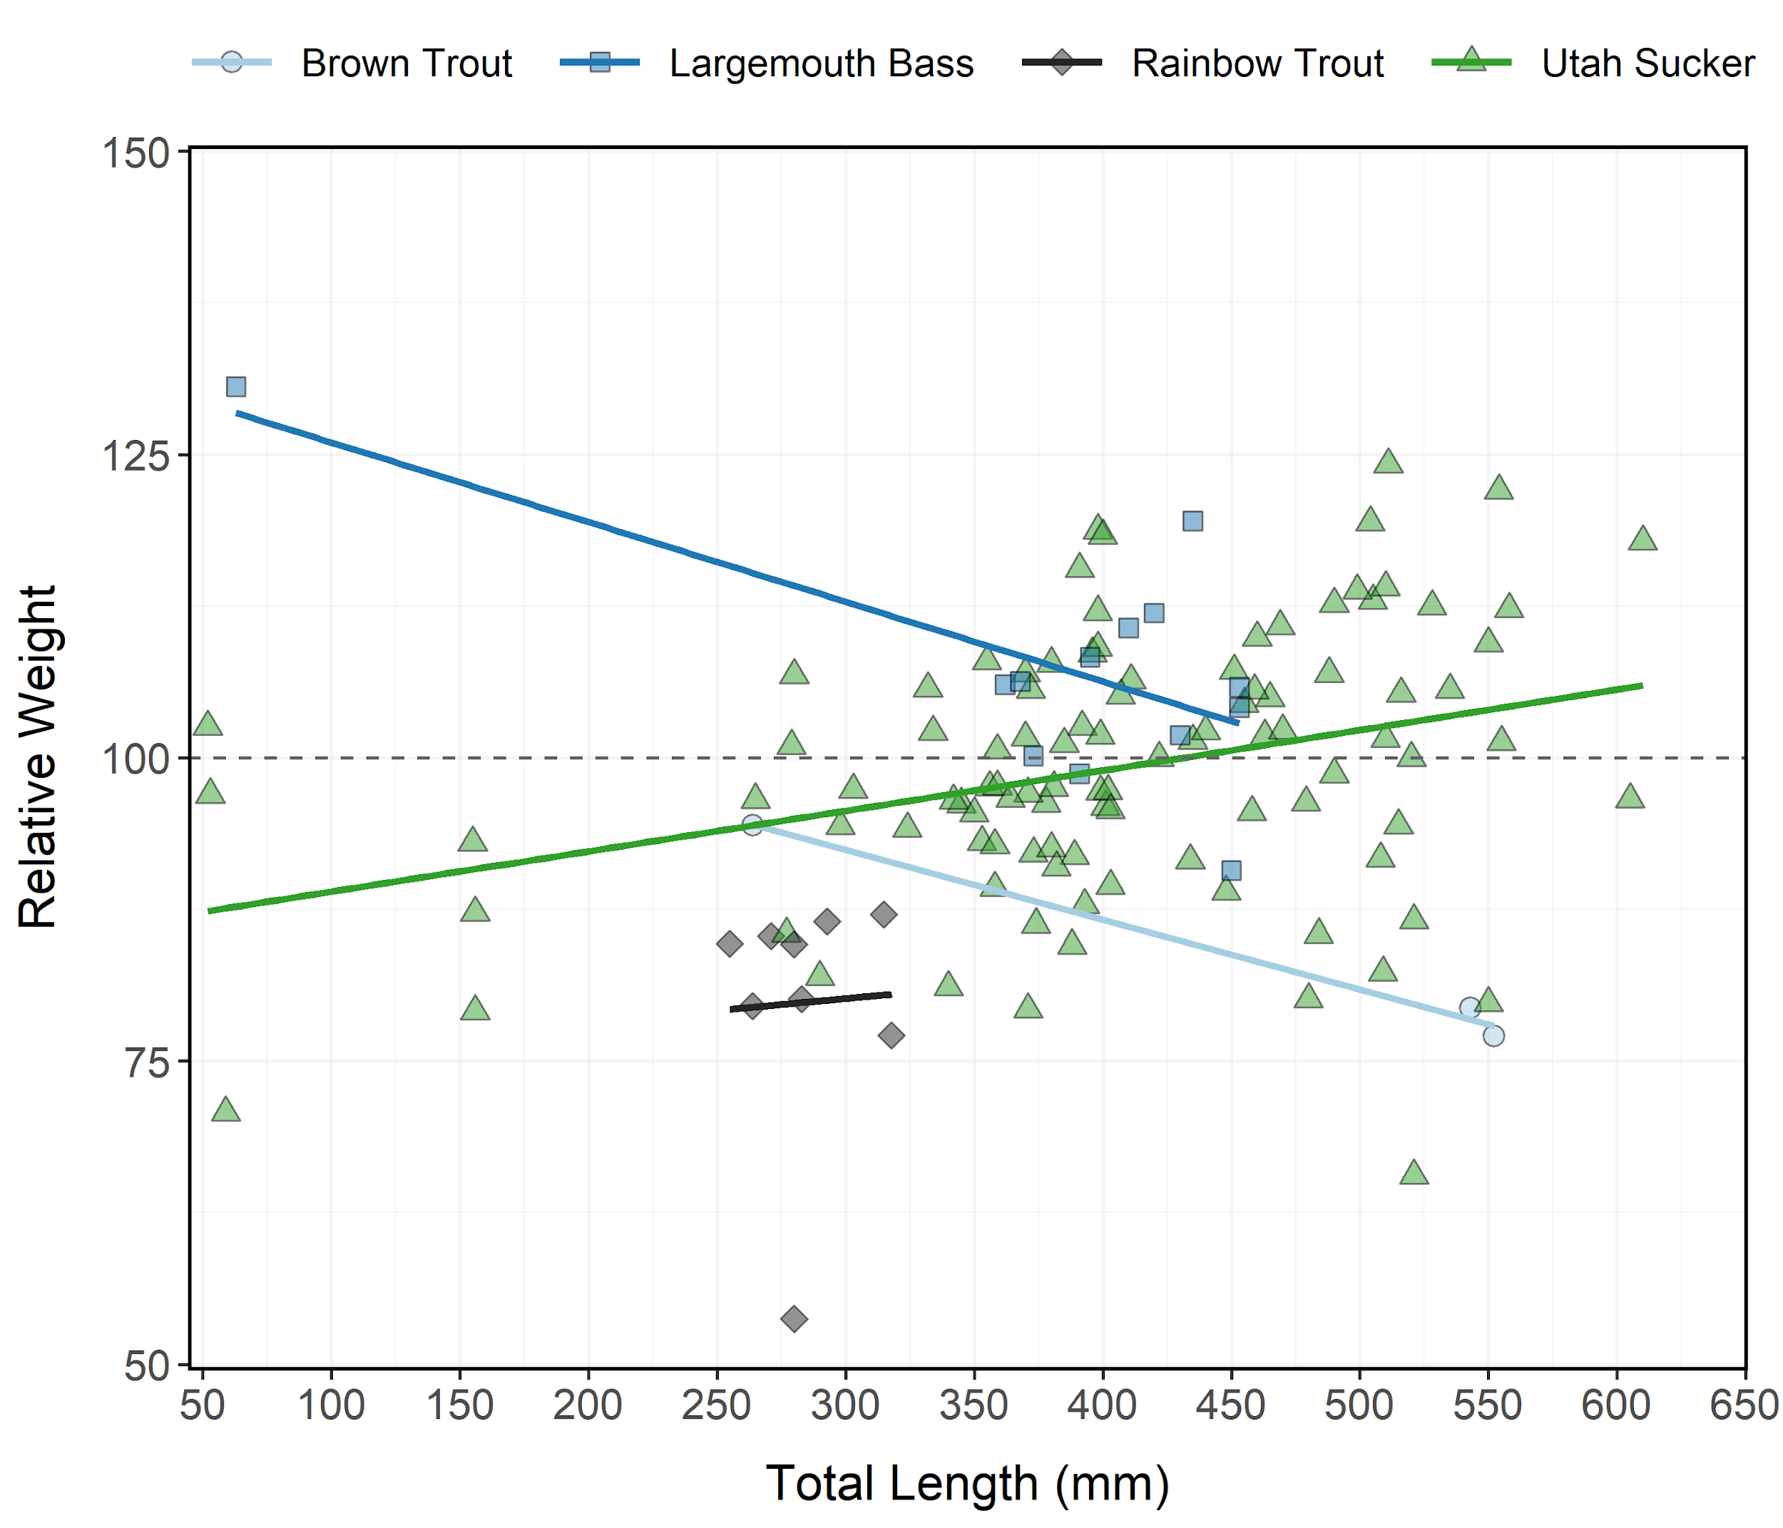

Figure 13: Relative weight (± standard error) of Brown Trout, Largemouth Bass, Rainbow Trout, and Utah Sucker sampled during curtain net and electrofishing surveys from Hyrum Reservoir in 2023 as an index of condition. The horizontal dashed line indicates a 1:1 relationship between standard weight and relative weight. Analyses are restricted to species with more than two observations.

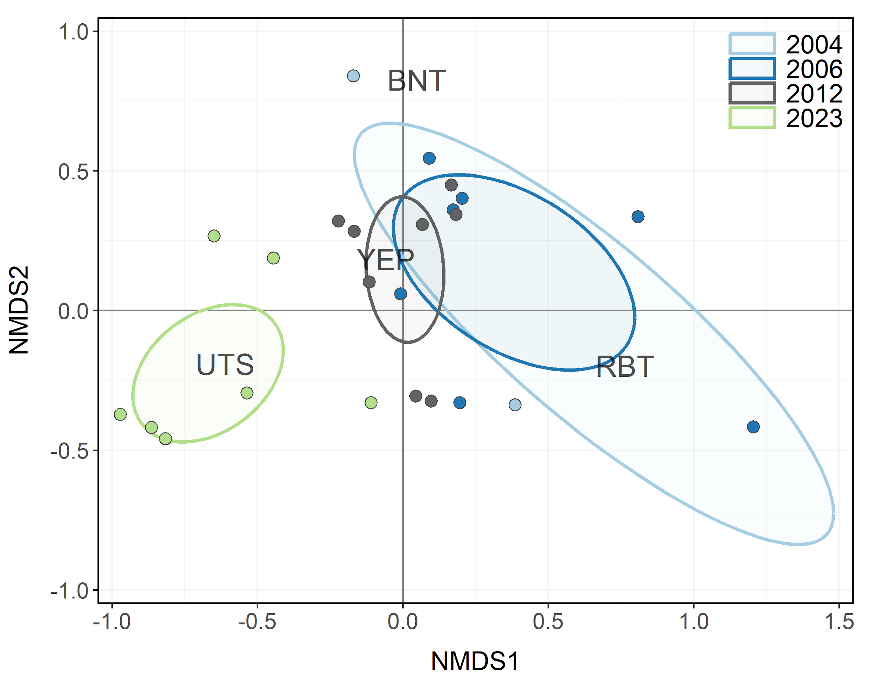

Figure 14: Non-metric multidimensional scaling (NMDS) bi-plot of stock-length Brown Trout, Rainbow Trout, Utah Sucker, and Yellow Perch sampled during gillnet surveys from Hyrum Reservoir between 2004-2023. Points closer together have more similar relative abundances among species. Ellipses highlight the community structure within each year sampled.

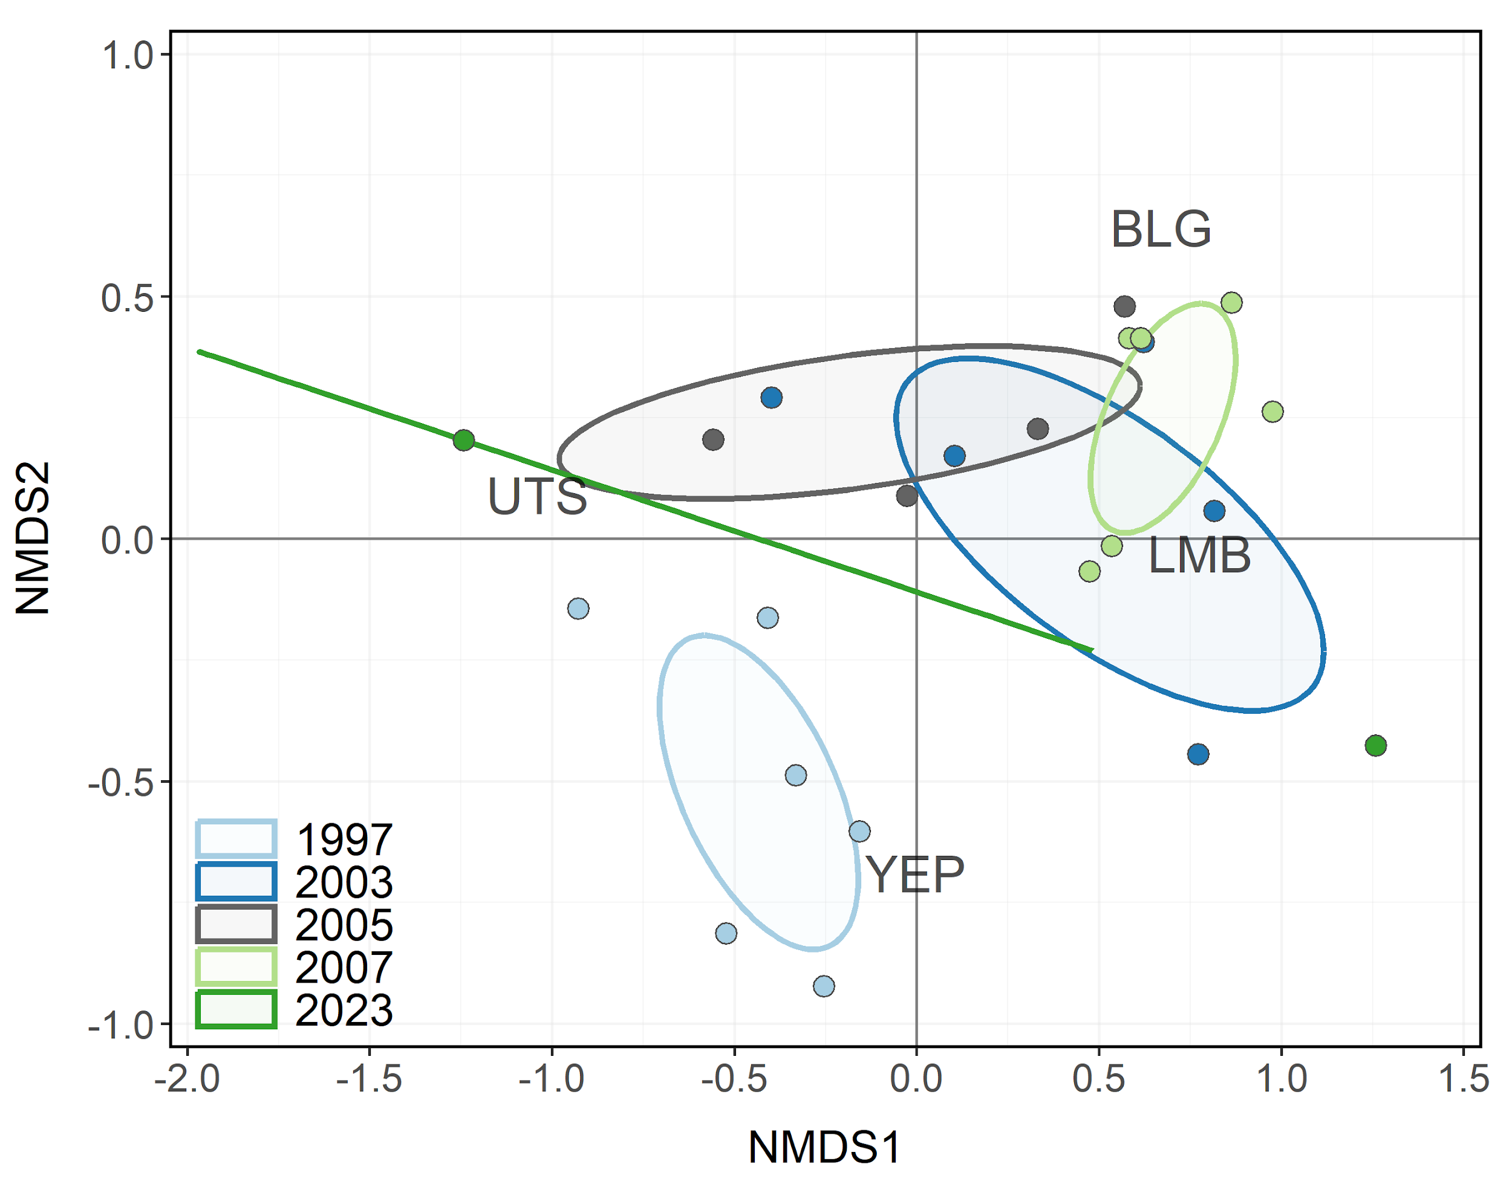

Figure 15: Non-metric multidimensional scaling (NMDS) bi-plot of stock-length Bluegill, Largemouth Bass, Utah Sucker, and Yellow Perch sampled during electrofishing surveys from Hyrum Reservoir between 1997-2023. Points closer together have more similar relative abundances among species. Ellipses highlight the community structure within each year sampled.

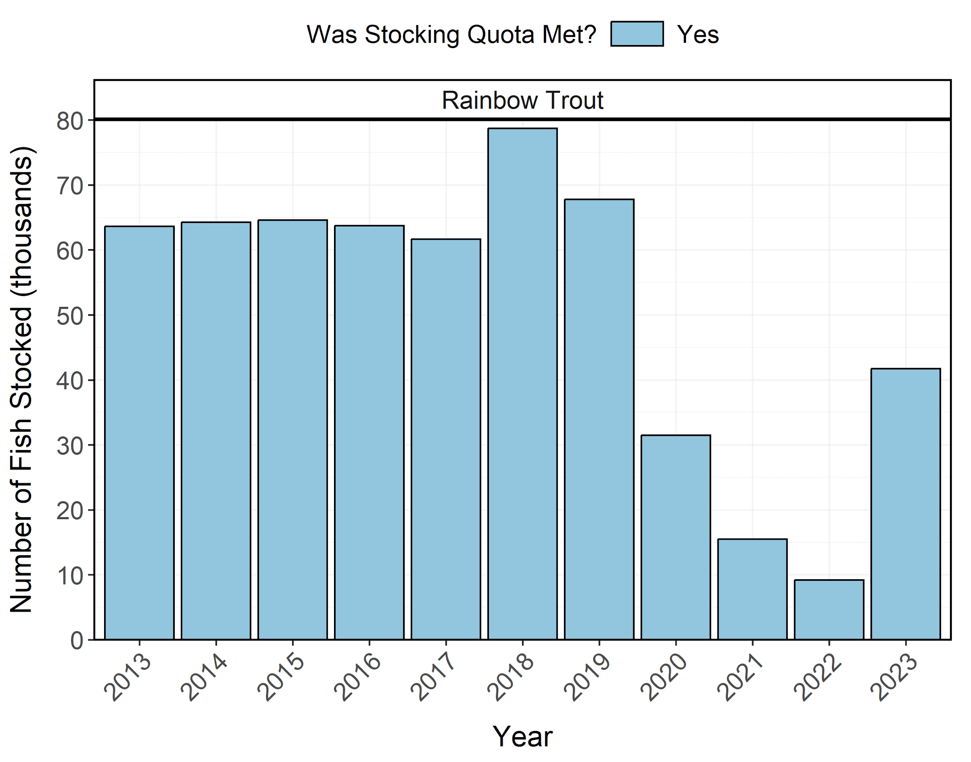

Figure 16: Number of individuals stocked in Hyrum Reservoir from 2013-2023. Length-at-stocking and stocking quota varies among years. A stocking quota was determined to be met if the number of stocked individuals was at least 90% of the stocking quota.