Utah Division of Wildlife Resources Fishery Monitoring Report

**Author**: Taylor R. Stewart  
**Contact**: [taylorstewart@utah.gov](mailto:taylorstewart@utah.gov)

**System**: East Canyon Reservoir  
**Sampling Dates**: 6/8/2023; 6/21/2023 - 6/22/2023  
**Target Species**: Brown Trout, Rainbow Trout, Smallmouth Bass, Utah Sucker, and Wiper  
**Species Stocked**: Kokanee, Rainbow Trout, and Wiper

**Monitoring Objectives**:

1. Provide data for assessment of trends in species occurrence, relative abundance, biomass, and size structure of forage and sport fish assemblages.
2. Evaluate population indices to improve the effectiveness of stocking efforts of Kokanee Salmon (hereafter Kokanee), Rainbow Trout, and Wiper.
3. Establish a naturally reproducing population of Kokanee.
4. Improve size structure of Smallmouth Bass.

**Sampling Design and Methods**:  
*Curtain Nets*  
A new sampling design was implemented in 2023 to improve the effectiveness of sampling methods in reservoirs that contain Kokanee and in deep reservoirs where benthic gillnets do not effectively quantify species that occupy pelagic habitats. The sampling design used experimental gillnets with extended depths (*i.e.,* curtain gillnets) suspended in the water column, thus giving managers the ability to sample benthic and pelagic habitats simultaneously or sample stratified portions of the pelagic fish community. Sampling occurred in the spring. Three curtain gillnets were suspended in the pelagic zone at 6-m depth intervals ranging from 0 to 18-m depth and an additional gillnet was set nearshore with 6 m of water to sample the benthic and littoral habitats (Table 1). All gillnets were 45.7 m long by 6.1 m deep with six 7.6-m panels that had bar mesh sizes of 13, 19, 25, 38, 51, and 64 mm. Nets were set overnight and retrieved at dawn. This sampling design was replicated at two sampling sites in distinct regions of the reservoir (Figure 1).

Prior to 2023, experimental benthic gillnets were used to conduct sampling. Benthic gillnets were 24.8 m long by 1.8 m deep with eight 3.1-m panels that had bar mesh sizes of 19, 25, 32, 38, 44, 51, 57, and 64 mm. The change in gear types precludes our ability to analyze data prior to 2022 as the assumptions that catchability was constant between gear types was violated.

*Boat Electrofishing*  
Shoreline boat electrofishing was conducted to sample the littoral fish community. Ten standardized transects were sampled with an electrofishing boat equipped with a Smith-Root, Inc. Apex Electrofisher Control Box (Figure 1). Electricity output from each second of active electrofishing was logged (Table 2). Transects were sampled for a total of 10 minutes.

*Statistical Methods*  
All fish caught were identified to species and measured for total length (mm) and weight (g). Gillnet and electrofishing data were combined to increase the sample size and statistical inference of size structure analyses. Relative abundance (*i.e.,* catch-per-unit-effort) and biomass were analyzed as the respective number or weight for each species per net-night or hour of electrofishing. Size structure was presented as an empirical cumulative distribution function (ECDF) and a histogram. The ECDF, which is the proportion of fish that are less than each observed length, was used to analyze changes among years while the histogram was used to show the frequency of individuals in each length interval for a single year. Weight-length residuals and relative weight were used as condition metrics. Changes in the fish community composition were analyzed among years using non-metric multidimensional scaling.

**Summary**:  
*Species Composition*  
Fish catches were comprised of Black Crappie, Brown Trout, Cutthroat Trout, Rainbow Trout, Smallmouth Bass, Utah Sucker, and Wiper (Figures 2 & 3). No Kokanee were observed. Rainbow Trout were the most abundant species by number caught (61.7%) and weight (46.5%) in curtain nets (Figure 2). Smallmouth Bass were the most abundant species by number caught (79.1%) and Rainbow Trout were the most abundant species by weight (59.1%) along electrofishing transects (Figure 3).

*Abundance*  
Rainbow Trout mean relative abundances were 11.6 fish/net-night (SE = 3.6) and 23.8 fish/hour (SE = 9.9), and had the highest relative abundance in the 0 to 6-m depth zones (Figures 4, 5, & 6). Wiper mean relative abundance was 5.0 fish/net-night (SE = 2.1) with the highest catch rate in the preferred-length category (Figure 4). Smallmouth Bass mean relative abundance was 20.1 fish/hour (SE = 4.3) and decreased by 31.1% from sampling conducted in 2019 (Figure 5). Catch rates of quality-length or greater Smallmouth Bass remain low (Figure 8). The relative abundance of Utah Sucker decreased to a 15-year low (mean = 0.9 fish/hour, SE = 0.9) and decreased by 84.9% from 2019 (Figures 5).

*Biomass*  
Wiper relative biomass was high (mean = 8.4 kg/net-night; SE = 3.2) but the lack of historical data prevents knowing normal bounds for this species (Figure 9). The mean relative biomass of Rainbow Trout, Smallmouth Bass, and Utah Sucker decreased (range = 29.2-92.9%) from sampling conducted in 2019 but was not significant expect for Utah Sucker (Figures 10).

*Size Structure*  
The size structure of Rainbow Trout decreased but Rainbow Trout in the quality-length category or larger remain abundant (Figures 11 & 12). Smallmouth Bass size structure remains stunted with few individuals growing outside of the stock-length category. Wiper continue to improve in length with multiple individuals caught in the preferred and memorable-length categories. Shifts in length distributions between 2019 and 2023 were statistically different, based on a bootstrapped Kolmogorov-Smirnov test, for Rainbow Trout (*P* = 0.001), Smallmouth Bass (*P* < 0.001), and Wiper (*P* = 0.001; Figure 11).

*Condition*  
Relative weights of Brown Trout, Rainbow Trout, and Utah Sucker had a negative relationship with total length (Figure 14). Smallmouth Bass relative weights were highly variable in fish under 125 mm and decreased as total length increased. Wiper relative weight remained stable (Figure 14).

*Community Structure*  
The fish community has not had any strong shifts over time, with the exception of a decrease in the relative importance of Utah Sucker in the fish community (Figure 15).

*Stocking*  
Stocking quotas are largely being met and maintained (Figure 16). Reestablishing Kokanee stocking will be imperative to support recent efforts to establish this fishery and not squander three years of stocking. No Kokanee spawning has been observed and this fishery will need to be maintained through stocking.

All other measurements and indices appear within normal bounds.

**Management Actions**:

1. Continue to perform the new sampling design with curtain gillnets. After an additional two years of data collection, a power analysis will be conducted to determine the effectiveness of the new sampling design. Sampling effort may need to increase to provide accurate and reliable population estimates.
2. Evaluate the stocking program of Kokanee. Three years of stocking Kokanee were performed in an attempt to establish a naturally-reproducing population. No stocking was performed in 2023 because of a low number of broodstock spawning, limiting the number of offspring available to be stocked throughout the state. The inlet river was monitored in 2023 to see if adult Kokanee were running up the river to spawn. Low numbers of Kokanee (<10 fish) were observed 0.75-km up the river staging below a passable culvert barrier. Additional years of monitoring are required to determine if the current stocking program is effective. Current recommendation is to increase Kokanee stocking density from 19,000 to 65,800 in 2024.
3. Observe Smallmouth Bass populations to ensure the population is at a low enough density to limit stunted growth. The recent increase in Wiper abundance has the potential to apply top-down control or induce interspecific competition (*i.e.,* compete for limited food resources). However, knowledge on the lower benthic food web (*e.g.,* macroinvertebrates, freshwater crustaceans) is absent, and should be considered as a potential growth bottleneck, and an area of need for monitoring. Benthic Ponar grabs and(or) crayfish traps should be deployed in 2024 if extra sampling time exists.
4. Continue to promote Smallmouth Bass harvest through outreach. A social media post was made in 2023 highlighting this survey, in particular the increasing quality of the Wiper fishery and the need to harvest Smallmouth Bass.
5. Wiper appear to be an effective biological control for Utah Sucker since being introduced in 2014 but have accrued a significant portion of the sportfish biomass present in the reservoir. Current recommendation is to decrease Wiper stocking rates from 25 to 18 fish/acre (*i.e.,* 15,000 to 10,900 fingerlings).

**Tables:**

Table 1: Date of collection, number of samples collected by sampling gear type, prescribed number samples by sampling gear type, mean water temperature (°C), and any additional data collected from East Canyon Reservoir in 2023.

| Gear Type | Date | # of Samples | # of Prescribed Samples | Water Temperature | Additional Comments |
| --- | --- | --- | --- | --- | --- |
| Boat Electrofishing | 6/8/2023 | 6 | 6 | – | – |
| Curtain Gillnets | 6/21/2023 - 6/22/2023 | 8 | 8 | 17.4 | – |

Table 2: Mean voltage (volts), current (amps), and power (watts) while actively electrofishing and the waveform (voltage, pulse-width, and frequency) settings for each electrofishing transect from East Canyon Reservoir in 2023.

| Transect ID | Mean Voltage | Mean Current | Mean Power | Waveform |
| --- | --- | --- | --- | --- |
| 1 | 126.0 | 12.9 | 1632.5 | 300V, 25%, 30Hz |
| 2 | 127.8 | 12.5 | 1604.3 | 300V, 25%, 30Hz |
| 3 | 126.9 | 13.3 | 1683.8 | 300V, 25%, 30Hz |
| 4 | 125.8 | 13.9 | 1750.7 | 300V, 25%, 30Hz |
| 5 | 125.6 | 14.1 | 1767.8 | 300V, 25%, 30Hz |
| 6 | 126.7 | 13.8 | 1747.4 | 300V, 25%, 30Hz |

Table 3: Mean total length (TL; mm), mean weight (WT; g), mean relative weight (Wr), and percentage of individuals within each traditional proportional size distribution (PSD) category for each trapnet target species from East Canyon Reservoir in 2023. All values in parentheses indicate standard deviation.

| Target Species | Mean TL | Mean WT | Mean Wr | PSD-  Quality | PSD-  Preferred | PSD-  Memorable | PSD-  Trophy |
| --- | --- | --- | --- | --- | --- | --- | --- |
| Brown Trout | 357.9  (136.1) | 672.9  (545.0) | 97.8  (16.8) | 67 | 56 | 0 | 0 |
| Rainbow Trout | 387.7  (72.8) | 677.2  (367.6) | 92.5  (17.4) | 30 | 7 | 0 | 0 |
| Utah Sucker | 408.5  (145.7) | 1027.2  (806.6) | 109.0  (15.5) | 100 | 60 | 40 | 20 |
| Wiper | 463.5  (127.8) | 1616.9  (969.2) | 92.1  (30.2) | 70 | 57 | 3 | 0 |

Table 4: Mean total length (TL; mm), mean weight (WT; g), mean relative weight (Wr), and percentage of individuals within each traditional proportional size distribution (PSD) category for each electrofishing target species from East Canyon Reservoir in 2023. All values in parentheses indicate standard deviation.

| Target Species | Mean TL | Mean WT | Mean Wr | PSD-  Quality | PSD-  Preferred | PSD-  Memorable | PSD-  Trophy |
| --- | --- | --- | --- | --- | --- | --- | --- |
| Rainbow Trout | 318.2  (103.0) | 455.4  (326.9) | 92.5  (17.4) | 30 | 7 | 0 | 0 |
| Smallmouth Bass | 138.2  (65.8) | 68.5  (127.0) | 126.8  (36.7) | 17 | 0 | 0 | 0 |
| Utah Sucker | 495.7  (72.7) | 1580.4  (568.7) | 109.0  (15.5) | 100 | 60 | 40 | 20 |

**Figures:**

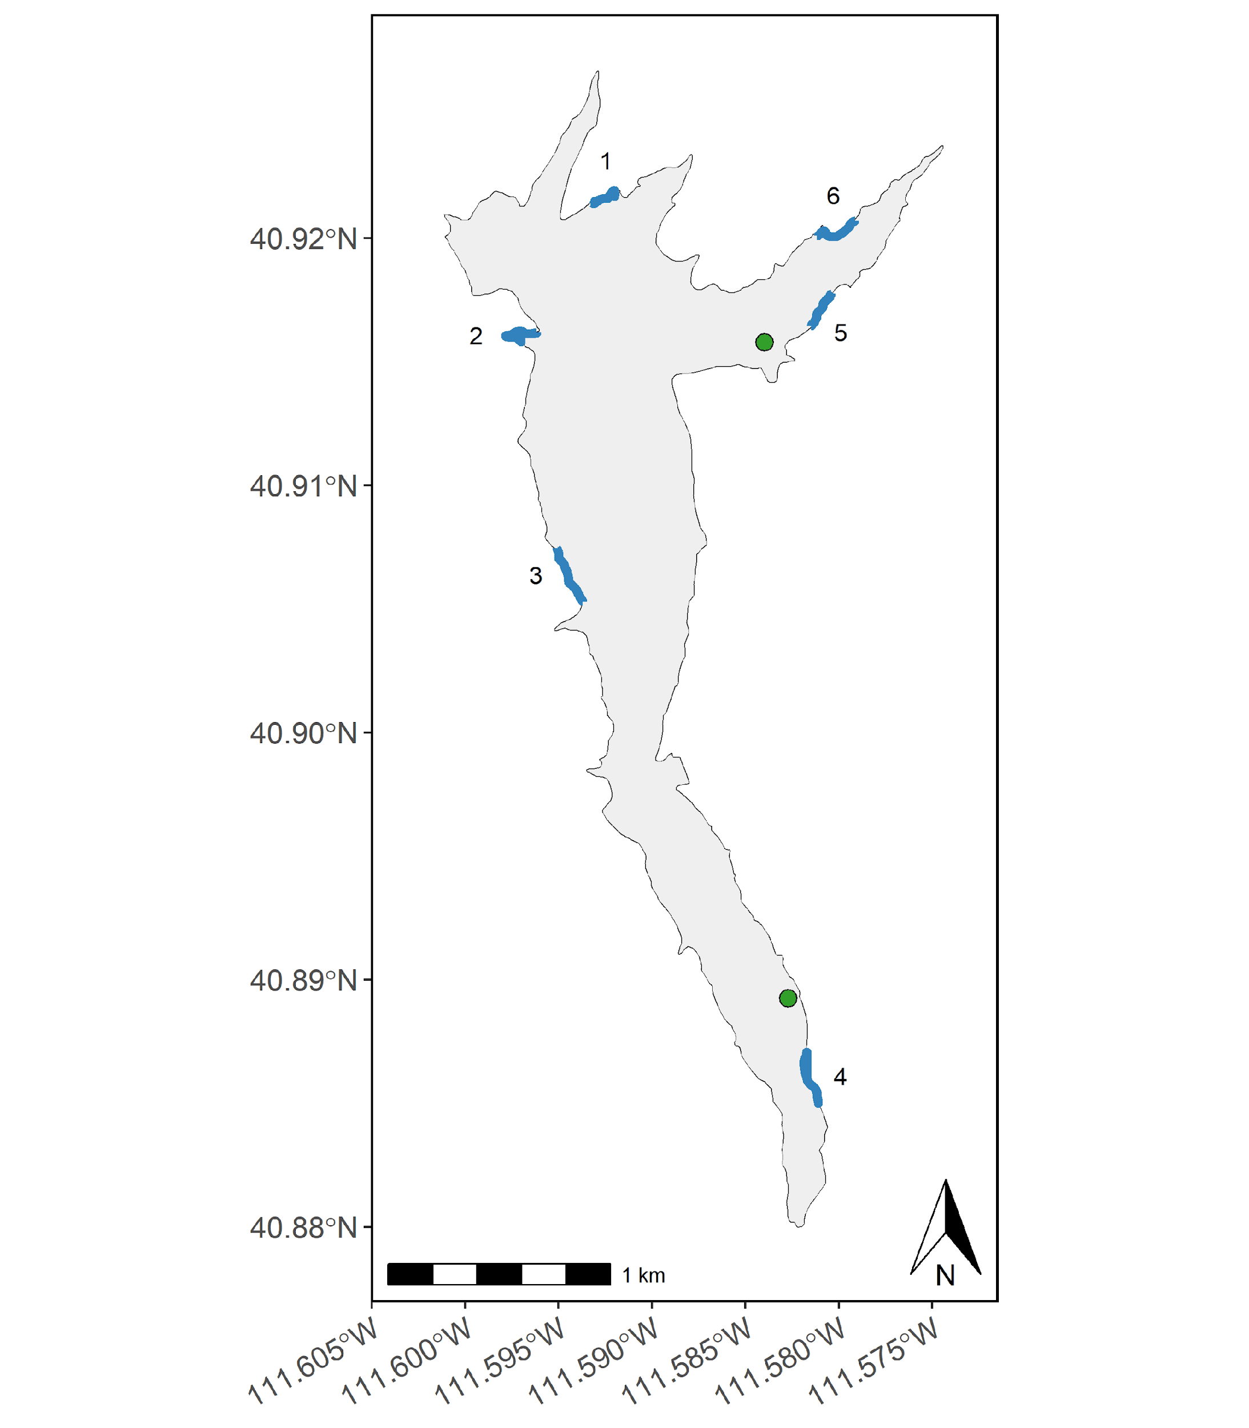

Figure 1: Map of East Canyon Reservoir sampling sites. Curtain nets are denoted as black circles and boat electrofishing transects are denoted as blue shoreline.

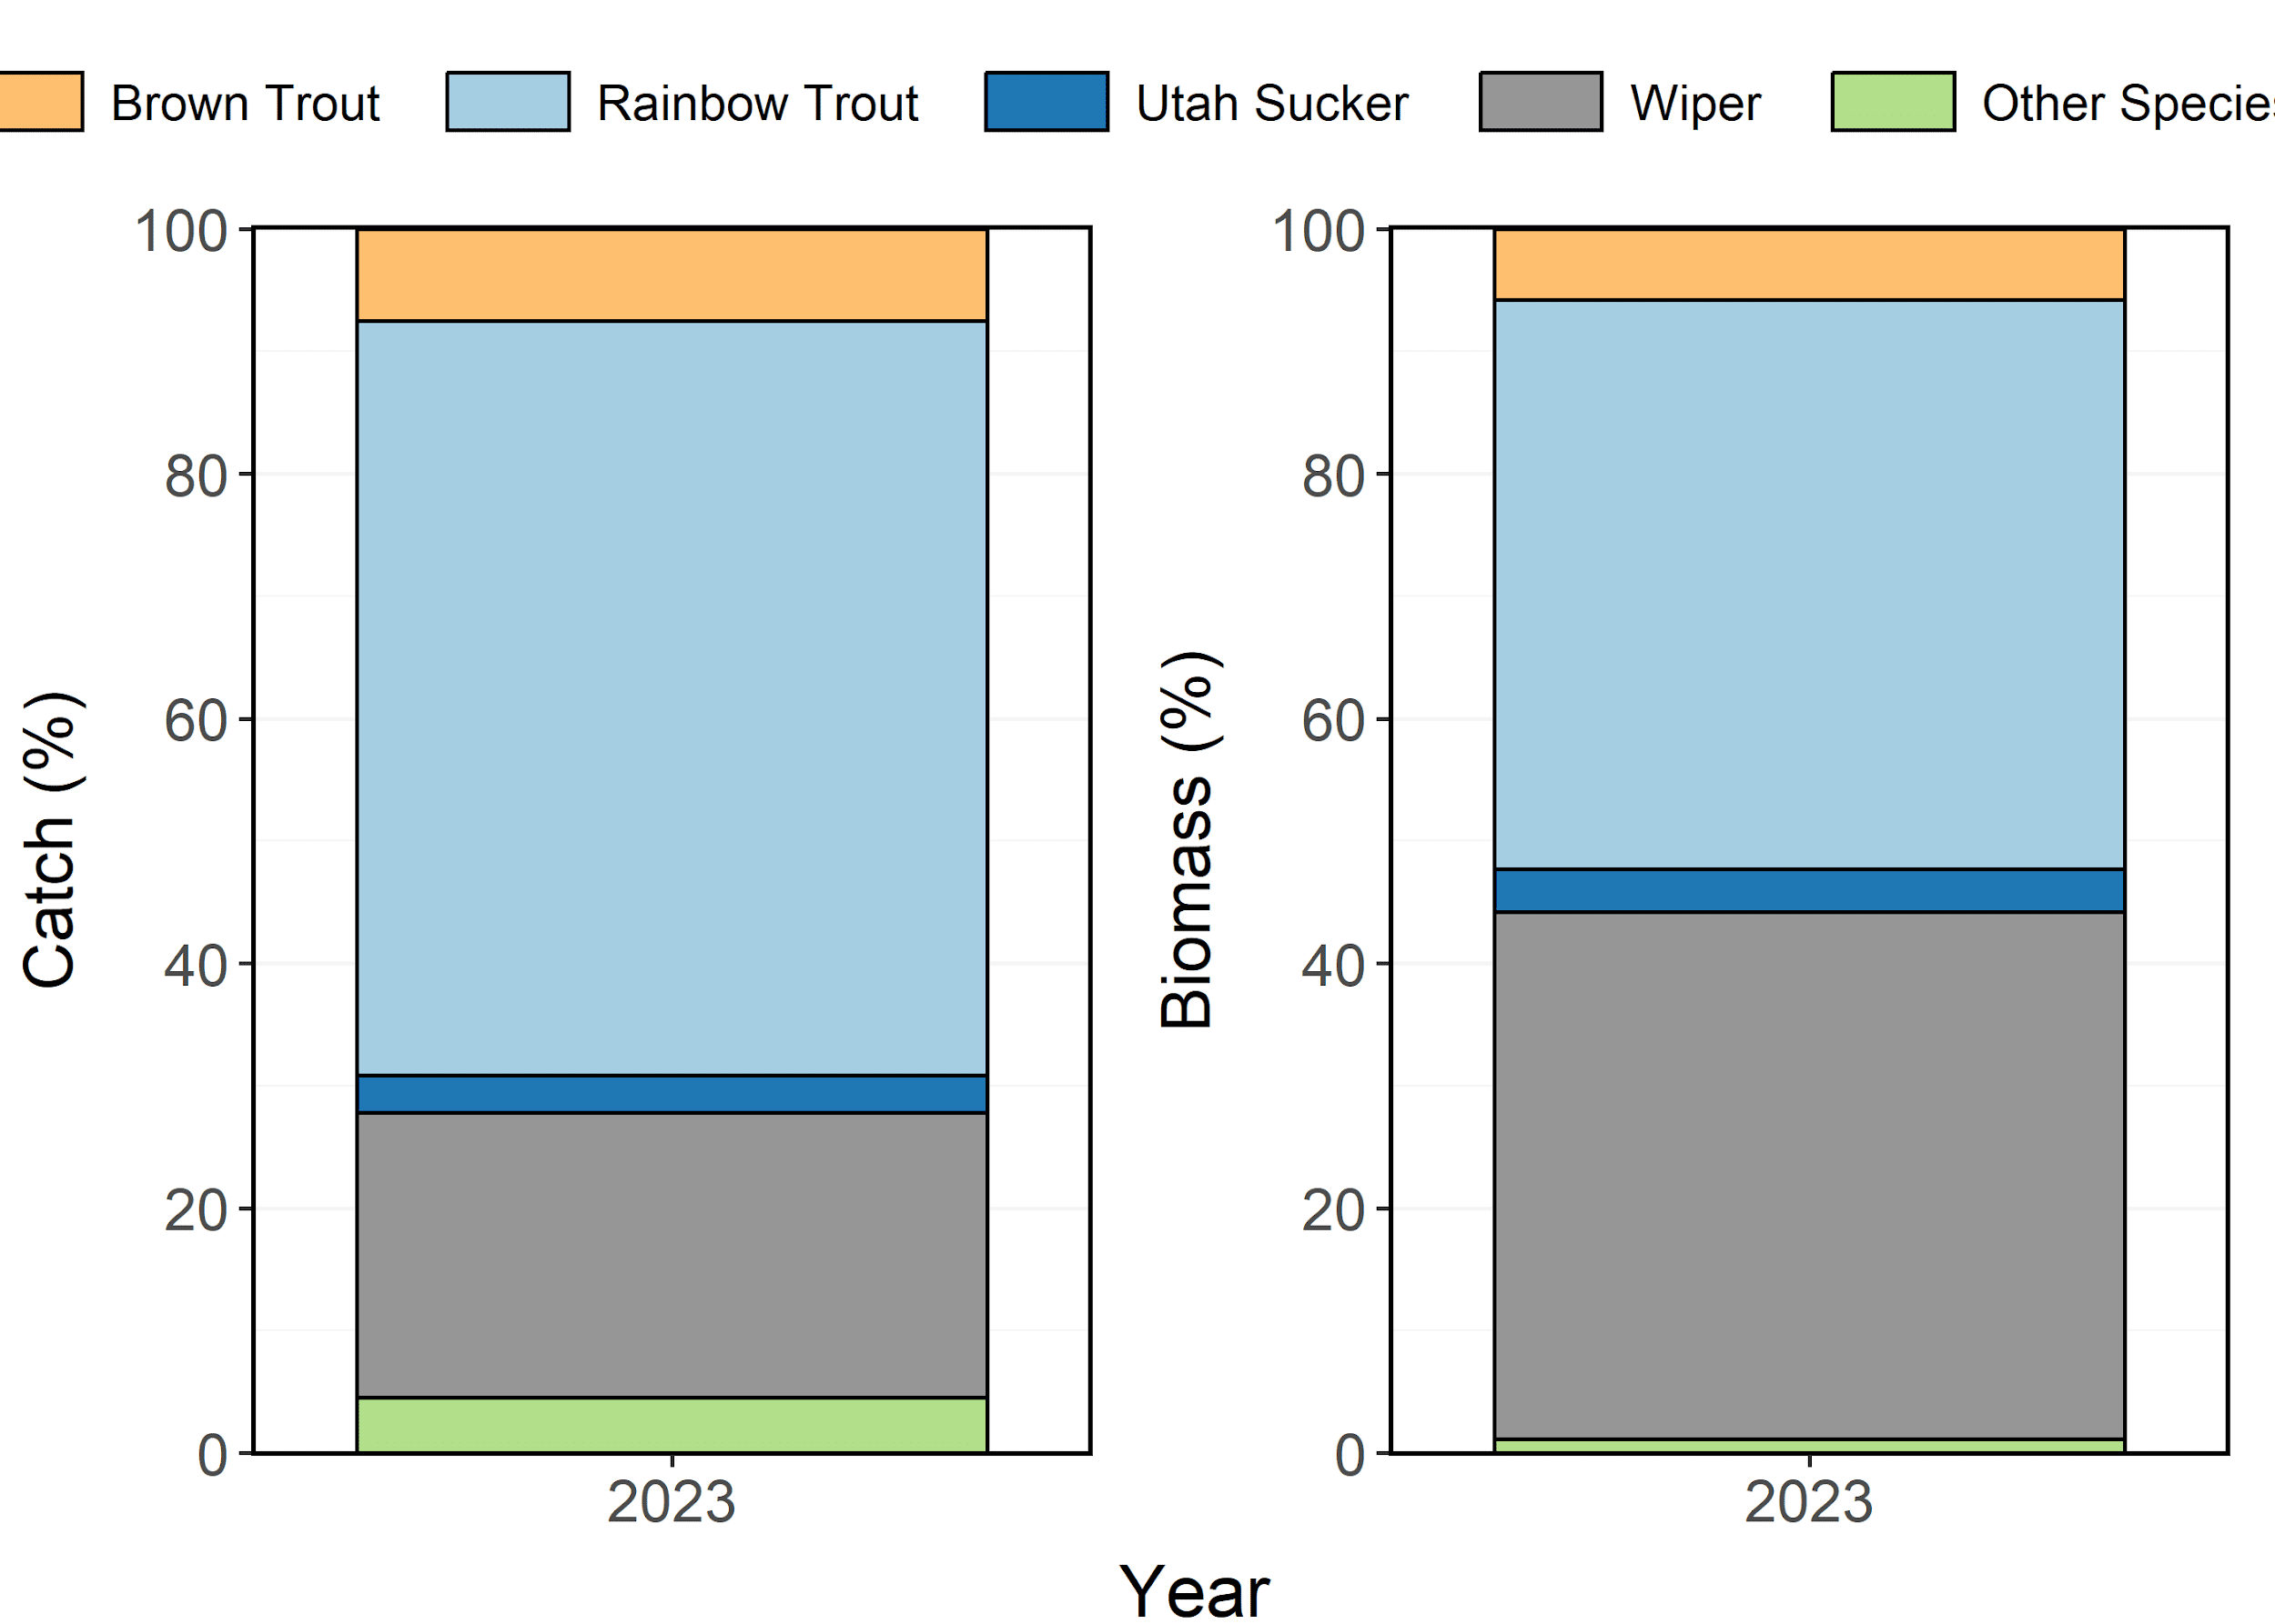

Figure 2: Species composition (%) by catch (# of fish) and biomass (kg) of Brown Trout, Rainbow Trout, Utah Sucker, and Wiper sampled in curtain nets from East Canyon Reservoir in 2023. Other species include Cutthroat Trout and Smallmouth Bass aggregated together.

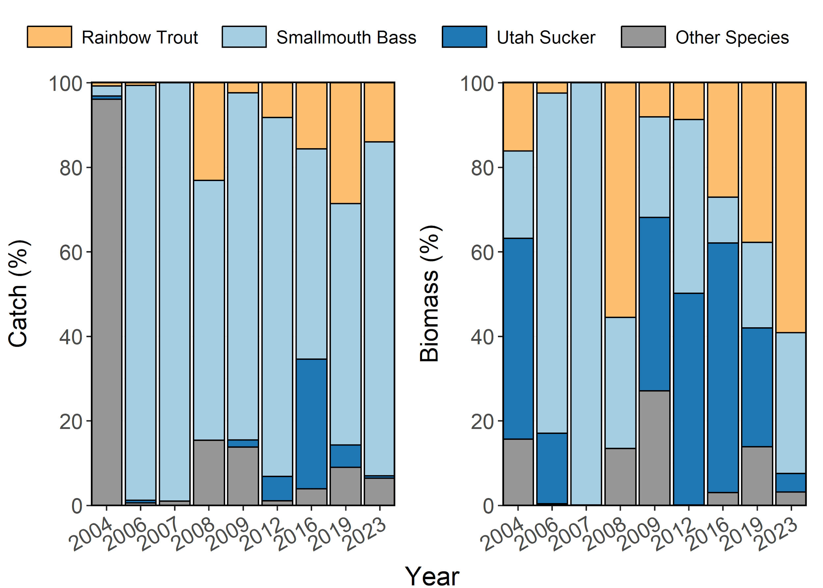

Figure 3: Species composition (%) by catch (# of fish) and biomass (kg) of Rainbow Trout, Smallmouth Bass, and Utah Sucker sampled during electrofishing surveys from East Canyon Reservoir between 1997-2023. Other species include Black Crappie and Brown Trout aggregated together.

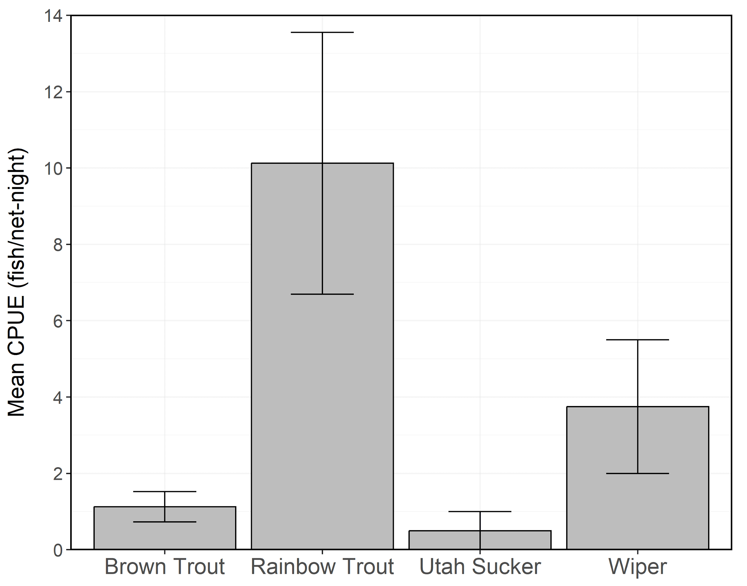

Figure 4: Mean relative abundance (CPUE; fish/net-night) of stock-length Brown Trout, Rainbow Trout, Utah Sucker, and Wiper sampled in curtain nets from East Canyon Reservoir in 2023. Error bars indicate standard error.

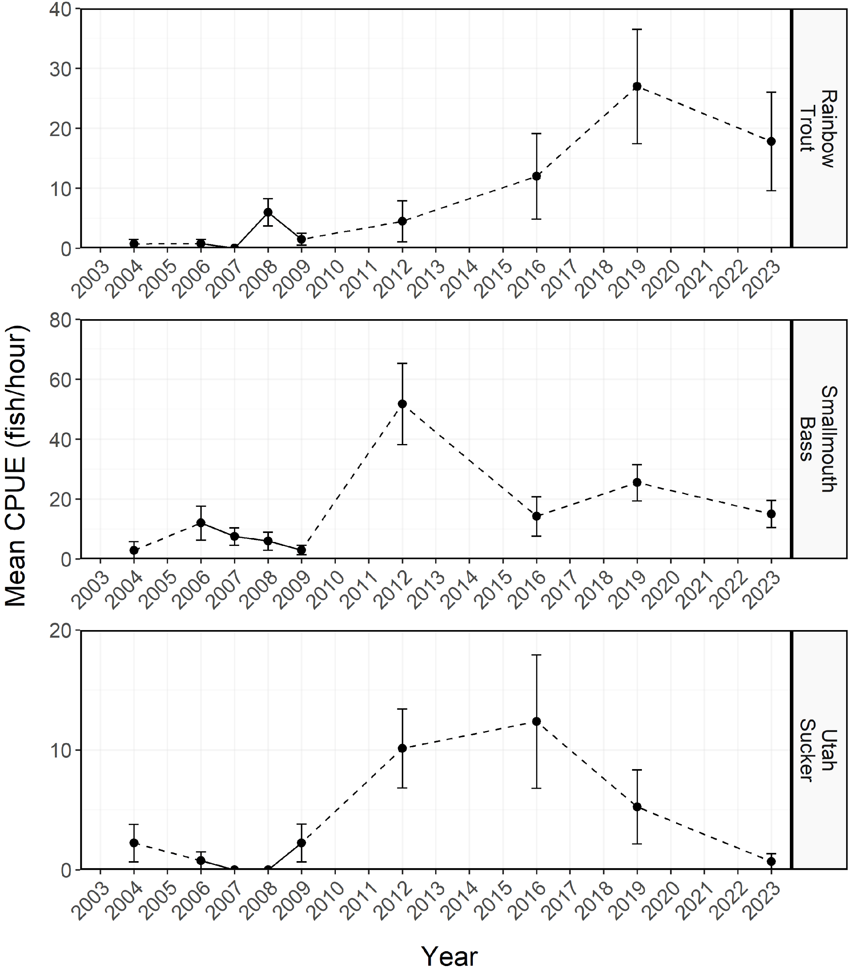

Figure 5: Mean relative abundance (CPUE; fish/net-night) of stock-length Rainbow Trout, Smallmouth Bass, and Utah Sucker sampled during electrofishing survey from East Canyon Reservoir between 1997-2023. Dashed lines represent interpolation across years of missing data between points. Error bars indicate standard error.

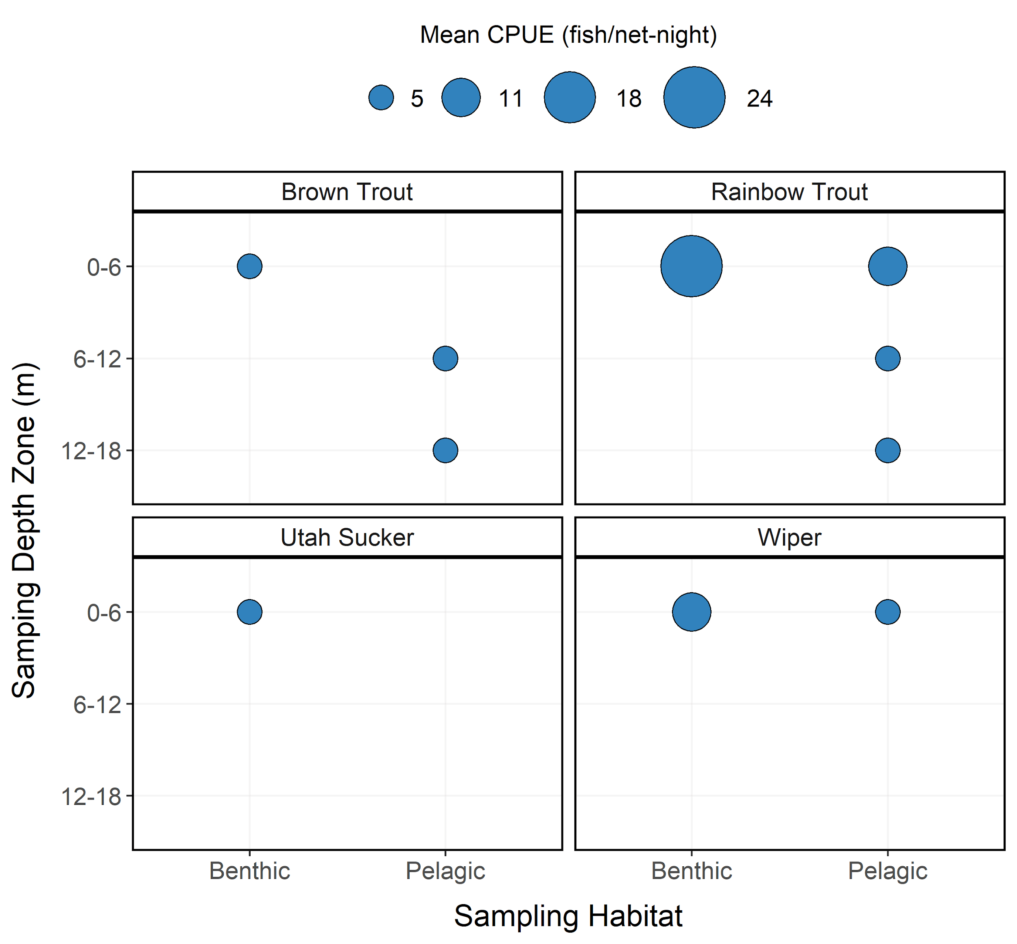

Figure 6: Mean relative abundance (CPUE; fish/net-night) of Brown Trout, Rainbow Trout, Utah Sucker, and Wiper at each sampling depth and habitat zones from East Canyon Reservoir in 2023. CPUE is depicted with varying point size and the diameter of the point is directly proportional to CPUE. No sampling was conducted in the 6-12 and 12-18 m depth zones for benthic habitat.

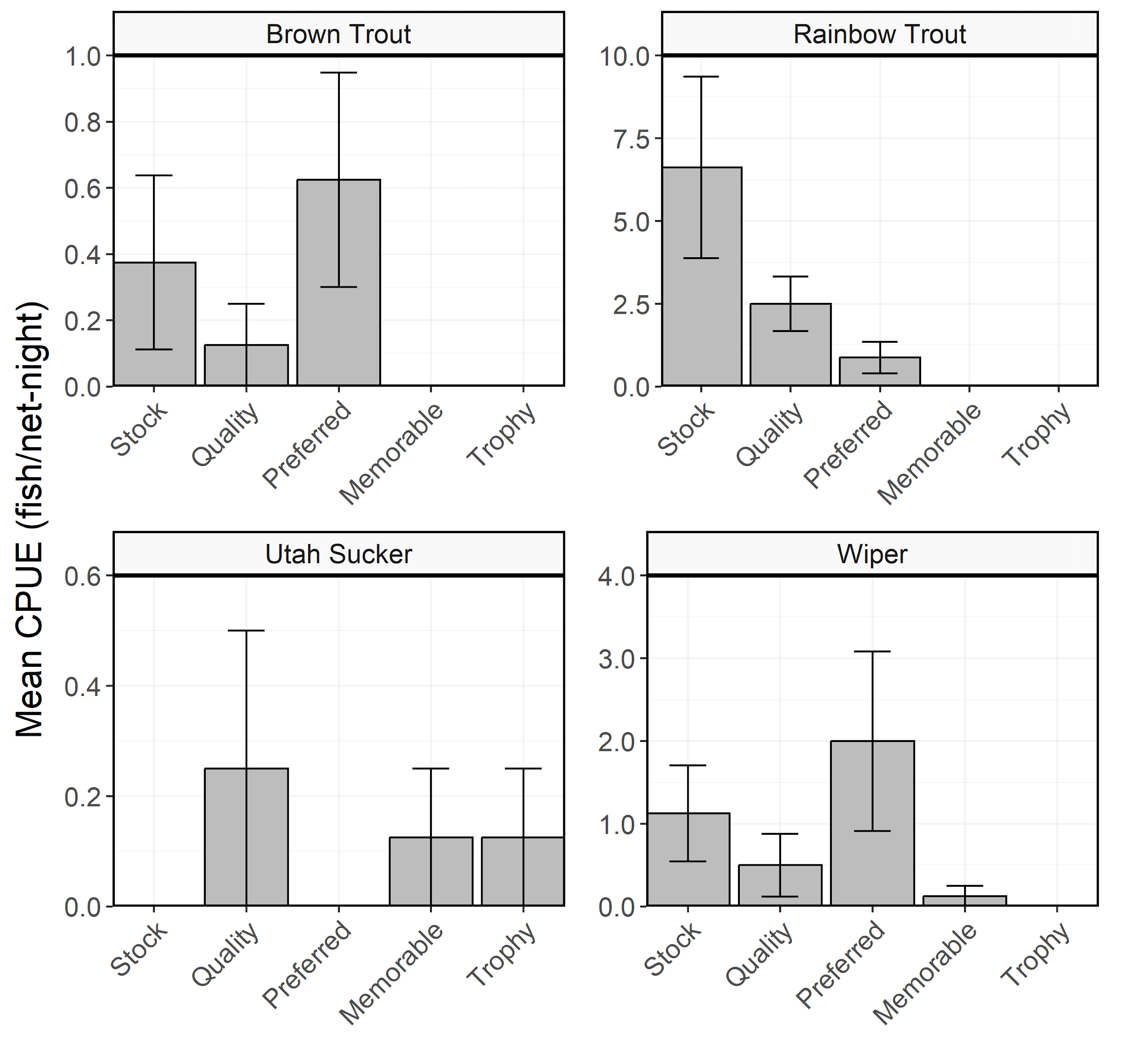

Figure 7: Mean relative abundance (CPUE; fish/net-night) of Brown Trout, Rainbow Trout, Utah Sucker, and Wiper within each Gablehouse length category sampled in curtain nets from East Canyon Reservoir in 2023. Error bars indicate standard error.

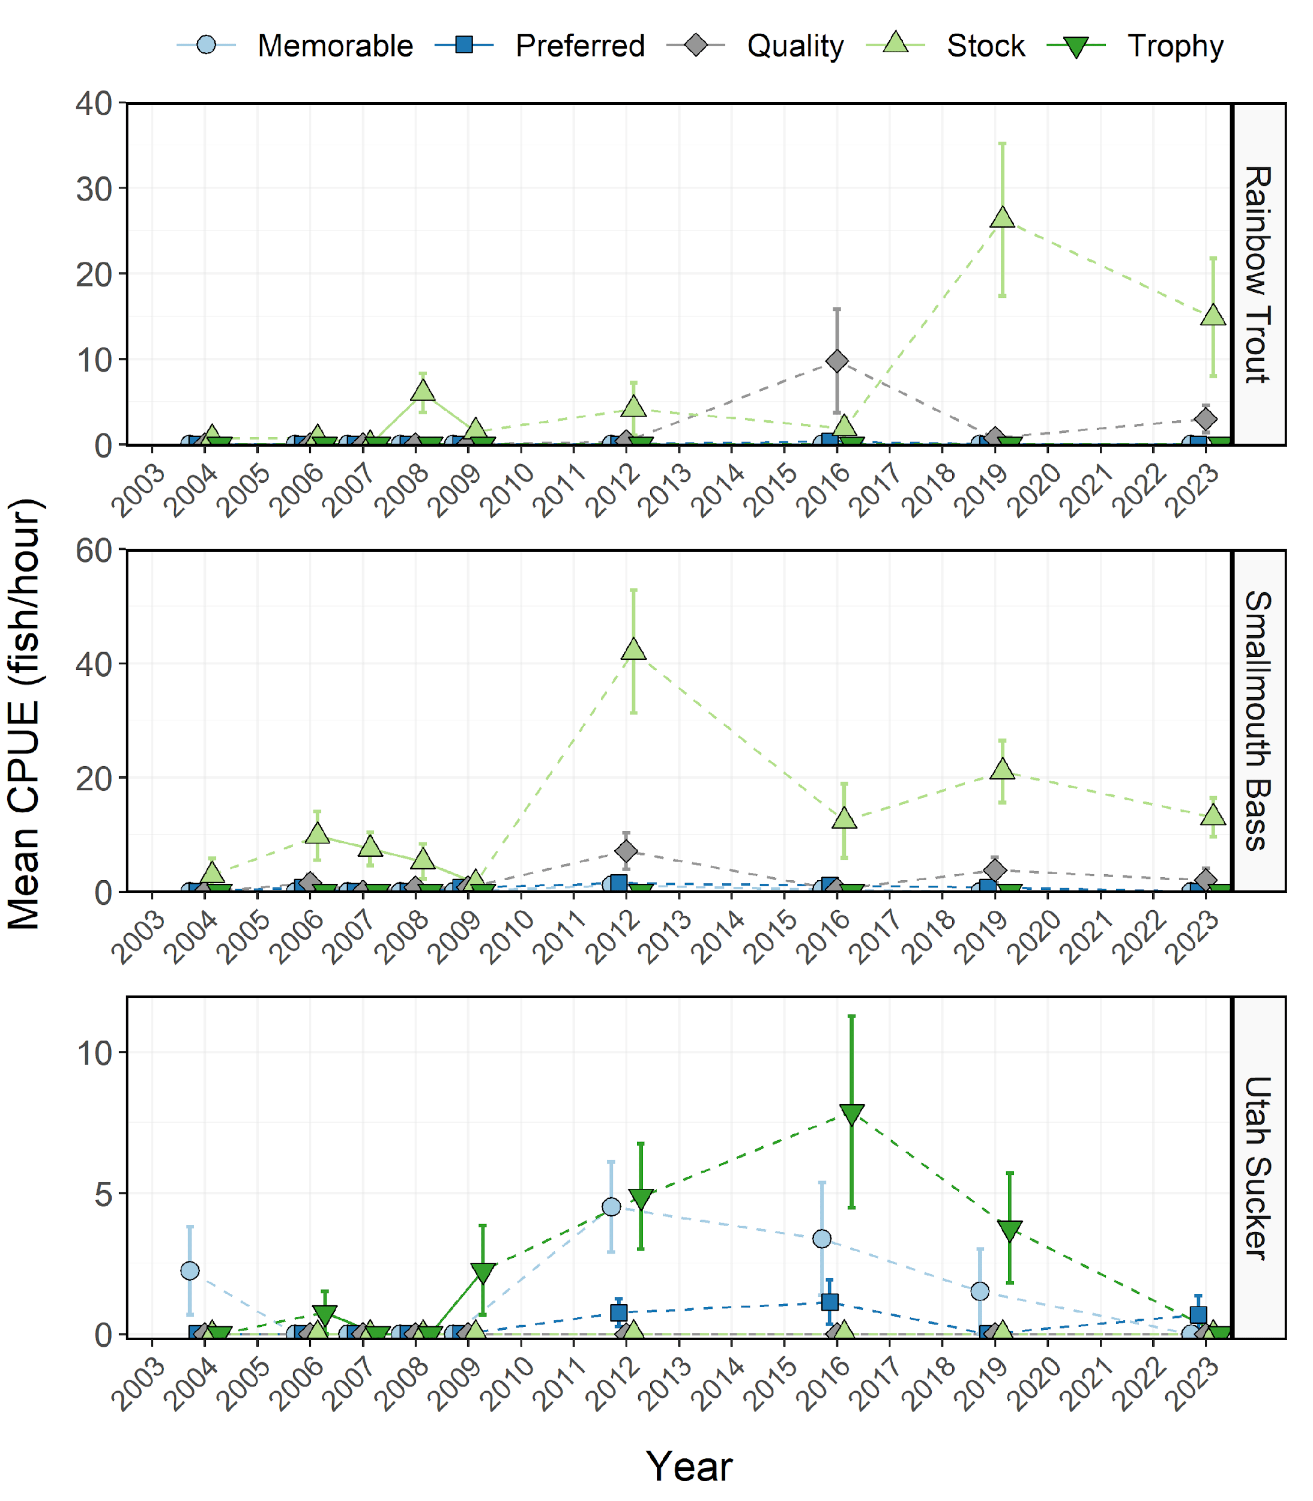

Figure 8: Mean relative abundance (CPUE; fish/net-night) of Rainbow Trout, Smallmouth Bass, and Utah Sucker within each Gablehouse length category sampled during electrofishing surveys from East Canyon Reservoir between 1997-2023. Dashed lines represent interpolation across years of missing data between points. Error bars indicate standard error.

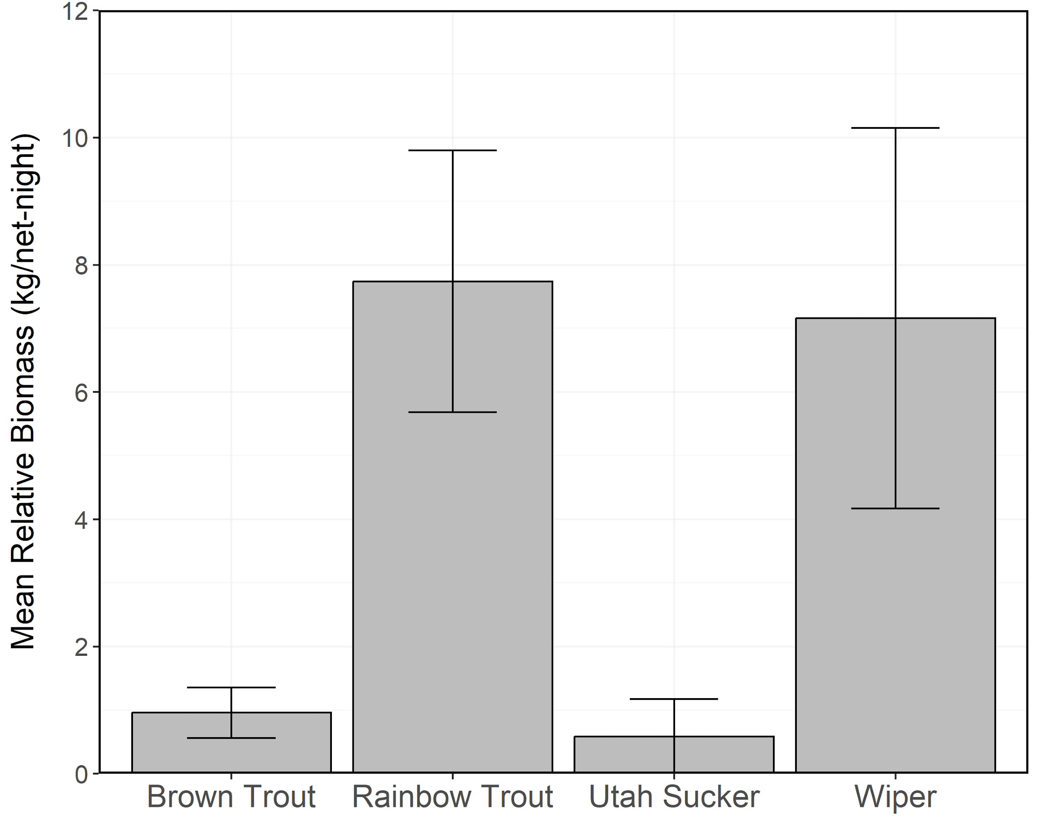

Figure 9: Mean relative biomass (kg/net-night) of stock-length Brown Trout, Rainbow Trout, Utah Sucker, and Wiper sampled in curtain nets from East Canyon Reservoir in 2023. Error bars indicate standard error.

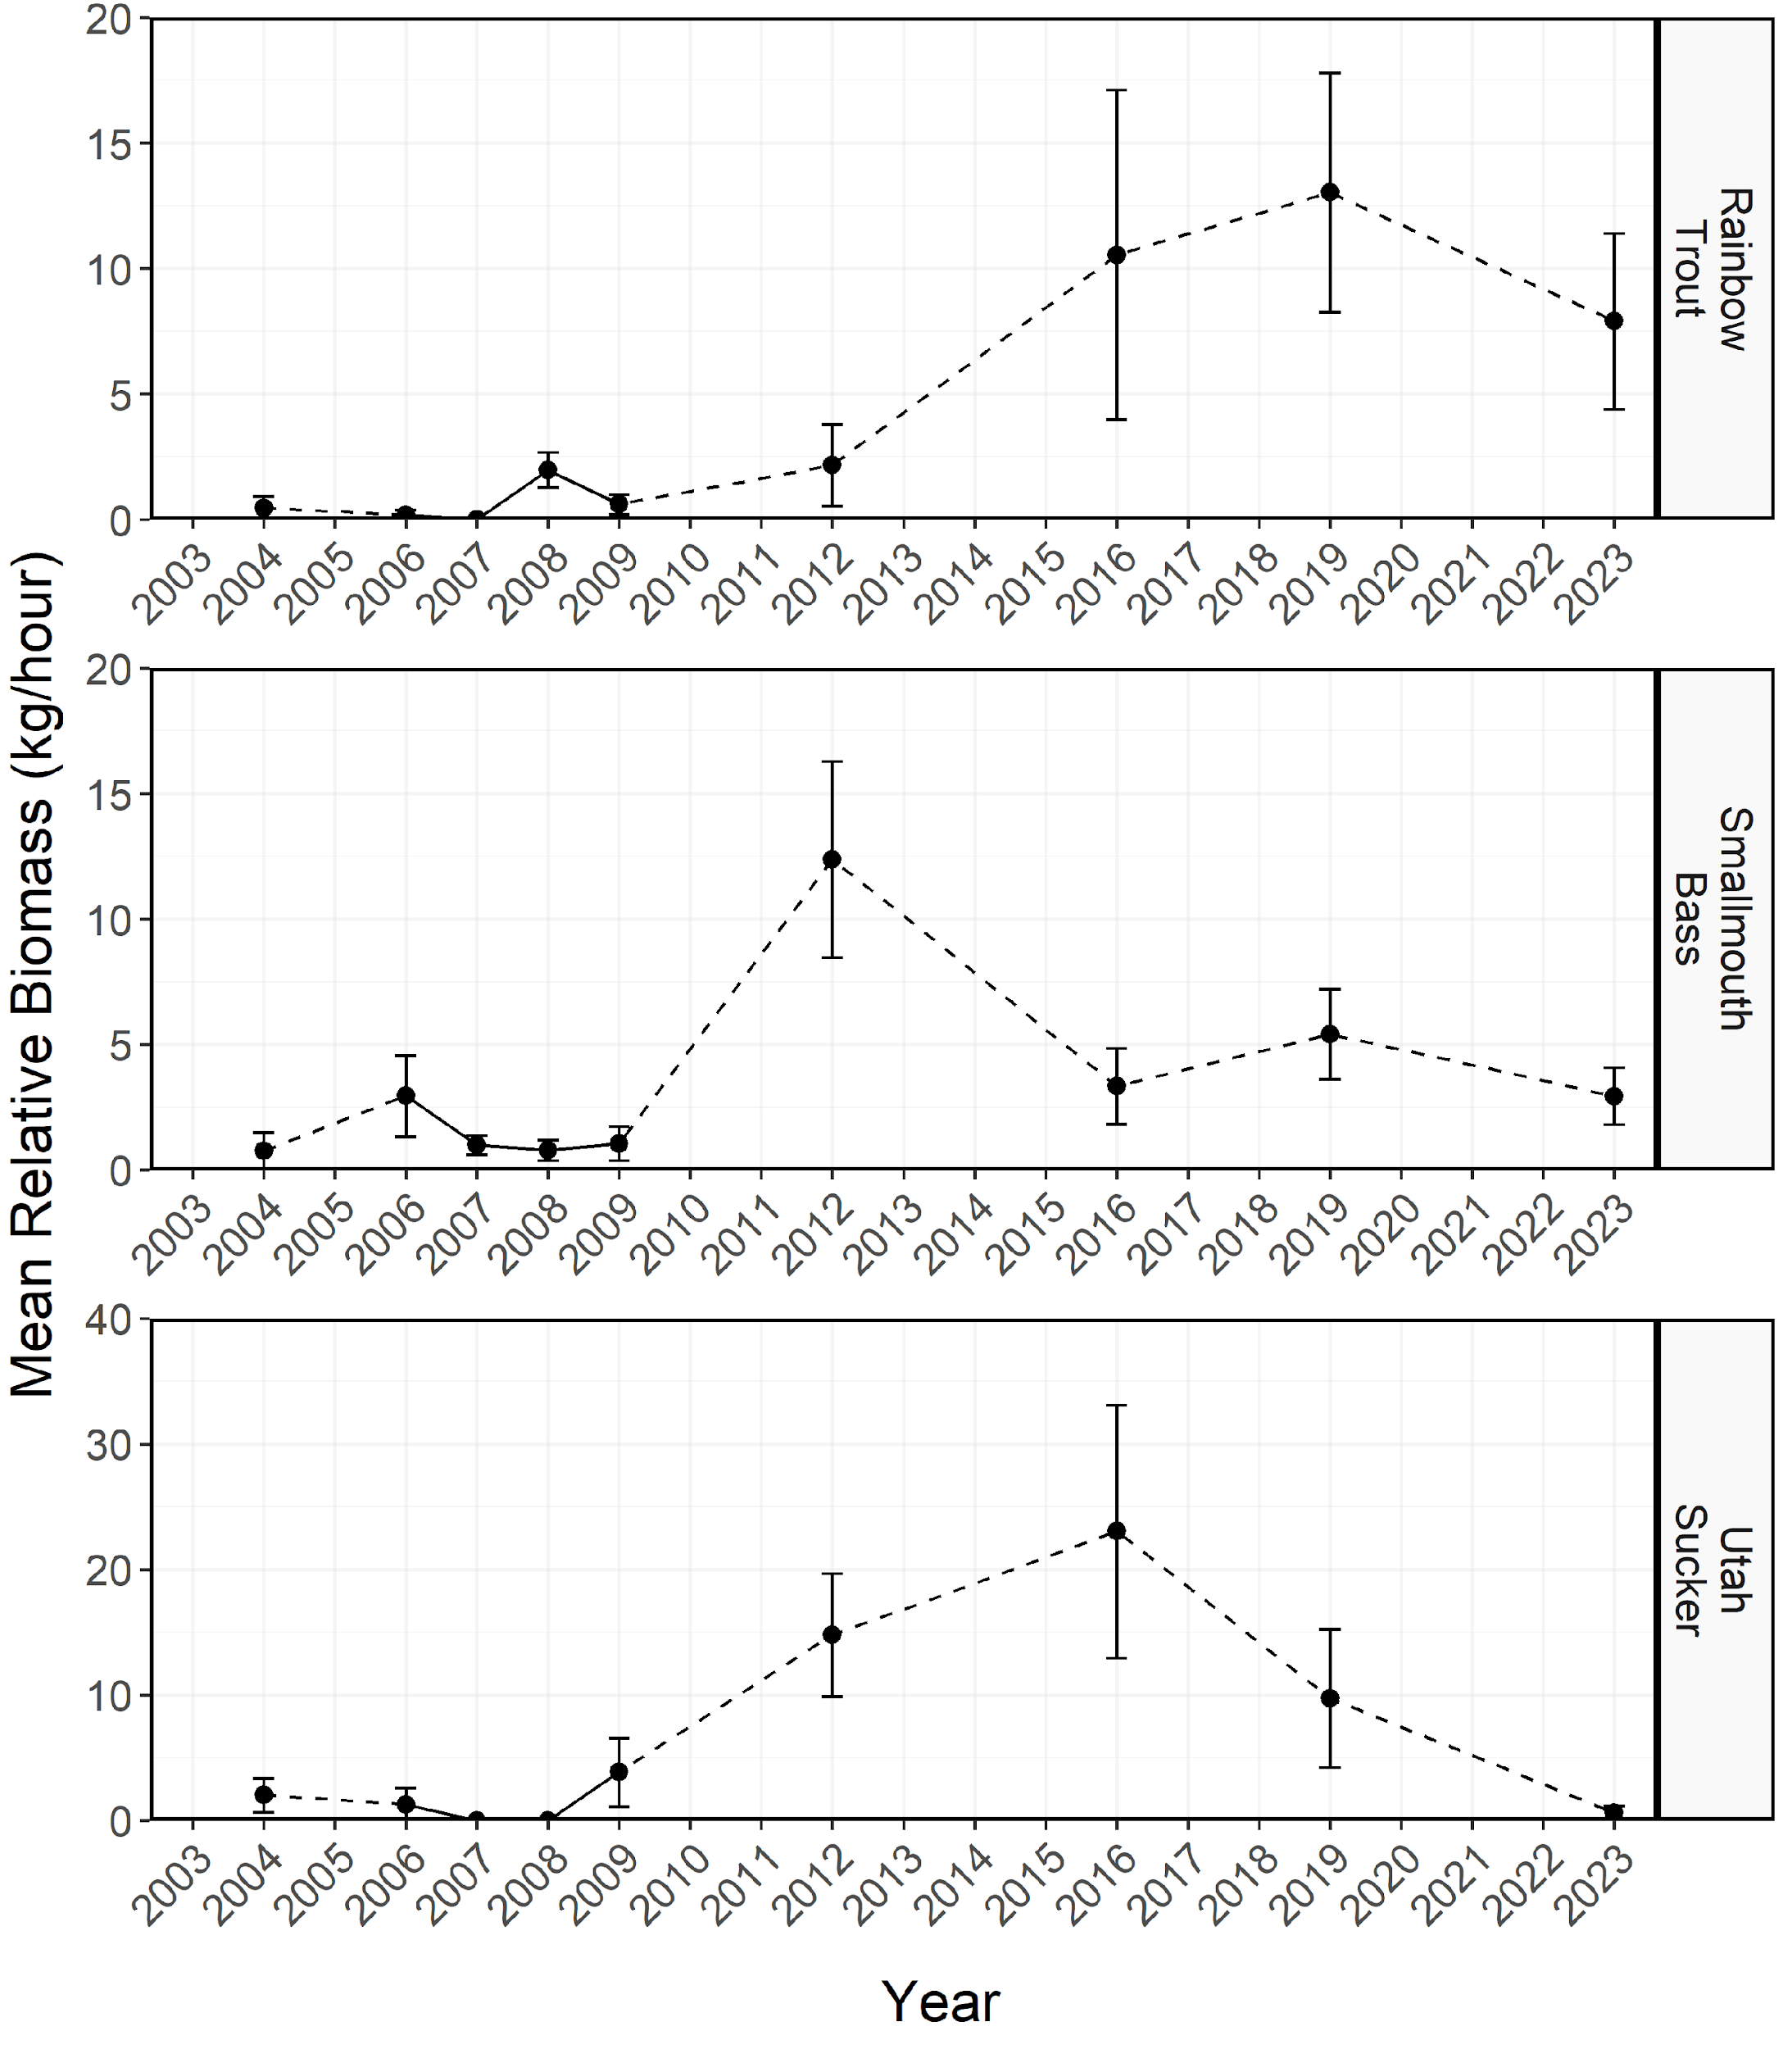

Figure 10: Mean relative biomass (kg/net-night) of stock-length Rainbow Trout, Smallmouth Bass, and Utah Sucker sampled during electrofishing surveys from East Canyon Reservoir between 1997-2023. Dashed lines represent interpolation across years of missing data between points. Error bars indicate standard error.

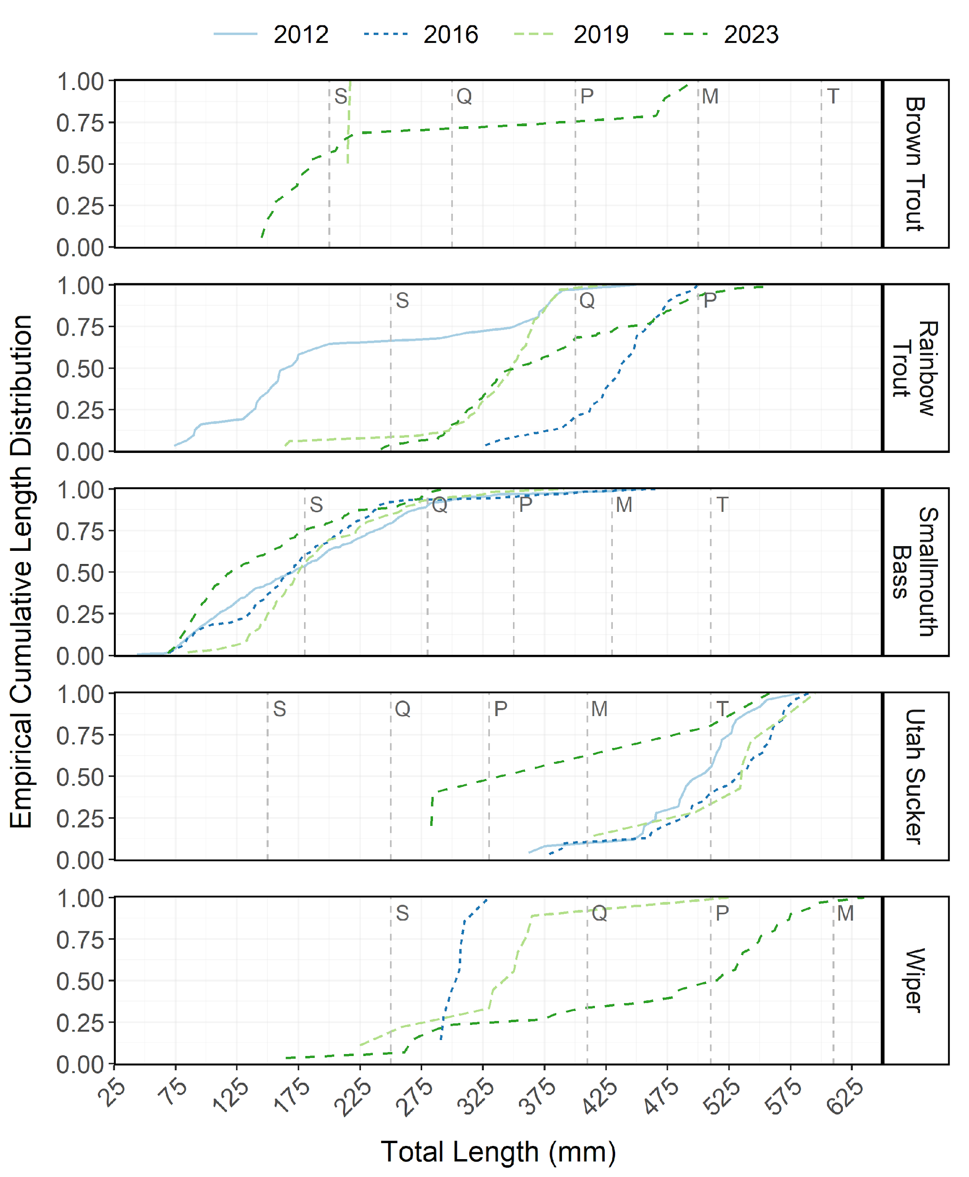

Figure 11: Empirical cumulative total length (mm) distribution of Brown Trout, Rainbow Trout, Smallmouth Bass, Utah Sucker, and Wiper sampled during curtain net and electrofishing surveys from East Canyon Reservoir between 2012-2023.

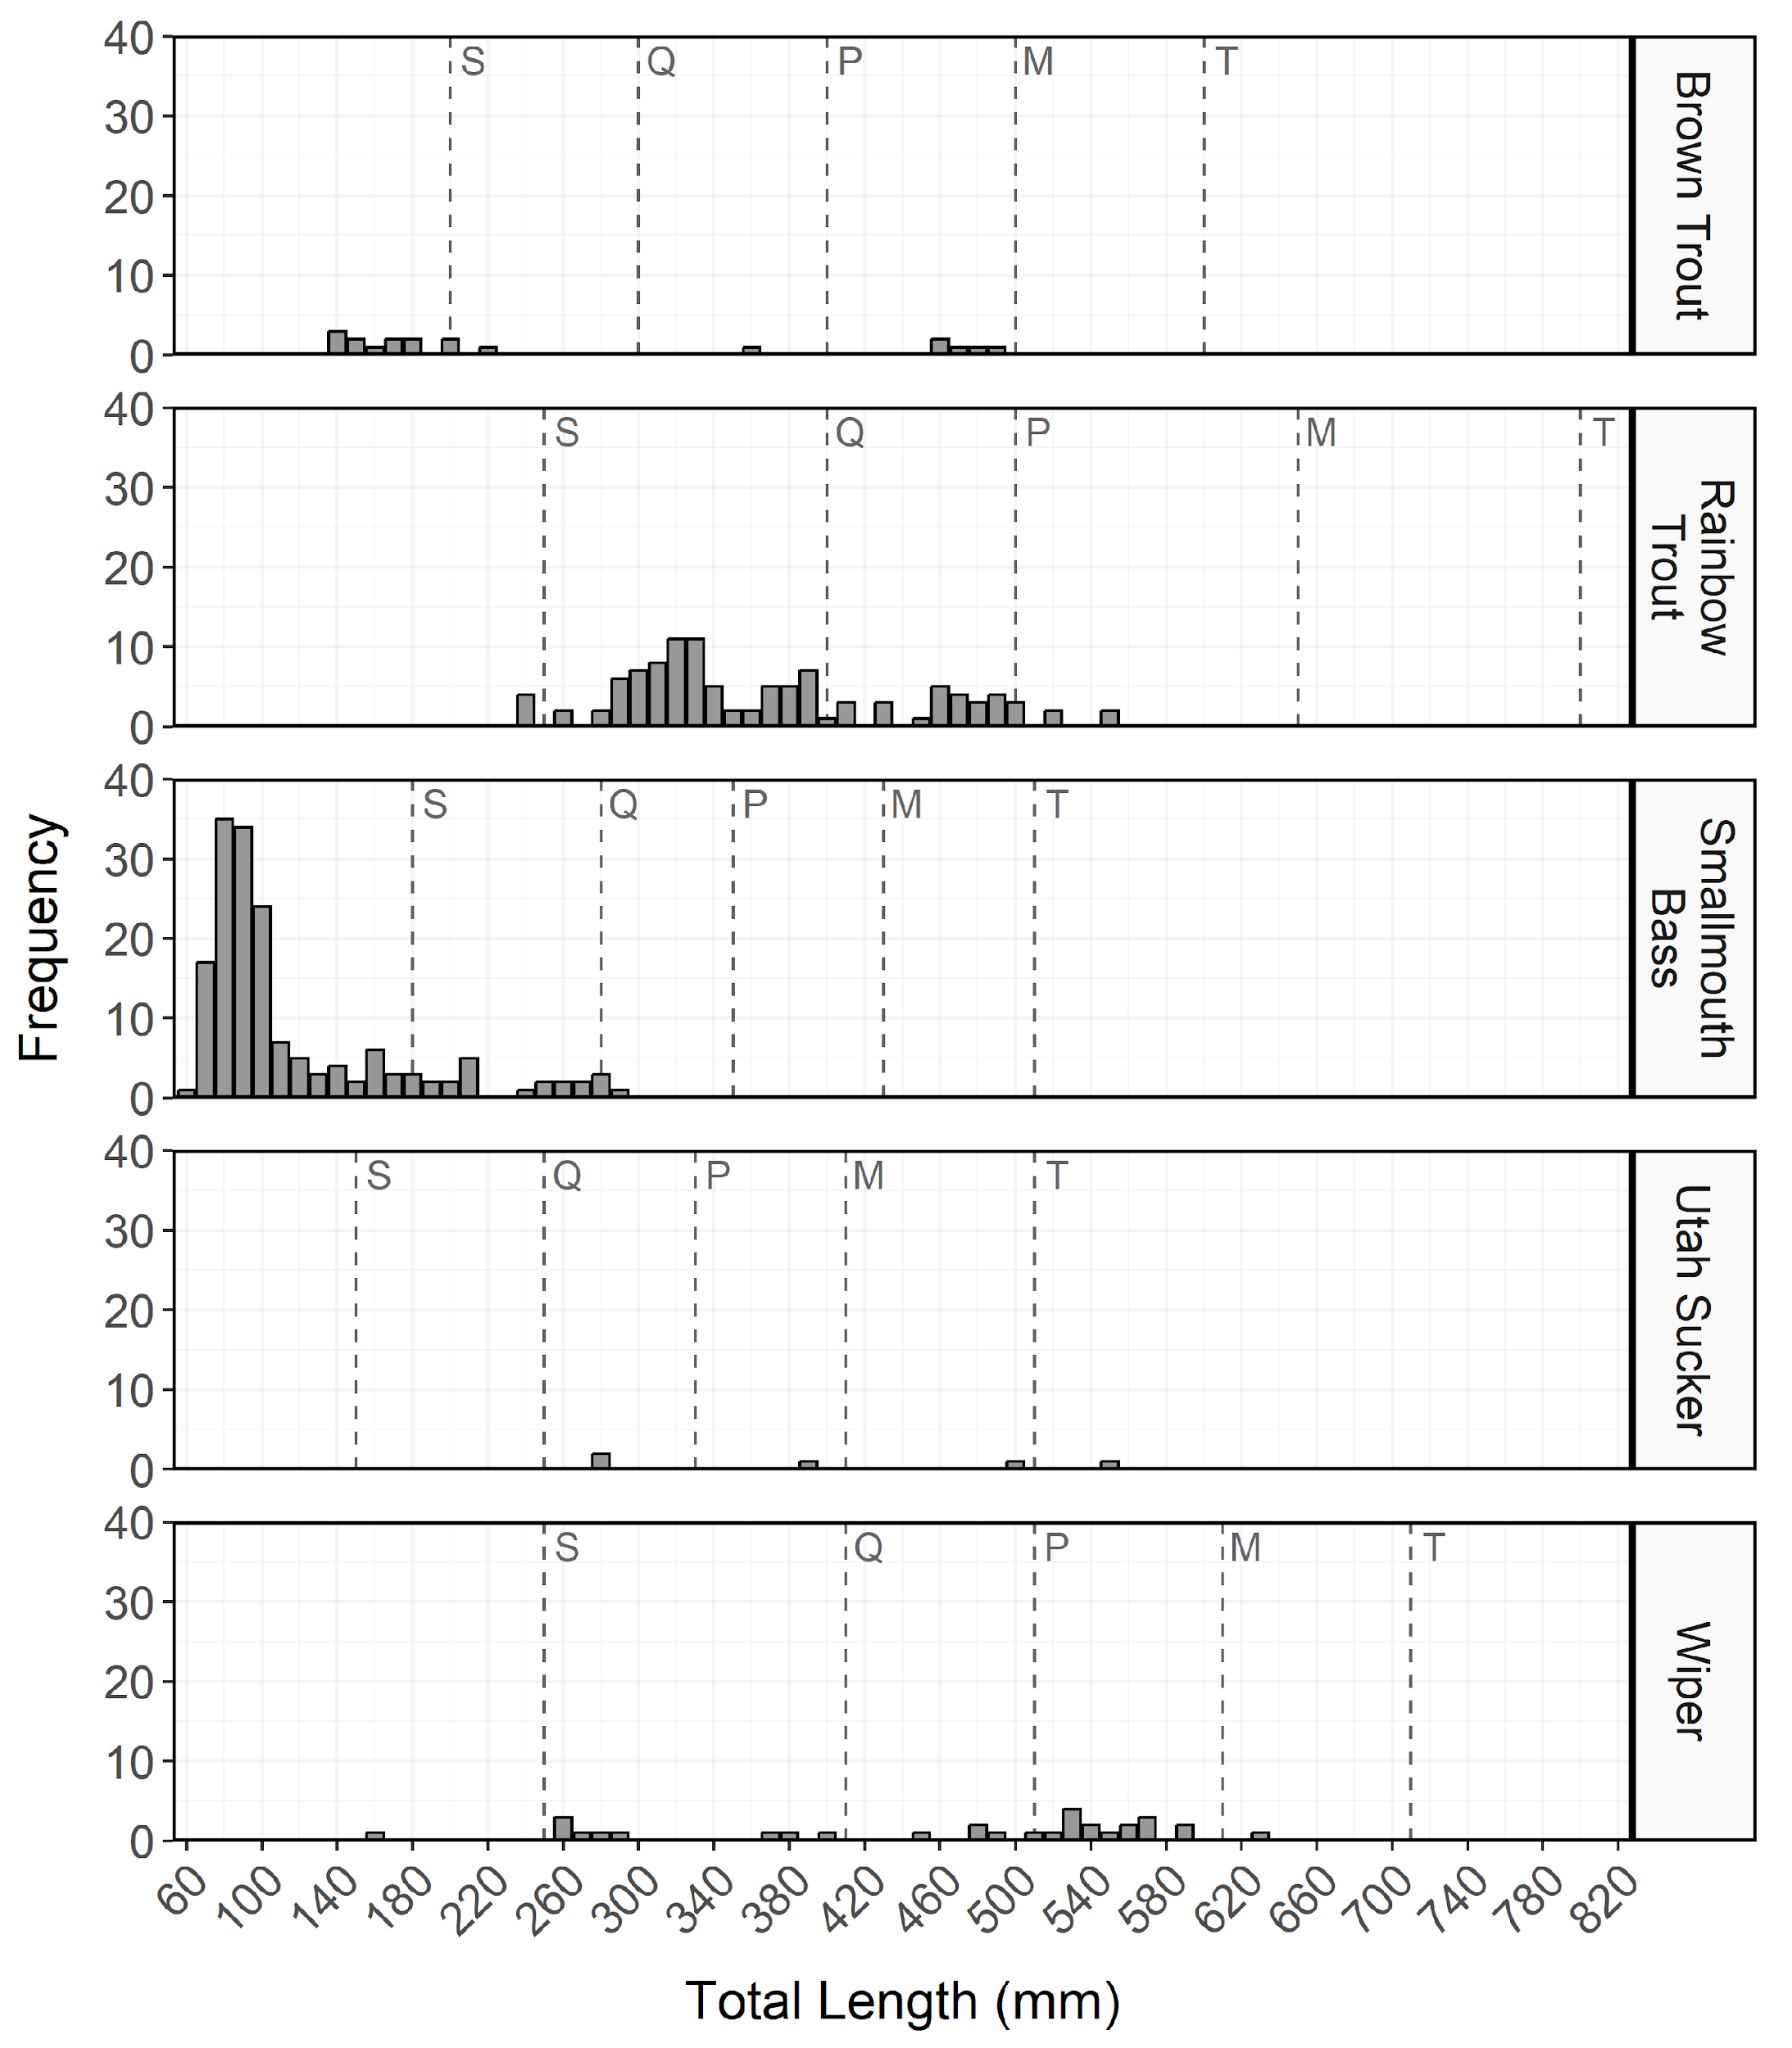

Figure 12: Total length (mm) frequency of Brown Trout, Rainbow Trout, Smallmouth Bass, Utah Sucker, and Wiper sampled during curtain net and electrofishing surveys from East Canyon Reservoir in 2023. The length intervals are left-inclusive and right-exclusive, and the x-axis labels represent the start of the length interval (i.e., left side). The start of each Gablehouse length category is identified by the vertical dashed lines and the category name (i.e., stock, quality, preferred, memorable, and trophy) is indicated by the first letter of each category on the right side of the dashed line.

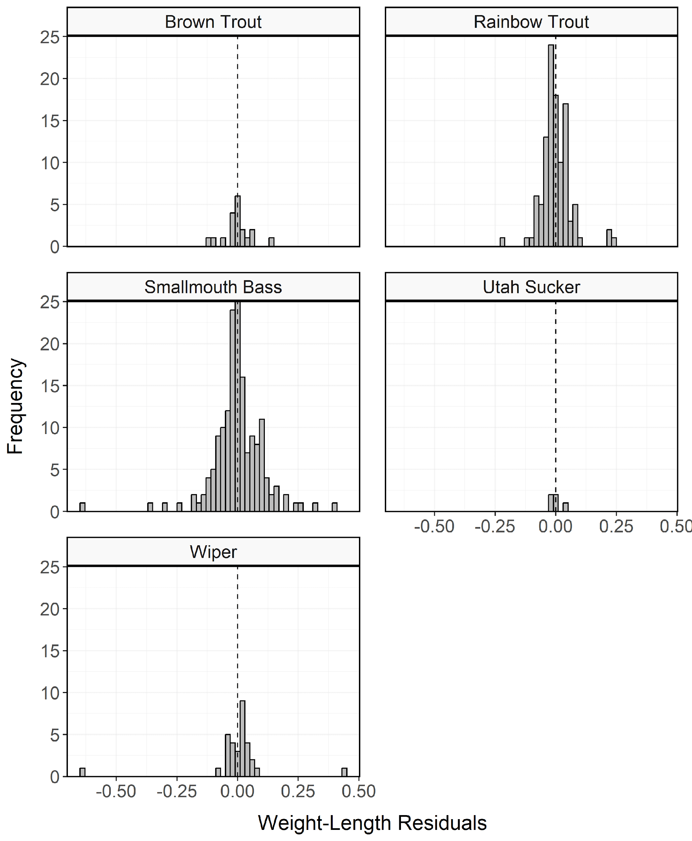

Figure 13: Histogram of residuals from the regression of log10 weight on log10 total length for Brown Trout, Rainbow Trout, Smallmouth Bass, Utah Sucker, and Wiper sampled during curtain net and electrofishing surveys from East Canyon Reservoir in 2023.

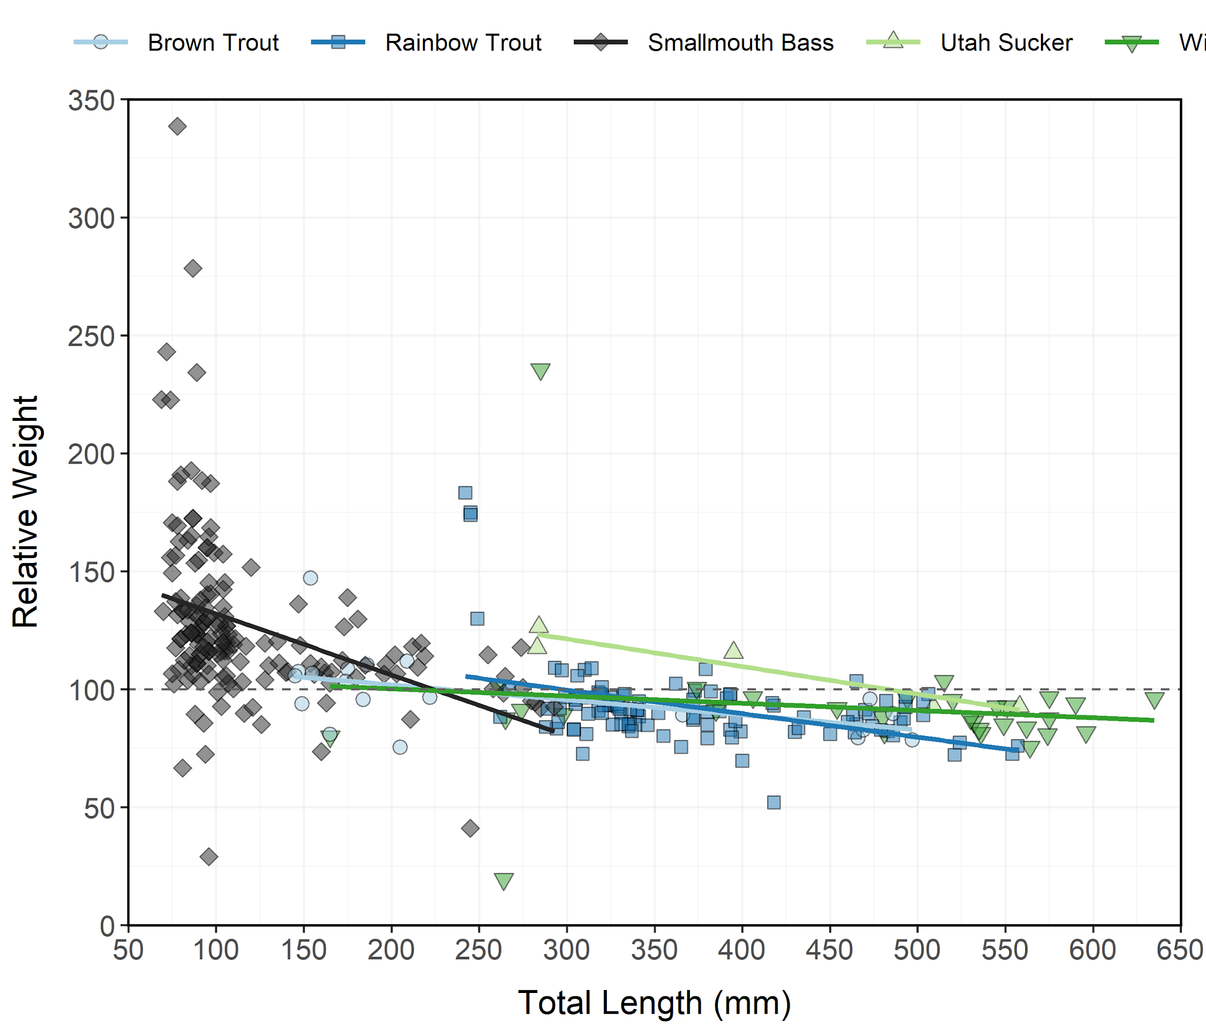

Figure 14: Relative weight (± standard error) of Brown Trout, Rainbow Trout, Smallmouth Bass, Utah Sucker, and Wiper sampled during curtain net and electrofishing surveys from East Canyon Reservoir in 2023 as an index of condition. The horizontal dashed line indicates a 1:1 relationship between standard weight and relative weight. Points and lines are jittered to minimize overplotting.

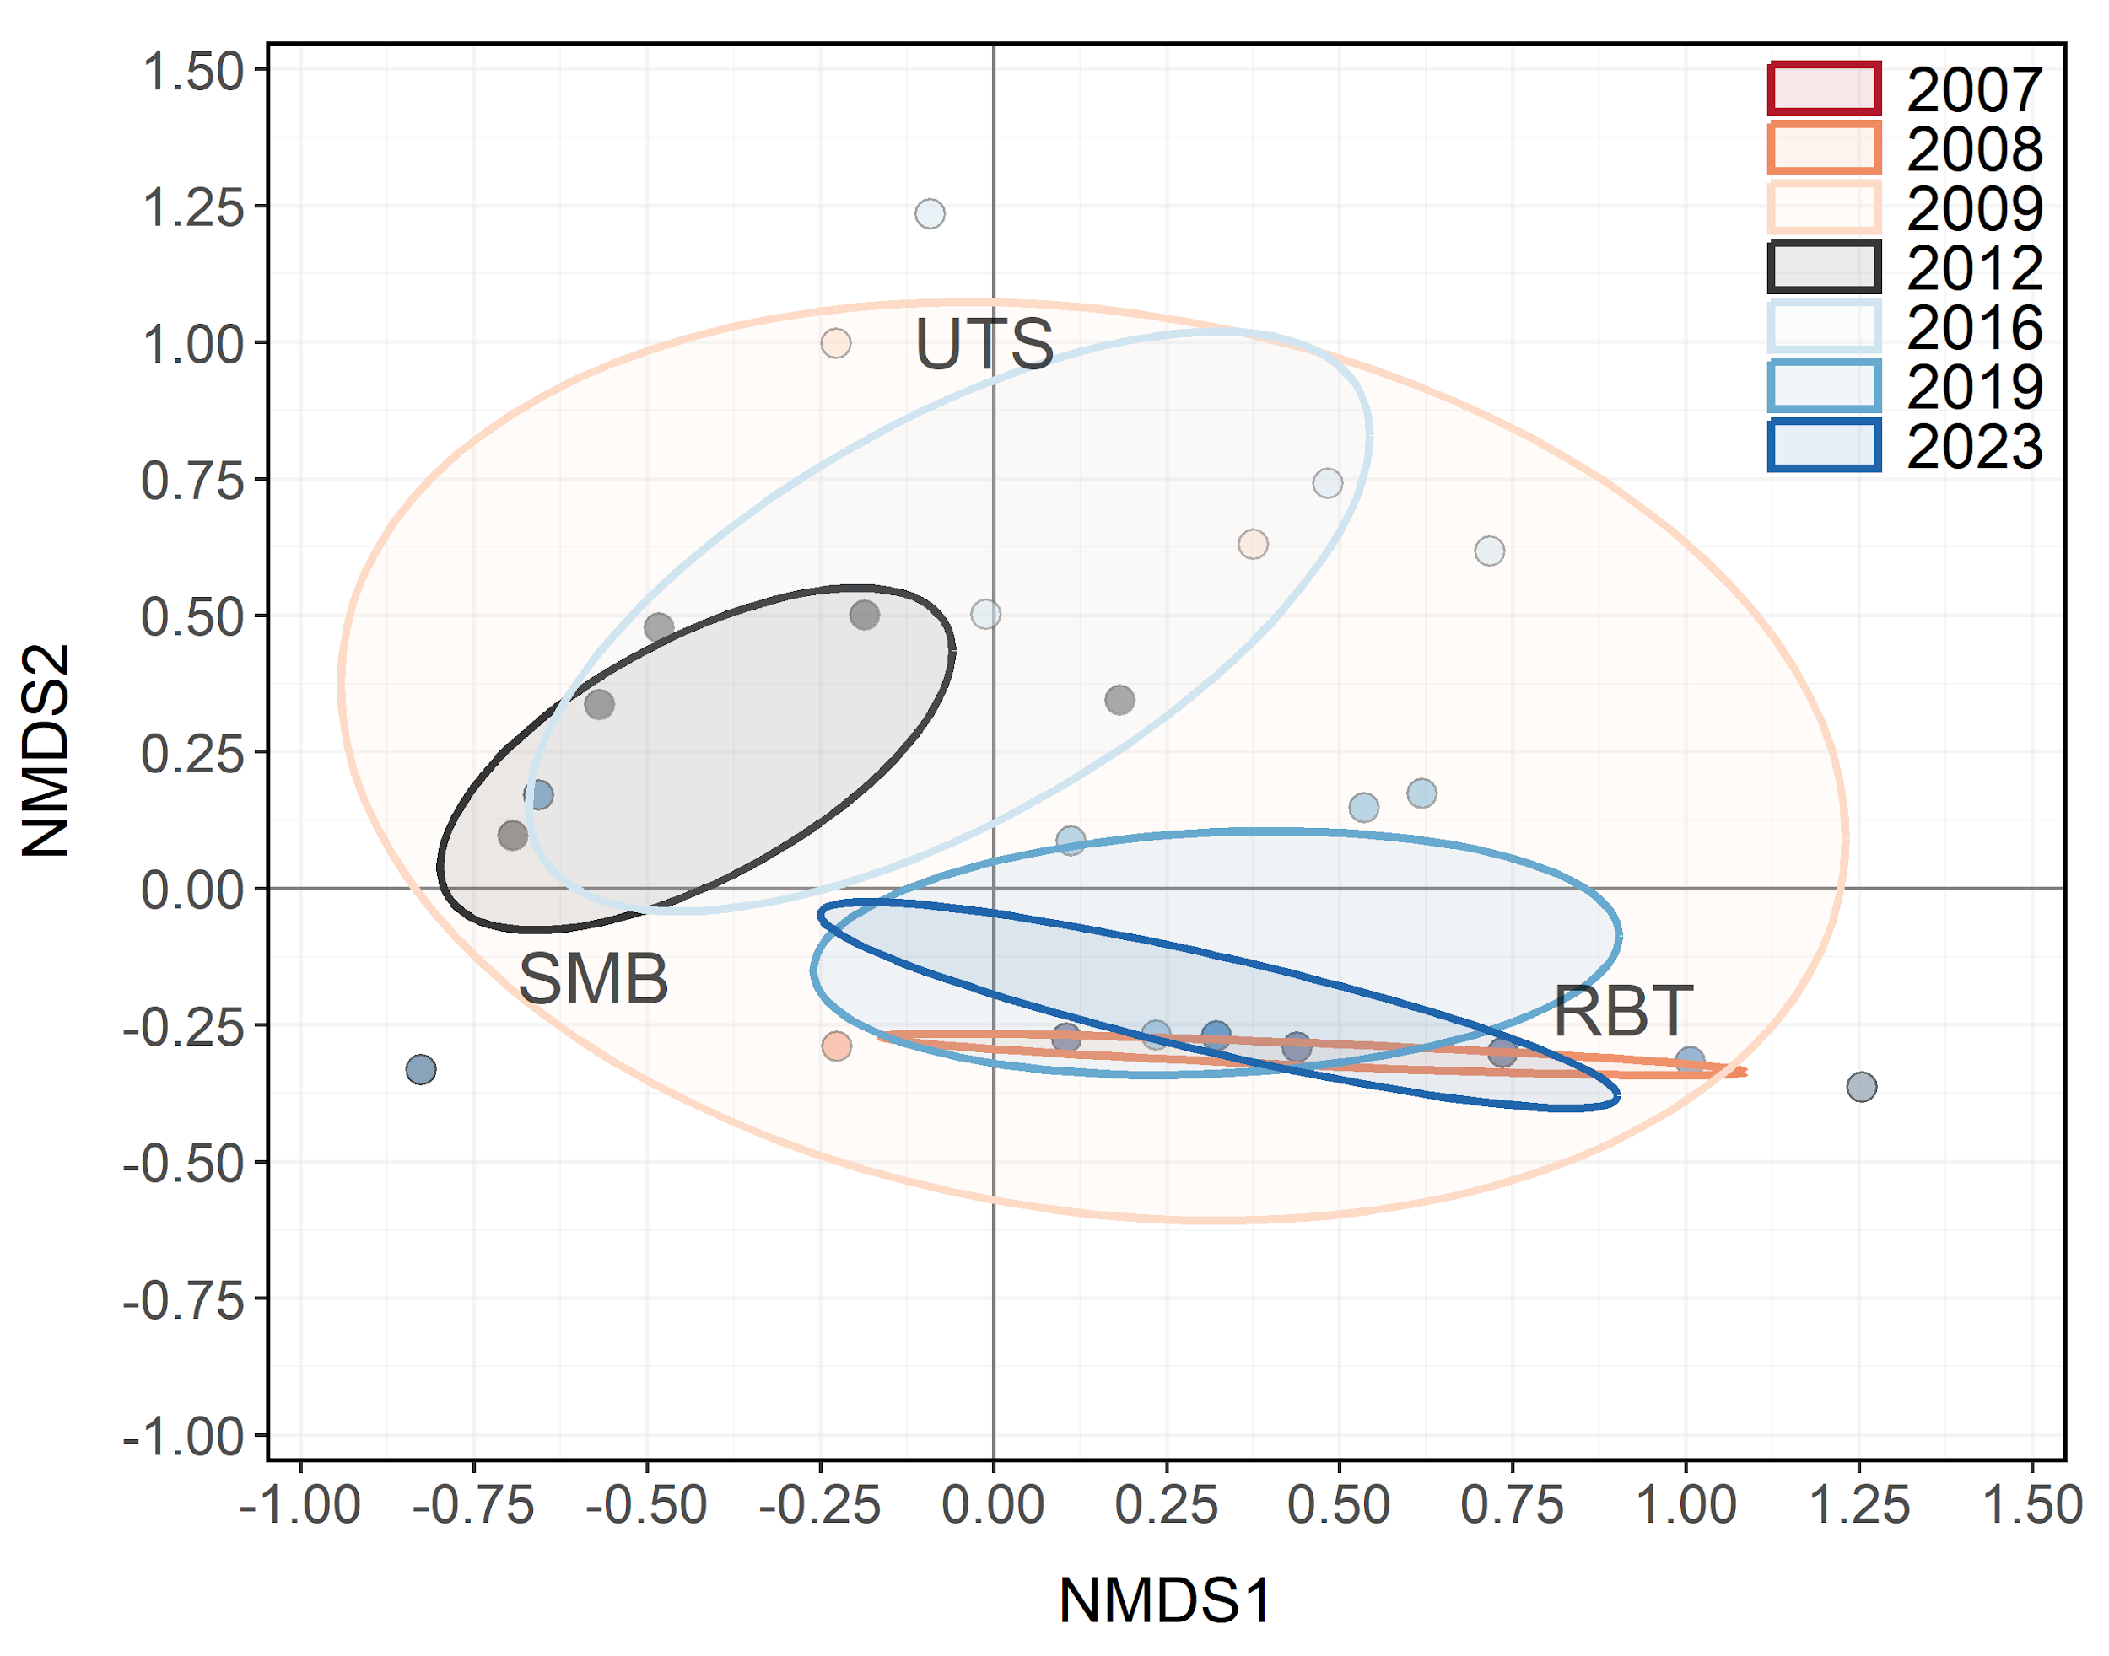

Figure 15: Non-metric multidimensional scaling (NMDS) bi-plot of stock-length Rainbow Trout, Smallmouth Bass, and Utah Sucker sampled during electrofishing surveys from East Canyon Reservoir between 2007-2023. Points closer together have more similar relative abundances among species. Ellipses highlight the community structure within each year sampled.

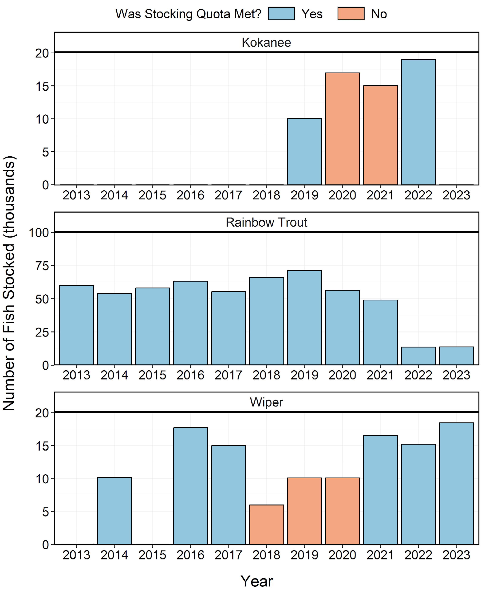

Figure 16: Number of individuals stocked in East Canyon Reservoir from 2013-2023. Length-at-stocking and stocking quota varies among years. A stocking quota was determined to be met if the number of stocked individuals was at least 90% of the stocking quota.