**Monitoring & Management Report**

**System**: Bear Lake

**Author**: Emily Wright

**Spawning Trap**: 4/15/2023 - 5/23/2023 - Operation and Flood Mitigation

**Stocking**: 5/8/2023 - 5/10/2023 – BLCT; 10/20/2023 - LKTP

**Sampling Dates**: May/August/October - Gillnet Survey; 7/16/2023-7/18/2023 – Hydroacoustic Survey

**Target Species**: Bear Lake Cutthroat Trout, Bear Lake Whitefish, Bonneville Whitefish, Bonneville Cisco, Lake Trout

**Monitoring & Management Objectives**:

1. Operate the Swan Creek Fish trap in order to collect Bear Lake Cutthroat Trout eggs necessary to meet stocking objectives for Bear Lake and state of Utah brood needs.
2. Evaluate population indices to improve the effectiveness of stocking efforts of Cutthroat Trout and Lake Trout.
3. Provide data for assessment of trends in species occurrence, relative abundance, biomass, and size structure of forage and sport fish assemblages.

**Introduction:**

The Bear Lake Cutthroat Enhancement Project was initiated by the Utah Division of Wildlife Resources (UDWR) in 1973 with two primary objectives; 1) to determine the status and life history of the indigenous Bear Lake cutthroat trout, *Oncorhynchus clarki Utah,* and; 2) to develop methodologies to enhance the population and develop a sport fishery. The Bear Lake Cutthroat Enhancement Project was partitioned into four segments; 1) Cutthroat trout egg-taking operations on Bear Lake, 2) Bear Lake fish stocking and marking, 3) Bear Lake gill-netting surveys and 4) measurement of angler pressure, harvest and success.

The current project has evolved to include all species found in Bear Lake, with special emphasis placed on monitoring the endemic fish populations. The results of this work for the 2023 calendar year are presented below in sections that focus on different job segments and/or monitoring methods.

**Methods**:

*Spawning Trap Operation and Egg Collection*

A fish trap is installed on Swan Creek in the spring of each year prior to the Bear Lake Cutthroat Trout spawning run. On a weekly basis during the spawning season, captured Cutthroat Trout are sorted by sex, anesthetized, examined for a hatchery fin clip, measured (TL, mm), weighed (g), tagged (previously caught fish will already be tagged), spawned, allowed to recover, and released downstream of the trap. When the egg quota is achieved for the year, fish trapping continues, however fish are only measured, weighed, examined for fin clips, tagged (if not already tagged) and then passed directly upstream of the fish trap where they can spawn naturally in the stream. The same style of dart tags (model PDL barbed, Hallprint, Ltd. of Australia) have been used for the past 30 years which included individual numbering and return address.

The UDWR spawning protocol used is considered a “dry” method. Adult Bear Lake Cutthroat Trout are not selected based on morphological characteristics or for size. Eggs from ripe females are individually hand stripped into a net covered pan in lots of five fish each, and samples of ovarian fluid are collected from the first 60 ripe females. The eggs from each of the five females are transferred to a bucket where they are pooled and held. Milt from five males is then striped and pooled and added immediately to the eggs for fertilization. Before being transported to the hatchery, the eggs are rinsed to remove any debris and dead eggs, disinfected, and water hardened. If green females are encountered during spawning they are held until they became ripe. Males are typically released after spawning, however, in some instances when male numbers are limited, some individuals are held for two or more weeks and used more than once.

During this study period 60 *Oncorhynchus spp.* needed for disease testing were obtained by electrofishing from Swan Creek prior to the adult spawning run.

*Stocking*

The stocking program at Bear Lake was designed to maximize survival of stocked Cutthroat Trout by stocking at the most efficient size and time of year. A defined stocking protocol has been agreed upon between the UDWR and Idaho Department of Fish and Game (IDF&G), using wild Bear Lake Cutthroat Trout eggs and Utah’s hatchery system.

In 2023 all Bear Lake Cutthroat Trout were marked by spraying yellow fluorescent grit prior to stocking. This allows biologists to determine naturally reproduced fish from hatchery reared/stocked fish. Lake Trout were also marked to assess whether natural reproduction and recruitment of Lake Trout is occurring in the population. All Lake Trout stocked were triploid (Wagner et al. 2004) and marked with both adipose clip and right pelvic fin clip.

# Gillnets

Contour gill netting has been used to sample fish at Bear Lake since 1987. Contour netting was designed to sample representative bottom depth stations from the littoral to the profundal zone. Methods and nets used are consistent with standardized sampling techniques for surveying North American freshwater fish as described by (Bonar et. al. 2009). Gillnets are set annually in the spring, summer and fall in order to monitor spatial distributions, and provide estimates of relative abundance and composition of the overall fish assemblage. Spring netting is used to monitor over-winter survival of Bear Lake Cutthroat Trout and to determine trends in populations of endemic fish. In addition, the spring netting allows for diet analyses prior to plankton blooms and prior to stocking of Bear Lake Cutthroat Trout. Summer netting is used to examine the diets of fish during lake stratification when plankton and benthic invertebrates are concentrated at the intersection of the thermocline with the bottom; it also allows for monitoring post stock survival of Bear Lake Bonneville Cutthroat Trout. Fall netting is used to examine the condition of Bear Lake Bonneville Cutthroat Trout, Lake Trout, and Whitefish going into the winter.

Gill nets used in this sampling consisted of American Fisheries Society core monofilament sinking gill nets that were 48.8 m long and 1.8 m deep with alternating 3.1 m long panels of 38, 57, 25, 44, 19, 64, 32 and 51 mm bar mesh, in that particular order. Seven gill nets were set perpendicular to shore, one each at the 5, 10, 15, 20, 25, 35, and 50 m depth contours. These nets were of the same dimension as was used for sampling by trend gill netting from 1983-89 and for contour netting from 1992-2022.

The set of seven nets were set at two sites consecutively for two nights at each site. One was along an west/east transect which began at the 5 m depth on the west shoreline, approximately 1 km north of the Utah State Park marina. The remaining six nets were placed sequentially along this transect line in an easterly direction to the 50 m depth. A second station, on the east side of the lake, was located just off the mouth of North Eden canyon. All nets were set at contour locations and then the GPS coordinates were recorded for each net (Figure 1). Nets were set for a duration of 48 hours at each station in two 24 hour periods during each of the three sampled months: April, August, and October.

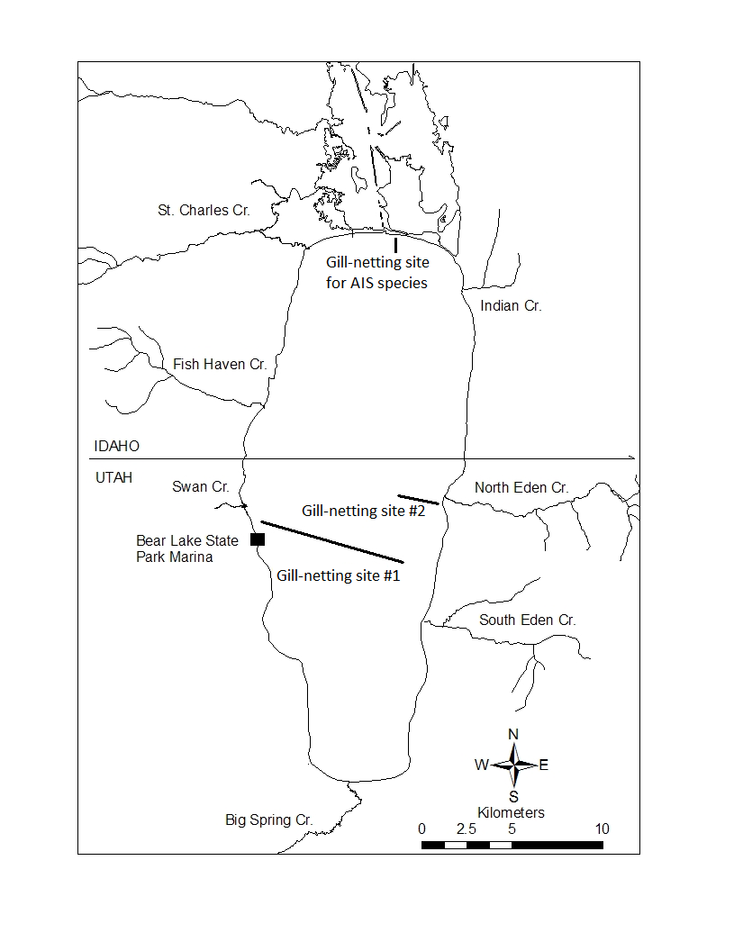

*Figure 1: Map of Bear Lake showing gill-netting locations (site 1 and 2) and the gill-netting location for aquatic invasive species (AIS) used in 2023.*

*Aquatic Invasive Species Sampling*Four stationary samplers for *Dreissenid spp*. mussel attachment were placed into Bear Lake from May-October 2023. These attachment samplers were deployed at four sites in Bear Lake (Figure 2).

A total of three sinking experimental gill nets, identical to those used for contour netting, are set at the north end of Bear Lake near the inlet structure to sample for any aquatic invasive species (AIS). The timing of the sampling correlates with the day that inflow to Bear Lake was shut off. The actual location is dependent on the water depth, but all three are set between the inflow and the end of the North Beach Jetty in the Idaho State Park. The nets are set for 24 hours each. Fish were identified to species, measured and released.

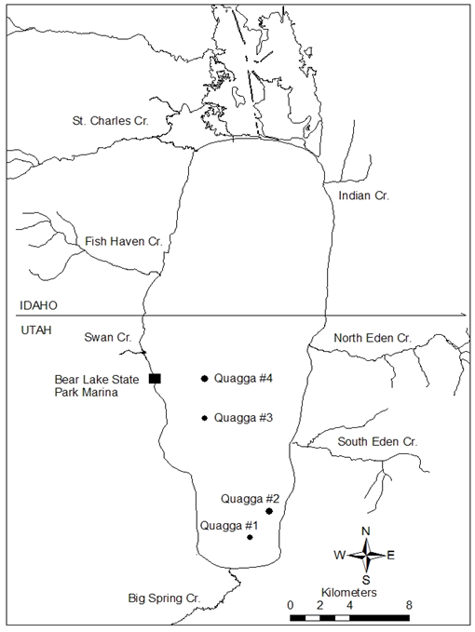

*Figure 2: Map of Bear Lake showing quagga mussel sampler locations used in 2023.*

# Hydroacoustics

In 1997 the UDWR assumed the responsibility of estimating Bonneville Cisco numbers using split beam hydroacoustic equipment. A total of five transects were sampled. These transects were the same transects that have been sampled from 1997-2022. GPS coordinates were used to locate the transects and sampling started at the five meter contour on either the west or east side of the lake and then a direct east/west line was driven in the boat using a GPS receiver (Figure 3). The end of the transect occurred when the five meter depth was reached on the opposite side of the lake. All sampling occurred during the dark-of-the-moon phase in July, and actual data collection did not begin until at least 0.5 hours after official sunset (Luecke and Wurtsbaugh 1993).

To estimate trends in the abundance of Cisco over the year, densities of fish targets from each transect were examined. Additional details of acoustic techniques and calculations used to determine Bonneville Cisco density estimates have been published in detail (Wurtsbaugh and Luecke 1998; Ruzycki et. al. 2001; Tolentino 2015). A one-way ANOVA was used to assess changes in the mean density of fish targets by year. Each transect was treated as a replicate of a lake-wide estimate. A Bonferoni multiple comparison of means was then used to asses which years were significantly different (p = 0.05) from each other. Using transects as a replicate also enabled confidence interval to be calculated for the year’s population estimate. Exact GPS locations of the sample transects are given in the Appendix.

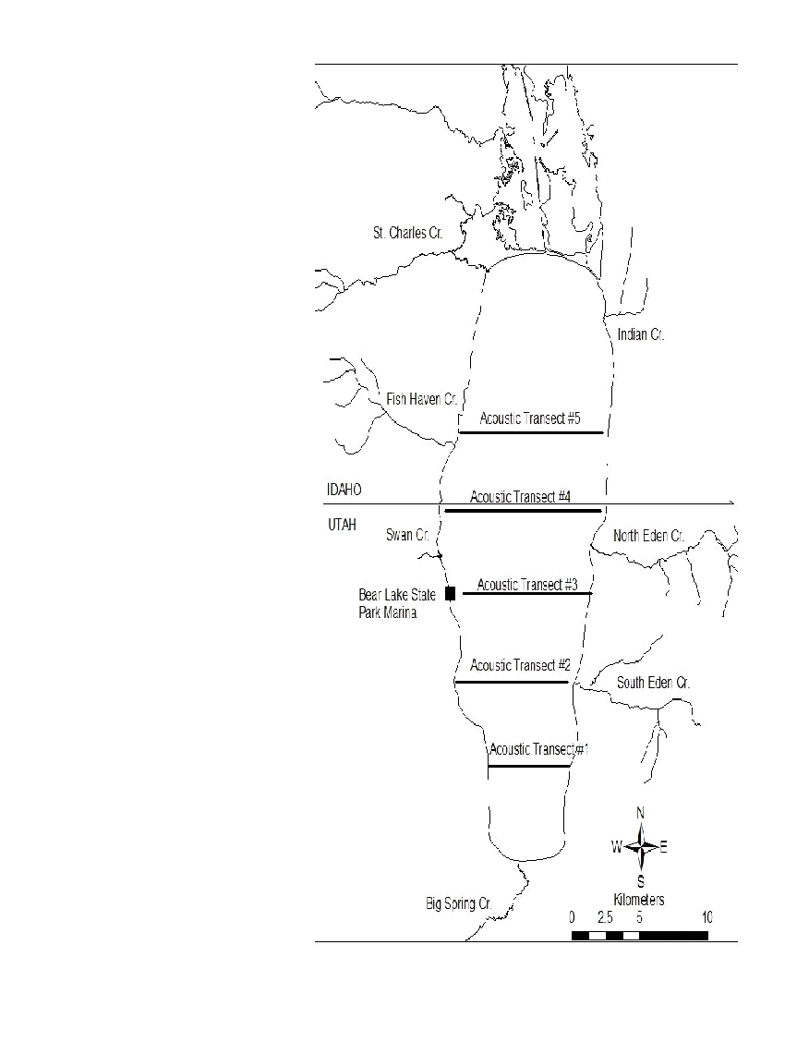

*Figure 3: Map of Bear Lake showing hydroacoustic transects sampled for Bonneville Cisco population estimates 1996-2023.*

**Summary**:

*Spawning Trap Operation and Egg Collection*The Swan Creek trap was installed on 14 April 2023. The first Bear Lake Cutthroat Trout (BLCT) was caught on 12 May 2023. Daily trapping of fish continued through 23 May 2023. Due to a record snow pack, and late spring ice off on Bear Lake, flooding conditions were extremely high. In order to protect private property surrounding the Swan Creek fish trap, as well as protect UDWR personnel safety, the decision was made to remove the weir from Swan Creek and let the water flow freely to the lake. The bypass culvert at the property was also opened to capacity for the remainder of the runoff in order to protect private property from flooding. The catch of BLCT at the Swan Creek trap in 2023 was much lower compared to previous years. The fish were delayed coming up the river due to ice over, lake temperatures, and we were unable to trap enough fish for spawning operations.

In the timeframe the trap was open ten Cutthroat Trout were captured in the spawning trap, of these 5 were females and 5 were males. All captured fish were examined for fin clips (Table 1). Of these fish, 1 (10%) were marked with fin clips, the remaining 9 (90%) were unmarked. Of the marked fish, all were marked with an adipose fin clip.

A total of 2 previously tagged Cutthroat Trout were captured in the trap. These fish averaged 446 (SD = 65.1) mm TL and weighed an average of 1369 (SD = 348.6) g.

No ovarian fluid was collected and examined for pathogens for the year of 2023. We sampled 60 cutthroat trout by electrofishing from Swan Creek on 4 April 2023; no prohibited pathogens were detected from the Cutthroat Trout.

Because the Swan Creek trap was not operational for spawning in 2023, gametes were collected from the BLCT brood stock in the Mantua Hatchery. Eggs remained at the Mantua Hatchery for eye-up and then the eggs were transferred to Midway for hatching and rearing.

*Stocking*A total of 95,000 Cutthroat Trout at a mean length of 6.75” were stocked into Bear Lake in 2023 which was short of the 107,100/7” quota of fish for the year due to unknown issues at the Kamas Hatchery (Figure 4, Table 2). All Bear Lake Cutthroat Trout were marked by spraying yellow fluorescent grit prior to stocking.

A total of 17,058 triploid Lake Trout (LKT) at a mean length of 5.7” were stocked in the lake during November 2023; slightly under the 7” length requested for the year (Figure 5, Table 2). All Lake Trout stocked were marked with both adipose clip and right pelvic fin clip. This was the 5th egg-take from the UDWR LKT brood.

BLCT stocking took place from the boat ramp of the Bear Lake State Park in Idaho (North Beach) due to ice persisting at the marina in Utah. LKT stocking took place from the boat ramp at Rainbow Cove. All fish were stocked directly from distribution trucks. Receiving water temperatures were suitable and tempering was not necessary.

A reduction in the scheduled stocking quota of yearling Cutthroat Trout (107,100 beginning in 2022 versus 170,000 prior to the year 2022) was made in order to ease predation pressure on the Bonneville Cisco population which is at a 26 year low. It is believed the current low in Cisco numbers is at least partly due to increased predator numbers as Bear Lake Cutthroat Trout have been at historical highs in recent years. The proposed stocking cut will last 3-5 years, which will allow time to monitor subsequent changes to the Cutthroat Trout and Cisco populations.

*Contour Gill Netting*A total of 1,745 fish were caught in 2,016 hours of netting which yielded an overall catch rate of 0.87 fish/net hour (Figure 6, Table 4). A total of 141 Cutthroat Trout were captured at a rate of 0.070 fish/net hour. They averaged 472 (SD = 126.4) mm total length (TL) and weighed an average of 766 (SD = 181.5) g (Figure 8). There were 120 cutthroat trout that were aged. The percentages of cutthroat trout gill-netted by age were: 2% - age 1, 5% - age 3, 23% - age 4, 30% - age 5, 20% - age 6, 11% - age 7, 9% - age 8 (figure 9). Marked Cutthroat Trout made up 38% of the total Cutthroat Trout caught in the gill nets. Diet analyses on 120 stomachs of Cutthroat Trout revealed that 39% of the stomachs (n = 47) were empty. Of the stomachs which contained food (n = 73), 68% contained fish, 18% contained terrestrial insects, 5% contained aquatic insects, 9% other matter (Table 3).

There were 65 Lake Trout caught in the 2023 gill-net sampling at a rate of 0.032 fish/net hours (Figure 7, Table 4). These fish averaged 646 (SD = 52.3) mm TL and 1,370 (SD = 977.4) g. Marked fish made up 48% of all Lake Trout captured in the gill nets. A breakdown of Lake Trout by mark revealed that 9% had only an adipose clip, 10% had a left pelvic clip, 25% had a right pelvic/adipose clip, 4% had only a right pelvic clip, and 52% were unmarked. The unclipped fish are a combination of an unknown number of triploid trout stocked since 2002 that did not receive clip, stocked Lake Trout in the 1980’s that were not fin clipped prior to stocking, and some limited natural recruitment.

A total of 575 Whitefish were captured in the 2023 gill-net sampling, comprised of both Bear Lake and Bonneville Whitefish. The overall Whitefish catch rate was 0.28 fish/net hour and the fish averaged 228 (SD = 19.7) (Figure 7). In 2023, 149 Whitefish were examined to determine the percent composition of the catch of Bonneville and Bear Lake Whitefish. An estimated 66% of the Whitefish catch was comprised of Bonneville Whitefish and 34% of the catch was comprised of Bear Lake Whitefish. The average length for Bonneville Whitefish averaged 204 (SD = 14.7) mm TL and the Bear Lake Whitefish averaged 197 (SD = 16.9) mm TL (Figure 10).

*Aquatic Invasive Species Sampling*A total of four attachment substrate quagga mussel samplers were deployed in Bear Lake in 2023 (Figure 2). These samplers showed no signs of mussels in 2023. They will be redeployed in 2024.

Gillnet sampling for AIS was not completed at the northern end of Bear Lake at the inlet structure. The inlet pumps were turned off during routine Bear Lake spring gillnet sampling making it impossible to sample both. This sampling was initiated by UDWR in 2009 and formally became part of the work plan in 2010. It was designed to monitor/detect Walleye *Sander vitreus*, Smallmouth Bass *Micropterus dolomieu*, and/or other invasive fish species which can migrate into Bear Lake from the Bear River system via the inlet structure. Currently, Walleye are present in Sulphur Creek Reservoir and in the Bear River just downstream of Sulphur Creek Reservoir, which are both upstream of Bear Lake and Smallmouth Bass are present in Alexander Reservoir, a Bear River reservoir downstream of Bear Lake. Gillnet sampling for AIS at the inlet structure will resume in 2024.

*Hydroacoustics*In July of 2023 lake elevation was at 5917.20’ (USGS Bear Lake State Park Marina Gauge). The Bonneville Cisco population estimate (+/- 95% confidence interval) was: 2.723 +/- 1.172 million cisco (+/- 43% of the mean) (Figure 11, Table 5).

The Cisco population estimates increased from the previous year’s 26 year low. We believe population numbers have been decreasing in previous years due to poor recruitment combined with an increase in Cisco predators in Bear Lake as a result of the combination of increased stocking success and recruitment success of cutthroat trout coupled with relatively stable lake trout numbers. Increased natural recruitment of BLCT is the result of multiple spawning habitat improvement projects on Bear Lake tributaries over the past two decades. It is also thought that increased water levels resulting from an above average snowpack year in 2017 resulted in increased recruitment and survival of stocked fish that year and in 2018, which can be seen in the large proportion of fish in the four- and five-year-old age groups. Finally, prior to 2022, the lake went 5 consecutive years without ice-over, putting the 10 year ice-over frequency at 40% and 30 year ice-over frequency at 47%, compared to 100 year ice-over frequency of 67%. The lack of ice-over frequency could contribute to lower recruitment and overall population estimates and is a topic that fishery managers plan on researching further.

**Management Actions**:

1. Continue to operate the Swan Creek fish trap in order to collect Bear Lake Cutthroat Trout eggs necessary to meet stocking objectives for Bear Lake and state of Utah brood needs. Egg quotas continue to be met each year, and standardized methods will be maintained to ensure consistency and reliability in egg collection.
2. Continue stocking 107,000 Bear Lake Cutthroat Trout and 17,000 Lake Trout to supplement the Bear Lake fishery. All relative abundance of these fish seem within objective, so stocking will continue at prescribed rate. Our management plan dictates that we will continue stocking until we fall below the action threshold.
3. Monitor Cutthroat Trout and Bonneville Cisco numbers for indications that Cutthroat Trout numbers have gone back down to historic averages and that Cisco numbers have rebounded and increased above the 3 million minimum. Given the system’s bottom-up trophic dynamics, it may be a matter of waiting for conditions to shift to see an increase in Cisco numbers. Our focus is on balancing reduced stocking of predatory fish, such as Lake Trout and Bear Lake Cutthroat Trout, to support the rebound of Bonneville Cisco numbers while meeting angler desires for good catch rates.
4. Collect abiotic data (*i.e.,* water temperature, dissolved oxygen, secchi). These variables require little additional effort to collect but can provide useful information on the lower trophic community and the production of forage fish.

**Tables:**

*Table 1. Total Number of Fish by Sex, Average Size (TL), Total Number of Eggs Collected, and Percentage of Fish Returning to the Swan Creek Trap that were fin clipped between 2017 and 2023.*

|  |  |  |  |  |  |  |  |
| --- | --- | --- | --- | --- | --- | --- | --- |
|  | **2017** | **2018** | **2019** | **2020** | **2021** | **2022** | **2023** |
| **Total Fish** | 170 F  156 M  326 Total | 197 F  155 M  352 Total | 255 F  237 M  492 Total | 208 F  140 M  348 Total | 231 F  162 M  393 Total | 112 F  88 M  200 Total | 5 F  5 M  10 Total |
| **Avg Size (mm)** | 529 F  579 M | 529 F  532 M | 515 F  542 M | 522 F  539 M | 520 F  564 M | 533 F  555 M | 557 F  559 M |
| **Total Eggs** | 297,324 | 281,694 | 261,192 | 254,914 | 241,327 | 150,079 | None |
| **% Mark** | 4% | 6% | 8% | 22% | 39% | 57% | 10% |

*Table 2. Summary of Fish Stocking on Bear Lake Occurring Between 2017 and 2023. No Lake Trout were stocked 2017-2018 while a Utah brood of Lake Trout were developed.*

|  |  |  |  |  |  |
| --- | --- | --- | --- | --- | --- |
| **Year** | **Species** | **Stock Date** | **Mark** | **Number** | **Avg. TL (mm)** |
| **2017** | BLCT  LKT | May  N/A | AD  N/A | 179,568  N/A | 193  N/A |
| **2018** | BLCT  LKT | May  N/A | AD  N/A | 173,219  N/A | 188  N/A |
| **2019** | BLCT  LKT | May  November | AD  AD | 173,510  12,159 | 187  151 |
| **2020** | BLCT  LKT | July  November | OTC  AD | 174,053  23,579 | 189  151 |
| **2021** | BLCT  LKT | May  November | OTC  AD | 169,413  36,103 | 174  125 |
| **2022** | BLCT  LKT | May  November | GRIT  AD | 107,164  19,263 | 175  153 |
| **2023** | BLCT  LKT | May  November | GRIT  AD | 95,000  17,058 | 172  145 |

*Table 3. Percent Occurrence of Food Items Found in Cutthroat Trout Stomachs (excluding empty stomachs), Collected From Contour Gill Netting Between 2017 and 2023 for Spring, Summer, and Fall Netting Combined.*

|  |  |  |  |  |  |
| --- | --- | --- | --- | --- | --- |
| **Year** | **Aquatic Insect** | **Terrestrial Insect** | **Zooplankton** | **Fish** | **Other** |
| **2017** | 1 | 14 | 5 | 79 | 1 |
| **2018** | 0 | 27 | 6 | 62 | 4 |
| **2019** | 1 | 29 | 1 | 67 | 2 |
| **2020** | 2 | 38 | 1 | 57 | 2 |
| **2021** | 6 | 24 | 0 | 64 | 6 |
| **2022** | 1 | 28 | 1 | 64 | 6 |
| **2023** | 5 | 18 | 0 | 68 | 9 |

*Table 4. Catch-per-unit-effort (CPUE), long-term (2003-2023) CPUE range (minimum, maximum), mean total length (TL;mm) and condition (Wr). All values in parentheses indicate standard deviation.*

|  |  |  |  |  |
| --- | --- | --- | --- | --- |
| ***Target Species*** | ***CPUE*** | ***CPUE range*** | ***Mean TL*** | ***Mean Wr*** |
| ***BLCT*** | 0.07 (0.024) | 0.038, 0.119 | 472 (126.4) | 73 (12.4) |
| ***LKT*** | 0.032 (0.006) | 0.004, 0.032 | 646 (52.3) | 92 (11.6) |
| ***WF*** | 0.28 (0.064) | 0.432, 0.161 | 228 (19.7) | -- |

*Table 5. Hydroacoustic Estimates of Bonneville Cisco in Bear Lake and Corresponding Confidence Intervals, Standard Deviations, and the Percentage of the Mean of the 95% Confidence Interval 2017-2023.*

|  |  |  |  |  |  |  |  |
| --- | --- | --- | --- | --- | --- | --- | --- |
|  | *2017* | *2018* | *2019* | *2020* | *2021* | *2022* | *2023* |
| *Estimate +/- 95% CI* | 7,471,716 +/- 1,023,739 | 8,090,819 +/- 5,344,108 | 3,371,497 +/- 2,312,077 | 3,076,580 +/- 941,714 | 2,877,909 +/- 1,667,767 | 2,618,194 +/-1,009,746 | 2,723,243 +/- 1,171,620 |
| *Standard Deviation* | 368,729 | 1,924,834 | 1,862,110 | 758,442 | 1,343,192 | 813,234 | 1,770,011 |
| *+/- of Mean* | 14% | 66% | 69% | 31% | 58% | 39% | 43% |

**Figures:**

*Figure 4: Comparison of Actual Stocking Totals and Prescribed Stocking Quota for Bear Lake Cutthroat Trout.*

*Figure 5: Comparison of Actual Stocking Totals and Prescribed Stocking Quota for Lake Trout.*

*Figure 6: Catch-per-unit-effort (CPUE) of Bear Lake Cutthroat Trout, Lake Trout, and Whitefish.*

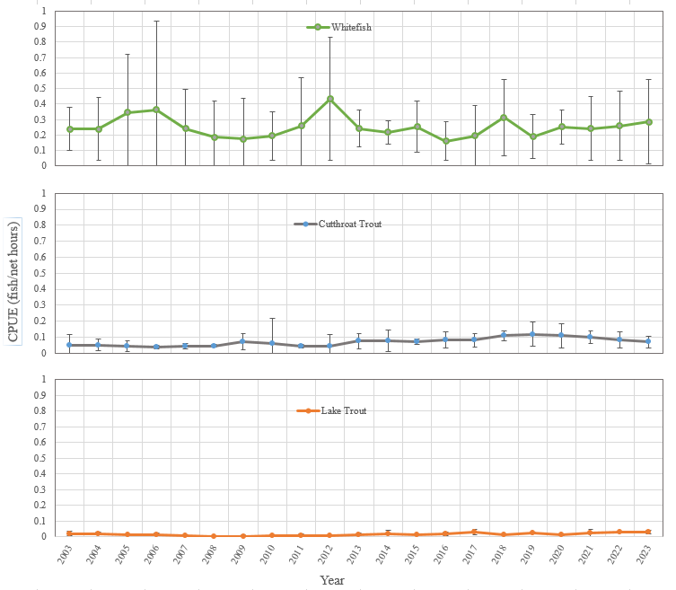  
 *Figure 7: Catch-per-unit-effort (CPUE) of Bear Lake Cutthroat, Lake trout, and Whitefish with 90% Confidence Interval bars.*

*Figure 8: Catch-per-unit-effort of Bear Lake Cutthroat Trout and average total length 2003-2023.*

Figure 9: Proportion of BLCT catch sampled in gill nets in 2023 by age.

Figure 10: Percent composition of Whitefish in the total gill-net catch from Bear Lake and average total length by species from 1999-2023. (Percentages determined by sub-sampling Whitefish <250 mm TL from each of seven different depths).

*Figure 11: Hydroacoustic estimates of Bonneville Cisco in Bear Lake (50-250 mm TL) and 95% confidence intervals from 1993-2023.*

**Literature Cited**

Bonar, S. A., Hubert, W. A., & Willis, D. W. (2009). Standard methods for sampling North American freshwater fishes.

Luecke, C., & Wurtsbaugh, W. A. (1993). Effects of moonlight and daylight on hydroacoustic estimates of pelagic fish abundance. *Transactions of the American Fisheries Society*, *122*(1), 112-120.

Ruzycki, J. R., Wurtsbaugh, W. A., & Luecke, C. (2001). Salmonine consumption and competition for endemic prey fishes in Bear Lake, Utah–Idaho. *Transactions of the American Fisheries Society*, *130*(6), 1175-1189.

Tolentino, S. A. (2021). Long-term hydroacoustic assessment of the Bonneville cisco (Prosopium gemmifer) population in Bear Lake, Utah/Idaho, USA, 1989-2016. Advances in Limnology, 189-204.

Wagner, E., J. Kozfkay, and S. Tolentino. (2004). Lake trout triploid production. Lateral Line 15:10-12.

**Appendix**

GPS coordinates in Lat/Long (degrees, minutes, thousandths of a minute) of hydroacoustic transects sampled in 2023. The latitude number is unchanged compared to previous years (1996-2022) however the longitude number varies slightly by year depending on the lake level. The longitude beginning and ending points are always at a point where the water depth is 5 meters. Due to the lake level fluctuating from year to year, that point can be up to several hundred meters due east or due west of the point shown in this table.

|  |  |  |
| --- | --- | --- |
| Transect Number | Lat/Long (east side) | Lat/Long (west side) |
| 1 | 410, 54.450’N  1110, 17.192’W | 410, 54.450’N  1110, 21.866’W |
| 2 | 410, 56.200’N  1110, 16.922’W | 410, 56.200’N  1110, 23.172’W |
| 3 | 410, 57.750’N  1110, 16.514’W | 410, 57.750’N  1110, 23.660’W |
| 4 | 420, 00.000’N  1110, 16.044’W | 420, 00.000’N  1110, 24.246’W |
| 5 | 420, 02.075’N  1110, 15.892’W | 410, 02.075’N  1110, 23.225’W |