**Red Fleet Reservoir Monitoring Report (NER)**

**Date(s):** May 10-11, 2023 **Target Species:** All Species

**Methods Description:**

|  |  |  |  |
| --- | --- | --- | --- |
| **Gear Type** | **Effort** | **Water Temp (°F)** | **Additional Data Collected** |
| Standardized gill nets (3) | 51.08 hrs | 59 | Max set depths- 15, 20, 35 ft, Fat, Diet |

**Site Location Table:** Netting locations were identified from surveysdone in previous years.

|  |  |  |
| --- | --- | --- |
| **Netting Site Description** | **UTM Easting** | **UTM Northing** |
| Inflow | 631447 | 4494279 |
| 2nd bay south of boat ramp | 632184 | 4493568 |
| Dam | 633610 | 4492891 |

**Abundance (CPUE), Condition (Wr) and Proportional Size Distribution (PSD) of Target Species**

|  |  |  |  |  |  |  |  |
| --- | --- | --- | --- | --- | --- | --- | --- |
| **Target Species** | **CPUE**  **fish/net hr** | **Mean TL mm**  **(min-max)** | **Mean Wr** | **PSD-Q** | **PSD-P** | **PSD-M** | **PSD-T** |
| Black crappie | 0.10 | 162 (115-230) | 81 | 100 | 0 | 0 | 0 |
| Bluegill | 0.02 | 129 | 78 | 0 | 0 | 0 | 0 |
| Flannelmouth sucker | 0.23 | NA | NA | NA | NA | NA | NA |
| Largemouth bass | 0.06 | 358 (340-377) | 102 | 100 | 0 | 0 | 0 |
| Mountain whitefish | 0.06 | 415 (410-421) | 105 | NA | NA | NA | NA |
| Rainbow trout | 0.02 | 500 | 74 | 100 | 100 | 0 | 0 |
| Tiger trout* | 0.04 | 522 (475-569) | 71 | 100 | 100 | 50 | 0 |
| Walleye | 0.02 | 330 | 89 | 0 | 0 | 0 | 0 |
| Wiper | 0.80 | 391 (351-444) | 69 | 15 | 0 | 0 | 0 |
| Yellow perch | 0.02 | 146 | 87 | 0 | 0 | 0 | 0 |

**Catch Summary**

|  |  |  |  |  |
| --- | --- | --- | --- | --- |
| **Species** | **Number Collected** | **Number as Percent (%)** | **Biomass**  **(kg)** | **Biomass as Percent (%)** |
| Black crappie | 5 | 7 | 0.361 | 1 |
| Bluegill | 1 | 1.5 | 0.033 | 0 |
| Flannelmouth sucker | 12 | 17 | NA | NA |
| Largemouth bass | 3 | 4 | 2.085 | 6 |
| Mountain whitefish | 3 | 4 | 2.308 | 7 |
| Rainbow trout | 1 | 1.5 | 1.102 | 3 |
| Tiger trout | 2 | 3 | 2.720 | 8 |
| Walleye | 1 | 1.5 | 0.320 | 1 |
| Wiper | 41 | 59 | 24.685 | 73 |
| Yellow perch | 1 | 1.5 | 0.035 | 0 |
| Totals | 70 | 100 | 33.649 | 99 |

**\*Note:** Currently, there are not accepted standard-weight or proportional size distribution values for hybrid tiger trout, so the values for lentic brown trout (Hyatt and Hubert 2001) were used in these analyses.

**Water:** Red Fleet Reservoir **Date(s):** July 5, 2023

**Target Species:** Wiper, walleye, largemouth bass, black crappie, yellow perch, bluegill

**Methods Description:** Three nighttime boat electrofishing transects, ~15 min/transect

|  |  |  |  |
| --- | --- | --- | --- |
| **Gear Type** | **Effort** | **Water Temp (°F)** | **Additional Data Collected** |
| Boat electrofishing | 2702 sec (0.75 hr) | 70.9 | VVP settings: 300V, 60 Freq, 30 pw, 8 amps |

**Site Location Table:**

|  |  |  |
| --- | --- | --- |
| **Transect Site Description** | **UTM Easting** | **UTM Northing** |
| Inflow | 631417 | 4494442 |
| 1st point south of boat ramp | 632092 | 4493589 |
| Dam | 633422 | 4492654 |

**Abundance (CPUE), Condition (Wr) and Proportional Size Distribution (PSD) of Target Species**

|  |  |  |  |  |  |  |  |  |
| --- | --- | --- | --- | --- | --- | --- | --- | --- |
| **Target Species** | **CPUE**  **fish/hr** | **CPUE range (8-yr)** | **Mean TL mm (min-max)** | **Mean Wr** | **PSD-Q** | **PSD-P** | **PSD-M** | **PSD-T** |
| Black crappie | 4 | 2-260 | 140 (103-215) | 102 | 100 | 0 | 0 | 0 |
| Bluegill | 8 | 0-58 | 108 (53-139) | 111 | 0 | 0 | 0 | 0 |
| Flannelmouth sucker | 1.3 | 0-1.3 | 520 (NA) | 118 | NA | NA | NA | NA |
| Largemouth bass | 6.7 | 0-36 | 339 (151-446) | 93 | 100 | 50 | 0 | 0 |
| Walleye | 0 | 0-93 | - | - | - | - | - | - |
| Wiper | 2.7 | 2.7-87 | 373 (364-382) | 70 | 0 | 0 | 0 | 0 |
| Yellow perch | 44 | 7-547 | 97 | 94 | 0 | 0 | 0 | 0 |

**Catch Summary**

|  |  |  |  |  |
| --- | --- | --- | --- | --- |
| **Species** | **Number Collected** | **Number as Percent (%)** | **Biomass**  **(kg)** | **Biomass as Percent (%)** |
| Black crappie | 3 | 6 | 0.165 | 2 |
| Bluegill | 6 | 12 | 0.225 | 3 |
| Flannelmouth sucker | 1 | 2 | 1.67 | 24 |
| Largemouth bass | 5 | 10 | 3.322 | 48 |
| Walleye | 0 | 0 | 0 | 0 |
| Wiper | 2 | 4 | 1.038 | 15 |
| Yellow perch | 33 | 66 | 0.523 | 8 |
| Totals | 50 | 100 | 6.943 | 100 |

**Comments:** Reservoir elevations varied greatly between 2022 and 2023 boat electrofishing surveys (5,585 ft and 5,607 ft respectively, courtesy of Uintah Water Conservancy District). Although surveys were conducted within the same 2 week window (late June- early July) high water in 2023 drastically altered the habitats surveyed at fixed transect locations. This is likely to have affected results, as electrofishing catch rates were lower for several species in 2023.

During gillnet surveys, flannelmouth sucker were scanned for PIT tags and immediately released in order to reduce stress and possible mortality, as this species is listed as a “Species of Greatest Conservation Need” under the Utah Wildlife Action Plan (2015).

Wiper proportional size distribution (PSD)was evaluated using the “striped bass hybrid” length values (Dumont and Neely 2011). Wiper were not stocked into Red Fleet Reservoir in 2023 (Figure 1). Wiper mean relative weight continues to decline (Figure 2), as both 2023 sampling events yielded the poorest condition observed to date (mean Wr 69, 70). Relative weight data also indicates that wiper condition deteriorates as they grow (Figure 3). Diet data collected in 2023 indicates a lack of forage availability for wiper, as most stomachs (66%) were empty and zooplankton was the primary food item of those not empty (Figure 4).

An increase in yellow perch abundance was observed during 2023 electrofishing, however no individuals greater than “stock” (200 mm) length were collected.

Crayfish were absent from all fish diets in 2023 (Figures 4 & 5). Three crayfish traps were baited and set during gillnet surveys, none of which collected crayfish. One trap was not recovered.

Currently, “quality” angling opportunities at Red Fleet include black crappie and largemouth bass, with some wiper exceeding “stock” length (Figure 6). Largemouth bass, rainbow trout, and tiger trout provide the only “preferred” and “memorable” length fish in this fishery.

**Suggested Management Changes:** In order to reduce electrofishing habitat variability, we recommend rescheduling this sampling to late summer when reservoir levels and littoral habitat are more consistent between years. Pursue stocking a pelagic forage, such as gizzard shad, to improve wiper condition and growth. If a pelagic forage cannot be established, reconsider species assemblage and long-term viability of wiper in Red Fleet Reservoir. Assess angler satisfaction and preference for wiper in Red Fleet during upcoming creel survey.

**Stocking Quota:**

|  |  |  |
| --- | --- | --- |
| **Species** | **Number** | **Length (in)** |
| Black crappie | 15,000 | 3 |
| Tiger trout | 1,000 | 6 |
| Walleye (triploid) | 65,000 | 2 |
| Wiper | 750 | 2 |

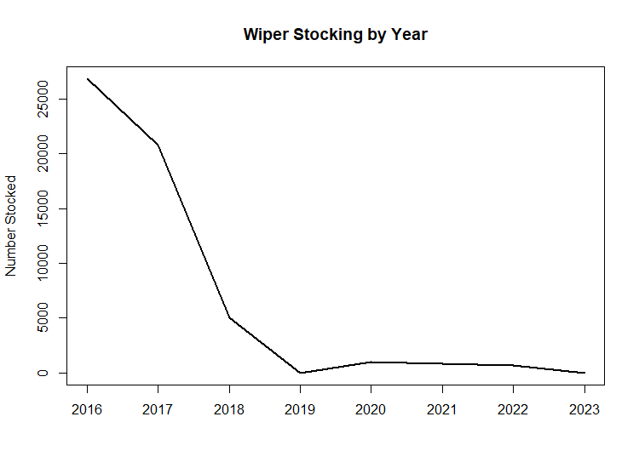

**Figure 1.** Number of wiper stocked per year in Red Fleet Reservoir from 2016 to 2023. Length at stocking has varied, but averaged 1.8 inches prior to 2019 and 4.6 inches since.

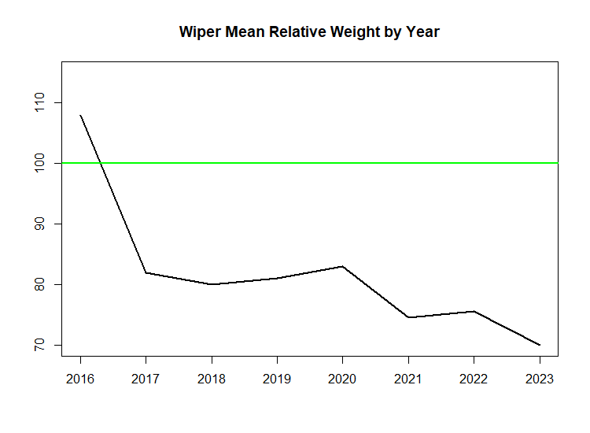

**Figure 2.** Mean relative weight of wiper sampled via boat electrofishing in Red Fleet Reservoir from 2016 to 2023. Relative weight for fish in good condition (100) is represented by the green line.

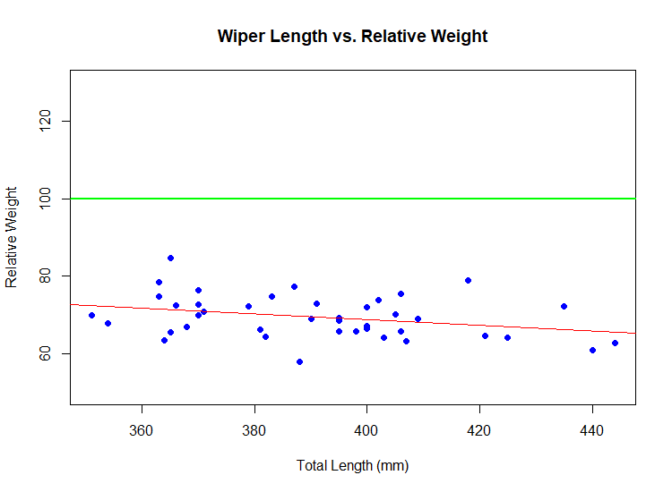

**Figure 3.** Total length and relative weight of wiper sampled via standardized gillnets in Red Fleet Reservoir in 2023. Relative weight at length for fish in good condition (100) is represented by the green line. The red represents the best-fit trend line of the data.

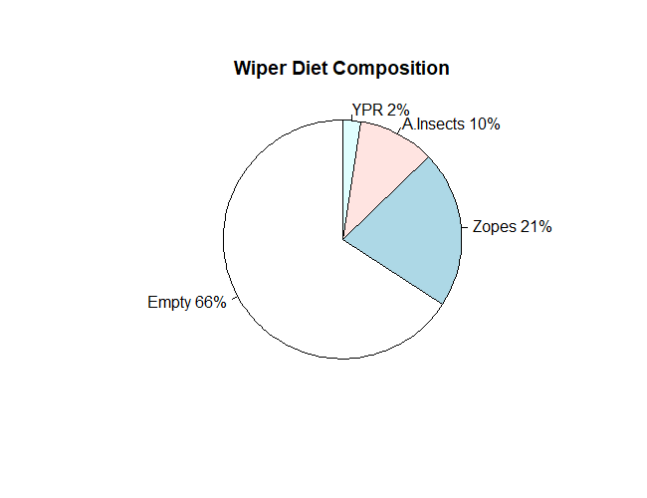

**Figure 4.** Diet composition for wiper (n=41) collected via standardized gillnets in Red Fleet Reservoir in 2023. “YPR” denotes yellow perch, “A.Insects” denotes aquatic insects, and “Zopes" denotes zooplankton.

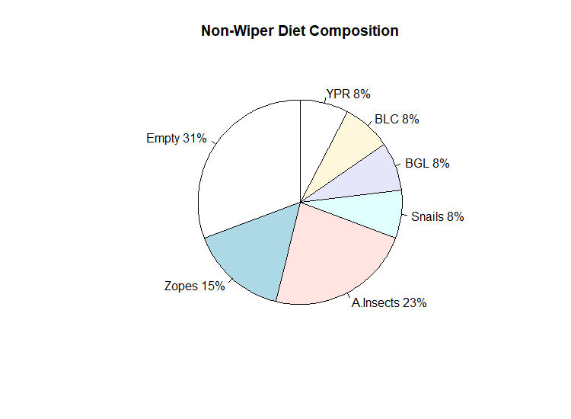

**Figure 5.** Diet composition for all fish excluding wiper (n=13), collected via standardized gillnets in Red Fleet Reservoir in 2023. “YPR” denotes yellow perch, “BLC” denotes black crappie, “BGL” denotes bluegill, “A.Insects” denotes aquatic insects, and “Zopes" denotes zooplankton.

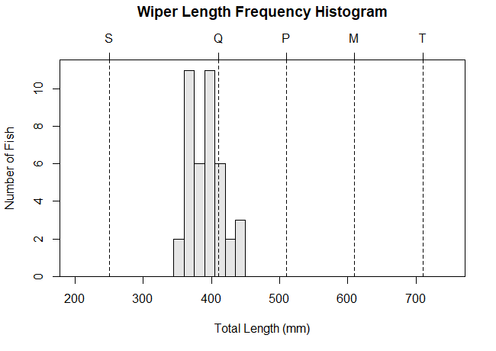

**Figure 6.** Total length frequency of wiper sampled during 2023 gill net surveys in Red Fleet Reservoir, including Gablehouse length categories (stock, quality, preferred, memorable, trophy).